GAMMA TOURISTIC CONSTANTA
DISPECERAT BULGARIA TEL/FAX. 0241-540604/ 0241-547837/ 0241-540614
TEL. RDS 0341174820 / 0766374787 / 0722553151 / 0744543949
bulgaria@estival.ro www.estival.ro
PROGRAM DISPECERAT LUNI-VINERI 09-19 SAMBATA 09-17

LAST MINUTE NR. 37 BULGARIA SUD 2019

TARIFELE NU INCLUD :
TAXA DE STATIUNE 6 € / ADULT /SEJUR ; 3 € /COPIL /SEJUR
PRECIZARI IMPORTANTE REDUCERE :
- REDUCERA ESTE VALABILA PT. PLATA INTEGRALA LA TERMENUL STABILIT
- REZERVARILE SE ACHITA INTEGRAL PINA LA DATA LIMITA !
- NU SE COMBINA CU OFERTELE SPECIALE
- REZERVARILE REDUCERE NU PERMIT MODIFICARI SI NICI ANULARI ! IN CAZ DE ANULARE PENALIZAREA ESTE DE 100 % !
- REDUCERILE SE APLICA DOAR LA TARIFELE DE BAZA FARA TAXE SI SUPLIMENTE !
PE VOUCHER SE SCRIE OBLIGATORIU ” REDUCERE “

”NOPTI GRATUITE ” -NU SE COMBINA CU “ REDUCERE”
***NOPTILE SUPLIMENTARE SE ACORDA CU SERVICIILE DE MASA DE BAZA ! FARA SUPLIMENTE .
7=5 » DACA SEJURUL SE INCADREAZA IN PERIOADA PRECIZATA ATUNCI CINE PLATESTE 5 NOPTI STA GRATUIT 7 NOPTI. CELE 2 NOPTI SE ACORDA CU SERVICII DE MASA DE BAZA , FARA SUPLIM. DE MASA
= ”RECOMANDAREA NOASTRA”
!IN CAZUL NEPREZENTARII TURISTILOR LA HOTEL IN ZIUA INCEPERII SEJURULUI (NO SHOW)-PENALIZAREA ESTE DE 100 %. DACA AVETI ANULARI CHIAR SI IN ZIUA INCEPERERI SEJURULUI,VA RUGAM SA NE ANUNTATI PENTRU A LIMITA PENALIZARILE.
!RECLAMATIILE PENTRU CALITATEA SI CANTITATEA SERVICIILOR TURISTICE SE FAC IN MOMENTUL CONSTATARII SAU PRODUCERII LOR !
PUTETI FOLOSITI TELEFOANELE AGENTIEI NOASTRE NON STOP ! AVEM ZILNIC IN BULGARIA REPREZENTANTI CARE POT CONSTATA SI REMEDIA ORICE DEFICIENTA A SERVICIILOR TURISTICE ! ORICE RECLAMATIE ULTERIOARA NU VA FII LUATA IN CONSIDERATIE !
!CLASIFICAREA HOTELURILOR ESTE CEA OFICIALA FACUTA DE AUTORITATEA TURISTICA , IN FUNCTIE DE REGLEMENTARILE LEGALE DIN BULGARIA !
!CONFORM REGLEMENTARILOR IN VIGOARE , MINORII TREBUIE SA INDEPLINEASCA SIMULTAM URMATOARELE CONDITII PENTRU A PUTEA IESI DIN TARA :
- SA DETINA UN PASAPORT SAU CARTE DE IDENTITATE ( PENTRU CEI DE PESTE 14 ANI ) SI SA FIE INSOTITI DE AMBII PARINTI
DACA MINORUL NU ESTE INSOTIT DE AMBII PARINTI ATUNCI SE APLICA CONDITIILE URMATOARE :
- SA FIE INSOTIT DE UN ADULT
- SA AIBA ASPUPRA LUI ACORDUL FACUT LA NOTARIAT AL AMBILOR PARINTI ( SAU AL PARINTELUI CARE NU IL INSOTESTE )
- ADULTUL CARE IL INSOTESTE , IN CAZUL IN CARE NU ESTE UNUL DIN PARINTI TREBUIE SA DETINA CAZIER JUDICIAR.
!ATENTIE LA CONDITIILE DE IESIRE DIN TARA A CELOR PROASPAT CASATORITI !

LEGENDA :
DUBLA= CAMERA CU 2 PATURI NORMALE PENTRU 2 PERSOANE
STUDIO=O CAMERA MAI MARE;
CAMERA SINGLA = CAMERA PENTRU O SINGURA PERSOANA
CAMERA TRIPLA= CAMERA CU 3 PATURI PENTRU 3 ADULTI
CAMERA/ APARTAMENT IN REGIM SINGLA= CAMERA/ APART. FOLOSIT DE O SINGURA PERSOANA
PAT SUPLIMENTAR= UN PAT SUPLIMENTAR INTR-O CAMERA DUBLA-POATE FII UN FOTOLIUEXTENSIBIL / PAT PLIANT /CANAPEA/ CANAPEA EXTENSIBILA ETC.
TERMEN DE ANULARE=NR. DE ZILE LUCRATOARE INAINTE DE INCEPEREA SEJURULUI IN CARE SE POT ANULA SERVICIILE TURISTICE FARA PENALIZARE
CAMERA FAMILY= CAMERA MAI MARE UNEORI CU MAI MULTE PATURI PT. CAZAREA FAMILIILOR MAI NUMEROASE
ALL INCLUSIVE = MIC DEJUN; PRANZ ; CINA ; GUSTARI INTRE MESE ; BAUTURI LOCALE NELIMITAT DE OBICEI INTRE ORELE 11.00-22.00 ;
VEDERE MARE = CAMERE CU FATA SPRE MARE -POATE FII PARTIAL BLOCATA DE VEGETATIE
VEDERE PARK = CAMERE CU VEDERE DIFERITA DE VEDEREA LA MARE
NO SHOW =NEPREZENTAREA LA HOTEL LA DATA INCEPERII SEJURULUI

*** DATELE DE DESCHIDERE / INCHIDERE SUNT STABILITE DE FIECARE HOTEL IN PARTE IN FUNCTIE DE SITUATIA REZERVARILOR.

***** LOCURILE DE PARCARE ( IN LIMITA DISPONIBILITATILOR ) SE OCUPA SI ACHITA DOAR LA FATA LOCULUI ! *****

HOTEL VEMARA CLUB (EX .CALIMERA ) 3*+
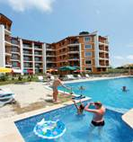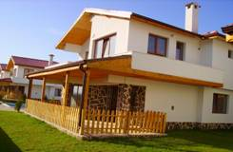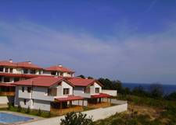

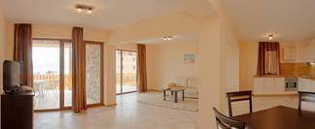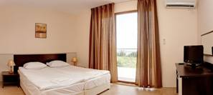
Localizare : la 200 de plaja , in partea sudica a localitatii byala.Complexul este situat pe malul marii pe o faleza inalta.
Facilitati complex : piscina exterioara ;parcare
Dotari apartamente: aer conditionat; bucatarie dotata;TV satelit ; balcon http://www.calimera.bg/
OFERTA LAST MINUTE COD « VT/20.05; 101/21.05; TK/21.05»
“DISCOUNT 20%”PT REZERVARILE TRIMISE IN PERIOADA 21.05-20.06.2019 SI ACHITATE IN 24 H- SEJUR IN PERIOADELE 1.06-9.06/29.08-20.09.2019
2 NOPTI PANA PE 20.06 SI 3 NOPTI DIN 29.08.2019
“DISCOUNT 15%”PT REZERVARILE TRIMISE IN PERIOADA 21.05-20.06.2019 SI ACHITATE IN 24 H- SEJUR MINIM 3 NOPTI IN PERIOADA 7.07-28.08.2019
*SE POATE COMBINA CU NOPTI GRATUITE
ALL INCLUSIVE | 31.05-15.06  08.09-30.09 | 16.06-9.07  24.08-7.09 | 10.07-23.08
CLADIREA PRINCIPALA
LOC IN CAMERA VED. PARK | 29,5 | 36 | 49
SUPLIMENT CAMERA SINGLE | +50% | +50% | +50%
LOC IN CAMERA VED. MARE | 31,5 | 38 | 51
SUPLIMENT CAMERA SINGLE | +50% | +50% | +50%
LOC IN APART. 1 DORM. SV | 34 | 40,5 | 53,5
LOC IN APART. 2 DORM. SV | 26 | 31,5 | 44,5
VILE
LOC IN CAMERA DUBLA PV | 28,5 | 35 | 48
SUPLIMENT CAMERA SINGLE | +50% | +50% | +50%
LOC IN CAMERA DUBLA SV | 30,5 | 37 | 50
SUPLIMENT CAMERA SINGLE | +50% | +50% | +50%
LOC IN APART. 2 DORM SV | 25 | 30,5 | 43,5
LOC IN VILA SV | 25 | 30,5 | 43,5
TERMEN DE ANULARE | 11 | 14 | 18
PENALIZARI | 3 | 3 | 4
CLADIREA PRINCIPALA
IN CAMERA DUBLA MAXIM 2 ADULTI+ 2 COPII/ 3 ADULTI
IN APARTAM. 1 DORMITOR- MAXIM 2 ADULTI+ 2 COPII / 3 ADULTI
IN APARTAM. 2 DORMITOARE MINIM 4 ADULTI; MAXIM 4 ADULTI + 2 COPII/ 5 ADULTI
VILE
IN DBL MAXIM 2 ADULTI+ 2 COPII/ 3 ADULTI
IN APART. 2 DORMITOARE MINIM 4 ADULTI; MAXIM 4 ADULTI + 2 COPII/ 5 ADULTI
IN VILA SV MINIM 6 ADULTI; MAXIM 8 ADULTI+ 2 COPII/10 ADULTI
REDUCERI:
-1 COPIL (0-1.99 ANI ) –GRATUIT,FARA SERVICII
- 1 COPIL ( 2-12.99 ANI ) IN PAT SUPLIMENTAR CU 2 ADULTI IN DUBLA –50%
- AL 2 LEA COPIL ( 2-12.99 ANI ) IN PAT SUPLIMENTAR- 50%
-1 COPIL ( 2-12.99 ANI ) IN PAT SUPLIMENTAR IN AP SAU VILA-70% REDUCERE
- AL 2 LEA ( 2-12.99 ANI ) IN PAT SUPLIMENTAR IN AP SAU VILA- 50%
-1-2 COPII ( 2-12.99 ANI ) CU 1 ADULT - FIECARE PLATESTE 50%
- ADULT IN PAT SUPLIMENTAR– 20% REDUCERE
NOPTI GRATUITEVALABIL PTSOSIRI PANA PE 20.06 SI DIN 7.09.2019
1) 1 NOAPTE GRATUITA PT SEJURURI 7-13 NOPTI
2) 2 NOPTI GRATUITE PT SEJURURI 14-20 NOPTI

HOTEL MIRAMAR OBZOR 4*++/OBZOR
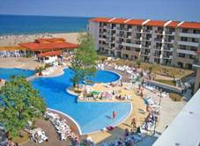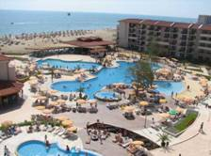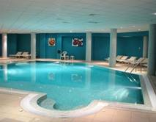

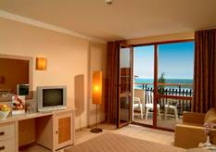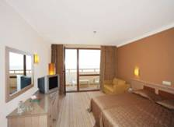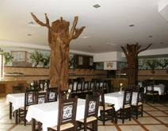
Localizare: la plaja
Dotari camera: telefon, cablu TV, canapea, aer conditionat, frigider, baie (cabina de dus), uscator, balcon/terasa.
Facilitati hotel: piscine exterioare , piscina interioara ,sauna, hammam (baie turceasca), sala de gimnastica, jacuzzi, loc de joaca pt. Copii
SEJUR MINIM 5 NOPTI IN PERIOADA 15.06-7.09.2018
OFERTA LAST MINUTE COD « 113/3.06 ; VT03.06»
“DISCOUNT 15%”PT REZERVARILE TRIMISE IN PERIOADA 1.06-30.06.2019 SI ACHITATE IN 24 H- SEJUR IN PERIOADELE 14.06-23.08/31.08-SF SEZON
ULTRA ALL INCLUSIVE | 14.6-19.6 | 20.6-09.7  28.8-31.08 | 10.07-  27.08
LOC IN CAMERA VED. PARK | 82 | 93 | 110
LOC IN CAMERA VED. LATERALA MARE | 84 | 96,5 | 113,5
CAMERA SINGLE | 100 | 116,5 | 138
LOC IN CAMERA LARGE | 95,5 | 113,5 | 131
LOC IN APART.1 DORMITOR | 1223,5 | 140 | 161,5
TERMEN DE ANULARE | 16 | 18 | 20
PENALIZARE | 3 | 3 | 4
TARIFUL INCLUDE SEZLONGURI SI UMRELA PE PLAJA , BEACH BAR SI REST NOU “THE SHIP”
IN CAMERA DUBLA MAXIM 2 ADULTI+1 COPIL/ 3 ADULTI
IN CAMERA DUBLA LARGE MINIM 2 ADULTI+ 2 COPII/ 3 ADULTI; MAXIM 3 ADULTI+1 COPIL
IN APARTAMENT MINIM 2 ADULTI + 2 COPII/ 3 ADULTI; MAXIM 3 ADULTI+ 1 COPIL
REDUCERI :
- COPIL ( 0-1.99 ANI ) – GRATUIT, FARA SERVICII
- 1 COPIL ( 2-12.99 ANI ) IN PAT SUPLIMENTAR– GRATUIT
- AL 2 LEA COPIL ( 2-12.99 ANI ) IN PAT SUPLIMENTAR IN DBL LARGE/APART- 50%
- 1 COPIL ( 2-12.99 ANI ) CU 1 ADULT -50%
- 2 COPII ( 2-12.99 ANI ) CU 1 ADULT - FIECARE PLATESTE 50%
- ADULT IN PAT SUPLIMENTAR - 30 % REDUCERE

HOTEL MIRAMAR DELUXE 4*/OBZOR
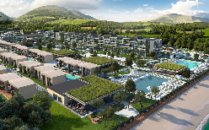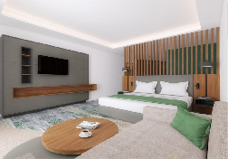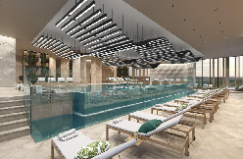
Localizare: 500 m de plaja/ corpurile A si B ale viitorului hotel Reina Del Mar
Dotari camera: aer conditionat, telefon, frigider, uscator de par, cablu/TV., baie cu dus;
Facilitati hotel: restaurant, bar, terasa,; piscina exterioara;piscine copii; bar piscina; piscine interioara;sauna;centru fitness;hammam;o zona de plaja privata; WI FI; parcare;
OFERTA LAST MINUTE COD « 112/3.06»
“DISCOUNT 20%”PT REZERVARILE TRIMISE IN PERIOADA 1.06-30.06.2019 SI ACHITATE IN 24 H- SEJUR IN PERIOADA 15.06-30.06.2019
“DISCOUNT 20%”PT REZERVARILE TRIMISE IN PERIOADA 1.06-30.06.2019 SI ACHITATE IN 24 H- SEJUR IN PERIOADA 1.07-10.10.2019
2 AD+ 2 COPII = 2 ( COPII GRATUITI IN DBL PV SI SV)
ULTRA ALL INCLUSIVE | 12.09-  30.09 | 15.06-19.6  4.09-11.09 | 20.06-9.07  28.08-3.09 | 10.07-27.08 | 1.10-8.10
LOC IN CAMERA VED. PARK | 75 | 93 | 104,5 | 121,5 | 61,5
CAMERA SINGLE | 149 | 184,5 | 207,5 | 241 | 122
LOC IN CAMERA VED. MARE | 80,5 | 98,5 | 111,5 | 130,5 | 68
CAMERA SINGLE | 160 | 196 | 221 | 259 | 102
LOC IN CAMERA FAMILY PV | 98,5 | 121 | 138 | 157 | 72,5
LOC IN SUITE VED. MARE | 109,5 | 134 | 151,5 | 173 | 81,5
TERMEN DE ANULARE | 12 | 14 | 16 | 20 | 20
PENALIZARE | 2 | 2 | 3 | 4 | 4
IN CAMERA DUBLA MAXIM 2 ADULTI +2 COPII/ 3 ADULTI
IN SUITE MAXIM 2 ADULTI +2 COPII/ 3 ADULTI+ 1 COPIL/4 ADULTI
IN CAMERA FAMILY MINIM 2 ADULTI +2 COPII/ 3 ADULTI+ 1 COPIL/ MAXIM 4 ADULTI+ 2 COPII - SE ACHITA MINIM 3 LOCURI INTREGI
INFANTUL CONTEAZA LA MAXIM OCUPARE !
REDUCERI :
- COPIL ( 0-1.99 ANI ) – GRATUIT, FARA SERVICII
- 1 COPIL ( 2-12.99 ANI ) IN PAT SUPLIMENTAR– GRATUIT
- AL 2 LEA COPIL ( 2-12.99 ANI ) IN PAT SUPLIMENTAR - GRATUIT
- 1-2 COPII ( 2-12.99 ANI ) CU 1 ADULT IN DBL PV–FIECARE PLATESTE 50%
- ADULT IN PAT SUPLIMENTAR - 30 % REDUCERE
REDUCERI IN FAMILY:
-3-4 COPII ( 2-12,99 ANI) IN PAT SUPLIMENTAR CU 2 ADULTI- FIECARE COPIL PLATESTE 50%
-1 COPIL ( 2-12,99 ANI) IN PAT SUPLIMENTAR CU 3 ADULTI- 50%
-2 COPII ( 2-12,99 ANI) IN PAT SUPLIMENTAR CU 3 ADULTI- FIECARE PLATESTE 50%
-1-2 COPII ( 2-12,99 ANI) IN PAT SUPLIMENTAR CU 4 ADULTI- FIECARE PLATESTE 50%
- AL 4 LEA ADULT IN PAT SUPLIMENTAR IN FAMILY-30% REDUCERE

HOTEL MARINA SANDS OBZOR BEACH 4*/OBZOR
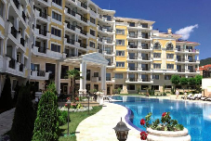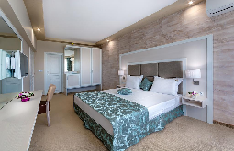
Localizare: pe plaja
Dotari camera:TV; A/C; zona relaxare; baie (cabina de dus),articole toaleta;uscator de par, telefon, balcon;frigider;WI FI;seif;semineu
Faciitati hotel: restaurant, lobby bar,facilitati gratar, piscina,piscina copii; loc de joaca pentru copii ;club copii;teren tenis;WI FI;parcare;terasa;gradina;fitness;
www.marinasands.bg
OFERTA LAST MINUTE COD « VT/4.06; SPO JUNE 117/05.06 »
“DISCOUNT 10%”PT REZERVARILE TRIMISE IN PERIOADA 4.06-30.06.2019 SI ACHITATE IN 24 H- SEJUR IN PERIOADA 5.06-30.09.2019
ALL INCLUSIVE | 5.06-10.06  8.09-30.09 | 11.06-1.07 | 2.07-25.08 | 26.08-7.09
LOC IN CAMERA DUBLA | 33,5 | 41 | 69 | 46,5
CAMERA SINGLE | 49,5 | 60,5 | 136 | 82
APART. 1 DORM 2 ADULTI/ZI* | 102,5 | 126 | 171 | 137
APART. 1 DORM 3 ADULTI/ZI* | 103,5 | 127,5 | 172 | 138,5
APART. 1 DORM 4 ADULTI/ZI* | 104 | 129 | 173,5 | 140
TERMEN DE ANULARE | 12 | 16 | 18 | 20
PENALIZARE | 2 | 2 | 3 | 4
IN CAMERA DUBLA MAXIM 2+ ADULTI+ 1 COPIL/ 3 ADULTI
IN APARTAMENT 1 DORM. MAXIM 2 ADULTI+ 2 COPII/3 ADULTI
IN APARTAMENT 2 DORM. MAXIM 4 ADULTI+ 1 COPIL
REDUCERI:
- COPIL ( 0-1.99 ANI ) – GRATUIT, FARA SERVICII
- 1 COPIL ( 2-11,99 ANI ) IN PAT SUPLIMENTAR – GRATUIT
- AL 2 LEA COPIL ( 2- 11,99 ANI) IN PAT SUPLIMENTAR- GRATUIT
- 1 COPIL( 2-11.99 ANI ) CU 1 ADULT IN DBL- FARA REDUCERE
- 2 COPII ( 2-11.99 ANI ) CU 1 ADULT IN DBL– FIECARE PLATESTE 50 %
- AL 3 LEA ADULT IN PAT SUPLIMENTAR IN DBL - 20 % REDUCERE
- AL 5 LEA ADULT IN PAT SUPLIM.IN AP 2 DORM- PLATESTE SUPLIMENT 41€/ZI
HOTEL RIU HELIOS BAY 4*/ OBZOR
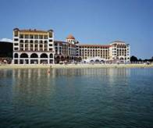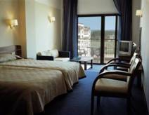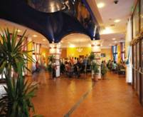
Localizare: pe plaja
Dotari camera: baie (cabina de dus),uscator de par, aer conditionat, telefon, balcon/terasa
Faciitati hotel: restaurant, lobby bar, piscina, piscina pentru copii, piscina interioara, jacuzzi, sala, salon de masaj, loc de joaca pentru copii
OFERTA LAST MINUTE COD « VT/3.06»
“DISCOUNT 25%”PT REZERVARILE TRIMISE IN PERIOADA 1.06-30.06.2019 SI ACHITATE IN 24 H- SEJUR IN PERIOADA 1.06-30.09.2019
ALL INCLUSIVE | 24.09-30.09 | 1.06-10.06  13.09-22.09 | 11.06-30.06  1.09-12.09 | 01.07-  31.08
SEJUR MINIM NOPTI | 3/1/1 | 1 | 1 | 1
LOC IN CAMERA STANDARD | 38,5 | 49,5 | 67 | 93
CAMERA SINGLE | 46 | 78 | 119 | 167
LOC IN CAMERA SUPERIOARA | 44,5 | 61 | 78,5 | 109
FAMILY 3 ADULTI/ZI* | 133,5 | 196,5 | 248 | 367,5
FAMILY 4 ADULTI/ZI* | 172 | 253 | 319 | 473
TERMEN DE ANULARE | 12 | 16 | 18 | 20
PENALIZARE | 2 | 2 | 3 | 4
IN CAMERA DUBLA MAXIM 2+ ADULTI+ 1 COPIL/ 3 ADULTI
IN CAMERA DUBLA SUPERIOARA MAXIM 2 ADULTI+ 2 COPII/ 3 ADULTI+1 COPIL
IN CAMERA FAMILY MINIM 2 ADULTI+ 2 COPII; 3 ADULTI+ 1 COPIL; MAXIM 4 ADULTI
INFANTII CONTEAZA LA GRAD OCUPARE !!!
REDUCERI:
- COPIL ( 0-1.99 ANI ) – GRATUIT, FARA SERVICII
- 1 COPIL ( 2-4.99 ANI ) IN PAT SUPLIMENTAR – GRATUIT
- 1 COPIL ( 5- 11,99 ANI) IN PAT SUPLIMENTAR- 50%
- 1 COPIL ( 2-11.99 ANI )CU 1 AD IN DBL SUP/FAM- FARA REDUDERE
- AL 2 LEA COPII ( 2-11.99 ANI ) IN DBL SUPERIOR/ FAMILY–50 %
- 1 -2 COPII ( 2-11.99 ANI ) CU 1 ADULT IN DBL STANDARD– FIECARE PLATESTE 75 %
- ADULT IN PAT SUPLIMENTAR - 20 % REDUCERE
HOTEL SUNRISE BLUE MAGIC 4*/OBZOR
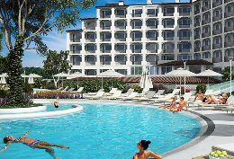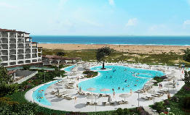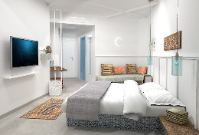
Localizare: 30m de plaja, 3 km de Obzor- INAUGURAT 2018
Dotari camera: baie cu dus ;uscator de par; A/C; TV LCD;acces internet contra cost;seif;frigider;balcon
Faciitati hotel: restaurante, 3 baruri, terasa,gradina, lift;incalzire,camera bagaje,sala fitness, centru spa,piscine exterioara;piscine copii;loc Joaca copii,mini club,sala jocuri,darts,tenis masa,teren volei,mini fotbal,aerobic;inchirieri biciclete,plaja private;sporturi nautice; parcare
OFERTA LAST MINUTE COD « 112/3.06;TK/1.06»
“DISCOUNT 20%”PT REZERVARILE TRIMISE IN PERIOADA 3.06-12.06.2019 SI ACHITATE IN 24 H- SEJUR IN PERIOADA 3.06-13.06.2019
ALL INCLUSIVE | 3.06-13.06
LOC IN CAMERA DUBLA PV | 50
CAMERA SINGLE | 99,5
LOC IN CAMERA DUBLA SV | 55
CAMERA SINGLE | 108,5
LOC IN STUDIO | 62,5
TERMEN DE ANULARE | 16
PENALIZARE | 2

OFERTA LAST MINUTE COD « 110/1.06; TK/1.06»
“DISCOUNT 15%”PT REZERVARILE TRIMISE IN PERIOADA 1.06-30.06.2019 SI ACHITATE IN 24 H- SEJUR IN PERIOADA 21.06-30.09.2019
ALL INCLUSIVE | 25.09-30.09 | 14.09-24.09 | 21.06-6.07  27.08-13.09 | 7.07-26.08
LOC IN CAMERA DUBLA PV | 38 | 50 | 69 | 91
CAMERA SINGLE | 75 | 99,5 | 136 | 181
LOC IN CAMERA DUBLA SV | 40 | 55 | 74,5 | 98
CAMERA SINGLE | 79,5 | 108,5 | 147 | 194
LOC IN STUDIO | 46 | 62,5 | 84,5 | 111,5
TERMEN DE ANULARE | 12 | 16 | 18 | 20
PENALIZARE | 2 | 2 | 3 | 4
IN CAMERA DUBLA MAXIM 2 ADULTI+ 2 COPII/ 3 ADULTI
IN STUDIO MAXIM 2 ADULTI+ 2 COPII/ 3 ADULTI
REDUCERI:
- COPIL ( 0-1.99 ANI ) – GRATUIT, FARA SERVICII
- 1 COPIL ( 2- 12,99 ANI) IN PAT SUPLIMENTAR- GRATUIT
- AL 2 LEA COPIL ( 2-12.99 ANI ) IN PAT SUPLIMENTAR–50 %
- 1 COPIL( 2-12.99 ANI ) CU 1 ADULT – FARA REDUCERE
- 2 COPII ( 2-12.99 ANI ) CU 1 ADULT- FIECARE PLATESTE 50%
- ADULT IN PAT SUPLIMENTAR - 20 % REDUCERE

HOTEL SOL LUNA BAY RESORT 4*/OBZOR
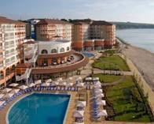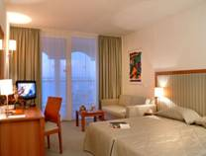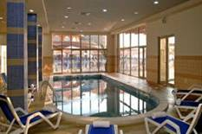

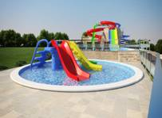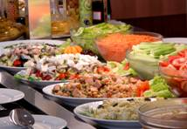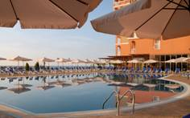
Localizare: pe plaja din Obzor
Dotari camera: aer conditionat, baie, uscator de par, telefon, televizor, seif, balcon.
Facilitati hotel: restaurant, bar, piscina, piscina pt. copii,piscina acoperita, internet in lobby, spectacole de animatie, fitness, masaj,
sauna, solar, aerobic, tenis de masa, volei pe plaja, teren de basket, biliard, darts, coafor, salon de frumusete.
COMPLEXUL ARE AQUA LAND !
OFERTA LAST MINUTE COD « VT12.06»
“DISCOUNT 15%”PT REZERVARILE TRIMISE IN PERIOADA 16.06.-30.06.2019 SI ACHITATE IN 24 H- SEJUR IN PERIOADELE 13.06-24.06 -DBL /SINGL SI FAM SUITES
“DISCOUNT 20%”PT REZERVARILE TRIMISE IN PERIOADA 16.06.-30.06.2019 SI ACHITATE IN 24 H- SEJUR IN PERIOADELE 05.07-20.07 -DBL /SINGL CU VED. MARE
“DISCOUNT 15%”PT REZERVARILE TRIMISE IN PERIOADA 16.06.-30.06.2019 SI ACHITATE IN 24 H- SEJUR IN PERIOADA 05.07-20.07 -DBL /SINGL CU VED. PARK
“DISCOUNT 15%”PT REZERVARILE TRIMISE IN PERIOADA 16.06.-30.06.2019 SI ACHITATE IN 24 H- SEJUR IN PERIOADA 8.08-26.08-DBL /SINGL SI FAM SUITES
“DISCOUNT 10%”PT REZERVARILE TRIMISE IN PERIOADA 16.06.-30.06.2019 SI ACHITATE IN 24 H- SEJUR IN PERIOADA 02.09-14.10-DBL /SINGL SI FAM SUITES
“DISCOUNT 15%”PT REZERVARILE TRIMISE IN PERIOADA 16.06.-30.06.2019 SI ACHITATE IN 24 H- SEJUR IN PERIOADA 11.06-21.06.2019-STUDIO
“DISCOUNT 25%”PT REZERVARILE TRIMISE IN PERIOADA 16.06.-30.06.2019 SI ACHITATE IN 24 H- SEJUR IN PERIOADA 11.06-21.06.2019-AP 1 DORM SI AP 2 DORM
-“DISCOUNT 10%”PT REZERVARILE TRIMISE IN PERIOADA 16.06.-30.06.2019 SI ACHITATE IN 24 H- SEJUR IN PERIOADA 1.07-21.07-STUDIO
“DISCOUNT 20%”PT REZERVARILE TRIMISE IN PERIOADA 16.06.-30.06.2019 SI ACHITATE IN 24 H- SEJUR IN PERIOADA 1.07-21.07-AP 1 DORM SI AP 2 DORM
-“DISCOUNT 10%”PT REZERVARILE TRIMISE IN PERIOADA 16.06.-30.06.2019 SI ACHITATE IN 24 H- SEJUR IN PERIOADA 27.07-10.09 -STUDIO
“DISCOUNT 20%”PT REZERVARILE TRIMISE IN PERIOADA 16.06.-30.06.2019 SI ACHITATE IN 24 H- SEJUR IN PERIOADA 27.07-10.09 -AP 1 DORM SI AP 2 DORM
ALL INCLUSIVE | 01.6-09.06  B | 10.06-20.06  1.09-10.09  C | 21.06-30.06  D | 1.07-  31.08  E
SEJUR MINIM / NOPTI | 1 | 7 | 7 | 7
LOC IN CAMERA VED. PARK | 48 | 67,5 | 71 | 93,5
CAMERA SINGLE | 76 | 112,5 | 116 | 155
LOC IN CAMERA VED. LATERALA MARE | 52,5 | 75,5 | 79 | 102,5
CAMERA SINGLE | 80,5 | 120 | 123,5 | 164
FAMILY VED. PARK 2 ADULTI + 2 COPII /ZI* | 163 | 235 | 257,5 | 322
FAMILY VED. PARK 2 ADULTI + 3 COPII /ZI* | 195,5 | 282,5 | 309,5 | 386,5
FAMILY VED. PARK 3 ADULTI+ 1 COPIL/ZI* | 179 | 258 | 283 |  | 353,5
FAMILY VED. PARK 3 ADULTI+ 2 COPII/ZI* | 208 | 305,5 | 334,5 |  | 419
FAMILY VED. PARK 4 ADULTI+ 1 COPIL/ZI | 227,5 | 328,5 | 360 |  | 450
FAMILY VED. MARE 2 ADULTI+ 2 COPII/ZI* | 174 | 306 | 277 |  | 344,5
FAMILY VED. MARE 2 ADULTI+ 3 COPII/ZI | 209 | 306 | 333 |  | 413
FAMILY VED. MARE 3 ADULTI+ 1 COPIL/ZI | 191 | 279,5 | 304,5 |  | 378
FAMILY VED. MARE 3 ADULTI+ 2 COPII/ZI | 226 | 331 | 360 |  | 447,5
FAMILY VED. MARE4 ADULTI+1 COPIL | 243 | 356 | 387 |  | 481
TERMEN DE ANULARE | 14 | 16 | 20 |  | 20
PENALIZARE | 50% | 100% | 100% |  | 100%
IN CAMERA DUBLA MAXIM 2 ADULTI+ 1 COPIL/ 3 ADULTI
IN CAMERA FAMILY MINIM 2 ADULTI+ 2 COPII;MAXIM 4 ADULTI+ 1 COPIL
INFANTII CONTEAZA LA GRAD OCUPARE
REDUCERI :
- COPII ( 0-1.99 ANI )– GRATUIT, FARA SERVICII
- 1 COPIL ( 2-11.99 ANI ) IN PAT SUPLIMENTAR – GRATUIT
- AL 2-LEA COPIL ( 2-11.99 ANI ) IN PAT SUPLIM.- FIECARE PLATESTE 50%
- 1 COPIL ( 2-11.99 ANI ) CU 1 ADULT IN CAMERA – 30% REDUCERE
- 2 COPII ( 2-11.99 ANI ) CU 1 ADULT IN CAMERA- FIECARE PLATESTE 50%
- AL 3 LEA ADULT IN PAT SUPLIMENTAR - 25 % REDUCERE
- AL 4 LEA SI AL 5 LEA ADULT IN PAT SUPLIMENTAR IN FAMILY- 25% REDUCERE

ALL INCLUSIVE | 01.6-09.06  B | 10.06-20.06  1.09-10.09  C | 21.06-30.06  D | 1.07-  31.08  E
STUDIO VED. PARK 2 ADULTI+ 1 COPIL/ZI* | 96,5 | 136,5 | 143 |  | 188
STUDIO VED. PARK 2 ADULTI+ 2 COPII/ZI* | 121 | 171 | 179 |  | 235
STUDIO VED. PARK 3 ADULTI/ZI* | 132 | 186 | 195 |  | 257
STUDIO VED. MARE 2 ADULTI+1 COPIL/ZI* | 105,5 | 152 | 159 |  | 206
STUDIO VED. MARE 2 ADULTI+2 COPII/ZI* | 132 | 189 | 197,5 |  | 257,5
STUDIO VED. MARE 3 ADULTI/ZI* | 144 | 207,5 | 217 |  | 281,5
APART. 1 DORM. VED. PARK 2 ADULTI+2 COPII/ZI* | 163 | 235 | 257,5 |  | 322
APART. 1 DORM. VED. PARK 2 ADULTI+3 COPII/ZI* | 195,5 | 282,5 | 309,5 |  | 386,5
APART. 1 DORM. VED. PARK 3 ADULTI+ 1 COPIL/ZI* | 179 | 258 | 283 |  | 353,5
APART. 1 DORM. VED. PARK 3 ADULTI+ 2 COPII/ZI* | 211,5 | 304 | 333 |  | 417
APART. 1 DORM. VED. PARK 4 ADULTI+ 1 COPIL/ZI* | 227,5 | 328,5 | 360 |  | 450
APART. 1 DORM. VED. MARE 2 ADULTI+2 COPII/ZI* | 174 | 255 | 277 |  | 344,5
APART. 1 DORM. VED. MARE 2 ADULTI+3 COPII/ZI* | 206 | 306 | 333 |  | 413,5
APART. 1 DORM. VED. MARE 3 ADULTI+1 COPIL/ZI* | 191 | 279,5 | 304,5 |  | 378
APART. 1 DORM. VED. MARE 3 ADULTI+2 COPII/ZI* | 226 | 331 | 360 |  | 447,5
APART. 1 DORM. VED. MARE 4 ADULTI+ 1 COPIL/ZI* | 243 | 356 | 387 |  | 481
APART. 2 DORM. VED. MARE 3 ADULTI+ 1 COPIL/ZI* | 208 | 304,5 | 331,5 |  | 412
APART. 2 DORM. VED. MARE 3 ADULTI+ 2 COPII/ZI* | 243 | 356 | 387 |  | 481
APART. 2 DORM. VED. MARE 3 ADULTI+ 3 COPII/ZI* | 278 | 407 | 443 |  | 550,5
APART. 2 DORM. VED. MARE 4 ADULTI+ 1 COPIL/ZI* | 260,5 | 381 | 414,5 |  | 515
APART. 2 DORM. VED. MARE 4 ADULTI+ 2 COPII/ZI* | 295 | 432 | 470 |  | 584
APART. 2 DORM. VED. MARE 5 ADULTI /ZI* | 311,5 | 455,5 | 496 |  | 617
TERMEN DE ANULARE | 14 | 16 | 20 |  | 20
PENALIZARE | 50% | 100% | 100% |  | 100%
IN STUDIO MINIM 2 ADULTI; MAXIM 2 ADULTI+ 2 COPII/3 ADULTI
IN APART. 1 DORMITOR MINIM 2 ADULTI= 2 COPII; MAXIM 4 ADULTI+ 1 COPIL
IN APART. 2 DORMITOARE MINIM 2 ADUL;TI+ 3 COPII; MAXIM 4 ADULTI+ 2 COPII/5 ADULTI

OFERTA LAST MINUTE COD « VT/11.03; 049/12.03»
SPO MINIM STAY
MINIM 3 NIGHTS: IN 10.06-20.06.2019- VALID FOR DBLS AND FAMILY SUITES
MINIM 3 NIGHTS: IN 10.06-20.06.2019- VALID FOR AP 1 OR 2 BEDROOMS
MINIM 3 NIGHTS: IN 21.06-15.09.2019- VALID DBLS AND FAMILY SUITES
ALL INCLUSIVE | 10.06-20.6  1.09-15.09  C | 21.06-30.06  D | 1.07-  31.08  E
LOC IN CAMERA VED. PARK | 67,5 | 71 | 93,5
CAMERA SINGLE | 112,5 | 116 | 155
LOC IN CAMERA VED. LATERALA MARE | 75,5 | 79 | 102,5
CAMERA SINGLE | 120 | 123,5 | 164
FAMILY VED. PARK 2 ADULTI + 2 COPII /ZI* | 235 | 257,5 | 322
FAMILY VED. PARK 2 ADULTI + 3 COPII /ZI* | 282,5 | 309,5 | 386,5
FAMILY VED. PARK 3 ADULTI+ 1 COPIL/ZI* | 258 | 283 |  | 353,5
FAMILY VED. PARK 3 ADULTI+ 2 COPII/ZI* | 305,5 | 334,5 |  | 419
FAMILY VED. PARK 4 ADULTI+ 1 COPIL/ZI | 328,5 | 360 |  | 450
FAMILY VED. MARE 2 ADULTI+ 2 COPII/ZI* | 306 | 277 |  | 344,5
FAMILY VED. MARE 2 ADULTI+ 3 COPII/ZI | 306 | 333 |  | 413
FAMILY VED. MARE 3 ADULTI+ 1 COPIL/ZI | 279,5 | 304,5 |  | 378
FAMILY VED. MARE 3 ADULTI+ 2 COPII/ZI | 331 | 360 |  | 447,5
FAMILY VED. MARE4 ADULTI+1 COPIL | 356 | 387 |  | 481
TERMEN DE ANULARE | 16 | 20 |  | 20
PENALIZARE | 100% | 100% |  | 100%

HOTEL SUNRISE ALL SUITE RESORT 3*+ /OBZOR
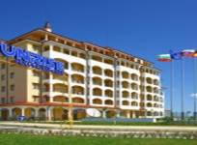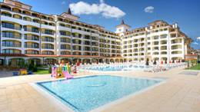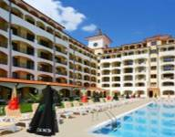

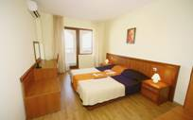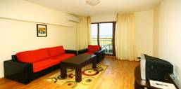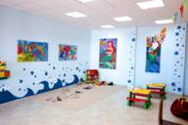

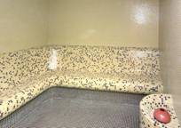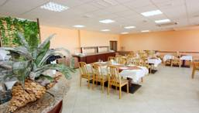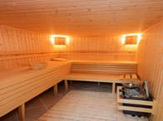
Localizare: situat la 200 m de plaja si 3 km de centrul localitatii Obzor
Dotari apartament 1 dormitor : apartamente au dormitor , living cu canapea exensibila , televizor , baie, balcon ,si au in dotare si colt de bucatarie utilata , internet wireless si aer conditionat.
Dotari apartament 2 dormitoare : apartamente au 2 dormitoare , living cu canapea exensibila , televizor , baie, balcon ,si au in dotare si colt de bucatarie utilata , internet wireless si aer conditionat.
Facilitati hotel: restaurant, 2 piscine exterioare, bar, lobby, lift, sauna, parcare, magazine ,centru spa, sala de fitness, minigolf ,miniclub pt. Copii intre 3-12 ani ,sala de conferinta
OFERTA LAST MINUTE COD « 109/30.05;TK/1.06»
“DISCOUNT 20%”PT REZERVARILE TRIMISE IN PERIOADA 1.06-21.06.2019 SI ACHITATE IN 24 H- SEJUR IN PERIOADELE 1.06-13.06/21.06-30.06.2019
ALL INCLUSIVE | 1.06-7.06 | 8.06-22.06 | 23.06-30.06
LOC IN DBL VED. PARK | 29 | 43,5 | 56,5
CAMERA SINGLE | 57 | 85 | 111,5
LOC IN DBL VED. MARE | 31 | 45 | 58,5
CAMERA SINGLE | 61,5 | 89,5 | 116
LOC IN APART. 1 DORM. VED. PARK | 30 | 45 | 60
LOC IN APART. 1 DORM. VED MARE | 32,5 | 47,5 | 62
LOC IN APART. 2 DORM. VED. PARK | 29 | 43 | 55,5
LOC IN APART 2 DORM. VED. MARE | 31 | 45 | 57,5
TERMEN DE ANULARE | 14 | 16 | 18
PENALIZARE | 3 | 3 | 4
TARIFUL INCLUDE : 1 UMBRELA SI 2 SEZLONGURI PE PLAJA / CAMERA ( IN LIMITA DISP )
IN DUBLA MAXIM 2 ADULTI+ 2 COPII/ 3 ADULTI
IN APART. 1 DORMITOR MAXIM 2 ADULTI+ 2 COPII/ 3 ADULTI
IN APART. 2 DORMITOARE MINIM 3 ADULTI+ 1 COPIL; MAXIM 4 ADULTI+ 2 COPII/ 5 ADULTI
REDUCERI:
- COPIL ( 0-1.99 ANI ) – GRATUIT, FARA SERVICII
- 1 COPIL ( 2-13,99 ANI ) CU 1 ADULT- FARA REDUCERE
- 2 COPII ( 2-13,99 ANI) CU 1 ADULT- FIECARE PLATESTE 50%
- AL 3 LEA COPIL ( 2-13,99 ANI) CU 1 ADULT IN DBL-50%
- 1 COPIL ( 2-13,99 ANI) IN PAT SUPLIMENTAR- GRATUIT
- AL 2 LEA COPIL ( 2-13,99 ANI) IN PAT SUPLIMENTAR- 50%
- ADULT IN PAT SUPLIMENTAR – 20% REDUCERE

OFERTA LAST MINUTE COD « VT13.06 »
“DISCOUNT 15%”PT REZERVARILE TRIMISE IN PERIOADA 11.06-30.06.2019 SI ACHITATE IN 24 H- SEJUR IN PERIOADA 08.07-30.09.2019
ALL INCLUSIVE | 1.05-7.06  16.9-30.9 | 6.09-  15.9 | 22.8-  5.09 | 8.07-  21.8
LOC IN DBL VED. PARK | 29 | 43,5 | 56,5 | 72
CAMERA SINGLE | 57 | 85 | 111,5 | 142,5
LOC IN DBL VED. MARE | 31 | 45 | 58,5 | 74,5
CAMERA SINGLE | 61,5 | 89,5 | 116 | 147
LOC IN APART. 1 DORM. VED. PARK | 30 | 45 | 60 | 75,5
LOC IN APART. 1 DORM. VED MARE | 32,5 | 47,5 | 62 | 77,5
LOC IN APART. 2 DORM. VED. PARK | 29 | 43 | 55,5 | 70
LOC IN APART 2 DORM. VED. MARE | 31 | 45 | 57,5 | 72
TERMEN DE ANULARE | 14 | 16 | 18 | 20
PENALIZARE | 3 | 3 | 4 | 5
TARIFUL INCLUDE : 1 UMBRELA SI 2 SEZLONGURI PE PLAJA / CAMERA ( IN LIMITA DISP )
IN DUBLA MAXIM 2 ADULTI+ 2 COPII/ 3 ADULTI
IN APART. 1 DORMITOR MAXIM 2 ADULTI+ 2 COPII/ 3 ADULTI
IN APART. 2 DORMITOARE MINIM 3 ADULTI+ 1 COPIL; MAXIM 4 ADULTI+ 2 COPII/ 5 ADULTI
REDUCERI:
- COPIL ( 0-1.99 ANI ) – GRATUIT, FARA SERVICII
- 1 COPIL ( 2-13,99 ANI ) CU 1 ADULT- FARA REDUCERE
- 2 COPII ( 2-13,99 ANI) CU 1 ADULT- FIECARE PLATESTE 50%
- AL 3 LEA COPIL ( 2-13,99 ANI) CU 1 ADULT IN DBL-50%
- 1 COPIL ( 2-13,99 ANI) IN PAT SUPLIMENTAR- GRATUIT
- AL 2 LEA COPIL ( 2-13,99 ANI) IN PAT SUPLIMENTAR- 50%
- ADULT IN PAT SUPLIMENTAR – 20% REDUCERE

HOTEL PARAISO BEACH 3*/OBZOR
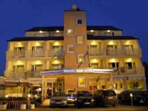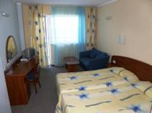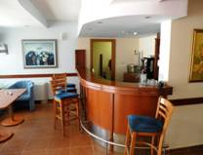
Localizare: este situat la 300 m de centrul orasului Obzor si 10 m de plaja.
Dotari camera: grup sanitar, Tv, minibar, aer conditionat, telefon, uscator de par, balcon.
Facilitati hotel: restaurant, lobby bar, beach bar, piscina.
OFERTA LAST MINUTE COD 095/14.05»
ALL INCLUSIVE | 10.05-30.05 | 1.06-10.06
LOC IN CAMERA DUBLA | 14,5 | 20
CAMERA SINGLE | 28 | 38
APARTAMENT–RENT  MAX 3 ADULTI+1 COPIL/ZI* | 43,5 | 60,5
TERMEN DE ANULARE | 12 | 18
PENALIZARE | 2 | 3

OFERTA LAST MINUTE COD « 045/7.03»
VALABIL REZERVARI IN PERIOADA 7.03-25.09.2019
ALL INCLUSIVE | 10.05-  26.05 | 27.05-  11.06 | 15.09-  25.09
LOC IN CAMERA DUBLA | 16,5 | 20 | 18
CAMERA SINGLE | 30 | 33,5 | 31
APARTAMENT – RENT MAX 3 ADULTI/ZI* | 49,5 | 59,5 | 53
TERMEN DE ANULARE | 12 | 18 | 20
PENALIZARE | 2 | 3 | 4
TARIFUL INCLUDE SEZLONGURI SI UMBRELA PE PLAJA- IN LIMITA DISPONIBILITATI
IN CAMERA DUBLA MAXIM 2 ADULTI+ 1 COPIL/ 3 ADULTI
IN APARTAMENT MAXIM 2 ADULTI+ 2 COPII/ 3 ADULTI+ 1 COPIL
REDUCERI:
- COPIL ( 0-1.99 ANI )– GRATUIT, FARA SERVICII
- 1 COPIL ( 2-11.99 ANI ) IN PAT SUPLIM CU 2 ADULTI – GRATUIT
- AL 2 LEA COPIL (2-199 ANI) IN PAT SUPLIM IN DBL – 50%
- 1 COPIL ( 2-11.99 ANI ) IN PAT NORMAL CU 1 ADULT– 30 % REDUCERE
- 2 COPII ( 2-11,99 ANI) CU 1 ADULT IN CAMERA – FIECARE COPIL PLATESTE- 50%
- ADULT IN PAT SUPLIMENTAR CU 2 ADULTI- 20 % REDUCERE

HOTEL ROYAL CASTLE 5*/ELENITE
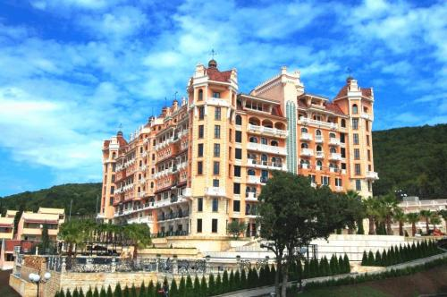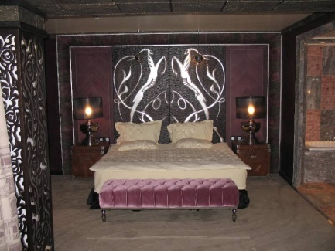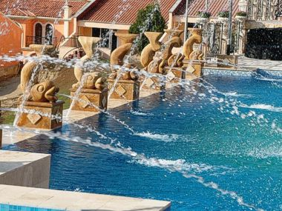
Localizare: 200 m de plaja.
Va fi cel mai nou si luxos hotel de pe litoralul bulgaresc .
Dotari camere: 53 camere duble (30 m²), 73 studiouri (50 m² - 64 m²), 4 apartamente (83 m²), 4 apartamente lux (103 m²) si 3 SuiteVIP (140 m²). cu ,TV-satelit, Minibar , Aer conditionat , Seif , Balcon ,Telefon , Uscator de par.
Facilitati : restaurant principal, 3 restaurante a la carte ,piscina interioara si exterioara ,fitness ,sauna, solar,,loc dejoaca pt copii ,teren de tenis, masa de tenis, biliard , spa, sala de conferinte, internet in lobby
http://www.victoria-group.net
OFERTA LAST MINUTE COD « VT/3.06;112/3.06; TK/3.06»
“DISCOUNT 15%”PT REZERVARILE TRIMISE IN PERIOADA 1.06-30.06.2019 SI ACHITATE IN 24 H- SEJUR IN PERIOADA 1.07-31.08.2019
DEMIPENSIUNE | 31.08- | 26.6-11.07  23.08-30.08 | 12.07-22.08
LOC IN DUBLA VED. PARK | 55 | 60,5 | 65
SUPLIMENT CAMERA SINGLE | +80% | +100% | +100%
LOC IN DUBLA VED. LATERALA MARE | 57,5 | 63 | 67,5
SUPLIMENT CAMERA SINGLE | +80% | +100% | +100%
LOC IN DUBLA VED. MARE | 60,5 | 66 | 71
SUPLIMENT CAMERA SINGLE | +80% | +100% | +100%
LOC IN STUDIO VED. PARK | 60,5 | 66 | 71
LOC IN STUDIO VED.LATERALA MARE | 63 | 68,5 | 73
LOC IN STUDIO VED. MARE | 66 | 72 | 76,5
LOC IN STUDIO DELUXE VED.LATERALA MARE | 68,5 | 74 | 78,5
LOC IN APART. 2 DORM. VED. PARK | 72 | 77,5 | 82
LOC IN APART. 2 DORM. VED. MARE | 77,5 | 83 | 87,5
TERMEN DE ANULARE | 12 | 16 | 18
PENALIZARE | 2 | 3 | 4
* TARIFUL ESTE PENTRU TIP CAMERA, NR PERSOANE MENTIONATE IN TABEL
SSV = VED. LATERALA LA MARE
IN CAMERA DUBLA MAXIM 2 ADULTI
IN STUDIO MAXIM 2 ADULTI+ 1 COPIL/3 ADULTI
IN APARTAMENT 2 DORMITOARE MINIM 2 ADULTI+ 2 COPII;3 ADULTI; MAXIM 3 ADULTI+ 1 COPIL/4 ADULTI+ 1 COPIL/ 4 PATURI NORMALE
IN APARTAMENT COUNTRY MAXIM 2 ADULTI
IN APARTAMENT SAFARI MAXIM 2 ADULTI
IN APARTAMENT 2 DORMITOARE HOLLYWOOD MAXIM 2 ADULTI+ 2 COPII/3 ADULTI+1 COPIL/4 ADULTI
IN APARTAMENT ZODIAC MAXIM 2 ADULTI
REDUCERI :
- COPIL ( 0-1,99 ANI) – GRATUIT, FARA SERVICII
- 1-2 COPII ( 2-11,99 ANI)IN PAT NORMAL IN AP 2 DORM -50%
- 1 COPIL ( 2-11,99 ANI) IN PAT SUPLIM. IN STUDIO/APART- 50%
- ADULT IN PAT SUPLIMENTAR STUDIO- 20% REDUCERE

ELENITE HOLIDAY VILLAGE 4*/ELENITE
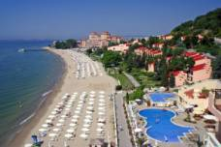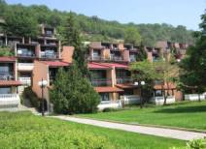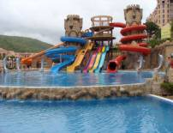

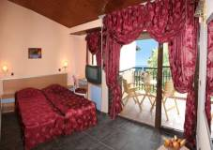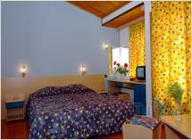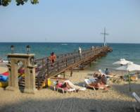

Localizare: la 10 km nord de statiunea Sunny Beach
Dotari camere:vile cu 2 sau 3 etaje. Camerele dispun de aer conditionat, telefon, TV, minibar, terasa, dus
Facilitati : 5 restaurante, cafenea, bar, club de noapte, baruri la piscine, 3 piscine pentru adulti si copii, animatie pentru adulti si copii, sporturi de apa, tenis de masa, fitness, volei de plaja, biliard, sauna, terenuri de tenis, masaj, hipodrom, spalatorie haine, centru medical, seif, sala de conferinte. http://www.victoria-group.net
OFERTA LAST MINUTE COD « VT/3.06;112/3.06;TK/3.06»
“DISCOUNT 25%”PT REZERVARILE TRIMISE IN PERIOADA 1.06-30.06.2019 SI ACHITATE IN 24 H- SEJUR IN PERIOADA 1.07-31.08.2019
ALL INCLUSIVE | 31.8 | 1.07-11.7  23.8-30.8 | 12.07-22.08
LOC IN CAMERA LINIA 2 | 46,5 | 60 | 63,5
SUPLIMENT CAMERA SINGLE | +80% | +100% | +100%
LOC IN CAMERA LINIA 1 | 52 | 66 | 69
SUPLIMENT CAMERA SINGLE | +80% | +100% | +100%
LOC IN STUDIO VILA ROYAL LINIA 2 | 58 | 71,5 | 74,5
TERMENE DE ANULARE | 12 | 14 | 18
PENALIZARE | 3 | 3 | 4
IN CAMERA DUBLA LINIA 2, MAXIM 2 ADULTI+ 2 COPII/ 3 ADULTI
IN CAMERA DUBLA LINIA 1, MAXIM 2 ADULTI+ 1 COPIL/ 3 ADULTI
IN VILA ROYAL MAXIM 2 ADULTI+ 2 COPII/ 3 ADULTI+ 1 COPIL
REDUCERI:
- COPII ( 0-4.99 ANI )– GRATUIT, FARA SERVICII
-2 COPII ( 5-11,99 ANI) CU 1 ADULT- FIECARE PLATESTE 50%
- 1 COPIL ( 2-11.99 ANI ) IN PAT SUPLIMENTAR- GRATUIT
- AL 2 LEA COPIL ( 5-11,99 ANI) IN PAT SUPLIMENTAR-50%( INTOTDEUNA CEL MAI VARSTIC E CONSIDERAT PRIMUL)
- AL 3 LEA COPIL ( 5-11,99 ANI)IN PAT SUPLIMENTAR IN AP- 50%
- ADULT IN PAT SUPLIMENTAR – 20% REDUCERE
HOTEL ROYAL PARK 4*/ELENITE
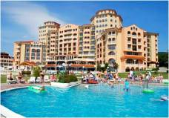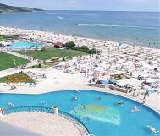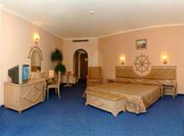
Localizare: in partea sudica a statiunii, in imediata apropiere a plajei .
Dotari camere: telefon, tv satelit, minibar, baie cu dus, uscator de par, aer conditionat;
Facilitati: internet, seif la receptie, piscina cu sezlonguri si umbrele de soare, minimarket, caterring, parcarea se face la intrare in satul de vacanta, servicii medicale http://www.victoria-group.net
OFERTA LAST MINUTE COD « VT/3.06;112/3.06;TK/3.06»
“DISCOUNT 25%”PT REZERVARILE TRIMISE IN PERIOADA 1.06-30.06.2019 SI ACHITATE IN 24 H- SEJUR IN PERIOADA 1.07-31.08.2019
ALL INCLUSIVE | 31.8 | 1.07-11.7  23.8-30.8 | 12.07-22.08
LOC IN CAMERA VED. PARK | 51 | 64,5 | 67
SUPLIMENT CAMERA SINGLE | +80% | +100% | +100%
LOC IN CAMERA VED. MARE | 54,5 | 68 | 70
SUPLIMENT CAMERA SINGLE | +80% | +100% | +100%
LOC IN STUDIO VED. PARK | 53,5 | 67 | 69
LOC IN STUDIO VED. MARE | 57 | 70 | 72,5
LOC IN APART 2 DORM V. PARK | 54,5 | 68 | 70
LOC IN APART 2 DORM V. MARE | 58 | 71,5 | 73,5
TERMENE DE ANULARE | 12 | 14 | 18
PENALIZARE | 3 | 3 | 4
* TARIFUL ESTE PENTRU STUDIO/APART PE ZI , NR PERSOANE INDICATE IN TABEL
IN CAMERA DUBLA MAXIM 2 ADULTI+ 2 COPII/ 3 ADULTI
IN STUDIO MAXIM 2 ADULTI+ 2 COPII/ 3 ADULTI+ 1 COPIL
IN STUDIO 2 DORM MINIM 2 ADULTI+2 COPII; MAXIM 4 ADULTI + 1 COPIL
REDUCERI:
- COPII ( 0-4.99 ANI )– GRATUIT, FARA SERVICII
-2 COPII ( 5-11,99 ANI) CU 1 ADULT- FIECARE PLATESTE 50%
- 1 COPIL ( 2-11.99 ANI ) IN PAT SUPLIMENTAR- GRATUIT
- AL 2 LEA COPIL ( 5-11,99 ANI) IN PAT SUPLIMENTAR-50%( INTOTDEUNA CEL MAI VARSTIC E CONSIDERAT PRIMUL)
- AL 3 LEA COPIL ( 5-11,99 ANI)IN PAT SUPLIMENTAR IN AP- 50%
- ADULT IN PAT SUPLIMENTAR – 20% REDUCERE

HOTEL ROYAL BAY 4*/ELENITE
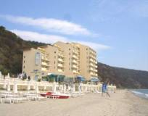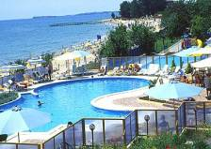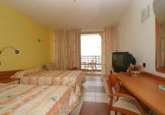
Localizare: in partea sudica a statiunii, in imediata apropiere a plajei
Dotari camere: telefon, tv satelit, minibar, baie cu dus, uscator de par, aer conditionat;
Facilitati: internet, seif la receptie, piscina cu sezlonguri si umbrele de soare, minimarket, caterring, parcarea se face la intrare in satul de vacanta, servicii medicale http://www.victoria-group.net
OFERTA LAST MINUTE COD « VT/3.06;112/3.06;TK/3.06»
“DISCOUNT 15%”PT REZERVARILE TRIMISE IN PERIOADA 1.06-30.06.2019 SI ACHITATE IN 24 H- SEJUR IN PERIOADA 1.07-31.08.2019
ALL INCLUSIVE | 31.8 | 1.07-11.7  23.8-30.8 | 12.07-22.08
LOC IN CAMERA VED. PARK | 49 | 60 | 64,5
SUPLIMENT CAMERA SINGLE | +80% | +100% | +100%
LOC IN CAMERA VED. MARE | 54,5 | 66 | 70
SUPLIMENT CAMERA SINGLE | +80% | +100% | +100%
LOC IN MAISONETTE V.MARE | 57 | 68 | 72,5
LOC IN STUDIO V. MARE | 57 | 68 | 72,5
LOC IN APART. 1 DORM. V. PARK | 57 | 68 | 72,5
LOC IN APART. 1 DORM. V. MARE | 57 | 68 | 72,5
TERMENE DE ANULARE | 12 | 14 | 18
PENALIZARE | 3 | 3 | 4
* TARIFUL ESTE PT TIP CAMERA, NR PERSOANE INDICATE IN TABEL
IN CAMERA DUBLA PV MAXIM 2 ADULTI
IN CAMERA DUBLA SV MAXIM 2 ADULTI+ 2 COPII/3 ADULTI
IN STUDIO MAXIM 2 ADULTI+2 COPII/ 3 ADULTI
IN APARTAMENT MAXIM 2 ADULTI+2 COPII/ 3 ADULTI+1 COPIL
IN MAISONETTE MAXIM 2 ADULTI+2 COPII/ 3 ADULTI
REDUCERI:
- COPII ( 0-4.99 ANI )– GRATUIT, FARA SERVICII
-2 COPII ( 5-11,99 ANI) CU 1 ADULT- FIECARE PLATESTE 50%
- 1 COPIL ( 2-11.99 ANI ) IN PAT SUPLIMENTAR- GRATUIT
- AL 2 LEA COPIL ( 5-11,99 ANI) IN PAT SUPLIMENTAR-50%( INTOTDEUNA CEL MAI VARSTIC E CONSIDERAT PRIMUL)
- AL 3 LEA COPIL ( 5-11,99 ANI)IN PAT SUPLIMENTAR IN AP- 50%
- ADULT IN PAT SUPLIMENTAR – 20% REDUCERE
HOTEL ANDALUSIA BEACH 4*/ELENITE
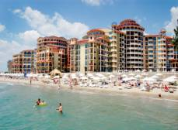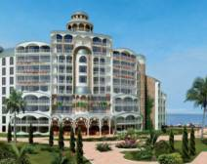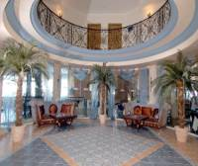

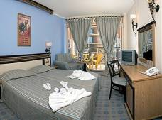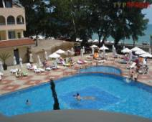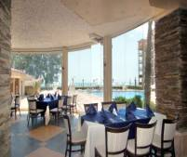
Localizare: in partea sudica a statiunii Elenite, la 12 km de Sunny Beach.
Dotari camere: baie , aer conditionat, tv sat, telefon, minibar, uscator de par, balcon
Facilitati : restaurant, baruri, bar la piscina, piscina exterioara, piscina pentru copii, loc de joaca pentru copii, fitness, baie turceasca, jacuzzi, masaj, SPA, salon de infrumusetare, magazin, acces internet, sala de jocuri, tenis, sporturi nautice, discoteca, animatie, club de noapte, parcare. http://www.victoria-group.net
OFERTA LAST MINUTE COD « VT/3.06;112/3.06; TK/3.06»
“DISCOUNT 15%”PT REZERVARILE TRIMISE IN PERIOADA 1.06-30.06.2019 SI ACHITATE IN 24 H- SEJUR IN PERIOADA 1.07-31.08.2019
ALL INCLUSIVE | 31.8 | 1.07-11.7  23.08-30.08 | 12.07-22.08
LOC IN CAMERA VED. PARK | 49 | 61 | 64,5
SUPLIMENT CAMERA SINGLE | +80% | +100% | +100%
LOC IN CAMERA VED. MARE | 52 | 64,5 | 68
SUPLIMENT CAMERA SINGLE | +80% | +100% | +100%
TERMENE DE ANULARE | 12 | 14 | 18
PENALIZARE | 3 | 3 | 4
IN CAMERA DUBLA PV MAXIM 2 ADULTI+ 1 COPIL/ 3 ADULTI
IN CAMERA DUBLA SV MAXIM 2 ADULTI+ 2 COPII/3 ADULTI
IN APARTAMENT 1 DORM MAXIM 2 ADULTI+ 2 COPII/3 ADULTI+ 1 COPIL
REDUCERI:
- COPII ( 0-4.99 ANI )– GRATUIT, FARA SERVICII
- 2 COPII (5-11,99 ANI) CU 1 ADULT-FIECARE PLATESTE 50%
- 1 COPIL ( 0-11.99 ANI ) IN PAT SUPLIMENTAR- GRATUIT
- AL 2 LEA COPII ( 0-4.99 ANI ) IN PAT SUPLIMENTAR- GRATUIT( INTOTDEUNA CEL MAI VARSTIC E CONSIDERAT PRIMUL)
- AL 2 LEA COPIL ( 5-11,99 ANI) IN PAT SUPLIMENTAR-50%( INTOTDEUNA CEL MAI VARSTIC E CONSIDERAT PRIMUL)
- AL 3 LEA COPIL ( 5-11,99 ANI)IN PAT SUPLIMENTAR IN AP- 50%
- ADULT IN PAT SUPLIMENTAR – 20% REDUCERE

HOTEL ATRIUM 4*/ELENITE

Localizare: in partea sudica a statiunii Elenite, la 12 km de Sunny Beach.
Dotari camere: baie , aer conditionat, tv sat, telefon, minibar, uscator de par, balcon
Facilitati : restaurant, baruri, bar la piscina, piscina exterioara, piscina pentru copii, loc de joaca pentru copii, fitness, baie turceasca, jacuzzi, masaj, SPA, salon de infrumusetare, magazin, acces internet, sala de jocuri, tenis, sporturi nautice, discoteca, animatie, club de noapte, parcare. http://www.victoria-group.net
OFERTA LAST MINUTE COD « VT/3.06;112/3.06; TK/3.06»
“DISCOUNT 15%”PT REZERVARILE TRIMISE IN PERIOADA 1.06-30.06.2019 SI ACHITATE IN 24 H- SEJUR IN PERIOADA 1.07-31.08.2019
ALL INCLUSIVE | 31.8 | 1.07-11.7  23.08-30.08 | 12.07-22.08
LOC IN CAMERA VED. PARK | 49 | 61 | 64,5
SUPLIMENT CAMERA SINGLE | +80% | +100% | +100%
LOC IN CAMERA VED. MARE | 52 | 64,5 | 68
SUPLIMENT CAMERA SINGLE | +80% | +100% | +100%
LOC IN APART. 1 DORM PV | 53,5 | 66 | 69
LOC IN APART. 1 DORM SSV | 57 | 69 | 72,5
TERMENE DE ANULARE | 12 | 14 | 18
PENALIZARE | 3 | 3 | 4
IN CAMERA DUBLA PV MAXIM 2 ADULTI+ 1 COPIL/ 3 ADULTI
IN CAMERA DUBLA SV MAXIM 2 ADULTI+ 2 COPII/3 ADULTI
IN APARTAMENT 1 DORM MAXIM 2 ADULTI+ 2 COPII/3 ADULTI+ 1 COPIL
REDUCERI:
- COPII ( 0-4.99 ANI )– GRATUIT, FARA SERVICII
- 2 COPII (5-11,99 ANI) CU 1 ADULT-FIECARE PLATESTE 50%
- 1 COPIL ( 0-11.99 ANI ) IN PAT SUPLIMENTAR- GRATUIT
- AL 2 LEA COPII ( 0-4.99 ANI ) IN PAT SUPLIMENTAR- GRATUIT( INTOTDEUNA CEL MAI VARSTIC E CONSIDERAT PRIMUL)
- AL 2 LEA COPIL ( 5-11,99 ANI) IN PAT SUPLIMENTAR-50%( INTOTDEUNA CEL MAI VARSTIC E CONSIDERAT PRIMUL)
- AL 3 LEA COPIL ( 5-11,99 ANI)IN PAT SUPLIMENTAR IN AP- 50%
- ADULT IN PAT SUPLIMENTAR – 20% REDUCERE

HOTEL MOONLIGHT 5*/SV. VLAS
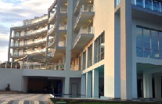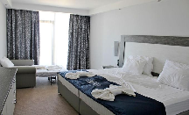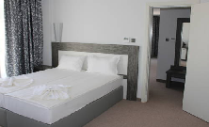
Localizare: la 10 m de plaja.
Dotari camere: A/C; frigider;TV; baie
Facilitati: piscina exterioara; restaurant; lobby bar;sauna;baie aburi;masaj;WI FI; parcare
OFERTA LAST MINUTE COD « VT/7.06 »
“DISCOUNT 20%”PT REZERVARILE TRIMISE IN PERIOADA 11.06-30.06.2019 SI
SI ACHITATE INTEGRAL IN 24 H-SEJUR IN PERIOADA 11.06-30.06.2019
DEMIPENSIUNE | 6.06-30.06
LOC IN CAMERA VED. MUNTE | 49,5
CAMERA SINGLE | 80
LOC IN CAMERA DUBLA SV | 54
CAMERA SINGLE | 98
LOC IN STUDIO | 58,5
APARTAMENT 4 AD /ZI* | 176
ALL INCLUSIVE | 6.06-30.06
LOC IN CAMERA VED. MUNTE | 53
CAMERA SINGLE | 85,5
LOC IN CAMERA DUBLA SV | 57,5
CAMERA SINGLE | 104,5
LOC IN STUDIO | 62
APARTAMENT 4 AD /ZI* | 188
TERMEN DE ANULARE | 16
PENALIZARE | 2

OFERTA LAST MINUTE COD « TK 10.06 ; VT/4.06; 117/5.06 »
“DISCOUNT 10%”PT REZERVARILE TRIMISE IN PERIOADA 5.06-31.08.2019 SI ACHITATE INTEGRAL IN 24 H-SEJUR IN PERIOADA 1.07-31.08.2019
DEMIPENSIUNE | 1.07-5.07  31.08 | 6.07-  30.08
LOC IN CAMERA VED. MUNTE | 49,5 | 63
CAMERA SINGLE | 80 | 100
LOC IN CAMERA VED MARE | 54 | 67,5
CAMERA SINGLE | 98 | 124,5
LOC IN STUDIO | 58,5 | 73
APARTAMENT 4 ADULTI /ZI* | 176 | 220,5
ALL INCLUSIVE | 1.07-5.07  31.08 | 6.07-  30.08
LOC IN CAMERA VED. MUNTE | 53 | 66,5
CAMERA SINGLE | 85,5 | 105,5
LOC IN CAMERA VED. MARE | 57,5 | 71
CAMERA SINGLE | 104,5 | 131,5
LOC IN STUDIO | 62 | 76,5
APARTAMENT 4 AD /ZI* | 188 | 229,5
TERMEN DE ANULARE | 16 | 18
PENALIZARE | 2 | 4
IN CAMERA DUBLA MAXIM 2 ADULTI+ 2 COPII/ 3 ADULTI
IN STUDIO MAXIM 3 ADULTI+ 1 COPIL/ 4 ADULTI
IN APARTAMENT MAXIM 3 ADULTI+ 1 COPIL/ 4 ADULTI
REDUCERI :
- COPII ( 0-1.99 ANI )– GRATUIT, FARA SERVICII
IN DBL:
- COPIL ( 2-11.99 ANI ) IN PAT SUPLIM CU 2 ADULTI– GRATUIT
- 2 COPII ( 2-11.99 ANI ) CU 1 ADULT IN CAM. DUBLA – FIECARE PLATESTE 50 %
- ADULT IN PAT SUPLIMENTAR IN DBL – 20% REDUCERE
IN STUDIO:
- 2 COPII ( 2-11.99 ANI ) IN PAT SUPLIMENTAR- 1 GRATUIT, AL 2 LEA 50%
- 2 COPII ( 2-11.99 ANI ) CU 1 ADULT- FIECARE PLATESTE 50 %
- 3 COPII ( 2-11.99 ANI ) CU 1 ADULT- 2 PLATESC FIECARE 50 %; AL 3 LEA GRATUIT
- AL 3 LEA SI AL 4 LEA ADULT IN PAT SUPLIM. IN STUDIO- FIECARE PLATESTE 60%
HOTEL ZORNITSA SANDS 4*++/SV. VLAS
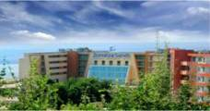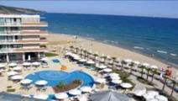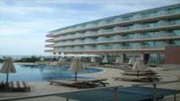

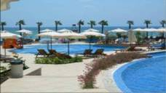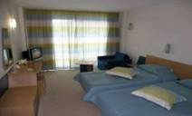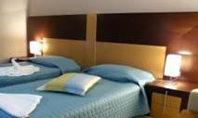
Localizare: pe plaja.
Dotari camere: aer conditionat, balcon, minibar, telefon, tv-satelit, baie cu dus, uscator de par, conexiune internet (toate camerele au vedere la mare).
Facilitati: centru spa , 2 piscine , 2 restaurante, cocktail bar, lobby bar, pool bar, masaj, sauna, jacuzzi, sala fitness, coafor, salon de frumusete, centru medical, gradinita, sala de internet, biliard, tenis, room service, exchange, magazine
OFERTA LAST MINUTE COD « 123/08.06 ; TK 10.06 ; VT/05.06 »
“DISCOUNT 10%”PT REZERVARILE TRIMISE IN PERIOADA 08.06-30.06.2019 SI ACHITATE INTEGRAL IN 24 H-PENALIZARE 100% DUPA CONFIRMARE
PENSIUNE COMPLETA | 23.05-10.6  6.09-23.09 | 11.06-7.07  27.08-5.09 | 8.07-  26.08
LOC IN CAMERA VED. PARK | 38 | 48,5 | 60
LOC IN CAMERA VED. LATER. MARE | 40 | 51 | 62
LOC IN CAMERA VED. MARE/PISCINA | 43,5 | 52 | 64
SUPLIMENT CAMERA SINGLE | +50% | +50% | +50%
SUITE SSV MAX 3 ADULTI+ 1 COPIL/ZI* | 138 | 173,5 | 196
SUITE SV/PISCINA MAX  3 ADULTI+ 1 COPIL/ZI* | 143,5 | 179 | 201,5
JUNIOR SUITE SV/PISCINA/  MAX 2 ADULTI+ 1 COPIL/ZI* | 165 | 189 | 211,5
JUNIOR SUITE DELUXE VED. MARE/PISCINA  MAX 2 ADULTI+ 1 COPIL/ZI* | 198,5 | 224,5 | 267,5
FAMILY SSV MAX 3 ADULTI+ 1 COPIL/ZI* | 115,5 | 140 | 162,5
FAMILY VED. MARE/PISCINA  MAX 3 ADULTI+ 1 COPIL/ZI* | 120 | 145,5 | 168
TERMEN DE ANULARE | 12 | 16 | 18
PENALIZARE | 2 | 2 | 4
FAMILY SSV – CAMERA FAMILY CU VED LATERALA MARE
TARIFUL INCLUDE :UMBRELE SI SEZLONGURI PE PLAJA ; ANIMATIE; PARCARE/ LOCURI LIMITATE
IN CAMERA DUBLA ( TWIN)VED. LATERALA MARE MAXIM 2 ADULTI+ 1 COPIL/ 3 ADULTI
IN CAMERA VED, MARE/PISCINA ( TWIN) MAXIM 2 ADULTI+ 1 COPIL/ 3 ADULTI
IN JUNIOR SUITE VED. MARE/PISCINA MAXIM 2 ADULTI+ 1 COPIL/3 ADULTI
IN JUNIOR SUITE DELUXE MAXIM 2 ADULTI+ 1 COPIL/3 ADULTI
IN SUITE MINIM 2 ADULTI / MAXIM 2 ADULTI+ 2 COPII/ 3 ADULTI+1 COPIL
IN FAMILY ROOM MAXIM 2 ADULTI+ 2 COPII/ 3 ADULTI+ 1 COPIL
REDUCERI :
- COPII ( 0-1.99 ANI )– GRATUIT, FARA SERVICII
- COPIL ( 2-11.99 ANI ) IN PAT SUPLIM CU 2 ADULTI– GRATUIT
- 1-2 COPII ( 2-11.99 ANI ) CU 1 ADULT– FIECARE PLATESTE 50 %
- AL 3-LEA DULT IN PAT SUPLIMENTAR – 25% REDUCERE
HOTEL CAESAR PALACE 4*/SV. VLAS
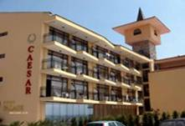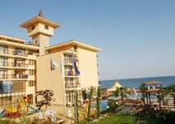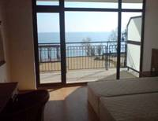

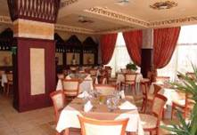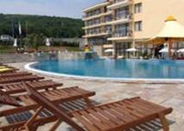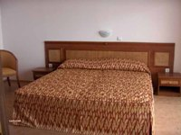
Localizare: situat pe plaja, în apropierea staţiunii Elenite şi St Vlas.
Facilitati:piscina, piscina pentru copii, restaurant, bar, club de noapte, biliard, internet cafe, tenis de masa, coafor, fitness, sauna, jacuzzi, masaj, loc de joaca pentru copii, room service, centru de prim ajutor, birou de schimb valutar, seif, lift, rent-a-car, parcare.
Dotari camera: aer conditionat, balcon, vedere la mare, chicineta, baie cu dus, uscator de par, televizor, telefon, frigider.
OFERTA LAST MINUTE COD « 115/306»
“DISCOUNT 10%”PT REZERVARILE TRIMISE IN PERIOADA 3.06-30.06.2019 SI ACHITATE INTEGRAL IN 24 H-SEJUR 4-6 NOPTI IN PERIOADELE 5.07-20.07/8.08-18.08/7.09-13.09.2019
“DISCOUNT 15%”PT REZERVARILE TRIMISE IN PERIOADA 3.06-30.06.2019 SI ACHITATE INTEGRAL IN 24 H-SEJUR 7 NOPTI IN PERIOADELE 5.07-20.07/8.08-18.08/7.09-13.09.2019
ALL INCLUSIVE | 9.09-23.09 | 26.08-8.09 | 19.08-25.08 | 5.07-18.08
LOC IN CAMERA DUBLA | 32,5 | 49,5 | 56,5 | 67,5
CAMERA SINGLE | 63,5 | 98 | 111,5 | 133,5
APART. 1 DORM. 2 AD/ZI* | 89 | 137 | 148,5 | 181
APART. 1 DORM. 3 AD/ZI* | 90 | 138,5 | 152 | 182,5
APART. 1 DORM. 4 AD/ZI* | 111 | 160 | 173,5 | 204
APART. 2 DORM. 4 AD/ZI* | 120 | 185 | 202,5 | 243
APART. 2 DORM. 5 AD/ZI* | 141 | 206 | 224 | 264,5
TERMEN DE ANULARE | 10 | 14 | 16 | 16
PENALIZARI | 2 | 3 | 4 | 4

IN CAMERA DUBLA MAXIM 2 ADULTI+ 1 COPIL/ 3 ADULTI
IN APARTAMENT 1 DORMITOR MAXIM 2 ADULTI+ 2 COPII/ 3 ADULTI
IN APARTAMENT 2 DORMITOARE MAXIM 4 ADULTI+ 2 COPII
REDUCERI:
- COPIL ( 0-1.99 ANI ) – GRATUIT, FARA SERVICII
- 1 COPIL (2-11,99 ANI) IN PAT SUPLIMENTAR-GRATUIT
- AL 2 LEA COPIL(2-11,99 ANI) IN PAT SUPLIM. AP 1 DORM –PLATESTE SUPLIMENT 5€/ZI
- AL 2 LEA COPIL (2-11,99 ANI) IN PAT SUPLIM IN AP 2 DORM- PLATESTE SUPLIMENT 5€/ZI
- ADULT IN PAT SUPLIMENTAR IN DUBLA- 30% REDUCERE

HOTEL PRIMASOL SINEVA PARK 3*+SVETI VLAS
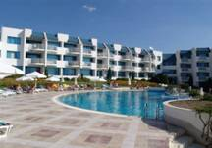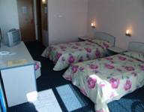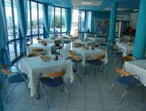
Localizare: pe plaja.
Facilitati: restaurant, lobby bar, piscina, loc de joaca pentru copii, teren de tenis, sauna, masaj.
Dotari camera: TV, telefon, minibar,grup sanitar, balcon.
OFERTA LAST MINUTE COD « TK/1.06; 113/3.06»
“DISCOUNT 20%”PT REZERVARILE TRIMISE IN PERIOADA 1.06-31.07.2019 SI ACHITATE INTEGRAL IN 24 H-SEJUR IN PERIOADA 1.07-31.07.2019
“DISCOUNT 20%”PT REZERVARILE TRIMISE IN PERIOADA 1.06-31.08.2019 SI ACHITATE INTEGRAL IN 24 H-SEJUR IN PERIOADA 18.08-2.09.2019
ALL INCLUSIVE | 31.08–2.09 | 11.07– 31.07  18.08-30.08
LOC IN CAMERA STANDARD | 47 | 59
CAMERA SINGLE | 70 | 88
LOC IN CAMERA VED. PISCINA | 48 | 60,5
CAMERA SINGLE | 94,5 | 119
TERMEN DE ANULARE | 14 | 16
PENALIZARI | 2 | 4
IN CAMERA DUBLA MAXIM 2 ADULTI+ 1 COPIL/ 3 ADULTI
REDUCERI :
- COPII ( 0-1.99 ANI )– GRATUIT, FARA SERVICII
- 1 COPIL ( 2-11.99 ANI ) IN PAT SUPLIM CU 2 ADULTI – GRATUIT
- 1 COPIL( 2-11.99 ANI ) CU 1 ADULT– 30% REDUCERE
- 2 COPII( 2-11.99 ANI ) CU 1 ADULT- FIECARE PLATESTE 50%
- ADULT IN PAT SUPLIMENTAR CU 2 ADULTI- 20 % REDUCERE
HOTEL PARADISE BEACH 4*/SV. VLAS
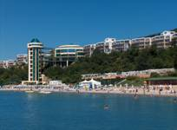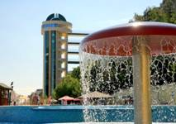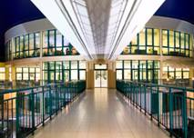

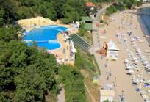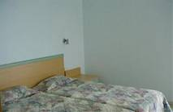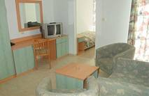
Localizare:situat la iesirea din Sveti Vlas spre Elenite .
Facilitati: receptie, restaurant, terasa, lobby bar, grill bar, pool bar, disco/ night club, internet club, SPA cu sauna, masaj si baie turceasca, piscina exterioara, centru fitness.
Dotari camera: grup sanitar propriu, aer conditionat, telefon, televizor, baie, uscator de par, balcon.
OFERTA LAST MINUTE COD « TK/29.05; VT 10.06 »
“DISCOUNT 15%”PT REZERVARILE TRIMISE IN PERIOADA 1.06-30.06.2019 SI ACHITATE INTEGRAL IN 24 H
ALL INCLUSIVE | 08.09-30.09 | 6.06-  19.06 | 20.06-4.07  24.08-7.09 | 5.07-  23.08
LOC IN CAMERA VED. PARK | 30 | 44,5 | 63 | 74,5
CAMERA SINGLE | 44,5 | 67 | 93,5 | 110
LOC IN CAMERA VED. MARE | 34,5 | 49 | 67,5 | 79
CAMERA SINGLE | 51,5 | 72,5 | 100 | 117
APART1 DORM. VED. PARK MAX 3 ADULTI +1 COPIL /ZI* | 90,5 | 134,5 | 190,5 | 224
APART1 DORM. VED. MARE MAX 3 ADULTI +1 COPIL /ZI* | 104 | 145 | 204 | 237,5
TERMEN DE ANULARE | 20 | 20 | 20 | 20
PENALIZARI | 2 | 3 | 4 | 5
1 UMRELA SI 2 SEZLONGURI PE PLAJA= 6 €/ZI
GARANTIE 20 €/PERSOANA LA CAZARE- SE RETURNEAZA LA PLECARE !
IN CAMERA DUBLA MAXIM 2 ADULTI+1 COPIL/ 3 ADULTI
IN APARTAMENT MAXIM 2 ADULTI+ 2 COPII/3 ADULTI+ 1 COPIL/4 ADULTI
REDUCERI :
- COPIL ( 0-1.99 ANI )– GRATUIT, FARA SERVICII
IN DBL:
- COPIL ( 2-11.99 ANI) IN PAT SUPLIMENTAR - GRATUIT
- 2 COPII ( 2-11.99 ANI) CU 1 ADULT -FIECARE PLATESTE 50%
- 1 COPIL ( 2-11.99 ANI ) CU 1 ADULT– 50% IN PERIOADELE 20.05-4.07 /24.08-30.09; 20% REDUCERE IN PERIOADA 5.07-23.08.2017
- ADULT IN PAT SUPLIMENTAR- 20% REDUCERE
HOTEL TROPICS 3*SV . VLAS
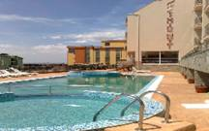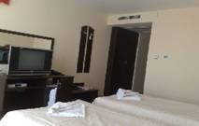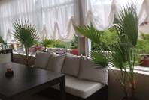
Localizare: situat la 70 m de plaja si 500 m de port.
Facilitati: restaurant,sistem karaoke, piscina exterioara,jacuzzi,solarium,sauna;baie aburi,loc joaca si piscina copii,internet,fitness;inchirieri,parcare,room service,gratar,spa.
Dotari camera: baie cabina dus si uscator de par, aer conditionat, TV, mini bar, telefon, balcon,internet http://www.tropics-hotel.com/
OFERTA LAST MINUTE COD « TK/10.06»
“DISCOUNT 15%”PT REZERVARILE TRIMISE IN PERIOADA 1.06-30.06.2019 SI ACHITATE INTEGRAL IN 24 H PENTRU SEJUR IN PERIOADA 10.06-06.07
MIC DEJUN | 11.06-20.06 | 21.06-6.07
LOC IN CAMERA DUBLA | 15 | 21
CAMERA SINGLE | 22 | 31
TERMEN DE ANULARE | 10 | 14
PENALIZARI | 2 | 3
IN CAMERA DUBLA MAXIM 2 ADULTI+ 1 COPIL/ 3 ADULTI
REDUCERI :
- COPIL ( 0-1.99 ANI ) – GRATUIT, FARA SERVICII
- 1 COPIL ( 2-4,99 ANI ) IN PAT SUPLIMENTAR– GRATUIT
- 1 COPIL ( 5-12,99 ANI ) IN PAT SUPLIM.– GRATUIT CU MD
- 1 COPIL ( 2-12,99 ANI ) CU 1 ADULT- FARA REDUCERE IN SEZ VARF; IN REST 60%
- 2 COPII ( 2-12,99 ANI ) CU 1 ADULT- FIECARE PLATESTE 50%
- ADULT IN PAT SUPLIMENTAR - 30% REDUCERE
HOTEL VILLA MARIA REVAS 5*/SUNNY BEACH
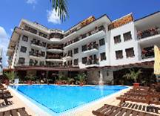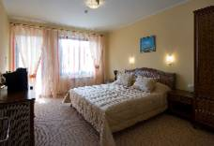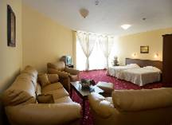
Localizare: la 100 m de plaja,construit 2006, in zona sud- vest a statiunii
Dotari camera:baie; uscator par; internet; TV; telefon; mini bar;bucatarie
Facilitati hotel:restaurant; piscina;seif la receptie; baruri; room service; fitness; sauna; sala conferinte;parcare; wi fi
OFERTA LAST MINUTE COD « TK/17.05»
“DISCOUNT 10%”PT REZERVARILE TRIMISE IN PERIOADA 17.05-15.06.2019 SI ACHITATE INTEGRAL IN 24 H-SEJUR IN PERIOADA 17.05-15.06.2019
“DISCOUNT 10%”PT REZERVARILE TRIMISE IN PERIOADA 17.05-30.09.2019 SI ACHITATE INTEGRAL IN 24 H-SEJUR IN PERIOADA 10.09-30.09.2019
*SE POATE COMBINA CU NOPTI GRATUITE
MIC DEJUN | 25.4-31.05  17.9-31.10 | 1.06-15.6  10.9-16.9 | 16.6-1.07  29.8-9.09 | 2.07-13.7  17.8-28.8 | 14.07-16.08
SEJUR MINIM NOPTI | 5 | 5 | 5 | 5 | 5
LOC IN CAMERASTANDARD | 14,5 | 19 | 26 | 37,5 | 39,5
CAMERA SINGLE | 20 | 26 | 36 | 52 | 61
STUDIO 2 ADULTI/ZI* | 35,5 | 40 | 54,5 | 77 | 97
STUDIO 3 ADULTI/ZI* | 36 | 40,5 | 56 | 78 | 98,5
APART. 1 DORM 2 ADULTI/ZI* | 44,5 | 58 | 80 | 115 | 128,5
APART. 1 DORM 3 ADULTI/ZI* | 45 | 58,5 | 81,5 | 116 | 129,5
APART. 1 DORM 4 ADULTI/ZI* | 46 | 59,5 | 83 | 117,5 | 131
APART. 1 DORM LUX 2 ADULTI/ZI* | 53 | 82,5 | 103,5 | 137 | 146
APART. 1 DORM LUX 3 ADULTI/ZI* | 54 | 83 | 105 | 138,5 | 147,5
APART. 1 DORM LUX 4 ADULTI/ZI* | 55 | 84 | 106,5 | 140 | 149
MIC DEJUN | 25.4-31.05  17.9-31.10 | 1.06-15.6  10.9-16.9 | 16.6-1.07  29.8-9.09 | 2.07-13.7  17.8-28.8 | 14.07-16.08
LOC IN CAMERASTANDARD | 19 | 23,5 | 33 | 44 | 46,5
CAMERA SINGLE | 25,5 | 32,5 | 45 | 61 | 71
STUDIO 2 ADULTI/ZI* | 49 | 49 | 68 | 90 | 110
STUDIO 3 ADULTI/ZI* | 49,5 | 49,5 | 69 | 91,5 | 112
APART. 1 DORM 2 ADULTI/ZI* | 58 | 71 | 93,5 | 128,5 | 142
APART. 1 DORM 3 ADULTI/ZI* | 58,5 | 72 | 95 | 129,5 | 154,5
APART. 1 DORM 4 ADULTI/ZI* | 59,5 | 73 | 96 | 131 | 144,5
APART. 1 DORM LUX 2 ADULTI/ZI* | 67 | 96 | 124 | 151 | 159,5
APART. 1 DORM LUX 3 ADULTI/ZI* | 67,5 | 96,5 | 125 | 152 | 161
APART. 1 DORM LUX 4 ADULTI/ZI* | 68 | 97,5 | 126,5 | 153,5 | 162,5
TERMEN DE ANULARE | 12 | 14 | 16 | 20 | 16
PENALIZARI | 2 | 3 | 3 | 4 | 3
TARIFUL INCLUDE: PISCINA; FITNESS; WI FI IN SPATII COMUNE;
IN CAMERA DUBLA MAXIM 2 ADULTI
IN STUDIO MAXIM 2 ADULTI+ 1 COPIL/3 ADULTI
IN APARTAMENT 1 DORM MAXIM 2 ADULTI+ 2 COPII/3 ADULTI+ 1 COPIL
IN APARTAMENT 1 DORM LUX MAXIM 4 ADULTI+ 1 COPIL/2 ADULTI+ 3 COPII
REDUCERI :
-COPIL ( 0-1,99 ANI) – GRATUIT, FARA SERVICII
- 1-2 COPII ( 2-11,99 ANI) CU 1 ADULT- FIECARE PLATESTE 50%
- 1 COPIL ( 2-11,99 ANI) IN PAT SUPLIM IN STUD/ AP 1 DORM- GRATUIT
- AL 2 LEA COPIL ( 2-11,99 ANI) IN PAT SUPLIM IN AP 1 DORM-PLATESTE SUPLIMENT 5 €/ZI
- ADULT IN PAT SUPLIMENTAR IN DBL –50%
NOPTI GRATUITEPT SEJUR IN PERIOADELE 25.04. -15.06/10.09-314.10.2019
  - NOAPTE GRATUITA PT SEJUR 7-13 NOPTI
2)2 NOPTI GRATUITE PT SEJUR 14-21 NOPTI
3)4 NOPTI GRATUITE PT SEJUR DE LA 22 NOPTI
HOTEL ROYAL HELENA SANDS 5*/SUNNY BEACH
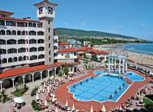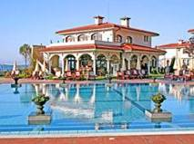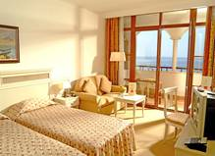

OFERTA LAST MINUTE COD « 122 /08.06 »
“DISCOUNT 20%”PT REZERVARILE TRIMISE IN PERIOADA 11.06-30.06.2019 SI ACHITATE INTEGRAL IN 24 H-SEJUR IN PERIOADA 8.06-31.08.2019
DEMIPENSIUNE | 1.06-12.6  B | 13.6-05.07  26.8-31.08  C | 6.07-  25.08  D
LOC IN CAMERA DUBLA V. PARK | 56 | 74,5 | 90
CAMERA SINGLE | 72,5 | 108 | 142,5
LOC IN CAMERA DUBLA V. MARE | 62,5 | 80 | 99
CAMERA SINGLE | 81,5 | 111,5 | 157
LOC IN JUNIOR SUITE | 80,5 | 105,5 | 119
LOC IN SUITE | 85 | 117 | 132,5
LOC IN DUPLEX SUITE/MAISONETTE | 93 | 123,5 | 147
TERMEN DE ANULARE | 14 | 16 | 20
PENALIZARI | 3 | 3 | 4
TARIFUL INCLUDE :2 SEZLONGURI SI 1 UMBRELA PE PLAJA DIN FATA HOTELULUI ( IN LIMITA DISP. ); WI FI IN LOBBY SI CAMERE;INTERNET CABLU IN CAMERE
IN CAMERA DUBLA MAXIM 2 ADULTI+ 1 COPIL/ 3 ADULTI
IN JUNIOR ( 2 CAMERE FARA USA COMUNICANTA ) MAXIM 2 ADULTI+ 2 COPII/ 3 ADULTI
IN SUITE ( 2 CAMERE COMUNICANTE ) MAXIM 2 ADULTI+ 2 COPII/ 3 ADULTI
IN SUITE DUPLEX ( PE 2 NIVELE)-MAISONETTE MAXIM 2 ADULTI+ 2 COPII/ 3 ADULTI
INFANTII CONTEAZA LA GRAD OCUPARE !!!
REDUCERI :
- 1 COPIL ( 0-1, 99 ANI )–GRATUIT ,FARA SERVICII
-1 COPIL ( 2-11, 99 ANI ) CU 1 ADULT IN CAMERA - 30% REDUCERE
- 2 COPII ( 2-11, 99 ANI ) CU 1 ADULT IN CAMERA- FIECARE PLATESTE 50%
-1 COPIL ( 2-11, 99 ANI )IN PAT SUPLIM IN DBL/SUITE- GRATUIT
- AL 2 LEA COPIL ( 2-11, 99 ANI )IN PAT SUPLIM IN SUITE- 50%
- ADULT IN PAT SUPLIMENTAR - 30% REDUCERE
HOTEL ROYAL HELENA PARK 5*/SUNNY BEACH
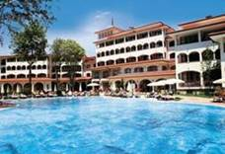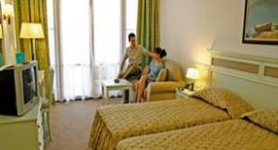
OFERTA LAST MINUTE COD « 122 /08.06 »
“DISCOUNT 20%”PT REZERVARILE TRIMISE IN PERIOADA 11.06-30.06.2019 SI ACHITATE INTEGRAL IN 24 H-SEJUR IN PERIOADA 8.06-31.08.2019
ULTRA ALL INCLUSIVE | 1.06-12.6  B | 13.06-05.7  26.08-31.08  C | 06.07-  25.08  D
LOC IN CAMERA STANDARD | 58 | 77,5 | 94,5
CAMERA SINGLE | 75 | 108 | 149,5
LOC IN CAMERA VED GRADINA | 65 | 83,5 | 100
CAMERA SINGLE | 84 | 117 | 159,5
LOC IN APART. 1 DORMITOR | 83 | 116 | 131,5
TERMEN DE ANULARE | 14 | 16 | 20
PENALIZARI | 3 | 3 | 4
TARIFUL INCLUDE :2 SEZLONGURI SI 1 UMBRELA PE PLAJA DIN FATA HOTELULUI ( IN LIMITA DISP. ); WI FI IN LOBBY SI CAMERE;INTERNET CABLU IN CAMERE
IN CAMERA DUBLA STANDARD MAXIM 2 ADULTI
IN CAMERA DUBLA SUPERIOR MAXIM 2 ADULTI + 1 COPIL/ 3 ADULTI
IN APARTAMENT MAXIM 2 ADULTI+ 2 COPII/ 3 ADULTI
INFANTII CONTEAZA LA GRAD OCUPARE !!!
REDUCERI :
- 1 COPIL ( 0-1, 99 ANI )–GRATUIT ,FARA SERVICII
-1 COPIL ( 2-11, 99 ANI ) CU 1 ADULT IN CAMERA – 30% REDUCERE
- 2 COPII ( 2-11, 99 ANI ) CU 1 ADULT IN CAMERA- FIECARE PLATESTE 50%
- 1 COPIL ( 2-11, 99 ANI ) IN PAT SUPLIMENTAR IN DBL SUP/SUITE- GRATUIT
- AL 2 LEA COPIL ( 2-11, 99 ANI ) IN PAT SUPLIMENTAR IN SUITE -50%
- ADULT IN PAT SUPLIMENTAR - 30% REDUCERE

HOTEL VICTORIA PALACE RESIDENCE 5*
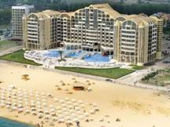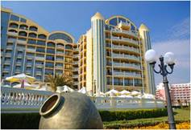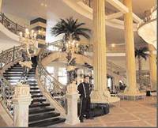

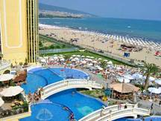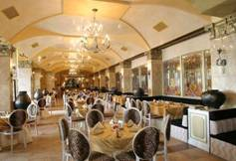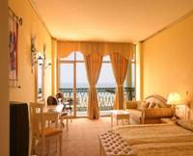
Localizare: pe plaja
Dotari camera: seif, telefon, tv satelit, aer conditionat, minibar, uscator de par, balcon.
Facilitati hotel: piscina exterioara, piscina pt. copii, restaurant, baruri, fitness, masaj, beauty center, sala de conferinte.
OFERTA LAST MINUTE COD « VT/05.06 »
“DISCOUNT 15%”PT REZERVARILE TRIMISE IN PERIOADA 05.06-15.062019 SI ACHITATE INTEGRAL IN 24 H- SEJUR IN PERIOADA 01.06-3.07.2019/23.08-30.09.2019
“DISCOUNT 10%”PT REZERVARILE TRIMISE IN PERIOADA 05.06-15.062019 SI ACHITATE INTEGRAL IN 24 H- SEJUR IN PERIOADA 4.07-22.08.2019
*NU SE COMBINA CU ALTE DISCOUNTURI

OFERTA LAST MINUTE COD « TK/1.06; 112/3.06 ; VT 07.06»
“DISCOUNT 15%”PT REZERVARILE TRIMISE IN PERIOADA 1.06-15.06.2019 SI ACHITATE INTEGRAL IN 24 H- SEJUR IN PERIOADA 1.06-3.07.2019
“DISCOUNT 10%”PT REZERVARILE TRIMISE IN PERIOADA 1.06-15.06.2019 SI ACHITATE INTEGRAL IN 24 H- SEJUR IN PERIOADA 4.07-22.08.2019
“DISCOUNT 15%”PT REZERVARILE TRIMISE IN PERIOADA 1.06-15.06.2019 SI ACHITATE INTEGRAL IN 24 H- SEJUR IN PERIOADA 23.08-30.09.2019

MIC DEJUN | 1.06-10.06  11.09-30.09 | 11.06-25.6  31.8-10.09 | 26.06-11.07  23.08-30.08 | 12.07  22.08
LOC IN CAMERA VED. PARK /FARA BALCON | 23,5 | 39,5 | 44 | 48,5
CAMERA SINGLE | 34,5 | 70 | 86,5 | 95,5
LOC IN CAMERA VED. PARK | 25,5 | 42 | 47,5 | 52
CAMERA SINGLE | 38 | 74 | 93,5 | 102,5
LOC IN CAMERA VED. MARE | 28 | 44 | 49,5 | 54
CAMERA SINGLE | 41,5 | 78 | 97 | 107
LOC IN STUDIO VED . MARE | 30 | 46,5 | 52 | 56,5
LOC IN MAISONETTE VED. MARE | 30 | 46,5 | 52 | 56,5
DEMIPENSIUNE | 1.06-10.06  11.09-30.09 | 11.06-25.6  31.8-10.09 | 26.06-11.07  23.08-30.08 | 12.07  22.08
LOC IN CAMERA VED. PARK /FARA BALCON | 29 | 45 | 49,5 | 54
CAMERA SINGLE | 43 | 80 | 98 | 107
LOC IN CAMERA VED. PARK | 31 | 47,5 | 53 | 57,5
CAMERA SINGLE | 46,5 | 84 | 104,5 | 113,5
LOC IN CAMERA VED. MARE | 33,5 | 49,5 | 55,5 | 60
CAMERA SINGLE | 49,5 | 88 | 109 | 118
LOC IN STUDIO VED . MARE | 35,5 | 52 | 57,5 | 62
LOC IN MAISONETTE VED. MARE | 35,5 | 52 | 57,5 | 62
ALL INCLUSIVE | 1.06-10.06  11.09-30.09 | 11.06-25.6  31.8-10.09 | 26.06-11.07  23.08-30.08 | 12.07  22.08
LOC IN CAMERA VED. PARK /FARA BALCON | 38 | 54 | 58,5 | 63
CAMERA SINGLE | 56,5 | 98,5 | 116 | 125
LOC IN CAMERA VED. PARK | 40 | 56,5 | 62 | 66,5
CAMERA SINGLE | 60 | 100,5 | 122,5 | 131,5
LOC IN CAMERA VED. MARE | 42,5 | 58,5 | 64 | 69
CAMERA SINGLE | 63 | 104,5 | 127 | 136
LOC IN STUDIO VED . MARE | 44,5 | 61 | 66,5 | 71
LOC IN MAISONETTE VED. MARE | 44,5 | 61 | 66,5 | 71
TERMEN DE ANULARE | 12 | 14 | 18 | 20
PENALIZARI | 100 % | 100% | 100% | 100 %

OFERTA LAST MINUTE COD « 084/30.04/ VT/30.04; TK/30.04»
“DISCOUNT 15%”PT REZERVARILE TRIMISE IN PERIOADA 1.06-31.07.2019 SI ACHITATE INTEGRAL IN 24 H- SOSIRI IN PERIOADA 1.09-10.092019
*SE COMBINA CU NOPTI GRATUITE
MIC DEJUN | 15.05-10.06  11.09-30.09 | 11.06-25.6  31.8-10.09 | 26.06-11.07  23.08-30.08 | 12.07  22.08
LOC IN CAMERA VED. PARK /FARA BALCON | 23,5 | 39,5 | 44 | 48,5
CAMERA SINGLE | 34,5 | 70 | 86,5 | 95,5
LOC IN CAMERA VED. PARK | 25,5 | 42 | 47,5 | 52
CAMERA SINGLE | 38 | 74 | 93,5 | 102,5
LOC IN CAMERA VED. MARE | 28 | 44 | 49,5 | 54
CAMERA SINGLE | 41,5 | 78 | 97 | 107
LOC IN STUDIO VED . MARE | 30 | 46,5 | 52 | 56,5
LOC IN MAISONETTE VED. MARE | 30 | 46,5 | 52 | 56,5
DEMIPENSIUNE | 15.05-10.06  11.09-30.09 | 11.06-25.6  31.8-10.09 | 26.06-11.07  23.08-30.08 | 12.07  22.08
LOC IN CAMERA VED. PARK /FARA BALCON | 29 | 45 | 49,5 | 54
CAMERA SINGLE | 43 | 80 | 98 | 107
LOC IN CAMERA VED. PARK | 31 | 47,5 | 53 | 57,5
CAMERA SINGLE | 46,5 | 84 | 104,5 | 113,5
LOC IN CAMERA VED. MARE | 33,5 | 49,5 | 55,5 | 60
CAMERA SINGLE | 49,5 | 88 | 109 | 118
LOC IN STUDIO VED . MARE | 35,5 | 52 | 57,5 | 62
LOC IN MAISONETTE VED. MARE | 35,5 | 52 | 57,5 | 62
ALL INCLUSIVE | 15.05-10.06  11.09-30.09 | 11.06-25.6  31.8-10.09 | 26.06-11.07  23.08-30.08 | 12.07  22.08
LOC IN CAMERA VED. PARK /FARA BALCON | 38 | 54 | 58,5 | 63
CAMERA SINGLE | 56,5 | 98,5 | 116 | 125
LOC IN CAMERA VED. PARK | 40 | 56,5 | 62 | 66,5
CAMERA SINGLE | 60 | 100,5 | 122,5 | 131,5
LOC IN CAMERA VED. MARE | 42,5 | 58,5 | 64 | 69
CAMERA SINGLE | 63 | 104,5 | 127 | 136
LOC IN STUDIO VED . MARE | 44,5 | 61 | 66,5 | 71
LOC IN MAISONETTE VED. MARE | 44,5 | 61 | 66,5 | 71
TERMEN DE ANULARE | 12 | 14 | 18 | 20
PENALIZARI | 100 % | 100% | 100% | 100 %

OFERTA LAST MINUTE COD « VT/2.03;TK/1.03»
“DISCOUNT 15%”PT REZERVARILE TRIMISE IN PERIOADA 1.06-31.07.2019 SI ACHITATE INTEGRAL IN 24 H- SOSIRI IN PERIOADA 1.09-10.092019
*SE COMBINA CU NOPTI GRATUITE
MIC DEJUN | 15.05-10.06  11.09-30.09 | 11.06-25.6  31.8-10.09 | 26.06-11.07  23.08-30.08 | 12.07  22.08
LOC IN CAMERA VED. PARK /FARA BALCON | 23,5 | 39,5 | 44 | 48,5
CAMERA SINGLE | 34,5 | 70 | 86,5 | 95,5
LOC IN CAMERA VED. PARK | 25,5 | 42 | 47,5 | 52
CAMERA SINGLE | 38 | 74 | 93,5 | 102,5
LOC IN CAMERA VED. MARE | 28 | 44 | 49,5 | 54
CAMERA SINGLE | 41,5 | 78 | 97 | 107
LOC IN STUDIO VED . MARE | 30 | 46,5 | 52 | 56,5
LOC IN MAISONETTE VED. MARE | 30 | 46,5 | 52 | 56,5
DEMIPENSIUNE | 15.05-10.06  11.09-30.09 | 11.06-25.6  31.8-10.09 | 26.06-11.07  23.08-30.08 | 12.07  22.08
LOC IN CAMERA VED. PARK /FARA BALCON | 29 | 45 | 49,5 | 54
CAMERA SINGLE | 43 | 80 | 98 | 107
LOC IN CAMERA VED. PARK | 31 | 47,5 | 53 | 57,5
CAMERA SINGLE | 46,5 | 84 | 104,5 | 113,5
LOC IN CAMERA VED. MARE | 33,5 | 49,5 | 55,5 | 60
CAMERA SINGLE | 49,5 | 88 | 109 | 118
LOC IN STUDIO VED . MARE | 35,5 | 52 | 57,5 | 62
LOC IN MAISONETTE VED. MARE | 35,5 | 52 | 57,5 | 62
ALL INCLUSIVE | 15.05-10.06  11.09-30.09 | 11.06-25.6  31.8-10.09 | 26.06-11.07  23.08-30.08 | 12.07  22.08
LOC IN CAMERA VED. PARK /FARA BALCON | 38 | 54 | 58,5 | 63
CAMERA SINGLE | 56,5 | 98,5 | 116 | 125
LOC IN CAMERA VED. PARK | 40 | 56,5 | 62 | 66,5
CAMERA SINGLE | 60 | 100,5 | 122,5 | 131,5
LOC IN CAMERA VED. MARE | 42,5 | 58,5 | 64 | 69
CAMERA SINGLE | 63 | 104,5 | 127 | 136
LOC IN STUDIO VED . MARE | 44,5 | 61 | 66,5 | 71
LOC IN MAISONETTE VED. MARE | 44,5 | 61 | 66,5 | 71
TERMEN DE ANULARE | 12 | 14 | 18 | 20
PENALIZARI | 100 % | 100% | 100% | 100 %
IN CAMERA DUBLA FARA BALCON MAXIM 2 ADULTI
IN CAMERA DUBLA PV SAU SV MAXIM 2 ADULTI+ 2 COPII/3 ADULTI
IN STUDIO SAU MAISONETTE MAXIM 2 ADULTI+ 2 COPII/ 3 ADULTI
REDUCERI :
- COPIL ( 0-4,99 ANI ) – GRATUIT, FARA SERVICII
- 1 COPIL ( 0-11,99 ANI ) CU 1 ADULT –TARIF SINGLE
- 2 COPII ( 5-11,99 ANI ) CU 1 ADULT – FIECARE PLATESTE 50%
-2 COPII ( 0-4,99 ANI ) CU 1 ADULT –TARIF SINGLE
- 1 COPIL ( 0-11, 99 ANI ) IN PAT SUPLIMENTAR- GRATUIT
- AL 2 LEA COPIL ( 0-4,99 ANI ) IN PAT SUPLIMENTAR- GRATUIT( CEL MAI VARSTINC E INTOTDEUNA CONSIDERAT PRIMUL )
- AL 2 LEA COPIL ( 5-11,99 ANI ) IN PAT SUPLIMENTAR- 50%( CEL MAI VARSTINC E INTOTDEUNA CONSIDERAT PRIMUL )
- ADULT IN PAT SUPLIMENTAR -20 % REDUCERE
NOPTI GRATUITEVALABIL SOSIRI IN PERIOADELE 15.05-10.06/11.09-30.09.2019
1)1 NOAPTE GRATUITA PT SEJUR 7-13 NOPTI
2) 2 NOPTI GRATUITE PT SEJUR 14-21 NOPTI

HOTEL RIU PALACE 5*/ SUNNY BEACH
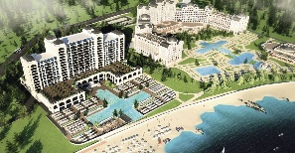
Localizare: pe plaja,langa Riu Helios, deschis 2019
OFERTA LAST MINUTE COD « VT/3.06; 114/3.06; TK/1.06 ; VT 07.06»
“DISCOUNT 25%”PT REZERVARILE TRIMISE IN PERIOADA 1.06-30.06.2019 SI ACHITATE INTEGRAL IN 24 H- SEJUR IN PERIOADA 15.06-30.06.2019- DBL SUP SV
“DISCOUNT 20%”PT REZERVARILE TRIMISE IN PERIOADA 1.06-30.06.2019 SI ACHITATE INTEGRAL IN 24 H- SEJUR IN PERIOADA 1.07-31.08.2019- DBL SUP SV
“DISCOUNT 25%”PT REZERVARILE TRIMISE IN PERIOADA 1.06-30.06.2019 SI ACHITATE INTEGRAL IN 24 H- SEJUR IN PERIOADA 1.09-SF SEZON- DBL SUP SV
ALL INCLUSIVE | 15.06-30.06  1.09-12.09 | 1.07-31.08 | 13.09-23.09 | 24.09-5.10
LOC IN CAMERA SUPERIOR VED. MARE | 103 | 125,5 | 83,5 | 54,5
CAMERA SINGLE | 184,5 | 225 | 133 | 72,5
LOC IN JUNIOR SUITE VED. MARE | 112,5 | 139 | 90,5 | 58,5
LOC IN SUITE 1 DORM | 121,5 | 151 | 97 | 64
PENALIZARI ANULARI | 100 % | 100% | 100% | 100 %
TARIFUL INCLUDE UMBRELE SI SEZLONGURI PE PLAJA- IN LIMITA DISP
ACEST HOTEL ESTE ADULTS ONLY !!- PESTE 18 ANI
IN CAMERA DUBLA MAXIM 2 ADULTI
IN JUNIOR SUITE MAXIM 2 SAU 3 ADULTI
IN SUITE MAXIM 4 ADULTI
REDUCERI :
- ADULT IN PAT SUPLIMENTAR -30 % REDUCERE
HOTEL PLANETA 5*& AQUA PARK/SUNNY BEACH
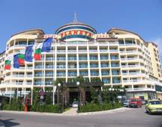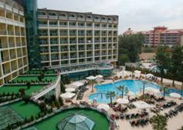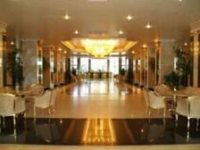

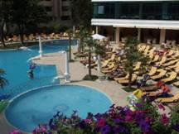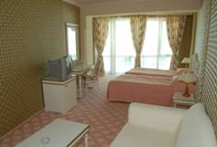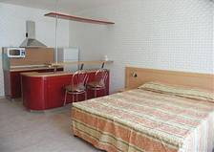
Localizare:la circa 80 m de plaja.
Dotari camera: aer conditionat, uscator de par, minibar, telefon
Facilitati hotel: restaurant, lobby bar, centru spa, bar de noapte, centru medical, salon de infrumusetare, club de joaca pentru copii, piscina, biliard
OFERTA LAST MINUTE COD « 129/11.06 ; VT11.06»
“DISCOUNT 15%” PT REZERVARILE TRIMISE DE LA 11.06.2019 SI ACHITATE INTEGRAL IN 24 H- SOSIRI IN PERIOADA 1.06-30.06.2019
“DISCOUNT 20%” PT REZERVARILE TRIMISE DE LA 11.06.2019 SI ACHITATE INTEGRAL IN 24 H- SOSIRI IN PERIOADA 1.07-15.10.2019
“DISCOUNT 15%” PT REZERVARILE TRIMISE DE LA 11.06.2019 SI ACHITATE INTEGRAL IN 24 H- SOSIRI IN PERIOADA 15.07-15.10.2019
ALL INCLUSIVE | 1.06-05.06  13.9-15.10 | 6.06-20.06  3.09-12.09 | 21.06-6.07  24.08-2.09 | 7.07-  23.08
LOC IN DBL DELUXE STANDARD | 34,5 | 48,5 | 61 | 73
CAMERA SINGLE | 51,5 | 72 | 96,5 | 130,5
LOC IN DBL DELUXE SSV | 37 | 51 | 63 | 75,5
CAMERA SINGLE | 72,5 | 100 | 125 | 149,5
LOC IN DBL SUPERIOR | 37 | 51 | 63 | 75,5
LOC IN FAMILY STANDARD | 34,5 | 48,5 | 61 | 73
LOC IN JUNIOR SUITE | 34,5 | 48,5 | 61 | 73
TERMEN DE ANULARE | 10 | 12 | 16 | 20
PENALIZARI | 2 | 3 | 3 | 4
IN CAMERA DUBLA MAXIM 2 ADULTI+2 COPII / 3 ADULTI
IN CAMERA SUPERIOARA MINIM 2 ADULTI; MAXIM 2 ADULTI+ 3 COPII/3 ADULTI+ 1 COPIL
IN JUNIOR SUITE MINIM 2 ADULTI; MAXIM 2 ADULTI+ 3 COPII /3 ADULTI+ 2 COPII/4 ADULTI
IN CAMERA FAMILY (4 PATURI NORMALE )MINIM 2 ADULTI+ 2 COPII;MAXIM 4 ADULTI+ 2 COPII
REDUCERI :
- COPIL ( 0-1,99 ANI ) – GRATUIT, FARA SERVICII
- 1 COPIL ( 2-11, 99 ANI ) CU 1 ADULT IN DBL LUX–30% REDUCERE
- AL 2 LEA SI AL 3 LEA COPIL ( 2-11, 99 ANI ) CU 1 ADULT IN DBL LUX - FIECARE 70% REDUCERE
- 1 COPIL ( 2-11, 99 ANI ) CU 1 ADULT IN DBL SUP/JUNIOR–FARA REDUCERE
- 1 COPIL ( 2-11, 99 ANI ) IN PAT NORMAL IN FAMILY- 30% REDUCERE
- 1 COPIL ( 2-11, 99 ANI ) IN PAT SUPLIM IN DBL LUX – GRATUIT
- AL 2 LEA COPIL ( 2-11, 99 ANI ) IN PAT SUPLIM IN DBL LUX -50%
- 1 COPIL ( 2-11, 99 ANI ) IN PAT SUPLIM IN DBL SUP/JUNIOR – 50%
- AL 2 LEA COPIL ( 2-11, 99 ANI ) IN PAT SUPLIM IN DBL SUP/JUNIOR-70% REDUCERE
- AL 3 LEA COPIL ( 2-11, 99 ANI ) IN PAT SUPLIM IN DBL SUP/JUNIOR-GRATUIT
- 1 COPIL ( 2-11, 99 ANI ) IN PAT SUPLIM IN FAMILY – 70% REDUCERE
- AL 2 LEA COPIL ( 2-11, 99 ANI ) IN PAT SUPLIM IN FAMILY- GRATUIT
- ADULT IN PAT SUPLIMENTAR – 20% REDUCERE
HOTEL TARSIS CLUB & SPA 4*/ SUNNY BEACH
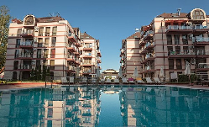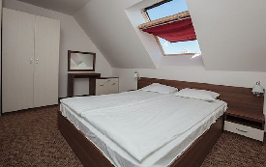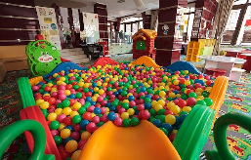
Localizare:deschis 2010 ,la 550 m de plaja.
Dotari camera: aer conditionat, uscator de par, minibar, telefon,chicineta,TV;internet
Facilitati hotel: restaurant, lobby bar, gradina,centru SPA,teren sportiv;locuri de Joaca copii,parcare,2 piscine exterioare,WI FI;
http://tarsis-bg.com/
OFERTA LAST MINUTE COD « TK/17.05»
“DISCOUNT 30%”PT REZERVARILE TRIMISE IN PERIOADA 17.05-25.06.2019 SI ACHITATE INTEGRAL IN 24 H- SEJUR IN PERIOADA 11.06-25.06.2019
*SE POATE COMBINA CU NOPTI GRATUITE

OFERTA LAST MINUTE COD « 131/12.06»
“DISCOUNT 20%”PT REZERVARILE TRIMISE IN PERIOADA 17.05-30.06.2019 SI ACHITATE INTEGRAL IN 24 H- SEJUR IN PERIOADA 11.06-30.06.2019
*SE POATE COMBINA CU NOPTI GRATUITE
ALL INCLUSIVE PREMIUM | 17.5-7.06  5.9-10.10 | 8.06-17.06 | 18.06-6.07  17.08-4.09 | 7.07-16.08
LOC IN CAMERA DUBLA PROMO | 15,5 | 23,5 | 36 | 46,5
CAMERA SINGLE | 27 | 34,5 | 47,5 | 80
LOC IN CAMERA DUBLA | 27 | 34,5 | 47,5 | 57,5
CAMERA SINGLE | 38 | 46 | 58,5 | 91
LOC IN APART. 1 DORM | 30 | 38 | 51 | 62
APART. 2 DORM/4 ADULTI/ZI* | 120 | 151 | 202,5 | 247,5
TERMEN DE ANULARE | 10 | 12 | 16 | 18
PENALIZARI | 2 | 3 | 3 | 4
IN CAMERA DUBLA MAXIM 2 ADULTI+1 COPIL/3 ADULTI
IN APARTAMENT 1 DORMITOR MAXIM 2 ADULTI+ 2 COPII/3 ADULTI+1 COPIL
IN APARTAMENT 2 DORMITOARE MAXIM 4 ADULTI+ 2 COPII/5 ADULTI+ 1 COPIL
ALL INCL PREMIUM: LA MIEZUL NOPTII- GUSTARI RECI SI SUPA;PRAJITURELE;INGHETATA;APA;SUCURI;BAUTURI CALDE;BAUTURI RACORITOARE;BERE SI VIN DRAFT;COCKTAILURI;BAUTURI ALCOOLICE
REDUCERI :
- COPIL ( 0-1,99 ANI ) – GRATUIT, FARA SERVICII
- 1 COPIL ( 2-11,99 ANI) CU 1 ADULT- 25% REDUCERE
- 2 COPII ( 2-11,99 ANI) CU 1 ADULT- FIECARE PLATESTE 50%
- 1 COPIL ( 2-11,99 ANI) IN PAT SUPLIMENTAR- GRATUIT
- AL 2 LEA COPIL ( 2-11,99 ANI) IN PAT SUPLIMENTAR-50%
- ADULT IN PAT SUPLIMENTAR –25 % REDUCERE
NOPTI GRATUITE
1)7=5 ;8=6;9=7;10=8;11=9;12=10;13=11;14=10;21=15; PT SOSIRI IN PERIOADELE 10.05-7.06/18.09-10.10.2019
2) 7=6; 8=7;9=8;10=9;11=10;12=11;13=12;14=1;21-18 2 PT SOSIRI IN PERIOADELE 8.06-15.06/1.09-17.09.2019

COMPLEX CHAIKA BEACH RESORT 4*++/SUNNY BEACH
HOTEL ARKADIA 4*+ METROPOL 4*+
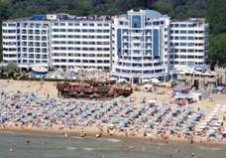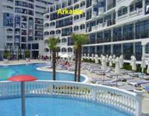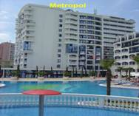

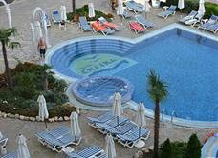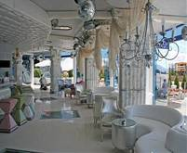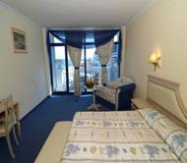
Localizare: pe plaja
Dotari camera:minibar, baie cu dus si uscator de par, aer conditionat, telefon, tv satelit
Facilitati hotel:acces internet, piscina cu zona pentru copii, parcare, receptie si room service 24/24, camere nefumatori, servicii medicale, schimb valutar, magazin, centru frumusete.
Complexul este fortmat din 2 corpuri de cladire H. Metropol si H. Arcadia
OFERTA LAST MINUTE COD « VT/3.06;112/3.06; TK/1.06»
“DISCOUNT 15%”PT REZERVARILE TRIMISE IN PERIOADA 1.06-30.06.2019 SI ACHITATE IN 24 H- SEJUR IN PERIOADA 1.07-31.08.2019
MIC DEJUN | 31.8 | 1.07-11.07  23.08-30.08 | 12.07-22.08
LOC IN CAMERA( FARA BALCON) VED. PARK/METROPOL | 30,5 | 35 | 39,5
CAMERA SINGLE | 54 | 69 | 77,5
LOC IN CAMERA VED. PARK/METROPOL | 33 | 37,5 | 42
CAMERA SINGLE | 58 | 73 | 82
LOC IN CAMERA VED. PARK /CKAIKA/ARKADIA | 36 | 41 | 45
CAMERA SINGLE | 63 | 80 | 89
LOC IN CAMERA VED. MARE /CHAIKA | 39,5 | 44 | 48,5
CAMERA SINGLE | 70 | 86,5 | 95,5
LOC IN STUDIO VED.PARK /CHAIKA/ARKADIA | 38,5 | 43 | 47,5
LOC IN STUDIO VED.MARE /CHAIKA | 42 | 46,5 | 51
LOC IN APART.1 DORM PV/METROPOL | 42 | 46,5 | 51
LOC IN APART.1 DORM PV/ARKADIA | 42 | 46,5 | 51
MAISONETTE SV/CHAIKA/2ADULTI/ZI* | 207 | 215,5 | 224,5
DEMIPENSIUNE | 31.8 | 1.07-11.07  23.08-30.08 | 12.07-22.08
LOC IN CAMERA( FARA BALCON) VED. PARK/METROPOL | 36 | 41 | 45
CAMERA SINGLE | 63,5 | 80 | 89
LOC IN CAMERA VED. PARK/METROPOL | 68 | 84,5 | 93,5
CAMERA SINGLE | 67 | 84 | 93,5
LOC IN CAMERA VED. PARK /CKAIKA/ARKADIA | 42 | 46,5 | 51
CAMERA SINGLE | 74 | 91 | 100
LOC IN CAMERA VED. MARE /CHAIKA | 45 | 49,5 | 54
CAMERA SINGLE | 80 | 98 | 107
LOC IN STUDIO VED.PARK /CHAIKA/ARKADIA | 44 | 48,5 | 52
LOC IN STUDIO VED.MARE /CHAIKA | 47,5 | 52 | 56,5
LOC IN APART.1 DORM PV/METROPOL | 47,5 | 52 | 56,5
LOC IN APART.1 DORM PV/ARKADIA | 47,5 | 52 | 56,5
MAISONETTE SV/CHAIKA/2ADULTI/ZI* | 218 | 227 | 236
ALL INCLUSIVE | 31.8 | 1.07-11.07  23.08-30.08 | 12.07-22.08
LOC IN CAMERA( FARA BALCON) VED. PARK/METROPOL | 45 | 49,5 | 54
CAMERA SINGLE | 80 | 98 | 107
LOC IN CAMERA VED. PARK/METROPOL | 47,5 | 52 | 56,5
CAMERA SINGLE | 84 | 102,5 | 111,5
LOC IN CAMERA VED. PARK /CKAIKA/ARKADIA | 51 | 55,5 | 60
CAMERA SINGLE | 90 | 109 | 118
LOC IN CAMERA VED. MARE /CHAIKA | 53 | 58,5 | 63
CAMERA SINGLE | 96 | 116 | 125
LOC IN STUDIO VED.PARK /CHAIKA/ARKADIA | 53 | 57,5 | 62
LOC IN STUDIO VED.MARE /CHAIKA | 56,5 | 61 | 65,5
LOC IN APART.1 DORM PV/METROPOL | 56,5 | 61 | 65,5
LOC IN APART.1 DORM PV/ARKADIA | 56,5 | 61 | 65,5
MAISONETTE SV/CHAIKA/2ADULTI/ZI* | 236 | 245 | 254
TERMEN DE ANULARE | 16 | 18 | 20
PENALIZARI | 100% | 100% | 100%
IN CAMERA DUBLA METROPOL MAXIM 2 ADULTI+ 1 COPIL/ 3 ADULTI
IN CAMERA DUBLA CHAIKA/ARKADIA MAXIM 2 ADULTI+ 2 COPII/ 3 ADULTI
IN STUDIO CHAIKA/ ARKADIA MAXIM 2 ADULTI+ 2 COPII/ 3 ADULTI+ 1 COPIL
IN APARTAMENT METROPOL MAXIM 2 ADULTI+ 2 COPII/ 3 ADULTI
IN APARTAMENT ARKADIA MAXIM 3 ADULTI+ 1 COPIL/2 ADULTI+ 3 COPII
IN MAISONETTE CHAIKA MAXIM 2 ADULTI
REDUCERI :
- COPIL ( 0-4,99 ANI )– GRATUIT, FARA SERVICII
- 1 COPIL ( 0-11, 99 ANI ) CU UN ADULT IN DBL- TARIF SINGLE
- 2 COPII ( 0-4,99 ANI) ) CU 1 ADULT- TARIF SINGLE
- 2 COPII ( 5-11,99 ANI) CU 1 ADULT- FIECARE PLATESTE 50%
- 1 COPIL ( 0-11,99 ANI) IN PAT SUPLIMENTAR- GRATUIT
- AL 2 LEA COPIL ( 0-4,99 ANI) IN PAT SUPLIMENTAR- GRATUIT ( INTOTDEUNA CEL MAI VARSTNIC E CONSIDERAT PRIMUL )
- AL 2 LEA COPIL ( 5-11,99 ANI) IN PAT SUPLIMENTAR- 50%( INTOTDEUNA CEL MAI VARSTNIC E CONSIDERAT PRIMUL )
- AL 3 LEA COPIL ( 5-11,99 ANI) IN PAT SUPLIMENTAR- 50%
- ADULT IN CAMERA IN PAT SUPLIMENTAR – 20 % REDUCERE

HOTEL WELA 4*/SUNNY BEACH

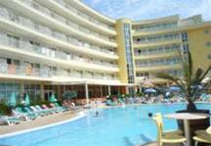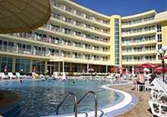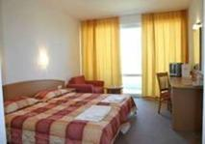

Localizare: la 250 m fata de plaja

Dotari camera:telefon international, Tv-antena satelit, baie si balcon

Facilitati hotel:piscina, bar in hol si bar la piscina, piscina pentru copii, piscina pentru hydro-massaj si centru SPA www.welahotel.com
OFERTA LAST MINUTE COD « TK/10.06 ; 119/06.06»
“DISCOUNT 10%”PT REZERVARILE TRIMISE IN PERIOADA 01.06-30.06.2019 SI ACHITATE INTEGRAL IN 24 H PENTRU SEJUR IN PERIOADELE 10.06-01.07.2019 SI 16.07-14.10.2019
“DISCOUNT 20%”PT REZERVARILE TRIMISE IN PERIOADA 01.06-30.06.2019 SI ACHITATE INTEGRAL IN 24 H PENTRU SEJUR IN PERIOADA 02.07-15.07.2019
ALL INCLUSIVE PREMIUM | 24.4-03.06  24.9-14.10 | 04.6-17.06  10.9-23.09 | 18.6-01.7  27.08-9.9 | 02.07-  26.08
LOC IN CAMERA DUBLA | 30 | 34 | 47 | 60,5
CAMERA SINGLE | 42 | 50 | 72 | 101
LOC IN DUBLA DELUXE | 34,5 | 39 | 53,5 | 69
CAMERA SINGLE | 48 | 57,5 | 82 | 113,5
JUNIOR SUITE 3 ADULTI/ZI* | 91,5 | 103,5 | 145 | 185,5
JUNIOR SUITE 4 ADULTI/ZI* | 116 | 131 | 182 | 235,5
JUNIOR SUITE DELUXE 3 ADULTI/ZI* | 105 | 118,5 | 164 | 211
JUNIOR SUITE DELUXE 4 ADULTI/ZI* | 133 | 150 | 208 | 267,5
FAMILY 4 ADULTI/ZI* | 122 | 138 | 191,5 | 247,5
FAMILY 5 ADULTI/ZI* | 146,5 | 165,5 | 230 | 297
FAMILY 6 ADULTI/ZI* | 170,5 | 193 | 268,5 | 347
FAMILY DELUXE 4 ADULTI/ZI* | 140 | 158 | 218,5 | 281
FAMILY DELUXE5 ADULTI/ZI* | 168 | 189,5 | 262 | 337,5
FAMILY DELUXE6 ADULTI/ZI* | 196 | 221 | 306 | 394
TERMEN DE ANULARE | 14 | 14 | 18 | 20
PENALIZARI | 2 | 2 | 4 | 4
IN CAMERA DUBLA MAXIM 2 ADULTI +2 COPII /3 ADULTI
IN JUNIOR SUITE MINIM 3 ADULTI; MAXIM 5 ADULTI
IN CAMERA FAMILY MINIM 4 ADULTI; MAXIM 4 ADULTI+ 2 COPII/ 5 SAU 6 ADULTI( 2 DBL INTERCONECTATE)
REDUCERI :
- COPIL ( 0-1.99 ANI ) - GRATUIT, FARA SERVICII
- 1 COPIL ( 2-11,99 ANI ) IN CAMERA CU 1 ADULT – FARA REDUCERE
- 2 COPII ( 2-11,99 ANI ) IN CAMERA CU 1 ADULT- FIECARE PLATESTE 50%+ SUPLIMENT 9€/ZI- PT AL 2 LEA COPIL
- 2 COPII ( 2-11.99 ANI ) CU 2 ADULTI IN JUNIOR- TARIF 3 ADULTI+ SUPLIMENT 9 €/ZI- PT AL 2 LEA COPIL
- 1 COPIL ( 2-5,99 ANI) IN PAT SUPLIMENTAR IN DBL SAU JUNIOR- GRATUIT
- 1 COPIL ( 6-11,99 ANI) IN PAT SUPLIM. IN DBL SAU JUNIOR-PLATESTE SUPLIMENT 9€/ZI
- AL 2 LEA COPIL ( 2-11,99 ANI) IN PAT SUPLIM. IN DBL SAU JUNIOR-50%
- 1-2 COPII ( 2-5,99 ANI) IN PAT SUPLIM IN FAMILY- GRATUITI
- 1-2 COPII ( 6-11,99 ANI) IN PAT SUPLIM IN FAMILY- FIECARE PLATESTE SUPLIMENT 9€/ZI
- ADULT IN PAT SUPLIMENTAR – 20 % REDUCERE

HOTEL FIESTA M 4*/SUNNY BEACH
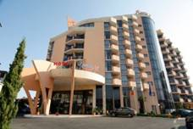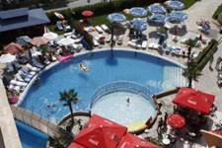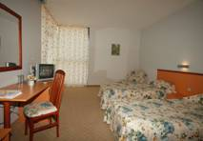
Localizare:in nordul statiunii Sunny Beach ; langa plaja
Dotari camera:mini-bar, TV satelit, telefon, baie cu dus si uscator de par, aer conditionat, balcon.
Facilitati hotel: piscina exterioara, safe, mini-market, frizerie, casa de schimb, masaj. http://fiestamhotel.com/
OFERTA LAST MINUTE COD « 116/4.06 ;TK 10.06»
“DISCOUNT 20%”PT REZERVARILE TRIMISE IN PERIOADA 4.06-20.06.2019 SI ACHITATE INTEGRAL IN 24 H-SEJUR IN PERIOADA 14.07-17.08.2019
“DISCOUNT 15%”PT REZERVARILE TRIMISE IN PERIOADA 14.06-20.06.2019 SI ACHITATE INTEGRAL IN 24 H-SEJUR IN PERIOADA 24.08-09.09.2019
*NU SE COMBINA CU ALTE OFERTE
ALL INCLUSIVE | 1.09-9.09 | 14.07-15.07  16.08-17.08  24.08-31.08 | 16.07-  15.08
LOC IN CAMERA VED. MARE | 43,5 | 50 | 58,5
CAMERA SINGLE | 64,5 | 74,5 | 87
LOC IN CAMERA VED. PARK | 40 | 47 | 56,5
CAMERA SINGLE | 59,5 | 69,5 | 84
STUDIO VED. MARE/ 2 ADULTI/ZI* | 110,5 | 125 | 147,5
STUDIO VED. MARE/ 3 ADULTI/ZI* | 149,5 | 169 | 199
STUDIO VED. PARK/ 2 ADULTI/ZI* | 102,5 | 119,5 | 142
STUDIO VED. PARK/ 3 ADULTI/ZI* | 139 | 161,5 | 192
TERMEN DE ANULARE | 16 | 18 | 20
PENALIZARI | 10 | 10 | 15

OFERTA LAST MINUTE COD « TK 10.06»
“DISCOUNT 20%”PT REZERVARILE TRIMISE IN PERIOADA 4.06-20.06.2019 SI ACHITATE INTEGRAL IN 24 H-SEJUR IN PERIOADELE 21.06-29.06 SI 06.07-13.07 IN CAMERE VEDERE PARK
“DISCOUNT 20%”PT REZERVARILE TRIMISE IN PERIOADA 4.06-20.06.2019 SI ACHITATE INTEGRAL IN 24 H-SEJUR IN PERIOADA 21.06-27.06 IN CAMERE VEDERE PARK
ALL INCLUSIVE | 21.06 –7.7 | 8.07-13.07
LOC IN CAMERA VED. MARE | 42 | 49
CAMERA SINGLE | 63 | 73
LOC IN CAMERA VED. PARK | 39 | 46
CAMERA SINGLE | 58 | 68
LOC IN STUDIO VED. MARE | 48 | 55
STUDIO SINGLE | 94,5 | 108
TERMEN DE ANULARE | 12 | 15
PENALIZARI | 4 | 4
IN CAMERA DUBLA MAXIM 2 ADULTI+2 COPII/3 ADULTI
IN STUDIO MAXIM 2 ADULTI+2 COPII/3 ADULTI
REDUCERI :
- COPIL ( 0-1,99 ANI )– GRATUIT, FARA SERVICII
- 1 COPIL ( 2-13, 99 ANI ) IN CAMERA CU 2 ADULTI IN PAT SUPLIMENTAR– GRATUIT
- AL 2 LEA COPIL( 2-13, 99 ANI ) IN PAT SUPLIMENTAR - 50%
- 1 -2 COPII ( 2-13, 99 ANI ) CU 1 ADULT IN DBL – FIECARE PLATESTE 50 %
- AL 3-LEA ADULT IN CAMERA IN PAT SUPLIMENTAR – 30 % REDUCERE
OFERTA LAST MINUTE COD « 114/3.06;TK/1.06»
“DISCOUNT 20%”PT REZERVARILE TRIMISE IN PERIOADA 4.06-30.06.2019 SI ACHITATE INTEGRAL IN 24 H-SEJUR IN PERIOADA 9.09-10.10.2019
ALL INCLUSIVE | 10.09-10.10 | 9.09
LOC IN DUBLA VED. MARE | 34,5 | 43,5
CAMERA SINGLE | 43 | 64,5
LOC IN DUBLA VED. PARK | 32,5 | 40
CAMERA SINGLE | 40 | 59,5
STUDIO VED. MARE/ 2 ADULTI/ZI* | 91,5 | 110,5
STUDIO VED. MARE/ 3 ADULTI/ZI* | 123,5 | 149,5
STUDIO VED. PARK/ 2 ADULTI/ZI* | 87 | 102,5
STUDIO VED. PARK/ 3 ADULTI/ZI* | 117,5 | 139
TERMEN DE ANULARE | 10 | 16
PENALIZARI | 6 | 10
IN CAMERA DUBLA MAXIM 2 ADULTI+1 COPIL/3 ADULTI
IN STUDIO MAXIM 2 ADULTI+ 2 COPII/ 3 ADULTI
REDUCERI :
- COPIL ( 0-1,99 ANI )– GRATUIT, FARA SERVICII
- 1 COPIL ( 2-13, 99 ANI ) IN CAMERA CU 2 ADULTI IN PAT SUPLIMENTAR– GRATUIT
- AL 2 LEA COPIL( 2-13, 99 ANI ) IN PAT SUPLIM. IN STUDIO- 50%
- 1 -2 COPII ( 2-13, 99 ANI ) CU 1 ADULT IN DBL – FIECARE PLATESTE 50 %
- AL 3-LEA ADULT IN CAMERA IN PAT SUPLIMENTAR – 30 % REDUCERE
HOTEL GRAND VICTORIA 4*/SUNNY BEACH
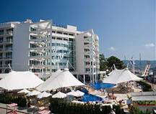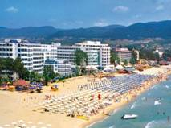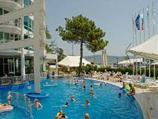

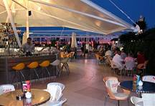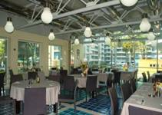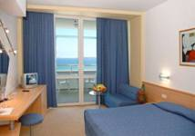

Localizare:pe plaja, in partea de nord a statiunii Sunny Beach.
Dotari camera:TV, aer conditionat, telefon, terasa, seif, minibar.
Facilitati hotel: restaurant Hollywood, restaurant traditional bulgaresc, Irish pub, Safari bar, Caribbean bar, pool bar, Palm bar, piscina exterioara, piscina copii, Jacuzzi, sauna, baie turceasca, masaj, fitness, manichiura, coafor, SPA
OFERTA LAST MINUTE COD « VT/13.06»
“DISCOUNT 45%”PT REZERVARILE TRIMISE IN PERIOADA 11.06-28.06.2019 SI ACHITATE INTEGRAL IN 24 H-SEJUR IN PERIOADA 15.06-30.06.2019
“DISCOUNT 30%”PT REZERVARILE TRIMISE IN PERIOADA 11.06-28.06.2019 SI ACHITATE INTEGRAL IN 24 H-SEJUR IN PERIOADA 01.07-31.07.2019
“DISCOUNT 20%”PT REZERVARILE TRIMISE IN PERIOADA 11.06-28.06.2019 SI ACHITATE INTEGRAL IN 24 H-SEJUR IN PERIOADA 01.08-30.09.2019
ALL INCLUSIVE | 1.06-12.06  10.09-30.09 | 13.06-5.07  26.08-9.09 | 6.07-25.08
LOC IN CAMERA VED. PARK | 50 | 66,5 | 80
CAMERA SINGLE | 75 | 112,5 | 150,5
LOC IN CAMERA SUPERIOR SSV | 51,5 | 69 | 85
CAMERA SINGLE | 102 | 136 | 163
LOC IN CAMERA VED. MARE | 51,5 | 67,5 | 81
CAMERA SINGLE | 102 | 133,5 | 160,5
APART. 1 DORM. 2 ADULTI/ZI* | 107 | 139,5 | 166,5
APART. 1 DORM. 3 ADULTI/ZI* | 150 | 195,5 | 233
APART. 2 DORM. 4 ADULTI/ZI* | 200,5 | 243 | 292
APART. 2 DORM. 5 ADULTI/ZI* | 240,5 | 292 | 351
TERMEN DE ANULARE | 14 | 18 | 20
PENALIZARI | 3 | 4 | 7
IN CAMERA DUBLA PV MAXIM 2 ADULTI+1 COPIL( 2 COPII PANA LA 8,99 ANI)/3 ADULTI
IN CAMERA DUBLA SUPERIOR SSV 2 ADULTI+1 COPIL
IN CAMERA DUBLA SV MINIM/MAXIM 2 ADULTI
IN APARTAMENT 1 DORMITOR MAXIM 2 ADULTI+ 2 COPII/3 ADULTI
IN APARTAMENT 2 DORMITOARE MAXIM 4 ADULTI+ 2 COPII/5 ADULTI
REDUCERI :
- COPII ( 0-1.99 ANI )– GRATUIT, FARA SERVICII/PATUT LA CERERE 2,5 E/ZI
- 1 COPIL( 2-11.99 ANI ) IN PAT SUPLIMENTAR– GRATUIT
- AL 2 LEA COPIL ( 2-11.99 ANI ) IN PAT SUPLIMENTAR IN AP- 50%
- 2 COPII ( 2-8,99 ANI) IN PAT SUPLIM CU 2 ADULTI IN DBL PV- FIECARE PLATESTE 25%
- 1 COPIL ( 2-11.99 ANI ) IN PAT NORMAL CU 1 ADULT–25% REDUCERE
- 2 COPII ( 2-11.99 ANI ) CU 1 ADULT – FIECARE PLATESTE 50 %
- ADULT IN PAT SUPLIMENTAR – 20 % REDUCERE
HOTEL GRENADA 4*/SUNNY BEACH

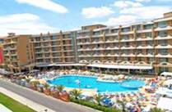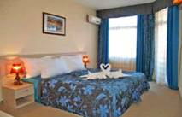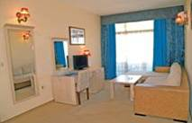

Localizare:situat in partea sudica a faimoasei statiuni de la Marea Neagra – Sunny Beach, la 100 m fata de plaja

Dotari camera: tv, telefon, aer conditionat, baie cu dus, frigider (mini-bar),

Facilitati hotel:restaurant cu terasa Grenada, lobby bar, 4 lifturi, spalatorie, schimb valutar, coafor, magazine, sala de conferinta, billiard, fitness, masaj
OFERTA LAST MINUTE COD « VT/29.05;113/3.06»
“DISCOUNT 10%”PT REZERVARILE TRIMISE IN PERIOADA 1.06-30.06.2019 SI ACHITATE INTEGRAL IN 24 H-SEJUR IN PERIOADA 1.06-30.06.2019
ALL INCLUSIVE | 1.06-12.06 | 13.06-30.06
LOC IN CAMERA DUBLA | 31 | 46,5
CAMERA SINGLE | 42,5 | 71
APART.1 DORM. 2 ADULTI+ 2 COPII/3 ADULTI+1 COPIL/ZI* | 93 | 140
TERMEN DE ANULARE | 18 | 20
PENALIZARI | 3 | 4
*TARIFUL ESTE PE TIP CAMERA,NUMAR PERSOANE INDICATE IN TABEL
IN CAMERA DUBLA MAXIM 2 ADULTI+1 COPIL /3 ADULTI
IN APARTAMENT 1 DORMITOR MAXIM 2 ADULTI+ 2 COPII/ 3 ADULTI+ 1 COPIL
REDUCERI :
- COPIL ( 0-5.99 ANI ) – GRATUIT, FARA SERVICII
- 1 COPIL ( 6-11.99 ANI ) IN PAT SUPLIM CU 2 ADULTI IN DBL– 30% REDUCERE
- 1-2 COPII ( 2-11.99 ANI ) CU 1 ADULT IN CAMERA –FIECARE PLATESTE 50 %
- ADULT IN PAT SUPLIMENTAR – 30 % REDUCERE

HOTEL TIARA BEACH 4*+/SUNNY BEACH
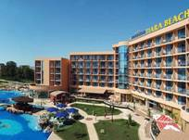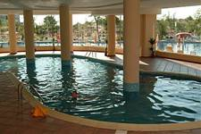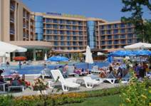
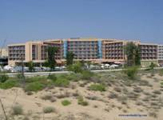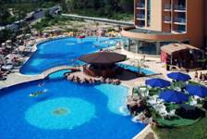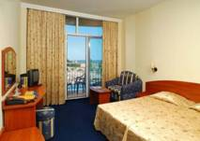
Localizare: la 100 m de plaja.
Dotari camera:telefon, TV satelit, baie, aer conditionat, minibar, balcon.
Facilitati hotel:lobby bar, seif la receptie, restaurant, piscina acoperita, fitness, sauna, masaj, piscina descoperita cu sectiune pentru copii, bar la piscine
OFERTA LAST MINUTE COD « 110/1.06;VT/07.06; TK/1.06»
“DISCOUNT 20%”PT REZERVARILE TRIMISE IN PERIOADA 1.06-17.06.2019 SI ACHITATE INTEGRAL IN 24 H-SEJUR IN PERIOADA 1.06-17.06.2019
ALL INCLUSIVE | 1.06-07.06 | 08.06-17.06
LOC IN CAMERA VED. PARC | 39 | 54
CAMERA SINGLE | 39 | 65,5
LOC IN JUNIOR SUITE V. PARK | 40 | 57,5
LOC IN SUITE VED. MARE | 46 | 75,5
SUPLIMENT VED. MARE/PERS | 3 | 3
TERMEN DE ANULARE | 12 | 14
PENALIZARI | 2 | 3
IN CAMERA DUBLA MAXIM 2 ADULTI + 1 COPIL/ 3 ADULTI
IN JUNIOR /SUITE MAXIM 2 ADULTI +2 COPII/ 3 ADULTI
IN SUITE MAXIM 2 ADULTI +2 COPII/ 3 ADULTI
INFANTUL CONTEAZA LA GRAD OCUPARE !
REDUCERI IN DBL :
- COPIL ( 0-1,99 ANI )– GRATUIT, FARA SERVICII
- 1-2 COPII ( 2-11,99 ANI ) CU 1 ADULT IN DBL – FIECARE PLATESTE 50 %
- 1 COPIL ( 2-11,99 ANI ) CU 1 ADULT IN JUNIOR/APART- FARA REDUCERE
- AL 2 LEA COPIL ( 2-11,99 ANI ) CU 1 ADULT IN JUNIOR/APART- PLATESTE 25%
- 1 COPIL ( 2-11,99 ANI ) IN PAT SUPLIMENTAR IN DBL– GRATUIT
- COPII( 2-11,99 ANI ) IN PAT SUPLIMENTAR IN JUNIOR SAU SUITE- FIECARE PLATESTE 25%
- ADULT IN PAT SUPLIMENTAR – 30 % REDUCERE
HOTEL MAJESTIC 4*+/SUNNY BEACH
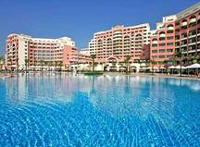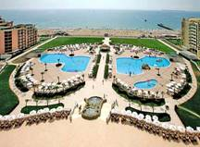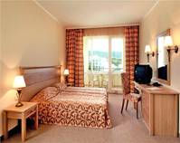
Localizare: pe plaja
Dotari camera:mini-bar, TV satelit, telefon, safe, baie proprie, uscator de par, aer conditionat.
Facilitati hotel: restaurant a - la - carte, snack bar, lobby bar, bar la pisina, centru de afaceri, acces internet, centru SPA, baie turceasca, masaj, 2 terenuri de tenis, fitness, 2 piscine exterioare, piscina pentru copii, snooker, biliard, darts, mini club, baby sitting. http://hotel.majestic-bg.com
OFERTA LAST MINUTE COD « 104/23.05; TK/29.05»
“DISCOUNT 30%”PT REZERVARILE TRIMISE IN PERIOADA 31.05-13.06.2019 SI ACHITATE INTEGRAL IN 24 H- SOSIRI IN PERIOADELE 1.06-30.06/1.09-29.09.2019
“DISCOUNT 20%”PT REZERVARILE TRIMISE IN PERIOADA 31.05-13.06.2019 SI ACHITATE INTEGRAL IN 24 H- SOSIRI IN PERIOADA 1.07-31.08.2019
DEMIPENSIUNE + | 1.06-14.06  14.09-30.09 | 15.6-02.07  25.8-13.09 | 03.07–  24.08
LOC IN CAMERA VED. PARK | 44,5 | 58,5 | 74,5
CAMERA SINGLE | 67 | 93,5 | 132,5
LOC IN CAMERA VED. MARE | 48 | 63 | 79
CAMERA SINGLE | 71,5 | 100 | 140,5
LOC IN APART. 1 DORM. | 49 | 65,5 | 82
LOC IN STUDIO | 47 | 62 | 77,5
TERMEN DE ANULARE | 14 | 16 | 20
PENALIZARI | 3 | 3 | 4
IN CAMERA DUBLA MAXIM 2 ADULTI+1 COPIL
IN STUDIO MAXIM 2 ADULTI+ 2 COPII/ 3 ADULTI
IN APARTAMENT MINIM/MAXIM 2 ADULTI+ 2 COPII/3 ADULTI
INFANTII CONTEAZA LA GRAD OCUPARE !!!
REDUCERI :
- COPIL ( 0-1,99 ANI ) – GRATUIT, FARA SERVICII
- 1 COPIL ( 2-11, 99 ANI ) CU 2 ADULTI IN CAMERA– GRATUIT
- AL 2 LEA COPIL ( 2-11, 99 ANI ) CU 2 ADULTI IN STUDIO-50%
- 2 COPII( 2-11, 99 ANI ) CU 2 ADULTI IN APART- FIECARE PLATESTE 50%
- 1 COPIL ( 2-11, 99 ANI ) CU 1 ADULT IN DBL PV- TARIF SINGLE
- 2 COPII ( 2-11, 99 ANI ) CU 1 ADULT- FIECARE PLATESTE 50%
- ADULT IN PAT SUPLIMENTAR IN STUDIO– 20 % REDUCERE
- AL 3 LEA ADULT IN AP- 80% REDUCERE

HOTEL BELLEVUE 4*/SUNNY BEACH
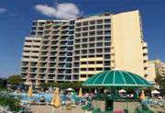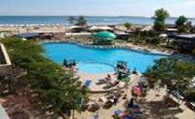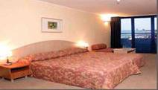
Localizare:pe plaja.
Dotari camera:aer conditionat, mini-bar, balcon, telefon, TV-satelit, uscator de par, baie cu dus sau cada.
Facilitati hotel: piscina exterioara, piscina copii, baruri, restaurant, birou de schimb valutar, magazin, internet, sala de fitness, masaj, tennis de masa, billiard, centru medical, seif
OFERTA LAST MINUTE COD « 113/3.06»
“DISCOUNT 20%”PT REZERVARILE TRIMISE DE LA 1.06.2019 SI ACHITATE INTEGRAL IN 24 H- SOSIRI IN PERIOADA 1.07-17.07.2019

OFERTA LAST MINUTE COD « VT/27.05; TK/29.05 ; VT 07.06»
“DISCOUNT 20%”PT REZERVARILE TRIMISE DE LA 1.06.2019 SI ACHITATE INTEGRAL IN 24 H- SOSIRI IN PERIOADA 1.06-30.06.2019
“DISCOUNT 20%”PT REZERVARILE TRIMISE DE LA 1.06.2019 SI ACHITATE INTEGRAL IN 24 H- SOSIRI IN PERIOADA 1.07-17.07.2019
“DISCOUNT 15%”PT REZERVARILE TRIMISE DE LA 1.06.2019 SI ACHITATE INTEGRAL IN 24 H- SOSIRI IN PERIOADA 18.07-31.07.2019
“DISCOUNT 10%”PT REZERVARILE TRIMISE DE LA 1.06.2019 SI ACHITATE INTEGRAL IN 24 H- SOSIRI IN PERIOADA 1.08-6.10.2019
*SE POATE COMBINA CU NOPTI GRATUITE
ALL INCLUSIVE+ | 1.06-04.06  15.9-10.10 | 05.06-16.6  7.09-14.09 | 17.06-04.07  23.08-06.09 | 05.07-22.08
LOC IN CAMERA DUBLA | 42,5 | 55 | 66,5 | 81
CAMERA SINGLE | 48 | 72,5 | 90 | 109
TERMEN DE ANULARE | 11 | 16 | 19 | 19
PENALIZARI | 2 | 3 | 3 | 4
TARIFUL INCLUDE : GRATUIT 1 UMBRELE SI 2 SEZLONGURI /CAMERA PE PLAJA IN LIMITA DISP
IN CAMERA DUBLA MAXIM 2 ADULTI+1 COPIL /3 ADULTI
REDUCERI :
- COPIL ( 0-1.99 ANI )– GRATUIT, FARA SERVICII( PATUT LA CERERE 3 E- RECEPTIE)
- 1 COPIL ( 2-12.99 ANI ) IN PAT SUPLIMENTAR CU 2 ADULTI –GRATUIT
- 1-2 COPII ( 2-12.99 ANI ) IN CAMERA DUBLA CU 1 ADULT– FIECARE PLATESTE 50%
- ADULT IN PAT SUPLIMENTAR–25 % REDUCERE
NOPTI GRATUITE
1)2 NOPTI GRATUITE PT SEJUR 7-13 NOPTI PT SOSIRI IN PERIOADELE 1.05-23.05/22.09-10.10.2019
2) 2 NOPTI GRATUITE PR SEJUR DE LA 14 NOPTI PT SOSIRI IN PERIOADELE 24.05-1.06/14.09-21.09.2019
3)1 NOAPTE GRATUITAPT SEJUR 7-13 NOPTI PT SOSIRI IN PERIOADELE 24.05-1.06/14.09-21.09.2019
4)4 NOPTI GRATUITE PT SEJUR DE LA 14 NOPTI PT SOSIRI IN PERIOADELE 1.05-23.05/22.09-10.10.2019
DAS CLUB HOTEL SUNNY BEACH 4*/ SUNNY BEACH
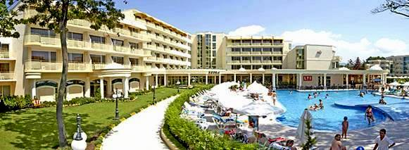

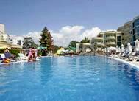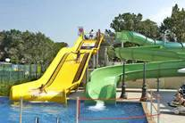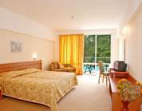
Localizare: la 150m de plaja
Dotari camera: Aer Conditionat , TV, telefon, frigider, uscator de par, balcon, baie cu dus
Facilitati hotel: restaurant, bar de zi si de noapte, sala Internet, magazin, 4 piscine exterioare cu bar, sala fitness, masa de tenis, darts
OFERTA LAST MINUTE COD « 112/3.06;TK/1.06»
“DISCOUNT 15%”PT REZERVARILE TRIMISE IN PERIOADA 5.06-25.06.2019 SI ACHITATE INTEGRAL IN 24 H- SOSIRI IN PERIOADA 20.06-20.08.2019
ALL INCLUSIVE | 20.06-2.07  24.08-9.09 | 03.07-  23.08
SEJUR MINIM NOPTI | 7 | 7
LOC IN CAMERA DUBLA | 60 | 71
LOC IN STUDIO | 62 | 74,5
LOC IN APARTAMENT | 67,5 | 77,5
TERMEN DE ANULARE | 16 | 18
PENALIZARI | 3 | 3
IN CAMERA DUBLA MAXIM 2 ADULTI+1 COPIL
IN STUDIO /APARTAMENT MAXIM 2 ADULTI+2 COPII
IN APARTAMENT MAXIM 3 ADULTI+ 1 COPIL
ATENTIE INFANTII CONTEAZA LA GRAD OCUPARE !
REDUCERI :
- COPIL ( 0-1.99 ANI )– GRATUIT, FARA SERVICII
- 1 COPIL ( 2-11.99 ANI ) CU 1 ADULT IN DBL– 30% REDUCERE
- 2 COPII( 2-11.99 ANI ) CU 1 ADULT IN DBL–FIECARE PLATESTE 50%
- COPIL ( 2-11.99 ANI ) IN PAT SUPLIMENTAR IN DBL – GRATUIT
- 1 COPIL ( 2-11.99 ANI ) IN PAT SUPLIMENTAR IN ST/AP- 50%
- AL 2 LEA COPIL ( 2-11.99 ANI ) IN PAT SUPLIM IN ST/AP –50%
- ADULT IN PAT SUPLIMENTAR IN AP – 10 % REDUCERE

HOTEL AKTINIA 4*/SUNNY BEACH
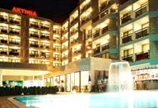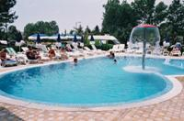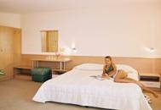
Localizare: la 150 metri de plaja.RENOVAT 2017
Dotari camera:baie proprie , telefon , aer conditionat , frigider , tv satelit si balcon.
Facilitati hotel:restaurant, bar, piscina, sauna, TV, telefon, parcare, room-service.
OFERTA LAST MINUTE COD « TK/1.06;112/3.06 »
“DISCOUNT 15%”PT REZERVARILE TRIMISE IN PERIOADA 1.06-15.06.2019 SI ACHITATE INTEGRAL IN 24 H- SEJUR IN PERIOADA 14.07-15.10.2019
ALL INCLUSIVE | 1.05-7.06  7.09-30.09  A | 8.06 – 13.07  24.08 – 6.09  B | 14.07-23.08  C
SEJUR MINIM NOPTI | 3 | 3 | 3
LOC IN CAMERA | 33,5 | 44 | 54
CAMERA SINGLE | 52,5 | 66,5 | 82
LOC IN CAMERA LARGE | 35,5 | 47,5 | 56,5
CAMERA SINGLE | 70,5 | 93,5 | 111,5
LOC IN STUDIO | 38 | 48,5 | 58,5
LOC IN APART. 1 DORMITOR | 44,5 | 55,5 | 65,5
TERMEN DE ANULARE | 12 | 16 | 18
PENALIZARI | 2 | 3 | 4
IN CAMERA DUBLA MAXIM 2 ADULTI
IN CAMERA DUBLA LARGE MINIM 2 ADULTI; MAXIM 2 ADULTI+ 2 COPII/3 ADULTI
IN STUDIO MINIM 2 ADULTI;MAXIM 2 ADULTI+ 2 COPII/3 ADULTI
IN APARTAMENT MAXIM 2 ADULTI+ 2 COPII/3 ADULTI+ 1 COPIL
REDUCERI :
- COPIL ( 0-1.99 ANI )– GRATUIT ,FARA SERVICII
- 1 COPIL ( 2-12.99 ANI ) IN PAT SUPLIMENTAR - GRATUIT
- AL 2 LEA COPIL ( 2-12.99 ANI ) IN PAT SUPLIMENTAR -50%
- 1 COPIL (2- 12.99 ANI ) CU 1 ADULT – 50% IN SEZON A/B; FARA REDUCERE IN SEZON C
- 2 COPII (2- 12.99 ANI ) CU 1 ADULT- FIECARE PLATESTE 50%
- ADULT IN PAT SUPLIMENTAR– 20 % REDUCERE

HOTEL BLUE PEARL 4*/SUNNY BEACH
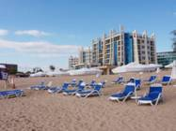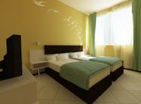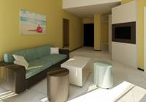
Localizare : in centru statiunii ., linga plaja
Facilitati camere : 17 camere duble; 58 apartamente cu 1 dormitor ; 14 apartamente cu 2 dormitoare cu aer conditionat centralizat ;tv satelit ; frigider
Faciliatai hotel : seif ( la receptie ) ; internet gratuit wi-fi in lobby ; internet cafe ( contra cost ) parcare cu plata ; salon de infrumusetare ; magazine ; schimb valutar ( la receptie ) ; piscina cu sectiune pentru copii ; ; mini club si mini disco pentru copii ; restaurant;
OFERTA LAST MINUTE COD « VT12.06;131/12.06»
“DISCOUNT -30%”PT REZERVARILE TRIMISE IN PERIOADA 11.06-23.06.2019 SI ACHITATE INTEGRAL IN 24 H PENTRU SEJUR IN PERIOADA 11.06-23.06.2019
ULTRA ALL INCLUSIVE | 11.06-15.6 | 16.6-23.06
LOC IN CAMERA PROMO/FARA BALCON | 48 | 62
LOC IN CAMERA COMFORT | 53,5 | 72
CAMERA SINGLE | 76 | 109
LOC IN APART. 1 DORMITOR | 54,5 | 73
LOC IN APART. 2 DORMITOARE | 50 | 66,5
TERMEN DE ANULARE | 30 | 30
PENALIZARI | 100% | 100%

OFERTA LAST MINUTE COD « TK/1.06; 112/3.06»
“DISCOUNT 20%”PT REZERVARILE TRIMISE IN PERIOADA 1.06-15.06.2019 SI ACHITATE INTEGRAL IN 24 H- SEJUR IN PERIOADELE 1.06-20.06/19.08-6.10.2019
“DISCOUNT 15%”PT REZERVARILE TRIMISE IN PERIOADA 1.06-15.06.2019 SI ACHITATE INTEGRAL IN 24 H- SEJUR IN PERIOADA 21.06-19.07.2019
“DISCOUNT 10%”PT REZERVARILE TRIMISE IN PERIOADA 1.06-15.06.2019 SI ACHITATE INTEGRAL IN 24 H- SEJUR IN PERIOADA 20.07-18.08.2019
ULTRA ALL INCLUSIVE | 22.09-6.10 | 26.5-15.6  8.9-21.09 | 16.6-30.06  1.09-7.09 | 1.07-  31.08
LOC IN CAMERA PROMO/FARA BALCON | 32,5 | 48 | 62 | 80
LOC IN CAMERA COMFORT | 36 | 53,5 | 72 | 89
CAMERA SINGLE | 47,5 | 76 | 109 | 176
LOC IN APART. 1 DORMITOR | 37,5 | 54,5 | 73 | 90
LOC IN APART. 2 DORMITOARE | 35,5 | 50 | 66,5 | 84,5
TERMEN DE ANULARE | 30 | 30 | 30 | 30
PENALIZARI | 50% | 100% | 100% | 100%
TARIFUL INCLUDE UMBRELA SI SEZLONGURI PE PLAJA IN LIMITA DISPONIBILITATI
CAMERELE DUBLE SUNT TWIN SI NU AU VEDERE MARE !
IN CAMERA DUBLA MAXIM 2 ADULTI+ 1 COPIL/3 ADULTI
IN APARTAMENT 1 DORMITOR MAXIM 2 ADULTI +2 COPII /3 ADULTI+ 1 COPIL/ 4 ADULTI
IN APARTAMENT 2 DORMITOARE MINIM 4 ADULTI /; MAXIM 3 ADULTI +3 COPII /4 ADULTI+2 COPII;5 ADULTI+ 1 COPIL/6 ADULTI
REDUCERI:
- COPIL ( 0-1.99 ANI )– GRATUIT, FARA SERVICII
- COPIL ( 2-11,99 ANI ) CU 1 ADULT-IN DBL / APART 1 DORM 20% REDUCERE
- 1 COPIL ( 2-11,99 ANI ) IN PAT SUPLIMENTAR IN DBL/APART – GRATUIT
- AL 2 LEA COPIL ( 2-11,99 ANI ) IN PAT SUPLIMENTAR IN APART 1 DORM - 50%
- AL 2 LEA COPIL ( 2-11,99 ANI ) IN PAT SUPLIMENTAR IN APART 2 DORM- 80% REDUCERE
- ADULT IN PAT SUPLIMENTAR – 20 % REDUCERE

HOTEL GOLD PEARL 3*( EX ORPHEUS BOUTIQUE)SUNNY BEACH
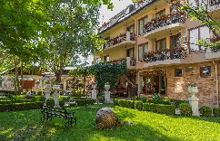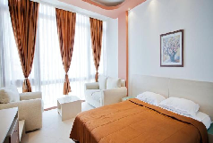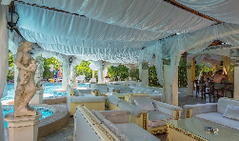
Localizare: la 50 m de plaja.
Dotari camera: balcon, dus/WC, TV, minibar,Aer Conditionat, telefon
Facilitati hotel: aer conditionat central, lift, lobby bar, restaurant, piscina, bar la piscina.
OFERTA LAST MINUTE COD « VT12.06 ; 131/12.06»
“DISCOUNT -30%”PT REZERVARILE TRIMISE IN PERIOADA 11.06-30.06.2019 SI ACHITATE INTEGRAL IN 24 H PENTRU SEJUR IN PERIOADA 11.06-30.06.2019
MIC DEJUN | 11.06-15.06 | 16.06-30.6
LOC IN CAMERA PROMO FARA BALCON | 29 | 37,5
CAMERA SINGLE | 40 | 58,5
LOC IN CAMERA STANDARD | 33,5 | 39,5
CAMEAR SINGLE | 44,5 | 62
LOC IN APART. 1 DORM | 40 | 48,5
LOC IN APART. 2 DORM | 46 | 60
TERMEN DE ANULARE | 14 | 16
PENALIZARI | 2 | 3
IN CAMERA DUBLA PROMO MAXIM 2 ADULTI+ 1 COPIL/3 ADULTI
IN CAMERA DUBLA CONFORT MAXIM 2 ADULTI
IN APART 1 DORM MAXIM 2 ADULTI+ 2 COPII/3 ADULTI
IN APART. 2 DORM MAXIM 5 ADULTI
REDUCERI :
- COPIL ( 0-1,99 ANI )– GRATUIT, FARA SERVICII
- 1 COPIL ( 2-11, 99 ANI ) IN PAT SUPLIMENTAR - GRATUIT
- AL 2 LEA COPIL ( 2-11, 99 ANI ) IN PAT SUPLIM. CU 2 ADULTI - 50%
- AL 2 LEA COPIL ( 2-11, 99 ANI ) IN PAT SUPLIM. CU 4 ADULTI IN AP 2 DORM-80% REDUCERE
- 1 COPIL ( 2-11, 99 ANI ) CU 1 ADULT–20% REDUCERE
- 2 COPII ( 2-11, 99 ANI ) CU 1 ADULT- FIECARE PLATESTE 50%
- ADULT IN CAMERA IN PAT SUPLIMENTAR – 20 % REDUCERE
HOTEL DIT CLUB EVRIKA BEACH 4*+
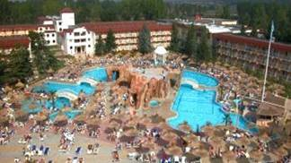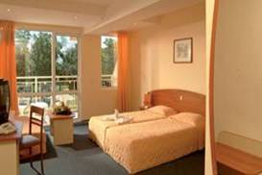
Localizare:la 150 m de plaja.
Dotari camera:telefon, TV satelit, uscator de par, frigider, balcon.
Facilitati hotel: restaurant, 2 baruri, 4 lifturi, piscina descoperita, masaj, fitness, loc de joaca pentru copii, animatie,teren de tenis, tenis de masa, biliard, seif la receptie, cabinet medical, schimb valutar, beauty center, magazine.
OFERTA LAST MINUTE COD « VT11.06 ; 131/12.06»
“DISCOUNT 20%”PT REZERVARILE TRIMISE IN PERIOADA 14.06-30.06.2019 SI ACHITATE INTEGRAL IN 24 H-SEJUR IN PERIOADA 14.06-30.06.2019
“DISCOUNT 10%”PT REZERVARILE TRIMISE IN PERIOADA 14.06-03.07.2019 SI ACHITATE INTEGRAL IN 24 H-SEJUR IN PERIOADA 01.07-31.07.2019
“DISCOUNT 30%”PT REZERVARILE TRIMISE IN PERIOADA 14.06-03.07 SI ACHITATE INTEGRAL IN 24 H-SEJUR IN PERIOADA 08.09-29.09.2019
ALL INCLUSIVE | 1.06-3.06 | 4.6-12.6 | 13.6-21.6  5.9-6.09 | 22.6-2.7  25.8-4.9 | 3.7-24.8
LOC IN DBL STAND. | 52,5 | 58 | 73 | 80 | 89
1 ADULT+ 1 COPIL | 78 | 91,5 | 126 | 144 | 173
CAMERA SINGLE STAND. | 57 | 61,5 | 74,5 | 81 | 90
LOC IN DBL VED. GRADINA | 53,5 | 60,5 | 75,5 | 82 | 92
CAMERA SINGLE | 77 | 93 | 127 | 147 | 177,5
LOC IN DBL VED. PISCINA | 55 | 62,5 | 79 | 85,5 | 85,5
CAMERA SINGLE | 79,5 | 96 | 132,5 | 153 | 183
LOC IN FAMILY  VED. GRADINA | 65 | 72,5 | 90 | 99 | 111,5
LOC IN STUDIO  VED. GRADINA | 58 | 68 | 86,5 | 94,5 | 104,5
LOC IN PREMIUM DBL STANDARD | 55 | 60,5 | 75,5 | 82 | 91
CAMERA SINGLE | 79,5 | 93 | 127 | 147 | 176
LOC IN PREMIUM DBL VED. PISCINA | 59 | 67 | 83,5 | 90 | 99
CAMERA SINGLE | 85 | 103 | 140,5 | 160,5 | 192
LOC IN PREMIUM DBL VED. MARE | 62,5 | 70,5 | 88 | 94,5 | 103,5
CAMERA SINGLE | 90,5 | 108,5 | 148 | 168,5 | 199,5
LOC IN PREMIUM DBL VED. LATERALA MARE | 60,5 | 68 | 85,5 | 92 | 101
CAMERA SINGLE | 87 | 105 | 145 | 165 | 196,5
PREMIUM APART. STANDARD/3 AD/ZI* | 197,5 | 221 | 269,5 | 296,5 | 330
PREMIUM APART. STANDARD/3 AD/ZI* | 250 | 280 | 342 | 376 | 418,5
PENALIZARI  ANULARI | 100% | 100% | 100% | 100% | 100%

OFERTA LAST MINUTE COD « 102/21.05»
SOSIRI IN PERIOADA 31.05-15.06.2019
ALL INCLUSIVE | 4.6-12.6 | 13.6-21.6 | 22.6-29.06
LOC IN CAMERA PREMIUM STANDARD | 58 | 73 | 80
LOC IN CAMERA PREMIUM VED. PISCINA | 60,5 | 75,5 | 82
PENALIZARIANULARI | 100% | 100% | 100%
IN CAMERA DUBLA STANDARD / PREMIUM STANDARD/PREMIUM SV MAXIM 2 ADULTI
IN CAMERA DUBLA MAXIM 2 ADULTI +1 COPIL/3 ADULTI
IN CAMERA FAMILY MINIM/ MAXIM 2 ADULTI+ 2 COPII
IN STUDIO MINIM / MAXIM 2 ADULTI+ 2 COPII
IN APARTAMENT MINIM 3 ADULTI ;MAXIM 3 ADULTI+2 COPII/4 ADULTI
!! ATENTIE: INFANTUL SE CONSIDERA LA OCUPARE !!!
REDUCERI :
- COPIL ( 0-1.99 ANI )– GRATUIT, FARA SERVICII
- COPIL (0-11,99 ANI) CU 1 ADULT IN DBL MICA – CONFORM TABEL
- 1 COPIL ( 0-11.99 ANI ) IN PAT SUPLIMENTAR IN DBL 80% REDUCERE
- AL 2 LEA COPIL ( 2-11.99 ANI ) IN PAT SUPLIMENTAR IN STUDIO/FAMILY/APART- 80% REDUCERE
- 1 COPIL ( 12-17.99 ANI ) IN PAT SUPLIMENTAR IN STUDIO/FAM- 20% REDUCERE
- AL 2 LEA COPIL ( 12-17.99 ANI ) IN PAT SUPLIMENTAR IN STUDIO/FAM - 20% REDUCERE
- ADULT 12-99IN PAT SUPLIMENTAR IN DBL/ APART–20 % REDUCERE

OFERTA LAST MINUTE COD « VT/17.05; TK/21.05»RUSALII
VALABIL REZERVARI TRIMISE IN PERIOADA 18.05-15.06.2019 SI ACHITATE IN 24 H- FREE PREMIUM UPGRADE- SOSIRI IN PERIOADA 18.05-15.06.2019

DBL STANDARD > CAMERA DUBLA PREMIUM / CORP D
DBL VEDERE GRADINA > CAMERA DUBLA PREMIUM VEDERE PISCINA / CORP D

ROME PALACE DELUXE 4*/SUNNY BEACH
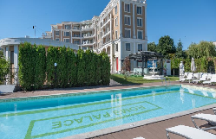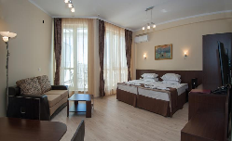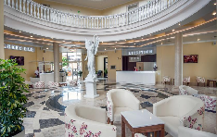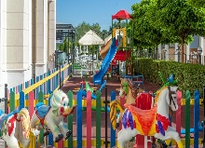
Localizare: cel mai nou hotel; 200 metri plaja
Dotari camera: chichineta;TV, frigider, sofa; balcon; baie cu dus; seif
Facilitati hotel: restaurant, bar, piscina exterioara cu sectiune copii ; bar la piscina, lobby bar; fitness; loc joaca copii;parcare; WI FI
OFERTA LAST MINUTE COD « 112/3.06»
“DISCOUNT 25%”PT REZERVARILE TRIMISE IN PERIOADA 1.06-15.06.2019 SI ACHITATE INTEGRAL IN 24 H-SEJUR IN PERIOADA 1.06-25.08.2019
“DISCOUNT 15%”PT REZERVARILE TRIMISE IN PERIOADA 1.06-15.06.2019 SI ACHITATE INTEGRAL IN 24 H-SEJUR IN PERIOADA 26.08-30.09.2019
*SE POATE COMBINA CU NOPTI GRATUITE
ALL INCLUSIVE | 1.06-15.06  11.09-30.9 | 16.06-5.07  26.08-10.9 | 6.07-25.08
SEJUR MINIM NOPTI | 5 | 5 | 5
LOC IN CAMERA DUBLA | 40 | 52 | 64
CAMERA SINGLE | 58 | 81 | 105,5
LOC IN STUDIO | 43,5 | 56,5 | 70
LOC IN STUDIO SUPERIOR | 47 | 62 | 75,5
LOC IN APART. 2 DORMITOARE | 43,5 | 58,5 | 70
TERMEN DE ANULARE | 12 | 16 | 20
PENALIZARI | 2 | 3 | 4
IN CAMERA DUBLA MAXIM 2 ADULTI
IN STUDIO MAXIM 2 ADULTI + 1 COPIL/ 3 ADULTI
IN STUDIO SUPERIOR MINIM 3 ADULTI- 3 LOCURI INTREGI ;MAXIM 3 ADULTI+ 1 COPIL
IN APARTAMENT 2 DORMITOARE MINIM 4 ADULTI- 4 LOCURI INTREGI ; MAXIM 4 ADULTI+ 2 COPII/5 ADULTI+1 COPIL/6 ADULTI
REDUCERI :
- COPIL ( 0-1.99 ANI ) – GRATUIT, FARA SERVICII
- 1 COPIL ( 2-12.99 ANI ) IN PAT SUPLIM IN STUDIO/DBL- GRATUIT
- AL 2 LEA COPIL( 2-12.99 ANI ) IN PAT SUPLIM IN STUDIO-50%
- 1 COPIL ( 2-11.99 ANI ) IN CAMERA CU 1 ADULT IN DBL/ST–20% REDUCERE
- 2 COPII( 2-11.99 ANI ) IN CAMERA CU 1 ADULT IN ST/AP 1 DORM- FIECARE PLATESTE 50%
- ADULT IN PAT SUPLIMENTAR– 20 % REDUCERE
- ADULT IN PAT NORMAL CU 3 AD IN AP 2 DORM- 50%

APARTHOTEL AVENUE DELUXE 4*/SUNNY BEACH
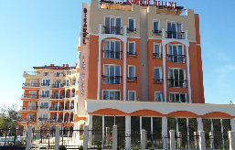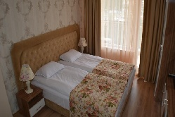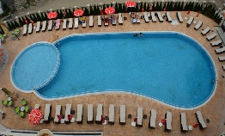

Localizare: la 5 minute pe jos / 300 m de plaja

Dotari camera: TV ecran plat si cablu, baie cu dus;balcon;A/C;

Facilitati hotel: restaurant; bar; lift; piscina;gradina;baie turceasca; baie aburi; masaj;sala fitness;sauna;parcare;WI FI
OFERTA LAST MINUTE COD « TK/1.06»
“DISCOUNT SUPLIMENTAR 10%”PT REZERVARILE TRIMISE IN PERIOADA 1.06- 18.06.2019 SI ACHITATE INTEGRAL IN 24 H-SOSIRI DE LA 16.06 PANA PE 18.06.2019
*SE COMBINA CU DISCOUNT 20%

OFERTA LAST MINUTE COD « VT/3.06; TK/1.06;112/3.06+»
“DISCOUNT 20%”PT REZERVARILE TRIMISE IN PERIOADA 1.06- 30.06.2019 SI ACHITATE INTEGRAL IN 24 H-SEJUR IN PERIOADA 1.06-30.09.2019
ALL INCLUSIVE | 15.09-30.09 | 1.06-15.06  9.09-14.09 | 16.06-3.07  29.08-8.09 | 4.07-28.08
LOC IN CAMERA DUBLA ECONOMY | 23,5 | 27 | 36 | 47,5
CAMERA SINGLE | 46 | 52,5 | 71 | 93,5
LOC IN CAMERA DUBLA | 25,5 | 29 | 39,5 | 51
CAMERA SINGLE | 29 | 37 | 64 | 82
LOC IN CAMERA DUBLA LARGE | 25,5 | 29 | 39,5 | 51
LOC IN CAMERA TRIPLA | 25,5 | 29 | 39,5 | 51
SUITE.1 DORM MAX. 3 ADULTI/ZI* | 71 | 80 | 109,5 | 140
SUITE.1 DORM MAX. 4 ADULTI/ZI* | 87,5 | 98,5 | 133 | 170
SUPLIM. 1-2 COPII CU 3 AD IN AP/DE FIECARE | 6,5 | 7,5 | 10,5 | 12,5
TERMEN DE ANULARE | 6 | 10 | 15 | 20
PENALIZARI | 100% | 100% | 100% | 100%
*TARIFUL ESTE PE APARTAMENT ( 2+1;3;1+2;1+1 PERSOANE)-PERS IN PLUS ACHITA DIFERENTE/ SUPLIMENTE
CAMERA DUBLA ECONOMICA ARE BAIA MAI MICA SI NU ARE BALCON !- MAXIM 2 ADULTI
IN CAMERA DUBLA MAXIM 2 ADULTI
IN CAMERA DUBLA LARGE MAXIM 2 ADULTI+ 2 COPII
IN CAMERA TRIPLA MAXIM 3 ADULTI
IN APARTAMENT MAXIM 3 ADULTI+ 2 COPII/4 ADULTI+ 1 COPIL/5 ADULTI
REDUCERI :
- COPIL (0-1,99 ANI) – GRATUIT, FARA SERVICII
-1 COPIL ( 2-12,99 ANI) IN PAT SUPLIMENTARIN DBL LARGE - GRATUIT
- AL 2 LEA COPIL ( 2-12,99 ANI) IN PAT SUPLIMENTAR IN DBL LARGE -50%
-1 -2 COPII ( 2-12,99 ANI) CU 1 ADULTIN DBL SAU 2 ADULTI IN TRIPLA- FIECARE PLATESTE 50%

HOTEL CLUB RIU HELIOS PARADISE 4*/SUNNY BEACH
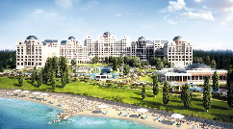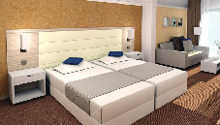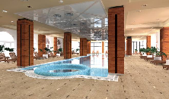

Localizare:este situat direct pe plaja

Dotari camera: aer conditionat, telefon, TV satelit, uscator de par, minibar, balcon,WI FI; seif; balcon sau terasa;;

Facilitati hotel:restaurante cu specific italian, bulgaresc, asiatic; programe divertisment la club; piscina interioara; piscine exterioare adulti/ copii; spa; sauna; jacuzzi;fitness; coafor;

http://www.riu.com/en/Paises/bulgaria/sunnybeach/cluhotel-riu-helios-paradise/index.jsp
OFERTA LAST MINUTE COD « VT/3.06; TK/1.06»
“DISCOUNT 25%”PT REZERVARILE TRIMISE IN PERIOADA 1.06- 30.06.2019 SI ACHITATE INTEGRAL IN 24 H-SEJUR IN PERIOADA 1.06-30.06.2019
“DISCOUNT 25%”PT REZERVARILE TRIMISE IN PERIOADA 1.06- 30.06.2019 SI ACHITATE INTEGRAL IN 24 H-SEJUR IN PERIOADA 1.07-31.08.2019
“DISCOUNT 25%”PT REZERVARILE TRIMISE IN PERIOADA 1.06- 30.06.2019 SI ACHITATE INTEGRAL IN 24 H-SEJUR IN PERIOADA 1.09-SF SEZON
ALL INCLUSIVE | 24.09-15.10 | 1.06-10.06  13.09-23.09 | 11.06-30.06  1.09-12.09 | 01.07-  31.08
LOC IN CAMERA STANDARD | 47 | 66 | 81 | 101
CAMERA SINGLE | 56 | 105,5 | 145 | 180
LOC IN CAMERA VED. MARE | 53 | 72 | 89 | 110
CAMERA SINGLE | 63 | 114,5 | 159,5 | 197
LOC IN CAMERA SUPERIOARA | 53 | 76,5 | 97,5 | 118
LOC IN CAMERA SUPER. SV | 55 | 81 | 105,5 | 129,5
LOC IN CAMERA FAMILY | 57,5 | 89 | 120,5 | 146
FAMILY SUITE 3 ADULTI/ZI* | 178,5 | 281,5 | 361 | 437
TERMEN DE ANULARE | 12 | 16 | 18 | 20
PENALIZARI | 2 | 3 | 3 | 4
IN CAMERA STANDARD MAXIM 2 ADULTI +1 COPIL /3 ADULTI
IN CAMERA SUPERIOARA MAXIM 2 ADULTI +2 COPII /3 ADULTI+1 COPIL
IN CAMERA FAMILY MINIM 2 ADULTI+ 2 COPII; MAXIM 3 ADULTI+ 1 COPIL
IN SUITE MINIM 3 ADULTI; MAXIM 4 ADULTI+ 2 COPII/5 ADULTI
INFANTII CONTEAZA LA GRAD OCUPARE !!!
REDUCERI:
- COPII ( 0-1.99 ANI )– GRATUIT, FARA SERVICII
- 1-2 COPII ( 2-11,99 ANI) CU 1 ADULT IN DBL- FIECARE PLATESTE 75%
- 1 COPIL ( 2-11,99 ANI) CU 1 ADULT IN DBL SUP/FAM/SUITE- FARA REDUCERE
- 1 COPIL ( 2-4.99 ANI )IN PAT SUPLIM. CU 2 ADULTI IN DBL/DBL SUP –GRATUIT
- 2 COPII ( 2-4.99 ANI )IN PAT SUPLIM. CU 2 ADULTI IN FAM- 75% REDUCERE FIECARE
- 2 COPII ( 5-11.99 ANI )IN PAT SUPLIM. CU 2 ADULTI IN FDBL/DBL SUP/FAM- 50%
- 2 COPII ( 2-4.99 ANI )IN PAT SUPLIM. CU 3 ADULTI IN SUITE- 75% REDUCERE FIECARE
- 2 COPII ( 5-11.99 ANI )IN PAT SUPLIM. CU 3 ADULTI IN SUITE- 50% FIECARE
- ADULT IN PAT SUPLIM. IN DBL/DBL SUP/FAM– 20 % REDUCERE
- AL 4 LEA ADULT IN PAT SUPLIMENTAR IN SUITE-20% REDUCERE
- AL 5 LEA ADLT IN SUITE-50%
HOTEL RIU HELIOS 4*+/SUNNY BEACH

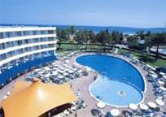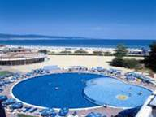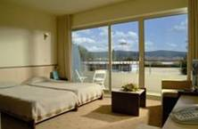

Localizare:este situat in apropriere de plaja in statiunea Sunny Beach

Dotari camera: aer conditionat, telefon, TV satelit, uscator de par, minibar, balcon.

Facilitati hotel:lobby bar, pool bar, bar, salon, 2 piscine in aer liber cu apa dulce si cu o sectiune pentru copii, volei pe plajă, teren de tenis, tenis de masă, mini golf, biliard, sala de fitness, sauna, masaje, ajutor medical 24 de ore/zi, salon de frumusete, frizerie, loc de joaca, club pentru copii, animaţie pentru copii, sala-privat în seif, club de internet, curatatorie, masina de spalat si calcat, sala de conferinte, magazine, parcare păzită, rent-a-car.
OFERTA LAST MINUTE COD « VT/7.06; TK/1.06»
“DISCOUNT 30%”PT REZERVARILE TRIMISE IN PERIOADA 1.06- 30.06.2019 SI ACHITATE INTEGRAL IN 24 H-SEJUR IN PERIOADA 1.06-30.09.2019
ALL INCLUSIVE | 24.09-7.10 | 1.06-10.06  13.09-23.09 | 11.06-30.06  1.09-12.09 | 01.07-  31.08
LOC IN CAMERA ST FARA BALCON | 39 | 56 | 66,5 | 81
CAMERA SINGLE | 46,5 | 89 | 118,5 | 144,5
LOC IN CAMERA ST CU BALCON | 43,5 | 61,5 | 74,5 | 90
CAMERA SINGLE | 52 | 98 | 132,5 | 161
LOC IN CAMERA SV CU BALCON | 49 | 67 | 81 | 100
CAMERA SINGLE | 59 | 106,5 | 144,5 | 179
LOC IN APARTAMENT | 53,5 | 83 | 105,5 | 136
TERMEN DE ANULARE | 12 | 16 | 18 | 20
PENALIZARI | 2 | 3 | 3 | 4
IN CAMERA FARA BALCON MAXIM 2 ADULTI +1 COPIL /3 ADULTI
IN CAMERA CU BALCON MAXIM 2 ADULTI +2 COPII /3 ADULTI
IN CAMERA VED. MARE MAXIM 2 ADULTI +2 COPII /3 ADULTI
IN APARTAMENT MINIM 2 ADULTI+ 2 COPII/ MAXIM 3 ADULTI+ 1 COPIL
INFANTII CONTEAZA LA GRAD OCUPARE !!!
REDUCERI:
- COPII ( 0-1.99 ANI )– GRATUIT, FARA SERVICII
- 1 COPIL ( 2-4,99 ANI )IN PAT SUPLIMENTAR CU 2 ADULTI –GRATUIT
- 1 COPIL ( 5-11,99 ANI) IN PAT SUPLIMENTAR CU 2 ADULTI - 50%
- AL 2 –LEA COPIL ( 2-11.99 ANI ) IN PAT SUPLIMENTAR CU 2 ADULTI - 50%
- 1- 2 COPII ( 2-11.99 ANI ) CU 1 ADULT IN DBL – FIECARE PLATESTE 75%
- ADULT IN PAT SUPLIMENTAR – 20 % REDUCERE

HOTEL LAGUNA PARK 4*/SUNNY BEACH
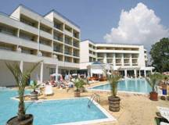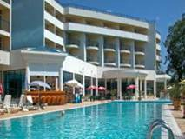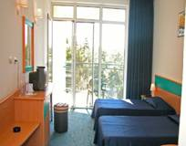
Localizare:la 150 m distanta fata de plaja.
Dotari camera: baie proprie, uscator de par, telefon, TV satelit, aer conditionat, minibar.
Facilitati hotel: 2 restaurante cu terasa, snack bar, bar la piscina, piscina exterioara, piscina pentru copii, jacuzzi, sala de fitness, masaj, club de noapte, coafor, magazin, casa de schimb valutar, teren de joaca pt copii.
NOU: MINI AQUAPARK
OFERTA LAST MINUTE COD « 115/3.06»
MINIM STAY 3 NOPTI IN PERIOADA 3.07-28.08.2019
ALL INCLUSIVE | 3.07-28.08
SEJUR MINIM NOPTI | 3
LOC IN CAMERA DUBLA | 74,5
CAMERA SINGLE | 111
LOC IN DUBLA SUPERIOARA | 77,5
LOC IN APARTAMENT 1 DORM. | 80
LOC IN MAISONETTE | 79
TERMEN DE ANULARE | 18
PENALIZARI | 4

OFERTA LAST MINUTE COD « TK/1.06 ; VT 07.06»
“DISCOUNT 15%”PT REZERVARILE TRIMISE IN PERIOADA 1.06- 20.06.2019 SI ACHITATE INTEGRAL IN 24 H-SEJUR IN PERIOADA 1.06-20.06.2019
ALL INCLUSIVE | 03.06-20.06
LOC IN CAMERA DUBLA | 57,5
CAMERA SINGLE | 85,5
LOC IN DUBLA SUPERIOARA | 61
LOC IN APARTAMENT 1 DORM. | 63
LOC IN MAISONETTE | 62
TERMEN DE ANULARE | 14
PENALIZARI | 3
IN CAMERA DUBLA MAXIM 2 ADULTI+2 COPII /3 ADULTI
IN CAMERA DUBLA SUPERIOARA MINIM 2 ADULTI+ 2 COPII/3 ADULTI; MAXIM 3 ADULTI+1 COPIL/4 ADULTI
IN APARTAMENT MINIM 2 ADULTI+2 COPII/ SE TAXEAZA 3 PATURI NORMALE; MAXIM 3 ADULTI+ 1 COPIL/4 ADULTI
IN MAISONETTE MINIM 2 ADULTI+ 2 COPII/ SE TAXEAZA 4 PATURI NORMALE; MAXIM 4 ADULTI+2 COPII/5 ADULTI+ 1 COPIL
REDUCERI :
- COPIL ( 0-1.99 ANI )– 5 € LA RECEPTIE/ PATUT/ZI
- 1 COPIL ( 2-11.99 ANI ) IN CAMERA CU 2 ADULTI IN DBL STANDARD – GRATUIT
- 2 COPII ( 2-11.99 ANI ) IN CAMERA CU 2 ADULTI IN DBL SUP/MAISONETTE/AP– FIECARE PLATESTE 50%
- COPII( 2-11.99 ANI )IN PAT SUPLIMENTAR IN APART/MAISONETTE- 50%
- 1 COPIL ( 2-11.99 ANI ) CU 1 ADULT IN CAMERA - FARA REDUCERE
- 2 COPII ( 2-11.99 ANI ) CU 1 ADULT IN CAMERA – FIECARE PLATESTE 50 %
- ADULT IN PAT SUPLIMENTAR IN DBL STANDARD –20 % REDUCERE
- AL 3 LEA AD IN PAT SUPLIM IN DBL SUP/AP- FARA REDUCERE
- AL 4 LEA ADULT IN PAT SUPLIM IN DBL SUP/ AP- 20% REDUCERE
- AL 3 LEA SI AL 4 LEA AD IN PAT NORMAL IN MAISONETTE- FARA REDUCERE
- AL 2 LEA AD IN PAT SUPLIM IN MAISONETTE- 20% REDUCERE

I HOTEL 4*( EX STRANDJA)/SUNNY BEACH
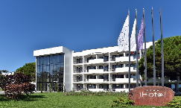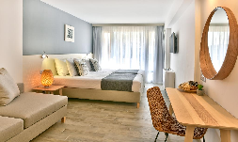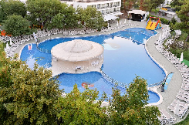
Localizare: in nordul statiunii, la 150 m de plaja
Dotari camera: mobiliar modern; TV, telefon, frigider, balcon; baie cu dus;A/C
Facilitati hotel: restaurant, bar, lift; piscina exterioara cu sestiune copii, aqua bar, piscina interioara;club de noapte;terasa ;sala fitness;masaj; sauna;loc joaca copii;WI FI;parcare
OFERTA LAST MINUTE COD « 114/3.06»
“DISCOUNT 30%”PT REZERVARILE TRIMISE IN PERIOADA 3.06- 3.07.2019 SI ACHITATE INTEGRAL IN 24 H-SEJUR IN PERIOADA 3.06-3.07.2019
ALL INCLUSIVE | 3.06-15.06 | 16.06-3.07
LOC IN CAMERA DUBLA | 52,5 | 67,5
CAMERA SINGLE | 68 | 87,5
LOC IN CAMERA FAMILY/PATURI SUPRAPUSE | 66 | 84
LOC IN CAMERA FAMILY SV | 81,5 | 100,5
TERMEN DE ANULARE | 16 | 20
PENALIZARI | 3 | 4
IN CAMERA DUBLA MAXIM 2 ADULTI + 1 COPIL/ 3 ADULTI
IN CAMERA FAMILY/PATURI SUPRAPUSE MAXIM 2 ADULTI+ 2 COPII
IN CAMERA FAMILY SV MAXIM 2 ADULTI+ 2 COPII/3 ADULTI+ 1 COPIL/4 ADULTI
REDUCERI :
- COPIL ( 0-1.99 ANI ) – GRATUIT, FARA SERVICII
- 1 COPIL ( 2-11.99 ANI ) IN PAT SUPLIM CU 2 ADULTI IN DBL GRATUIT
- 2 COPII ( 2-11.99 ANI ) IN PAT SUPLIM CU 2 ADULTI IN FAMILY- FIECARE COPIL PLATESTE SUPLIMENT 3 €/ZI
- 1 COPIL ( 2-11.99 ANI ) IN PAT SUPLIM CU 3 ADULTI IN FAMILY- PLATESTE SUPLIMENT 3 €/ZI
- 1 -2 COPII ( 2-11.99 ANI ) IN CAMERA CU 1 ADULT–FIECARE PLATESTE 50 %
- ADULT IN PAT SUPLIMENTAR IN DBL– 25 % REDUCERE
- AL 3 LEA ADULT IN PAT SUPLIMENTAR IN FAMILY– 60 % REDUCERE

HOTEL TRAKIA PLAZA 4*/SUNNY BEACH
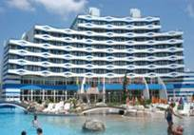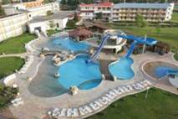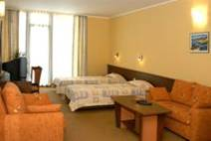
Localizare: la 200 m de plaja
Dotari camera:A/C, TV, telefon, mini-bar, balcon, baie cu dus
Facilitati hotel: sauna, salon masaj, sala fitness, piscina, jacuzzi, http://www.burgasbeach.com/
OFERTA LAST MINUTE COD « 110/1.06;VT/31.05; TK/1.06»
“DISCOUNT 10%”PT REZERVARILE TRIMISE IN PERIOADA 1.06-30.06.2019 SI ACHITATE INTEGRAL IN 24 H
*SE POATE COMBINA CU NOPTI GRATUITE
ALL INCLUSIVE | 16.09-30.09 | 1.06-15.06  7.09-15.09 | 16.06-3.07  25.08-06.09 | 4.07-  24.08
LOC IN CAMERA DUBLA | 27 | 33,5 | 47,5 | 57,5
CAMERA SINGLE | 34,5 | 43 | 61 | 85,5
TERMEN DE ANULARE | 12 | 16 | 18 | 20
PENALIZARI | 2 | 3 | 3 | 4

OFERTA LAST MINUTE COD « VT/22.04; TK/24.04; 081/23.04»
1 NOAPTE GRATUITA PT SEJUR 7-13 NOPTI SOSIRI PANA PE 5.06.2019
ALL INCLUSIVE | 01.05-31.05  16.09-30.09 | 1.06-15.06  7.09-15.09 | 16.06-3.07  25.08-06.09 | 4.07-  24.08
LOC IN CAMERA DUBLA | 27 | 33,5 | 47,5 | 57,5
CAMERA SINGLE | 34,5 | 43 | 61 | 85,5
TERMEN DE ANULARE | 12 | 16 | 18 | 20
PENALIZARI | 2 | 3 | 3 | 4
IN CAMERA DUBLA MAXIM 2 ADULTI + 2 COPII/ 3 ADULTI
REDUCERI :
- COPII ( 0-1.99 ANI )– GRATUIT, FARA SERVICII( PATUT LA CERERE RECEPTIE)
- 1 COPIL ( 2-12.99 ANI ) IN CAMERA CU 2 ADULTI –GRATUIT
- AL 2-LEA COPIL ( 2-11.99 ANI ) IN CAMERA CU 2 ADULTI – 50%
- 1-2 COPII ( 2-12.99 ANI ) CU 1 ADULT– FIECARE PLATESTE 50 %
- ADULT IN PAT SUPLIMENTAR IN DBL –25 % REDUCERE

HOTEL HRIZANTEMA 4*/SUNNY BEACH
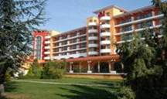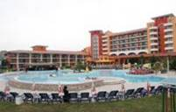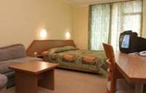
Localizare:120 m de plaja ; in zona centrala a statiuni
Dotari camera: tv, telefon, aer conditionat, baie uscator de par, frigider (mini-bar), balcon
Facilitati hotel: restaurant, lobby bar, pool bar, piscina exterioara cu sectiune pentru copii, birou de schimb valutar, seif , seif la receptie, magazine, masaj, sala de fitness, parcare http://www.burgasbeach.com/
OFERTA LAST MINUTE COD « TK/1.06»
“DISCOUNT 10%”PT REZERVARILE TRIMISE IN PERIOADA 1.06-15.06.2019 SI ACHITATE INTEGRAL IN 24 H-SOSIRI IN PERIOADA 21.06-30.09.2019
“DISCOUNT 20%”PT REZERVARILE TRIMISE IN PERIOADA 1.06-15.06.2019 SI ACHITATE INTEGRAL IN 24 H-SOSIRI IN PERIOADA 1.06-20.06.2019
ALL INCLUSIVE | 1.06-5.06  7.09-30.09 | 6.06-20.06 | 21.06-3.07  25.08-6.09 | 4.07-  24.08
LOC IN CAMERA DUBLA | 28 | 37 | 47,5 | 57,5
CAMERA SINGLE | 36 | 47,5 | 61 | 85,5
TERMEN DE ANULARE | 14 | 16 | 20 | 20
PENALIZARI | 3 | 3 | 4 | 4

OFERTA LAST MINUTE COD « VT/31.05;110/1.06»
“DISCOUNT 10%”PT REZERVARILE TRIMISE IN PERIOADA 1.06-30.06.2019 SI ACHITATE INTEGRAL IN 24 H
ALL INCLUSIVE | 7.09-30.10 | 21.06-3.07  25.08-6.09 | 4.07-  24.08
LOC IN CAMERA DUBLA | 28 | 47,5 | 57,5
CAMERA SINGLE | 36 | 61 | 85,5
TERMEN DE ANULARE | 14 | 20 | 20
PENALIZARI | 3 | 4 | 4
IN CAMERA DUBLA MAXIM 2 ADULTI+ 2 COPII/ 3 ADULTI
REDUCERI :
- COPII ( 0-1.99 ANI )– GRATUIT, FARA SERVICII(PATUT 5 LEVA/ZI)
- 1 COPIL ( 2-12.99 ANI ) IN CAMERA CU 2 ADULTI –GRATUIT
- AL 2-LEA COPIL ( 2-12.99 ANI ) IN CAMERA CU 2 ADULTI – 50%
- 1-2 COPII ( 2-12.99 ANI ) CU 1 ADULT IN CAMERA – FIECARE PLATESTE 50 %
- ADULT IN PAT SUPLIMENTAR –25 % REDUCERE
“EARLY BOOKING -20%”PT REZERVARILE TRIMISE PANA PE 28.02.2019 SI ACHITATE INTEGRAL PANA PE 5.03.2019
“EARLY BOOKING -10%”PT REZERVARILE TRIMISE PANA PE 31.03.2019 SI ACHITATE INTEGRAL PANA PE 5.04.2019

HOTEL IBEROSTAR SUNNY BEACH 4*+
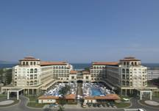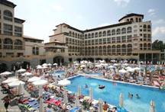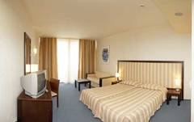
Localizare: aproape de plaja
Dotari camera:telefon, aer conditionat si incalzire, cablu TV, minibar, uscator de par
Facilitati hotel: restaurante principale cu bucatarie traditional bulgareasca si internationala, centru fitness cu echipament Technogym, jacuzzi, solar, sauna si masaj
OFERTA LAST MINUTE COD « VT/22.04;TK/24.04; 081/23.04»RUSALII
“DISCOUNT 30%”PT REZERVARILE TRIMISE IN PERIOADA 2.05-12.06.2019 SI ACHITATE INTEGRAL IN 24 H-SEJUR IN PERIOADA 23.04-12.06.2016
“DISCOUNT 20%”PT REZERVARILE TRIMISE IN PERIOADA 2.05-12.07.2019 SI ACHITATE INTEGRAL IN 24 H-SEJUR IN PERIOADA 23.04-12.07.2019
ALL INCLUSIVE | 1.05-25.05 | 26.5-12.06 | 13.6-29.06 | 30.06–  12.07
SEJUR MINIM / NOPTI | 7 | 7 | 7 | 7
LOC IN CAMERA VED. PARC | 41,5 | 54,5 | 71 | 83,5
CAMERA SINGLE | 49 | 72,5 | 93,5 | 125
LOC IN CAMERA VED. LATERALA MARE | 44,5 | 59 | 75,5 | 90
CAMERA SINGLE | 88,5 | 117,5 | 149,5 | 178,5
LOC IN CAMERA VED. PISCINA | 44,5 | 59 | 74,5 | 89
CAMERA SINGLE | 88,5 | 117,5 | 147 | 176
LOC IN CAMERA TRIPLA | 41,5 | 55 | 71 | 83,5
LOC IN CAMERA TRIPLA VED. PISCINA | 44,5 | 59 | 74,5 | 89
LOC IN JUNIOR SUITE VED. PARK | 44,5 | 59 | 76,5 | 90
LOC IN FAMILY V. PARC | 44,5 | 59 | 76,5 | 90
LOC IN FAMILY VED. PISCINA | - | - | 80 | 95,5
TERMEN DE ANULARE | 12 | 14 | 18 | 20
PENALIZARI | 2 | 3 | 3 | 4
*CAMERELE SSV AU VEDERE LIMITATA LA MARE DE VEGETATIE SI POZITIE !
IN CAMERA DUBLA PV MAXIM 2 ADULTI+1 COPIL/3 ADULTI
IN CAMERA DUBLA SS MAXIM 2 ADULTI+ 2 COPII/3 ADULTI+ 1 COPIL
IN CAMERA TRIPLA MINIM 2 ADULTI+ 2 COPII/MAXIM 3 ADULTI+ 1 COPIL/4 ADULTI
IN JUNIOR MINIM 3 ADULTI SAU 2 ADULTI+ 2 COPII ;MAXIM 3 ADULTI+2 COPII/ 5 ADULTI
IN FAMILY MINIM 2 ADULTI+2 COPII/3 ADULTI ;MAXIM 3 ADULTI+ 2 COPII/5 ADULTI
REDUCERI :
- COPII ( 0-1,99 ANI ) – GRATUIT, FARA SERVICII
- 1COPIL ( 2-12,99 ANI ) CU 1 ADULT IN DBL - 30% REDUCERE
- AL 2 LEA COPIL( 2-12,99 ANI ) CU 1 ADULT IN DBL -70% REDUCERE
- 1 COPIL ( 2-12,99 ANI ) IN PAT SUPLIMENTAR IN CAMERA– GRATUIT
- 1 COPIL ( 2-12,99 ANI ) IN PAT SUPLIM. CU 2 AD IN TRIPLA- 50%
- AL 2 LEA COPIL ( 2-12,99 ANI ) IN PAT SUPLIM. CU 2 AD IN TRIPLA-GRATUIT
- 1 -2 COPII ( 2-12,99 ANI ) IN PAT SUPLIM. IN JUNIOR/FAMILY –FIECARE PLATESTE 50%
- ADULT IN PAT SUPLIMENTAR – 25 % REDUCERE
HOTEL MARVEL 4*+/SUNNY BEACH
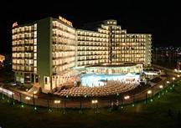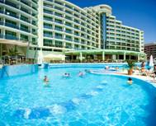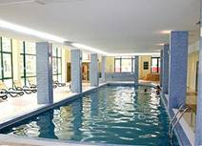

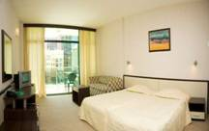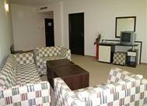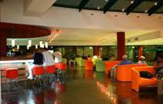
Localizare:in partea de nord a statiunii Sunny Beach, 180 m de plaja.
Dotari camera:aer conditionat, balcon, baie, tv cu program prin satelit, telefon si mini bar.
Facilitati hotel: piscina exterioara, cu ,sectiune pentru copii, 2 baruri la piscina, restaurant, bufet, restaurant a la carte, terasa pentru servirea mesei langa piscina, lobby - bar, parcare, lift, room service, casa de schimb valutar, seif la receptie, coafor, magazin de suveniruri, supermarket non stop, salon cu jocuri electronice, sala pentru tenis de masa, centru medical cu piscina interioara, sala masaj si sala de fitness, solar, sauna, jacuzzi
OFERTA LAST MINUTE COD « TK/1.06»
“DISCOUNT 20%”PT REZERVARILE TRIMISE IN PERIOADA 1.06-15.06.2019 SI ACHITATE INTEGRAL IN 24 H-SEJUR IN PERIOADA 1.06-6.07.2019
“DISCOUNT 15%”PT REZERVARILE TRIMISE IN PERIOADA 1.06-15.06.2019 SI ACHITATE INTEGRAL IN 24 H-SEJUR IN PERIOADA 12.07-15.10.2019
ALL INCLUSIVE | 1.06- 7.06  7.09- 5.10 | 8.06-13.07  24.08-6.09 | 14.07-23.08
LOC IN CAMERA DUBLA | 41,5 | 55,5 | 65,5
CAMERA SINGLE | 61,5 | 82 | 97,5
LOC IN CAMERA DUBLA VED. MARE | 44,5 | 58,5 | 69
CAMERA SINGLE | 66,5 | 87 | 102,5
LOC IN STUDIO | 47 | 61 | 71
STUDIO SINGLE | 93 | 120 | 140,5
LOC IN APART. 1 DORMITOR | 52,5 | 66,5 | 76,5
TERMEN DE ANULARE | 12 | 18 | 18
PENALIZARI | 2 | 4 | 4
TARIFUL INCLUDE 1 UMBRELA SI 2 SEZLONGURI/CAMERA- PE PLAJA IN LIMITA DISPONIBILITATI
IN CAMERA DUBLA MAXIM 2 ADULTI+2 COPII/3 ADULTI
IN STUDIO MAXIM 2 ADULTI+3 COPII/3 ADULTI+1 COPIL
IN APARTAMENT MAXIM 2 ADULTI+ 3 COPII/ 3 ADULTI+ 1 COPIL
REDUCERI :
- COPIL ( 0-1,99 ANI )– GRATUIT, FARA SERVICII
- 1 COPIL ( 2-12,99 ANI ) IN PAT SUPLIMENTAR CU 2 ADULTI – GRATUIT
- AL 2 LEA SI AL 3 LEA COPIL ( 2-11,99 ANI ) IN PAT SUPLIM. - 50%
- 1 COPIL ( 2-12,99 ANI ) CU 1 ADULT IN DBL – 50%; FARA REDUCERE SEZON VARF
- 2 COPII( 2-12,99 ANI ) IN DBL CU 1 ADULT- FIECARE PLATESTE 50%
- ADULT IN IN PAT SUPLIMENTAR – 30 % REDUCERE

HOTEL NOBEL 4*+SUNNY BEACH
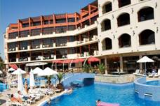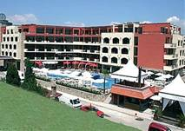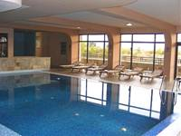

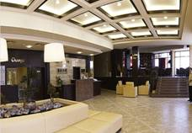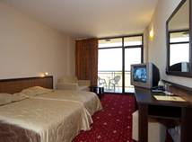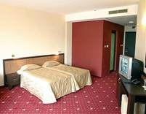
Localizare:la aproximativ 200 m de plaja.
Dotari camera: telefon direct, aer conditionat, frigider, balcon si TV satelit.
Facilitati hotel: piscina exterioara cu sectiune pentru copii, (sezlongurile si umbrele contra cost), piscina interioara, fitness, sauna, jacuzzi, tenis de masa, biliard, casa de schimb valutar si lobby bar.
OFERTA LAST MINUTE COD « TK/1.06 ; VT 07.06»
“DISCOUNT 20%”PT REZERVARILE TRIMISE IN PERIOADA 1.06-15.06.2019 SI ACHITATE INTEGRAL IN 24 H-SEJUR IN PERIOADA 1.06-6.07.2019
ULTRA ALL INCLUSIVE | 8.06-6.07
LOC IN CAMERA DUBLA | 63
CAMERA SINGLE | 94
LOC IN CAMERA DUBLA VED. MARE | 66,5
CAMERA SINGLE | 99
LOC IN STUDIO | 69
STUDIO SINGLE | 136
LOC IN APARTAMENT | 74,5
TERMEN DE ANULARE | 16
PENALIZARI | 3
TARIFUL INCLUDE 1 UMBRELA SI 2 SEZLONGURI/CAMERA- PE PLAJA IN LIMITA DISPONIBILITATI
IN CAMERA DUBLA MAXIM 2 ADULTI +2 COPII /3 ADULTI
IN STUDIO/ APARTAMENT MAXIM 2 ADULTI+ 2 COPII / 3 ADULTI +1 COPIL
IN APARTAMENT MAXIM 2 ADULTI+ 2 COPII / 3ADULTI +1 COPIL
REDUCERI :
- COPIL ( 0-1,99 ANI )– GRATUIT, FARA SERVICII
- 1 COPIL ( 2-12,99 ANI ) IN PAT SUPLIMENTAR– GRATUIT
- AL 2 LEA COPIL ( 2-12,99 ANI ) IN PAT SUPLIMENTAR - 50%
- 1 COPIL ( 2-12,99 ANI ) CU 1 ADULT IN DBL - 50%; FARA REDUCERE SEZON VARF
- 2 COPII( 2-12,99 ANI ) CU 1 ADULT IN DBL - FIECARE PLATESTE 50%
- ADULT IN IN PAT SUPLIMENTAR – 30 % REDUCERE

HOTEL PALAZZO RESIDENCE 4*/SUNNY BEACH
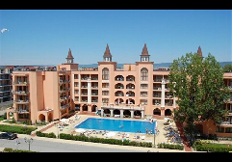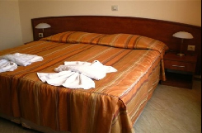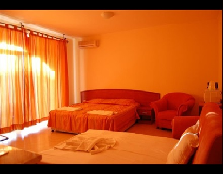

Localizare: la 300 m de plaja

Dotari camera: TV ;A/C; chicineta;canapea extensibila;baie;uscator par;balcon;mini bar

Facilitati hotel: restaurant; piscina;parcare;terasa;bar;spa;masaj;coafor
OFERTA LAST MINUTE COD « TK 10.06; 122/08.06 ; VT06.06»
ALL INCLUSIVE | 21.06-04.07 | 05.07-31.07
LOC IN CAMERA FAMILY | 31 | 42
CAMERA SINGLE | 47.5 | 64,5
TERMEN DE ANULARE | 14 | 18
PENALIZARI | 100% | 100%
IN CAMERA FAMILY MINIM 2 ADULTI; MAXIM 3 ADULTI+1 COPIL/4 ADULTI
REDUCERI :
- COPIL (0-1,99 ANI) – GRATUIT, FARA SERVICII
-1-2 COPII ( 2-11,99 ANI) CU 1 ADULT- FIECARE PLATESTE 50%
- 1 COPIL ( 2-11,99 ANI) CU 2 ADULTI IN PAT SUPLIMENTAR –GRATUIT
- AL 2 LEA COPIL ( 2-11,99 ANI) CU 2 ADULTI IN PAT SUPLIMENTAR-GRATUIT
- AL 3 LEA ADUNT IN PAT SUPLIMENTAR- 20% REDUCERE
- AL 4 LEA ADULT IN PAT SUPLIMENTAR- 50%

OFERTA LAST MINUTE COD « VT/21.05»
VALABIL PT REZERVARILE TRIMISE DE LA 22.05.2019 SI ACHITATE INTEGRAL IN 24 H
2 +2 = 2
ALL INCLUSIVE | 22.05-5.06  15.9-30.09 | 6.06-20.06  6.09-14.09 | 21.06-707  26.08-5.09 | 5.07-25.08
LOC IN CAMERA FAMILY | 28 | 30,5 | 42 | 53
CAMERA SINGLE | 43,5 | 56,5 | 80 | 91
TERMEN DE ANULARE | 6 | 10 | 15 | 20
PENALIZARI | 100% | 100% | 100% | 100%
IN CAMERA FAMILYMINIM 2 ADULTI; MAXIM 3 ADULTI+1 COPIL/4 ADULTI
REDUCERI :
- COPIL (0-1,99 ANI) – GRATUIT, FARA SERVICII
-1-2 COPII ( 2-11,99 ANI) CU 1 ADULT- FIECARE PLATESTE 50%
- 1 COPIL ( 2-11,99 ANI) IN PAT SUPLIMENTAR –GRATUIT
- AL 2 LEA COPIL ( 2-11,99 ANI) IN PAT SUPLIMENTAR-GRATUIT
- AL 3 LEA ADUNT IN PAT SUPLIMENTAR- 20% REDUCERE
- AL 4 LEA ADULT IN PAT SUPLIMENTAR- 50%

HOTEL MERCURY 4*+/SUNNY BEACH
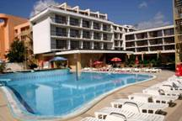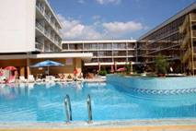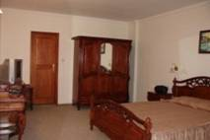
Localizare: Hotelul este situat in Sunny Beach, la 90 m de plaja.
Dotari camere: Aer conditionat, telefon, TV, mini bar, frigider, baie, uscator de par, balcon.
Facilitati hotel: Aer conditionat, room service, spalatorie, acces la internet, loc de joaca pentru copii, parcare exterioara, restaurant, bar, disco, lobby bar, pool bar, piscin exterioara, sala de fitness, masaj.
http://www.mercurysunnybeach.com
OFERTA LAST MINUTE COD « 121/06.06 ; TK 10.06 ; VT 06.06»
VALABIL PT REZERVARILE TRIMISE DE LA 07.06.2019 SI ACHITATE IN 24 H
ALL INCLUSIVE PREMIUM | 21.06-30.06
LOC IN CAMERA DUBLA | 38.5
CAMERA SINGLE | 55,5
LOC IN CAMERA DELUXE EXECUTIVE | 41
CAMERA SINGLE | 58
LOC IN APART. DELUXE EXECUTIVE | 45,5
TERMEN DE ANULARE | 14
PENALIZARI | 100%

OFERTA LAST MINUTE COD « 070/4.04»
VALABIL PT REZERVARILE TRIMISE DE LA 4.04.2019 SI ACHITATE IN 24 H
ALL INCLUSIVE PREMIUM | 6.06-13.06
LOC IN CAMERA DUBLA | 27
CAMERA SINGLE | 40
LOC IN CAMERA DELUXE EXECUTIVE | 29
CAMERA SINGLE | 57
LOC IN APART. DELUXE EXECUTIVE | 34,5
TERMEN DE ANULARE | 16
PENALIZARI | 3
IN CAMERA DUBLA MAXIM 2 ADULTI+2 COPII/ 3 ADULTI
IN CAMERA DUBLA DELUXE MAXIM 2 ADULTI+2 COPII/ 3 ADULTI
IN APARTAMENT MAXIM 2 ADULTI+2 COPII/ 3 ADULTI
REDUCERI :
- COPIL ( 0-1,99 ANI )– GRATUIT, FARA SERVICII
- 1 COPIL ( 2-11, 99 ANI ) IN PAT SUPLIM. CU 2 ADULTI - GRATUIT
- AL 2 LEA COPIL ( 2-11, 99 ANI ) IN PAT SUPLIM. CU 2 ADULTI - 50%
- 1-2 COPII ( 2-11, 99 ANI ) CU 1 ADULT–FIECARE PLATESTE 50 %
- ADULT IN CAMERA IN PAT SUPLIMENTAR – 30 % REDUCERE
HOTEL KOTVA 4*SUNNY BEACH
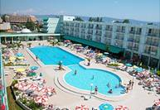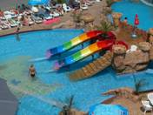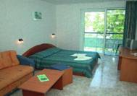
Localizare:situat in partea de sud a statiunii, la 180 m de plaja
Dotari camera: TV, frigider, telefon, balcon; baie cu dus
Facilitati hotel: restaurant, salon tv, magazin, cabinet medical, piscina exterioara cu bar si mini Aqua park. WWW.KOTVA-BG.COM
OFERTA LAST MINUTE COD « 121/06.06 »
“DISCOUNT 15%”PT REZERVARILE TRIMISE IN PERIOADA 07.06-07.07.2019 SI ACHITATE INTEGRAL IN 24 H-SOSIRI IN PERIOADA 19.06-30.09.2019
*NU SE COMBINA CU ALTE OFERTE
MIC DEJUN | 15.05-5.06  8.09-30.09 | 6.06-19.06 | 20.06 –4.07  24.08-7.09 | 5.07-23.08
LOC IN CAMERA DUBLA | 14,5 | 23,5 | 33 | 46,5
CAMERA SINGLE | 23,5 | 34,5 | 48,5 | 69
APART. 1 DORM. MAXIM 3 ADULTI+1 COPIL /ZI * | 43,5 | 70,5 | 101 | 140
ALL INCLUSIVE | 15.05-5.06  8.09-30.09 | 6.06-19.06 | 20.06 –4.07  24.08-7.09 | 5.07-23.08
LOC IN CAMERA DUBLA | 30 | 38 | 53 | 69
CAMERA SINGLE | 44,5 | 56 | 79 | 102,5
APART. 1 DORM. MAXIM 3 ADULTI+1 COPIL /ZI * | 90,5 | 114 | 160 | 207
TERMEN DE ANULARE | 12 | 16 | 18 | 18
PENALIZARI | 2 | 3 | 4 | 4
*TARIFUL ESTE PE APARTAMENT / ZI, NR PERSOANE INDICATE IN TABEL
TARIFUL INCLUDE 3 PISCINE- MINI AQUA PARK; WI FI
IN CAMERA DUBLA MAXIM 2 ADULTI+2 COPII/ 3 ADULTI
PARCARE 5 €/ZI
REDUCERI:
- COPIL ( 0-1.99 ANI ) – GRATUIT, FARA SERVICII
- 1 COPIL ( 2-5,99 ANI ) IN PAT SUPLIM CU 2 ADULTI–GRATUIT
- 1 COPIL ( 6-11,99 ANI) IN PAT SUPLIM CU 2 ADULTI-50%
- AL 2 LEA COPIL ( 2-11,99 ANI ) IN PAT SUPLIM CU 2 ADULTI- 50%(TOTDEUNA CEL MAI VASTNIC E CONSIDERAT AL 2 LEA )
- 1 COPIL ( 2-11.99 ANI ) CU 1 ADULT IN CAMERA –50 % IN PER. A/B/C
- 1 COPIL ( 2-11.99 ANI ) CU 1 ADULT IN CAMERA –PLATESTE 80 % IN VARF SEZON
- 2 COPII ( 2-11.99 ANI) CU 1 ADULT IN CAMERA –FIECARE PLATESTE 50 %
- ADULT IN PAT SUPLIMENTAR– 20 % REDUCERE

HOTEL KAROLINA 4*SUNNY BEACH

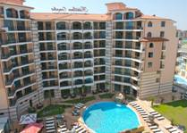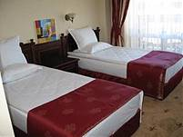

Localizare: pe coasta bulgară Mării Negre în staţiunea Sunny Beach, la 50m de plaja

Dotari camera: baie, bucatarie cu dulapuri şi aer condiţionat incluse în preţ.

Facilitati hotel: restaurant, bar http://www.karolinacomplex.com
OFERTA LAST MINUTE COD « VT 07.06 »
“DISCOUNT 10%”PT REZERVARILE TRIMISE IN PERIOADA 10.06-30.06.2019 SI ACHITATE INTEGRAL IN 24 H-SEJUR IN PERIOADA 03.06-29.092019
* SE COMBINA CU ALTE OFERTE
MIC DEJUN | 24.05-10.06  11.09-30.09 | 11.06-09.7  28.08-10.9 | 10.07-  27.08
LOC IN CAMERA DUBLA | 20 | 29,5 | 36
CAMERA SINGLE | 29 | 53 | 71
LOC IN STUDIO | 22 | 32 | 38,5
LOC IN JUNIOR SUITE | 22 | 32 | 38,5
APART. 1 DORM. 2 ADULTI/+2 COPII/3 ADULTI+1 COPIL/ZI* | 59,5 | 89,5 | 107,5
SUPLIMENT CINA ADULT/COPIL | 9/6 | 9/6 | 9/6
TERMEN DE ANULARE | 9 | 14 | 16
PENALIZARI | 2 | 3 | 4
* TARIFUL ESTE PT TIP CAMERA, NR PERSOANE INDICATE IN TABEL
IN CAMERA DUBLA , MAXIM 2 ADULTI
IN STUDIO ( CORP APARTAMENTE)-CU BUCATARIE/ MAXIM 2 ADULTI+ 2 COPII/ 3 ADULTI
IN JUNIOR SUITE ( CORP HOTEL )-FARA BUCATARIE/MAXIM 2 ADULTI+ 2 COPII/ 3 ADULTI
IN APARTAMENT( CORP APARTAMENTE)- CU BUCATARIE MAXIM 2 ADULTI+ 2 COPII/ 3 ADULTI+ 1 COPIL
REDUCERI :
- COPIL ( 0-1.99 ANI ) – GRATUIT, FARA SERVICII
- 1COPII ( 2-12.99 ANI ) IN DBL CU 1 ADULT ( IN DBL)– FARA REDUCERE
- 1 COPIL ( 2-12.99 ANI ) IN PAT SUPLIMENTAR– GRATUIT
- AL 2-LEA COPIL ( 2-12.99 ANI ) CU 2 ADULTI IN STUDIO/JUNIOR - 50 %
- ADULT IN PAT SUPLIMENTAR IN STUDIO/JUNIOR–20 % REDUCERE
NOPTI GRATUITE PT SOSIRI PANA PE 10.06 SI DIN 11.09.2019-DUPA EXPIRARE EARLY BOOKING
1)1 NOAPTE GRATUITA PT SEJUR 7-13 NOPTI
2)2 NOPTI GRATUITE PT SEJUR 14-20 NOPTI
3) 3 NOPTI GRATUITE PT SEJUR DE LA 21 NOPTI

HOTEL DIAMOND 4*/SUNNY BEACH
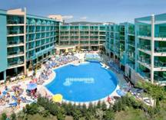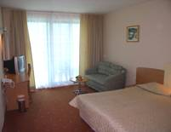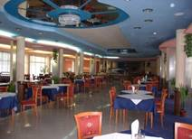
Localizare: la aproximativ 250 metri de plaja, in centrul statiunii
Dotari camera:aer conditionat, uscator de par, telefon, tv satelit, balcon.
Facilitati hotel: restaurant, cafenea, piscina exterioara cu sectiune pentru copii, bar la piscina, centru spa cu sauna, solar, baie turceasca, minimarket, biliard, internet.
OFERTA LAST MINUTE COD « TK/17.05»RUSALII
“DISCOUNT 15%”PT REZERVARILE TRIMISE IN PERIOADA 17.05-16.08.2019 SI ACHITATE INTEGRAL IN 24 H-SEJUR IN PERIOADA 16.08-21.08.2019
“DISCOUNT 15%”PT REZERVARILE TRIMISE IN PERIOADA 17.05-1.09.2019 SI ACHITATE INTEGRAL IN 24 H- SEJUR IN PERIOADA 1.09-7.09.2019*SE POATE COMBINA CU NOPTI GRATUITE
“DISCOUNT 10%”PT REZERVARILE TRIMISE IN PERIOADA 17.05-24.06.2019 SI ACHITATE INTEGRAL IN 24 H- SEJUR IN PERIOADA 11.06-24.06.2019*SE POATE COMBINA CU NOPTI GRATUITE
ALL INCLUSIVE | 1.5-10.06  8.9-10.10 | 11.06 – 4.07  24.08 – 7.09 | 5.07 –  23.08
LOC IN CAMERA DUBLA | 24,5 | 33 | 46,5
CAMERA SINGLE | 28 | 50 | 62
TERMEN DE ANULARE | 12 | 16 | 20
PENALIZARI | 2 | 3 | 4
IN CAMERA DUBLA STANDARD MAXIM 2 ADULTI+ 2 COPII/ 3 ADULTI+ 1 COPIL
REDUCERI :
- COPII ( 0-1.99 ANI )– GRATUIT, FARA SERVICII
- 1 COPIL ( 2-12.99 ANI ) IN PAT SUPLIM CU 2 ADULTI –GRATUIT
- AL 2-LEA COPIL ( 2-12,99 ANI ) IN PAT SUPLIM CU 2 ADULTI - 50%
- 1 -2 COPII ( 2-12.99 ANI ) IN CAMERA CU 1 ADULT - FIECARE PLATESTE 50%
- ADULT IN PAT SUPLIMENTAR – 30 % REDUCERE
NOPTI GRATUITE
  - NOPTI GRATUITE PT SEJUR 7-10 NOPTI, SOSIRI IN PERIOADELE 1.05-31.05/7.09-1.10.2019
2) 4 NOPTI GRATUITE PT SEJUR 11-20 NOPTI,SOSIRI IN PERIOADELE 1.05-31.05/7.09-1.10.2019
3) 5 NOPTI GRATUITE PT SEJUR DE LA 21 NOPTI,SOSIRI IN PERIOADELE 1.05-31.05/7.09-1.10.2019
4)1 NOAPTE GRATUITAPT SEJUR 7-10 NOPTI, SOSIRI IN PERIOADA 1.06-10.06.2019
5)2 NOPTI GRATUITE PT SEJUR 11-20 NOPTI,SOSIRI IN PERIOADA 1.06-10.06.2019
6)3 NOPTI GRATUITEPT SEJUR DELA 21 NOPTI, SOSIRI IN PERIOADA 1.06-10.06.2019
HOTEL FLAMINGO 4*/SUNNY BEACH
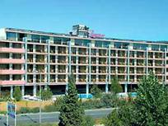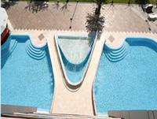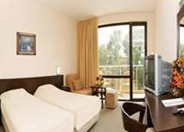
Localizare:in nordul staiunii Sunny Beach, la doar 10 minute de centrul comercial si la 250 m de plaja.
Dotari camera:camerele sunt dotate baie (dus)-wc, tv sat, telefon, balcon/terasa
Facilitati hotel: 2 piscine, sauna, masaj, salon de infrumusetare, restaurant
OFERTA LAST MINUTE COD « VT/23.04; 082/24.04»RUSALII
VALABILPT REZERVARILE TRIMISE DE LA 24.04.2019 SI ACHITATE INTEGRAL IN 24 H-SEJUR IN PERIOADA 20.05-21.06.2019
ALL INCLUSIVE LIGHT | 20.05-21.06
LOC IN CAMERA DUBLA | 23
CAMERA SINGLE | 23
TERMEN DE ANULARE | 12
PENALIZARI | 3
IN CAMERA DUBLA MAXIM 2 ADULTI+2 COPII /3 ADULTI
REDUCERI :
- COPII ( 0-1.99 ANI )– GRATUIT, FARA SERVICII( PATUT LA CERERE- GRATUIT)
- 1 COPIL ( 2-11.99 ANI ) IN PAT SUPLIM CU 2 ADULTI– GRATUIT
- AL 2 –LEA ( 2-11.99 ANI ) IN PAT SUPLIM CU 2 ADULTI - 50%
- 1-2 COPII ( 2-11.99 ANI ) IN CAMERA CU 1 ADULT – FIECARE PLATESTE 50%
- ADULT IN PAT SUPLIMENTAR – 20 % REDUCERE

HOTEL VIAND 4*/SUNNY BEACH
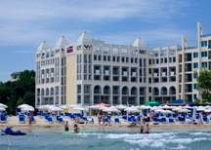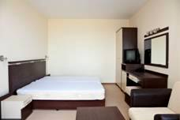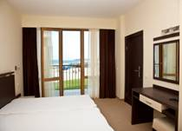
Localizare: Hotelul este situat in centrul statiunii, pe plaja.
Dotari camere: Aer conditionat, telefon, TV, radio, acces la internet, mini bar, baie, uscator de par.
Facilitati hotel: Piscina exterioara, loc de joaca pentru copii, restaurant, lobby bar, parcare. http://www.viandhotel.com
OFERTA LAST MINUTE COD « 070/4.04»
VALABIL PT REZERVARILE TRIMISE DE LA 4.04.2019 SI ACHITATE IN 24 H
ALL INCLUSIVE | 6.06-13.06
LOC IN CAMERA DUBLA PV | 29
CAMERA SINGLE | 42,5
LOC IN CAMERA DUBLA SV | 31
CAMERA SINGLE | 44,5
TERMEN DE ANULARE | 16
PENALIZARI | 3
IN CAMERA DUBLA MAXIM 2 ADULTI+2 COPII/ 3 ADULTI
REDUCERI :
- COPIL ( 0-1,99 ANI )– GRATUIT, FARA SERVICII
- 1 COPIL ( 2-11, 99 ANI ) IN PAT SUPLIMENTAR CU 2 ADULTI–GRATUIT
- AL 2 LEA COPIL ( 2-11, 99 ANI ) IN PAT SUPLIMENTAR CU 2 ADULTI-50%
- 1-2 COPII ( 2-11, 99 ANI ) CU 1 ADULT IN CAMERA DUBLA –FIECARE PLATESTE 50 %
- AL 3-LEA ADULT IN CAMERA IN PAT SUPLIMENTAR – 30 % REDUCERE

HOTEL MPM ASTORIA 4*/SUNNY BEACH
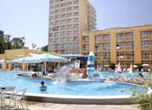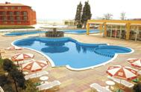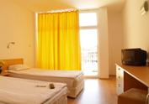

Localizare: Renovat 2018 ;la 50 m de plajă, în centrul complexului Sunny Beach

Dotari camera: aer conditionat, TV prin satelit, linie telefonică directă, frigider, balcon si dus.

Facilitati hotel:restaurant, bar la piscina si pe plaja, piscina cu sectiune copii;loc joaca copii;lobby bar, exchange,

http://www.hotel-astoria.bg/
OFERTA LAST MINUTE COD « VT/12.06 ;131/12.06»
“DISCOUNT 30%”PT REZERVARILE TRIMISE IN PERIOADA 11.06-30.06.2019 SI ACHITATE INTEGRAL IN 24 H
ULTRA ALL INCLUSIVE | 1.06-7.06  15.9-6.10 | 8.06-30.06  01.9-14.09 | 1.07-31.08
LOC IN CAMERA VED.PARK | 41,5 | 57,5 | 76,5
CAMERA SINGLE | 58 | 91 | 132,5
LOC IN SUITE | 46 | 63 | 85,5
TERMEN DE ANULARE | 10 | 12 | 16
PENALIZARI | 3 | 3 | 3

OFERTA LAST MINUTE COD « VT/28.05;TK/29.05; 113/3.06»
“DISCOUNT 20%”PT REZERVARILE TRIMISE DE LA 1.06.2019 SI ACHITATE INTEGRAL IN 24 H- SEJUR PANA PE 30.06.2019
“DISCOUNT 15%”PT REZERVARILE TRIMISE IN PERIOADA 1.06-20.06.2019 SI ACHITATE INTEGRAL IN 24 H- SEJUR 3-6 NOPTI DE LA 1.07.2019
“DISCOUNT 20%”PT REZERVARILE TRIMISE IN PERIOADA 1.06-20.06.2019 SI ACHITATE INTEGRAL IN 24 H- SEJUR 7 NOPTI DE LA 1.07.2019
ULTRA ALL INCLUSIVE | 1.06-7.06  15.9-6.10 | 8.06-30.06  01.9-14.09 | 1.07-31.08
LOC IN CAMERA VED.PARK | 41,5 | 57,5 | 76,5
CAMERA SINGLE | 58 | 91 | 132,5
LOC IN SUITE | 46 | 63 | 85,5
TERMEN DE ANULARE | 10 | 12 | 16
PENALIZARI | 3 | 3 | 3

OFERTA LAST MINUTE COD « 029/15.02; VT/20.02; TK/ 20.02»
ULTRA ALL INCLUSIVE | 16.09-6.10 | 1.06-10.06
SEJUR MINIM NOPTI | 2 | 2
LOC IN CAMERA VED.PARK | 23,5 | 30
TERMEN DE ANULARE | 10 | 12
PENALIZARI | 3 | 3

TARIFUL INCLUDE 1 UMBRELA SI 2 SEZLONGURI/CAMERA PE PLAJA IN LIMITA DISP.

IN CAMERELE DUBLE MAXIM 2 ADULTI + 2 COPII/ 3 ADULTI

IN STUDIO MAXIM 2 ADULTI +2 COPII/3 ADULTI+ 1 COPIL/4 ADULTI
REDUCERI :
- COPIL (0-1,99 ANI)- GRATUIT, FARA SERVICII
- 1 COPIL ( 2-12,99 ANI ) IN PAT SUPLIMENTAR– GRATUIT
- AL 2 LEA COPIL ( 2-12,99 ANI) IN PAT SUPLIMENTAR-50%
- 1 COPIL ( 2-12,99 ANI) CU 1 ADULT IN DBL- 25% REDUCERE
- 1 COPIL ( 2-12,99 ANI) CU 1 ADULT IN STUDIO- FARA REDUCERE
- 2 COPII ( 2-12,99 ANI) CU 1 ADULT IN DBL- FIECARE PLATESTE 50%
- AL 3-LEA ADULT IN PAT SUPLIMENTAR – 20 % REDUCERE

HOTEL MPM KALINA GARDEN 4*/SUNNY BEACH
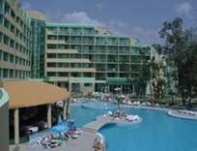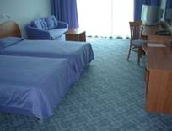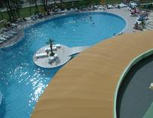
Localizare: in centrul statiunii
Facilitati hotel: restaurant, lobby bar, irishpub, piscina interioara si exterioara, piscina pt. copii, centru medical cu talasoterapie,masaj, fizioterapie,biliard,minigolf, masa tenis, loc de joaca pt. copii, schimb valutar, magazine, internet.
OFERTA LAST MINUTE COD « VT/12.06 ;131/12.06»
“DISCOUNT 30%”PT REZERVARILE TRIMISE IN PERIOADA 11.06-30.06.2019 SI ACHITATE INTEGRAL IN 24 H
ALL INCLUSIVE PREMIUM | 15.09-  6.10 | 8.09-  14.09 | 1.09-  7.09 | 1.07-  31.08
LOC IN CAMERA TWIN | 38 | 40 | 56 | 67,5
CAMERA SINGLE | 38 | 57 | 78 | 107
LOC IN SUITE STANDARD | 44,5 | 47 | 65 | 79
TERMEN DE ANULARE | 14 | 14 | 18 | 20
PENALIZARI | 2 | 2 | 4 | 4
IN CAMERA DUBLA MAXIM 2 ADULTI+2 COPII /3 ADULTI
IN SUITE MAXIM 2 ADULTI+2 COPII /3 ADULTI+ 1 COPIL/4 ADULTI
REDUCERI:
- COPIL ( 0-1.99 ANI )– GRATUIT, FARA SERVICII
- 1 COPIL ( 2-12.99 ANI ) CU 1 ADULT IN CAMERA -25% REDUCERE
- 2 COPII ( 2-12.99 ANI ) CU 1 ADULT IN CAMERA - FIECARE PLATESTE 50%
- 1 COPIL ( 2-12.99 ANI ) IN PAT SUPLIM. CU 2 ADULTI IN CAMERA –PRIMUL GRATUIT;AL 2-LEA - 50%
- ADULT IN CAMERA IN PAT SUPLIMENTAR – 25 % REDUCERE

OFERTA LAST MINUTE COD « VT/28.05;TK/29.05; 113/3.06»
“DISCOUNT 20%”PT REZERVARILE TRIMISE IN PERIOADA 1.06-20.06.2019 SI ACHITATE INTEGRAL IN 24 H- SEJUR 3-6 NOPTI DE LA 1.07.2019
“DISCOUNT 25%”PT REZERVARILE TRIMISE IN PERIOADA 1.06-20.06.2019 SI ACHITATE INTEGRAL IN 24 H- SEJUR 7 NOPTI DE LA 1.07.2019
ALL INCLUSIVE PREMIUM | 15.09-6.10 | 8.09-14.09 | 1.09-7.09 | 1.07-  31.08
LOC IN CAMERA TWIN | 38 | 40 | 56 | 67,5
CAMERA SINGLE | 38 | 57 | 78 | 107
LOC IN SUITE STANDARD | 44,5 | 47 | 65 | 79
TERMEN DE ANULARE | 14 | 14 | 18 | 20
PENALIZARI | 2 | 2 | 4 | 4
IN CAMERA DUBLA MAXIM 2 ADULTI+2 COPII /3 ADULTI
IN SUITE MAXIM 2 ADULTI+2 COPII /3 ADULTI+ 1 COPIL/4 ADULTI
REDUCERI:
- COPIL ( 0-1.99 ANI )– GRATUIT, FARA SERVICII
- 1 COPIL ( 2-12.99 ANI ) CU 1 ADULT IN CAMERA -25% REDUCERE
- 2 COPII ( 2-12.99 ANI ) CU 1 ADULT IN CAMERA - FIECARE PLATESTE 50%
- 1 COPIL ( 2-12.99 ANI ) IN PAT SUPLIM. CU 2 ADULTI IN CAMERA –PRIMUL GRATUIT;AL 2-LEA - 50%
- ADULT IN CAMERA IN PAT SUPLIMENTAR – 25 % REDUCERE

GRAND HOTEL SUNNY BEACH 4*/SUNNY BEACH
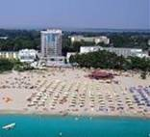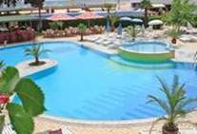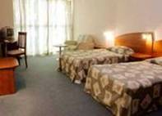
Localizare: pe plaja
Dotari camera:aer conditionat, minibar, baie cu dus, WC, balcon, uscator de par, TV, telefon
Facilitati hotel:restaurant principal, lobby bar, pool bar, 2 baruri, magazine de suveniruri, piscina exterioara, piscina pentru copii, schimb valutar, cabinet medical, seif la receptie, salon de frumusete, coafor.
OFERTA LAST MINUTE COD « 117 /05.06; TK 10.06»
“DISCOUNT 20%”PT REZERVARILE TRIMISE IN PERIOADA 05.06-24.08.2019 SI ACHITATE INTEGRAL IN 24 H- SEJUR IN PERIOADA 03.07-25.08.2019
SE COMBINA CU OFERTA 2 COPII MAXIM 13 ANI GRATUIT CU 2 ADULTI IN CAMERA (TK)
OFERTA LAST MINUTE COD « TK /21. 05»
2+2= 2PENTRU SEJUR IN PERIOADA 21.05-30.10.2019 SI REZERVARI FACUTE IN PERIOADA 21.05-30.06.2019
ALL INCLUSIVE | 3.07-24.08
LOC CAMERA DUBLA PROMO | 57
CAMERA SINGLE | 112,5
LOC CAMERA DUBLA | 60,5
CAMERA SINGLE | 101,5
STUDIO 2 ADULTI/ZI* | 131,5
STUDIO 3 ADULTI/ZI* | 184,5
STUDIO 4 ADULTI/ZI* | 237,5
APARTAMENT 2 ADULTI/ZI* | 143
APARTAMENT 3 ADULTI/ZI* | 200
APARTAMENT 4 ADULTI/ZI* | 257,5
TERMEN DE ANULARE | 19
PENALIZARI | 4
IN CAMERA DUBLA MAXIM 2 ADULTI+2 COPII /3 ADULTI
IN STUDIO MAXIM 2 ADULTI+ 3 COPII/ 4 ADULTI
IN APARTAMENT MAXIM 2 ADULTI+3 COPII/ 4 ADULTI
REDUCERI :
- COPII ( 0-1.99 ANI )– GRATUIT, FARA SERVICII
- 1 COPIL ( 2-12.99 ANI ) IN PAT SUPLIMENTAR – GRATUIT
- AL 2 LEA COPIL ( 2-12.99 ANI ) IN PAT SUPLIMENTAR- 50%
- AL 3 LEA COPIL ( 2-12.99 ANI ) IN PAT SUPLIM. IN SUITE SAU AP- 50%
- 1 -2 COPII( 2-12,99 ANI) CU 1 ADULT- FIECARE PLATESTE 50%
- ADULT IN PAT SUPLIMENTAR –20 % REDUCERE
HOTEL BURGASBEACH 4*/SUNNY BEACH
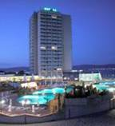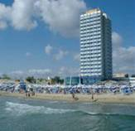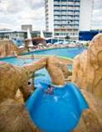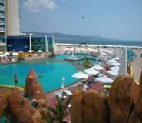

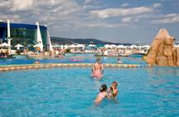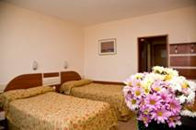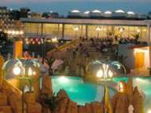
Localizare: pe plaja
Dotari camera: TV, telefon, frigider, balcon; baie cu dus
Facilitati hotel: restaurant, bar, cocktail bar, piscina exterioara cu bazin copii, bar la piscina, piscina interioara cu apa calda (pina in 30.05 si dupa 15.09) , hidromasaj , solar, sauna, masaj, fitness, schimb valutar, seif, parcarehttp://www.burgasbeach.com
OFERTA LAST MINUTE COD « VT/22.04; TK/24.04; 081/23.04»
1 NOAPTE GRATUITA PT SEJUR 7-13 NOPTI SOSIRI PANA PE 5.06.2019
ALL INCLUSIVE | 5.06-20.06
LOC IN CAMERA VED.PARK | 37
CAMERA SINGLE | 47,5
LOC IN CAMERA VED. MARE | 41,5
CAMERA SINGLE | 53,5
TERMEN DE ANULARE | 16
PENALIZARI | 3
IN CAMERA DUBLA MAXIM 2 ADULTI + 1 COPIL/ 3 ADULTI
REDUCERI :
- COPIL ( 0-1.99 ANI ) – GRATUIT, FARA SERVICII/ PATUT 5 LEVA/ZI
- 1 COPIL ( 2-12.99 ANI ) IN PAT SUPLIM CU 2 ADULTI IN CAMERA – GRATUIT
- 1 -2 COPII ( 2-12.99 ANI ) IN CAMERA CU 1 ADULT–FIECARE PLATESTE 50 %
- ADULT IN PAT SUPLIMENTAR – 25 % REDUCERE

HOTEL ALBA*/ SUNNY BEACH
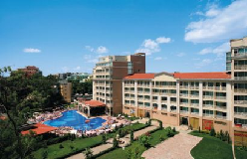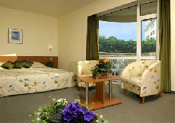
Localizare: in centrul statiunii, la 100 m de plaja
Dotari camera: mobiliar modern; TV, telefon, frigider, balcon; baie cu dus;uscator par;A/C;seif
Facilitati hotel: restaurant, bar, lift; piscina exterioara cu sectiune copii, aqua bar, piscina interioara;club de noapte;terasa ;sala fitness;masaj; sauna;loc joaca copii;WI FI;parcare
OFERTA LAST MINUTE COD « 110/1.06»
“DISCOUNT 20%”PT REZERVARILE TRIMISE IN PERIOADA 1.06-30.06.2019 SI ACHITATE INTEGRAL IN 24 H
ALL INCLUSIVE | 1.06-10.06  12.09-7.10 | 11.06-6.07  25.08-11.09 | 7.07-  24.08
LOC IN CAMERA DUBLA PV | 34,5 | 47,5 | 62
LOC IN CAMERA DUBLA SV | 37,5 | 50 | 65
LOC IN CAMERA DUBLA COMFORT PV | 38,5 | 46 | 65,5
LOC IN CAMERA DUBLA COMFORT SV | 41,5 | 54 | 69
LOC IN APART. 1 DORM. PV | 59 | 85 | 106
LOC IN APART. 1 DORM. SV | 62 | 84,5 | 109,5
TERMEN DE ANULARE | 12 | 16 | 20
PENALIZARI | 2 | 3 | 4
IN CAMERA DUBLA MAXIM 2 ADULTI + 2 COPII/ 3 ADULTI+ 1 COPIL
IN APART. 1 DORM MAXIM 2 ADULTI+ 2 COPII/3 ADULTI+ 1 COPIL/4 ADULTI
REDUCERI :
- 1 COPIL ( 2-11.99 ANI ) IN CAMERA CU 1 ADULT–FARA REDUCERE
- AL 2 LEA COPIL ( 2-11.99 ANI )IN CAMERA CU 1 ADULT- 50%
- COPIL ( 2-11.99 ANI ) IN PAT SUPLIMENTAR- GRATUIT
- AL 2 LEA COPIL ( 2-11.99 ANI ) IN PAT SUPLIMENTAR-50%
- CAMERA SINGLE- FARA REDUCERE !
- ADULT IN PAT SUPLIMENTAR IN DBL– 50%

MPM HOTEL BOOMERANG 3*/SUNNY BEACH
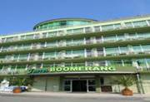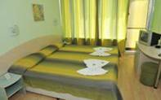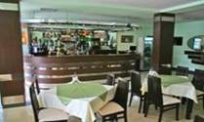
Localizare:este situat in centrul statiunii la 300 m de plaja.
Dotari camera:televizor aer conditionat, telefon direct, mini-bar, baie complet echipata, seif, balcon
Facilitati hotel: mini-market, farmacie, coafor, salon de cosmetica, bar la receptie, piscina exterioara cu sectiune pt.copii
OFERTA LAST MINUTE COD « VT/28.05;TK/29.05;113/3.06»
“DISCOUNT 15%”PT REZERVARILE TRIMISE DE LA 1.06.2019 SI ACHITATE INTEGRAL IN 24 H- SEJUR PANA PE 10.06.2019 SI PERIOADA 15.06-30.06.2019
“DISCOUNT 20%”PT REZERVARILE TRIMISE IN PERIOADA 1.06-20.06.2019 SI ACHITATE INTEGRAL IN 24 H- SEJUR IN PERIOADA 1.07-SF ZESON
ALL INCLUSIVE LIGHT | 1.06-24.05  15.09-6.10 | 25.05-14.06  8.09-14.09 | 15.06-30.06  1.09-7.09 | 1.07-31.08
LOC IN CAMERA DUBLA | 25,5 | 30 | 36 | 46,5
CAMERA SINGLE | 31 | 41,5 | 53 | 91
CAMERA FAMILY 4 ADULTI /ZI* | 102 | 120 | 144,5 | 185
CAMERA FAMILY 5 ADULTI /ZI* | 121 | 142,5 | 172 | 220
TERMEN DE ANULARE | 10 | 12 | 15 | 16
PENALIZARI | 3 | 3 | 4 | 4
IN CAMERA DUBLA MAXIM 2 ADULTI + 1 COPIL /3 ADULTI
IN CAMERA FAMILY MINIM 4 ADULTI( SE TAXEAZA 4 LOCURI INTREGI); MAXIM 4 ADULTI+ 2 COPII/5 ADULTI
REDUCERI:
- COPIL ( 0-1.99 ANI ) – GRATUIT, FARA SERVICII
- 1 COPIL ( 2-11,99 ANI ) IN PAT SUPLIMENTAR– GRATUIT
- AL 2 LEA COPIL( 2-11,99 ANI ) IN PAT SUPLIMENTAR IN FAMILY-50%
- 1 COPIL ( 2-11.99 ANI ) CU 1 ADULT IN CAMERA -25% REDUCERE
- 2 COPII ( 2-11.99 ANI ) CU 1 ADULT IN CAMERA – FIECARE PLATESTE 50 %
- ADULT IN PAT SUPLIMENTAR– 25 % REDUCERE

MPM HOTEL OREL 3*/SUNNY BEACH
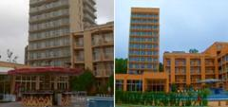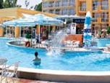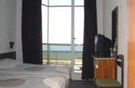
Localizare: RENOVAT ! pe plaja ,in zona centrala a statiunii
Dotari camera: cu TV, frigider, balcon, uscator de par; baie cu dus si wc.
Facilitati hotel: restaurant, bar, piscina exterioara cu bazin pentru copii, bar la piscina, schimb valutar, seif la receptie
OFERTA LAST MINUTE COD « VT/07.06; TK/29.05;113/3.06»
“DISCOUNT 20%”PT REZERVARILE TRIMISE DE LA 1.06.2019 SI ACHITATE INTEGRAL IN 24 H- SEJUR PANA PE 22.06.2019
“DISCOUNT 15%”PT REZERVARILE TRIMISE IN PERIOADA 1.06-20.06.2019 SI ACHITATE INTEGRAL IN 24 H- SEJUR 3-6 NOPTI IN PERIOADA 29.06-SF ZESON
“DISCOUNT 20%”PT REZERVARILE TRIMISE IN PERIOADA 1.06-20.06.2019 SI ACHITATE INTEGRAL IN 24 H- SEJUR 7 NOPTI IN PERIOADA 29.06-SF ZESON
ULTRA ALL INCLUSIVE | 10.05-7.06  15.9-6.10 | 8.6-30.06  1.09-14.09 | 1.07-31.08
LOC IN CAMERA DUBLA | 37 | 51 | 66,5
CAMERA SINGLE | 48 | 73 | 94,5
TERMEN DE ANULARE | 12 | 14 | 16
PENALIZARI | 2 | 3 | 3
TARIFUL INCLUDE 1 UMBRELA SI 2 SEZLONGURI/CAMERA PE PLAJA- IN LIMITA DISP
IN CAMERA DUBLA MAXIM 2 ADULTI+1 COPIL/3 ADULTI
REDUCERI :
- 1 COPIL ( 0-1.99 ANI ) – GRATUIT, FARA SERVICII
- 1 COPIL (2 -12,99 ANI) IN CAMERA CU 1 ADULT- 20% REDUCERE
-2 COPII (2 -12,99 ANI) IN CAMERA CU 1 ADULT- FIECARE PLATESTE 50%
- COPIL ( 2-12,99 AMI) IN PAT SUPLIMENTAR- GRATUIT
- ADULT IN PAT SUPLIMENTAR – 20 % REDUCERE

HOTEL SUNSET 3*SUNNY BEACH
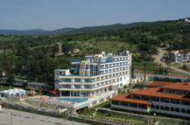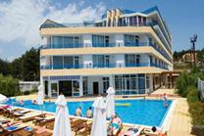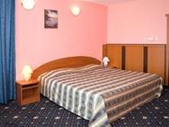
Localizare: la 180 m de plaja
Dotari camera: aer conditionat, TV, mini-bar, uscator de par, balcon; baie cu dus
Facilitati hotel: restaurant, lobby bar, Irish Pub, piscina exterioara, parcare, masaj, magazin, schimb valutar. http://www.hotelsunset.net/
OFERTA LAST MINUTE COD « VT/12.06»
“DISCOUNT 15%”PT REZERVARILE TRIMISE DE LA 11.06.2019 SI ACHITATE INTEGRAL IN 24 H- SEJUR PANA PE 02.07.2019
ALL INCLUSIVE | 1.05-15.06 | 16.06-2.07
LOC IN CAMERA | 29 | 39,5
CAMERA SINGLE | 34,5 | 78
LOC IN CAMERA LARGE | 29 | 39,5
LOC IN APARTAMENT | 34,5 | 41
TERMEN DE ANULARE | 12 | 16
PENALIZARI | 2 | 3
IN CAMERA DUBLA MAXIM 2 ADULTI+ 1 COPIL
IN CAMERA DUBLA LARGE MINIM 2 ADULTI+ 1 COPIL; MAXIM 2 ADULTI+ 2 COPII/3 ADULTI
IN APART.1 DORMIT0R MAXIM 2 ADULTI+ 2 COPII/3 ADULTI+ 1 COPIL/ 4 ADULTI
REDUCERI:
- COPIL ( 0-1.99 ANI ) – GRATUIT, FARA SERVICII
- 1-2 COPII (2 – 12,99 ANI) IN PAT SUPLIMENTAR – PRIMUL GRATUIT ; AL 2-LEA 50%
- 1-2 COPII (2 – 12,99 ANI) CU 1 ADULT – FIECARE PLATESTE 50%
- ADULT IN PAT SUPLIMENTAR –30% REDUCERE
REDUCERI IN APART. :
- COPIL ( 0-1.99 ANI ) – GRATUIT, FARA SERVICII
- 1-2 COPII (2 –12,99 ANI) IN PAT SUPLIMENTAR – PRIMUL GRATUIT ; AL 2-LEA 50%
- 2 COPII (2 –12,99 ANI) IN PAT NORMAL CU 1 ADULT – FIECARE PLATESTE 50%
- ADULT IN PAT SUPLIMENTAR –30% REDUCERE
NOPTI GRATUITE VALABIL PT SOSIRI PANA PE 15.06 SI DIN 9.09.2019
  - NOAPTE GRATUITA PT SEJUR 7-13 NOPTI
2)2 NOPTI GRATUITE PT SEJUR 14-20 NOPTI
3)3 NOPTI GRATUITE PT SEJUR DE LA 21 NOPTI
HOTEL BALATON 3*SUNNY BEACH
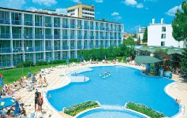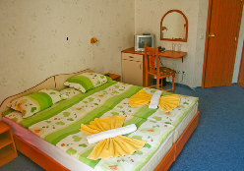
Localizare: aprox. 4 minute mers pe jos de cele mai uimitoare si salbatice dune de nisip, 150 m de plaja
Dotari camera:A/C ; TV cablu ; frigider ; baie cu dus;
Facilitati hotel: restaurant, lobby bar, piscina exterioara cu bar ,piscina copii , masaj,parcare ;zona loc joaca ;seif ;WI FI in lobby,terasa in aer liber
OFERTA LAST MINUTE COD « VT/07.06»
“DISCOUNT 10%”PT REZERVARILE TRIMISE DE LA 11.06.2019 SI ACHITATE INTEGRAL IN 24 H- SEJUR PANA PE 24.09.2019
MIC DEJUN | 23.05-19.06  10.09-24.09 | 20.06-6.07  22.08-9.09 | 7.07-21.08
LOC IN CAMERA DUBLA | 14,5 | 21,5 | 29,5
CAMERA SINGLE | 14,5 | 32 | 43,5
SUPLIMENT CINA ADULT/COPIL | 7/5 | 7/5 | 7/5
SUPLIMENT ALL INCL ADULT/COPIL | 13/7 | 13/7 | 13/7
TERMEN DE ANULARE | 12 | 16 | 18
PENALIZARI | 100% | 100% | 100%
IN CAMERA DUBLA MAXIM 2 ADULTI+ 1 COPIL/3 ADULTI
REDUCERI :
- COPIL ( 0-1.99 ANI ) – GRATUIT, FARA SERVICII( PATUT LA CERERE-2,5 E)
- COPIL ( 2-11,99 ANI ) IN PAT SUPLIMENTAR– PLATESTE SUPLIMENT 4 €/ZI CU MD + SUPLIMENTE DP SI ALL INCL
- 1-2 COPII ( 2-11,99 ANI ) CU 1 ADULT- FIECARE COPIL PLATESTE 50%
- ADULT IN PAT SUPLIMENTAR– 30% REDUCERE
HOTEL CALYPSO 3+/SUNNY BEACH
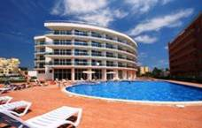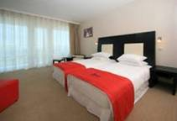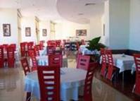
Localizare: se situeaza in partea centrala a statiunii Sunny Beach la doar 250 m de plaja. Imbina intr-un mod uimitor modernul cu clasicul, oferind o cazare relaxanta in matase si satin in camere spatioase si o masa intima si de bun gust din bucataria internationala.
Camere:aer conditionat , baie cu dus sau cada , Wc., Tv LCD, cablu , internet, telefon.
Facilitati: lobby impresionant cu canapele si fotolii, lift exterior din sticla, restaurant , lobby bar, internet wirless, piscina adulti, piscina copii, jacuzzi in aer liber si interior , sala de gimnastica si fitness
OFERTA LAST MINUTE COD « VT 12.06 ; 131/12.06»
“DISCOUNT 15%”PT REZERVARILE TRIMISE IN PERIOADA 11.06-23.06.2019 SI ACHITATE INTEGRAL IN 24 H-SEJUR IN PERIOADA 11.06-30.06.2019- DBL
ALL INCLUSIVE | 1.06-5.06 | 6.06-16.06 | 17.6-30.06
LOC IN CAMERA STANDARD | 27,5 | 32,5 | 44
TERMEN DE ANULARE | 12 | 16 | 18
PENALIZARI | 2 | 3 | 4
IN CAMERA STANDARD MAXIM 2 ADULTI+ 1 COPIL/ 3 ADULTI
IN CAMERA LARGE MAXIM 2 ADULTI+2 COPII /3 ADULTI
IN APARTAMENT MAXIM 2 ADULTI+2 COPII /3 ADULTI .
REDUCERI :
- COPII ( 0-1.99 ANI )– GRATUIT, FARA SERVICII
- 1 COPIL ( 2-13.99 ANI ) IN PAT SUPLIM CU 2 ADULTI– GRATUIT
- AL 2-LEA ( 2-13.99 ANI ) IN PAT SUPLIM CU 2 ADULTI– 50%
- 1 COPIL( 2-13,99 ANI ) CU 1 ADULT– FARA REDUCERE
- 2 COPII( 2-13,99 ANI ) CU 1 ADULT IN DBL LARGE - FIECARE PLATESTE 50 %
- ADULT IN PAT SUPLIMENTAR –20 % REDUCERE

HOTEL NESSEBAR BEACH 3*+/SUNNY BEACH
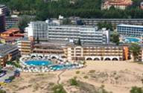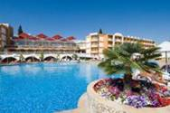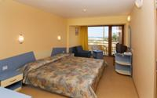
Localizare: la 30 m de plaja
Dotari camera:TV, telefon, uscator de par, balcon; baie cu dus ; Aer Conditionat
Facilitati hotel: piscina exterioara, restaurant, 2 baruri , snack bar, restaurant pescaresc, pizzeria, restaurant, teren de joaca, fitness, masaj, tennis de masa, biliard, bar de noapte, seif, internet, schimb valutar. http://www.burgasbeach.com/
OFERTA LAST MINUTE COD « VT/22.04; TK/24.04;081/24.04»
1 NOAPTE GRATUITA PT SEJUR 7-13 NOPTI SOSIRI PANA PE 11.06.2019
ALL INCLUSIVE | 1.05-5.06  7.09-30.09 | 6.06-25.06 | 26.06-3.07  25.08-6.09 | 7.07-24.08
LOC IN CAMERA VED.PARK | 27 | 34 | 45 | 53
CAMERA SINGLE | 34,5 | 44 | 58,5 | 79
TERMEN DE ANULARE | 12 | 16 | 18 | 22
PENALIZARI | 3 | 3 | 4 | 4
IN CAMERA DUBLA MINIM 2 PERSOANE SI MAXIM 2 ADULTI+1 COPIL /3 ADULTI
REDUCERI :
- COPIL ( 0-1.99 ANI ) CU 2 ADULTI IN CAMERA – GRATUIT, FARA SERVICII
- 1 COPIL ( 2-12,99 ANI ) IN PAT SUPLIM CU 2 ADULTI IN CAMERA –GRATUIT
- 1 -2 COPII ( 2 -12.99 ANI ) IN PAT NORMAL CU 1 ADULT IN CAMERA –FIECARE PLATESTE 50 %
- ADULT IN PAT SUPLIMENTAR IN DUBLA – 25 % REDUCERE

HOTEL BOHEMI 3*/SUNNY BEACH
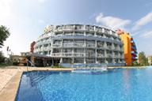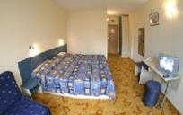

Localizare: contruit 2004, in Sunny Beach, la 350 m de plaja,

Dotari camera:baie (dus)-wc,uscator par; aer conditionat, tv sat, telefon, mini bar

Facilitati hotel:restaurant, parcare.,room service,piscina ;biliard; seif;internet
OFERTA LAST MINUTE COD « 112/3.06 ; TK 10.06»
“DISCOUNT 15%”PT REZERVARILE TRIMISE IN PERIOADA 1.06-30.06.2019 SI ACHITATE INTEGRAL IN 24 H-SEJUR IN PERIOADELE 1.06-30.06/1.09-30.09.2019
ALL INCLUSIVE | 15.09-20.09 | 1.06-15.06  9.09-14.09 | 16.06-30.06  1.09-8.09
LOC IN DUBLA ECONOMY | 22 | 28 | 34
CAMERA SINGLE | 28 | 32,5 | 48,5
LOC IN DUBLA | 24,5 | 29 | 36
CAMERA SINGLE | 28 | 32,5 | 48,5
APART. 2 DORM MAXIM 4 ADULTI/ ZI* | 82 | 99,5 | 131
TERMEN DE ANULARE | 12 | 18 | 20
PENALIZARI | 5 | 8 | 14

*TARIFUL ESTE PENTRU APARTAMENT, NR PERSOANE INDICATE IN TABEL

IN CAMERA DUBLA MAXIM 2 ADULTI+ 1 COPIL/3 ADULTI

IN APARTAMENT MAXIM 4 ADULTI

REDUCERI:

- COPIL (0-1,99 ANI) – GRATUIT ,FARA SERVICII

- COPIL ( 2-11,99 ANI) IN PAT SUPLIMENTAR- GRATUIT

- 1 COPIL( 2-11,99 ANI) CU 1 ADULT- TARIF SINGLE

- 2 COPII ( 2-11,99 ANI) CU 1 ADULT- FIECARE PLATESTE 50%

- ADULT IN PAT SUPLIMENTAR- 30% REDUCERE

HOTEL BREZA 3*/SUNNY BEACH

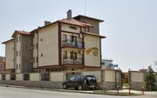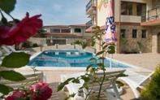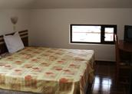

Localizare:este situat în zona de nord-est de staţiune de vacanţă pe Sunny Beach, la 100 m de plaja

Dotari camera: aer conditionat, frigider, telefon, tv, minibar

Facilitati hotel:restaurant. piscina, sala de fitness, internet, gratar.
OFERTA LAST MINUTE COD « 060/26.03»
MIC DEJUN | 1.06-15.06  10.09-30.9 | 16.06-10.07  30.08-9.09 | 11.07-29.8
SEJUR MINIM NOPTI | 6 | 6 | 6
LOC IN CAMERA STANDARD | 13,5 | 16 | 21,5
CAMERA SINGLE | 23,5 | 29,5 | 41
APART. 1 DORM.4 ADULTI/ZI* | 48 | 61,5 | 67
DEMIPENSIUNE | 1.06-15.06  10.09-30.9 | 16.06-10.07  30.08-9.09 | 11.07-29.8
LOC IN CAMERA STANDARD | 20 | 23 | 28,5
CAMERA SINGLE | 30 | 36 | 47,5
APART. 1 DORM.2 ADULTI/ZI* | 60 | 72 | 78
APART. 1 DORM.3 ADULTI/ZI* | 67,5 | 80,5 | 86
APART. 1 DORM.4 ADULTI/ZI* | 75 | 88,5 | 142,5
TERMEN DE ANULAREA | 10 | 14 | 16
PENALIZARI | 2 | 3 | 4
IN CAMERA DUBLA MAXIM 2 ADULTI + 1 COPIL /3 ADULTI
IN CAMERA DUBLA LARGE MAXIM 2 ADULTI + 2 COPII /3 ADULTI
IN APARTAMENT MAXIM 4 ADULTI
REDUCERI :
- COPIL ( 0-1.99 ANI ) – GRATUIT, FARA SERVICII
- 1 COPIL ( 2-11,99 ANI ) IN PAT SUPLIMENTAR– GRATUIT
- AL 2 LEA COPIL ( 2-11,99 ANI ) IN PAT SUPLIMENTAR- 50%
- 1 COPIL ( 2-11.99 ANI ) CU 1 ADULT IN CAMERA- TARIF SINGLE
- 2 COPII ( 2-11.99 ANI ) CU 1 ADULT IN CAMERA- FIECARE PLATESTE 50%
- ADULT IN PAT SUPLIMENTAR – 20 % REDUCERE

HOTEL RIAGOR 3*+/SUNNY BEACH
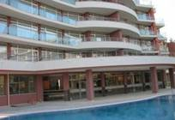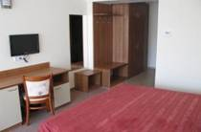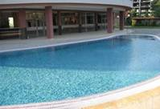
Localizare: la 350 m de plaja.
Dotari camera: A/C ,baie,TV,minibar,balcon.
Facilitati hotel:piscina exeterioara, bar,restaurant.
OFERTA LAST MINUTE COD « 114/3.06»
ALL INCLUSIVE LIGHT | 10.06 -23.06
LOC IN CAMERA DUBLA | 25
CAMERA SINGLE | 41,5
TERMEN DE ANULARE | 16
PENALIZARI | 3
IN CAMERA DUBLA MAXIM 2 ADULTI
REDUCERI :
- COPIL ( 0-1.99 ANI )– GRATUIT, FARA SERVICII- PATUT LA CERERE - RECEPTIE/1,5 €/ZI
- 2 COPII( 2-5,99 ANI) CU 1 ADULT- FIECARE PLATESTE 50%
- 2 COPII ( 6-11,99 ANI ) CU 1 ADULT- PRIMUL FARA REDUCERE; AL 2 LEA 50%
- COPIL ( 2-5,99 ANI) IN PAT SUPLIMENTAR- GRATUIT
- COPIL ( 6-11,99 ANI) IN PAT SUPLIMENTAR- 50%
- AL 2 LEA COPIL ( 2-5,99 ANI) IN PAT SUPLIMENTAR-60% REDUCERE
- ADULT IN PAT SUPLIMENTAR– 20 % REDUCERE

APARTHOTEL SUN CITY 3*/SUNNY BEACH
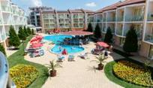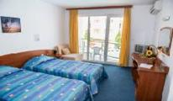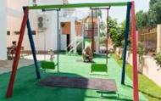

Localizare: in partea de nord a statiunii,la 10 min de plaja ,construit 2004

Dotari camera: TV cablu , balcon,baie,A/C;frigider;telefon;chicineta la apart

Facilitati hotel: seif;cabinet medical;masaj;restaurant;internet cafe;sky bar
http://www.hotelsuncitybg.com/
OFERTA LAST MINUTE COD « TK/1.06»
“DISCOUNT 25%”PT REZERVARILE TRIMISE IN PERIOADA 1.06-25.06.2019 SI ACHITATE INTEGRAL IN 24 H-SEJUR IN PERIOADA 1.06-30.06.2019
ALL INCLUSIVE | 18.05-8.06  8.09-30.09 | 9.06-10.07  24.08 -7.09 | 11.07–23.08
LOC IN CAMERA DUBLA | 34 | 42 | 46
CAMERA SINGLE | 50,3 | 66 | 77
TERMEN DE ANULARE | 10 | 14 | 18
PENALIZARI | 2 | 3 | 4
IN CAMERA DUBLA MAXIM ADULTI +1 COPIL/ 3 ADULTI
REDUCERI :
- COPIL(0-1,99 ANI) - GRATUIT FARA SERVICII(PATUT 5 LEVA/ZI- RECEPTIE)
- COPIL ( 2-12.99 ANI ) IN PAT SUPLIMENTAR–GRATUIT
- 1 -2 COPII ( 2-12.99 ANI ) IN CAMERA CU 1 ADULT –FIECARE PLATESTE 50 %
-ADULT IN PAT SUPLIMENTAR – 20 % REDUCERE

EUROPE HOTEL & CASINO 3*/SUNNY BEACH
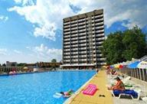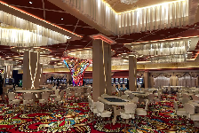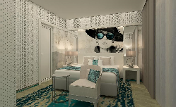

Localizare: pe malul marii

Dotari camera: A/C;balcon;minibar;TV;baie privaa

Facilitati hotel:piscina exterioara;restaurant;terasa spatioasa;baie turceasca;baie aburi;sala fitness;masaj; parcare;WI FI;teren joaca copii;casino
OFERTA LAST MINUTE COD « 119/06.06 »
“DISCOUNT 15%”PT REZERVARILE FACUTE IN PERIOADA 06.06-30.06.2019 SI ACHITATE INTEGRAL IN 24 H- SEJUR IN PERIOADA 06.06-28.09.2019
*SE POATE COMBINA DOAR CU NOPTI GRATUITE
MIC DEJUN | 01.04-19.05  30.09-31.10 | 20.05-09.06  09.09-29.09 | 10.06-07.07  26.08-08.09 | 08.07-25.08
LOC IN CAMERA DUBLA | 30,5 | 34 | 43 | 60
CAMERA SINGLE | 43 | 47,5 | 64,5 | 90.,5
TERMEN DE ANULARE | 12 | 16 | 18 | 20
PENALIZARI | 100% | 100% | 100% | 100%

OFERTA LAST MINUTE COD « 099/17.05»
DEMIPENSIUNE | 1.06-9.06 | 10.06-7.07 | 8.07-25.08
LOC IN CAMERA DUBLA | 34,5 | 44 | 61
CAMERA SINGLE | 48 | 65,5 | 91
TERMEN DE ANULARE | 12 | 16 | 18
PENALIZARI | 100% | 100% | 100%
IN CAMERA DUBLA MAXIM 2 ADULTI+2 COPII / 3 ADULTI
REDUCERI :
- COPIL ( 0-1.99 ANI ) – GRATUIT, FARA SERVICII
- 1 COPIL ( 2-11.99 ANI ) IN PAT SUPLIMENTAR–50%
- AL 2 –LEA COPIL ( 2-11.99 ANI ) IN PAT SUPLIMENTAR– 50%
- 1-2 COPII ( 2-11.99 ANI ) CU 1 ADULT IN CAMERA – FIECARE PLATESTE 70%
- ADULT IN CAMERA IN PAT SUPLIMENTAR – 20 % REDUCERE
NOPTI GRATUITE
7=6 ;8=7 ;9=8 ;10=9 ; 11=10 ; 12=11 ; 13=12 ; 14=12 VALABIL PT SOSIRI IN PERIOADELE 01.04-19.05/09.09-23.10.2019

HOTEL YUNONA 3*/SUNNY BEACH

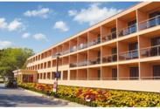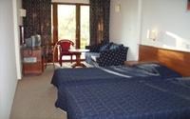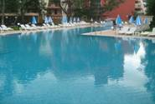

Localizare:este situat la 180 m de plaja, in centrul statiunii Sunny Beach

Dotari camera 3* : aer conditionat, mini bar, telefon, televizor, baie cu cabina de dus sau cada, uscator de par.

Facilitati hotel: piscina exterioara ,restaurant, terasa, casa de schimb valutar, seif la receptie
OFERTA LAST MINUTE COD « 111/3.06»
“DISCOUNT 20%”PT REZERVARILE TRIMISE PANA PE 30.06.2019 SI ACHITATE INTEGRAL IN 24 H- SEJUR IN PERIOADA 21.06-30.09.2019
*SE POATE COMBINA CU NOPTI GRATUITE
ALL INCLUSIVE | 9.09-30.09 | 21.06-5.07  26.08-8.09 | 6.07-25.08
LOC IN CAMERA DUBLA | 25,5 | 36 | 47,5
CAMERA SINGLE | 33,5 | 48,5 | 74
TERMEN DE ANULARE | 5 | 16 | 16
PENALIZARI | 2 | 3 | 3

OFERTA LAST MINUTE COD « 111/3.06»

VALABIL PT REZERVARILE TRIMISE IN PERIOADA 3.06-20.06.2019 SI ACHITATE IN 24 H
ALL INCLUSIVE | 3.06-7.06 | 8.06-20.06
SEJUR MINIM NOPTI | 3 | 3
LOC IN CAMERA DUBLA | 15 | 20
CAMERA SINGLE | 23 | 31
TERMEN DE ANULARE | 5 | 9
PENALIZARI | 2 | 3
IN CAMERA DUBLA, MAXIM 2 ADULTI+ 2 COPII/ 3 ADULTI+1 COPIL
REDUCERI :
-COPIL ( 0-1.99 ANI ) – GRATUIT, FARA SERVICII
-1 COPIL ( 2-13.99 ANI ) IN PAT SUPLIM CU 2 ADULTI IN CAMERA – GRATUIT
- AL 2 LEA COPIL ( 2-13.99 ANI ) IN PAT SUPLIM CU 2 ADULTI IN CAMERA- 50%
- 1 COPIL (2-6,99 ANI) IN PAT SUPLIM. CU 3 ADULTI- GRATUIT
-1 -2 COPII ( 2-13.99 ANI ) CU 1 ADULT IN CAMERA – FIECARE PLATESTE 50 % ;
- ADULT IN CAMERA IN PAT SUPLIMENTAR – 20 % REDUCERE

HOTEL LIANI 3*/SUNNY BEACH
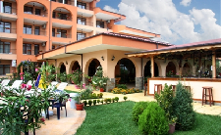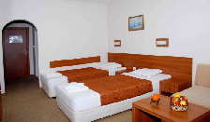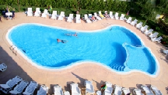
Localizare: in zona centrala a statiunii, construit 2008
Dotari camera: A/C;TV;baie;mini bar;balcon;
Facilitati hotel:: restaurant ;2 piscine;gradina;parcare;http://hotel-liani.com/
OFERTA LAST MINUTE COD « TK/29.05»
“DISCOUNT 10%”PT REZERVARILE TRIMISE PANA PE 9.06.2019 SI ACHITATE INTEGRAL IN 24 H- SEJUR IN PERIOADA 3.06-9.06.2019
ALL INCLUSIVE | 3.06-8.06 | 9.06
LOC IN CAMERA DUBLA | 23,5 | 27
CAMERA SINGLE FARA BALCON | 30 | 33,5
LOC IN TRIPLA | 23,5 | 27
APART 1 DORM/MAX 4 AD/ZI* | 90,5 | 102
TERMEN DE ANULARE | 11 | 16
PENALIZARI | 3 | 3
IN CAMERA DUBLA, MAXIM 2 ADULTI + 1 COPIL/ 3 ADULTI
IN CAMERA TRIPLA , MAXIM 3 ADULTI+ 1 COPIL / 4 ADULTI
REDUCERI :
- COPIL ( 0-1.99 ANI ) – GRATUIT, FARA SERVICII
- 1 COPIL ( 2-11.99 ANI ) IN PAT SUPLIM CU 2 SAU 3 ADULTI IN CAMERA –GRATUIT
- 1 COPIL ( 2-11.99 ANI ) CU 2 ADULTI IN TRIPLA- - FARA REDUCERE
- 1 COPIL ( 2-11.99 ANI ) IN PAT NORMAL CU 1 ADULT IN CAMERA – FARA REDUCERE
- 2 COPII ( 2-11.99 ANI ) CU 1 ADULT IN CAMERA - FIECARE PLATESTE 50%
-ADULT IN PAT SUPLIMENTAR – 20 % REDUCERE

HOTEL PALACE 3*+/SUNNY BEACH
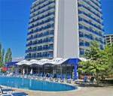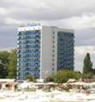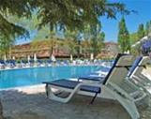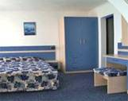
Localizare: pe plaja.
Dotari camera: aer conditionat, TV, frigider, telefon, balcon; baie cu dus
Facilitati hotel: : restaurant (cu muzica live ), lobby bar, piscina exterioara cu bar, masaj. cabinet medical, parcare, schimb valutar, seif la receptie.
OFERTA LAST MINUTE COD « TK/10.06; 117/05.06»
“DISCOUNT 20%”PT REZERVARILE TRIMISE IN PERIOADA 11.06-25.08.2019 SI ACHITATE INTEGRAL IN 24 H- SEJUR IN PERIOADA 03.07-25.08.2019
*SE POATE COMBINA CU NOPTI GRATUITE
DEMIPENSIUNE | 01.06-8.06  10.09-30.10 | 9.06–2.07  26.8–9.09 | 3.07–  25.08
LOC IN CAMERA DUBLA | 21,5 | 31 | 42
CAMERA SINGLE | 31 | 47,5 | 82
APART. 1 DORM. 2 ADULTI /ZI* | 65,5 | 92,5 | 123
APART. 1 DORM. 3 ADULTI /ZI* | 66,5 | 94 | 124
APART. 1 DORM. 4 ADULTI /ZI* | 84 | 119 | 157
TERMEN DE ANULARE | 12 | 16 | 18
PENALIZARI | 2 | 3 | 4

OFERTA LAST MINUTE COD « TK/29.05»
“DISCOUNT 25%”PT REZERVARILE TRIMISE IN PERIOADA 29.05-20.06.2019 SI ACHITATE INTEGRAL IN 24 H- SEJUR IN PERIOADA 3.06-21.06.2019
DEMIPENSIUNE | 3.06-8.06 | 9.06–21.06
LOC IN CAMERA DUBLA | 21,5 | 31
CAMERA SINGLE | 31 | 47,5
APART. 1 DORM. 2 ADULTI /ZI* | 65,5 | 92,5
APART. 1 DORM. 3 ADULTI /ZI* | 66,5 | 94
APART. 1 DORM. 4 ADULTI /ZI* | 84 | 119
TERMEN DE ANULARE | 12 | 16
PENALIZARI | 2 | 3

OFERTA LAST MINUTE COD « 117/05.06 »
“DISCOUNT 20%”PT REZERVARILE TRIMISE IN PERIOADA 05.06-25.08.2019 SI ACHITATE INTEGRAL IN 24 H- SEJUR IN PERIOADA 03.07-25.08.2019
*NU SE COMBINA CU ALTE OFERTE
DEMIPENSIUNE | 3.07–  25.08
LOC IN CAMERA DUBLA | 42
CAMERA SINGLE | 82
APART. 1 DORM. 2 ADULTI /ZI* | 123
APART. 1 DORM. 3 ADULTI /ZI* | 124
APART. 1 DORM. 4 ADULTI /ZI* | 157
TERMEN DE ANULARE | 18
PENALIZARI | 4

OFERTA LAST MINUTE COD « 094/13.05; TK/14.05»
“DISCOUNT 25%”PT REZERVARILE TRIMISE IN PERIOADA 14.05-20.06.2019 SI ACHITATE INTEGRAL IN 24 H- SEJUR IN PERIOADA 3.06-21.06.2019
DEMIPENSIUNE | 3.06-8.06 | 9.06–21.06
LOC IN CAMERA DUBLA | 21,5 | 31
CAMERA SINGLE | 31 | 47,5
APART. 1 DORM. 2 ADULTI /ZI* | 65,5 | 92,5
APART. 1 DORM. 3 ADULTI /ZI* | 66,5 | 94
APART. 1 DORM. 4 ADULTI /ZI* | 84 | 119
TERMEN DE ANULARE | 12 | 16
PENALIZARI | 2 | 3
* TARIFUL ESTE PE APARTAMENT, NR PERSOANE INDICATE IN TABEL
IN CAMERA DUBLA STANDARD MAXIM 2 ADULTI+1 COPIL
IN APARTAMENT MINIM 2 ADULTI+ 1 COPIL/ 3 ADULTI; MAXIM 2 ADULTI+ 3 COPII/3 ADULTI+ 2 COPII/ 4 ADULTI
REDUCERI :
- COPIL ( 0-1.99 ANI )– GRATUIT, FARA SERVICII
- 1 COPIL ( 2-11,99 ANI ) IN PAT SUPLIMENTAR IN DBL –GRATUIT
- AL 2 LEA COPIL ( 2-11,99 ANI ) IN PAT SUPLIM. CU 2 ADIN DBL -PLATESTE SUPLIMENT 4 €/ZI
- AL 3 LEA COPIL ( 2-11,99 ANI ) IN PAT SUPLIMENTAR -50% DIN LOC ADULT
- 1-2 COPII ( 2-11,99 ANI ) IN PAT SUPLIM. CU 3 AD -FIECARE PLATESTE 50%
- 1 COPIL ( 2-11.99 ANI ) CU 1 ADULT IN DBL–50 % ;20% REDUCERE IN PERIOADA VARF
- 2 COPII( 2-11.99 ANI ) CU 1 ADULT- FIECARE PLATESTE 50%
- ADULT IN PAT SUPLIMENTAR IN DBL – NU

HOTEL AZURRO 3*+/SUNNY BEACH
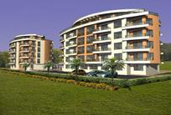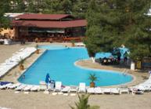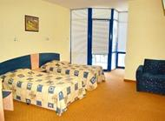
Localizare:la 200 m de plaja
Dotari camera:minibar, TV satelit, balcon ; Aer Conditionat
Facilitati hotel: : pool bar, piscina exterioara, fitness, loc de joaca pentru copii, schimb valutar, bar de zi.
OFERTA LAST MINUTE COD « 103/22.05»
MIC DEJUN | 16.6-26.06
LOC IN CAMERA DUBLA | 15,5
CAMERA SINGLE | 29
DEMIPENSIUNE | 16.6-26.06
LOC IN CAMERA DUBLA | 19
CAMERA SINGLE | 34,5
ALL INCLUSIVE | 16.6-26.06
LOC IN CAMERA DUBLA | 23,5
CAMERA SINGLE | 41,5
TERMEN DE ANULARE | 16
PENALIZARI | 3
IN CAMERA DUBLA MAXIM 2 ADULTI+1 COPIL /3 ADULTI
-AL 2 LEA COPIL FARA PAT !- PLATESTE SUPLIMENTE MASA !
REDUCERI :
- COPIL ( 0-1.99 ANI ) – GRATUIT, FARA SERVICII
- 1 COPIL ( 2-11.99 ANI ) CU 1 ADULT IN CAMERA - 50%
- 2 COPII ( 2-11.99 ANI ) CU 1 ADULT IN CAMERA –FIECARE PLATESTE 50 % CU MD + SUPLIMENTE PT FIECARE 2 €/ZI CU DP SAU ALL INCL
- 1 COPIL ( 2-11,99 ANI) IN PAT SUPLIM CU 2 ADULTI – GRATUIT
-ADULT IN PAT SUPLIMENTAR – 30 % REDUCERE

SUNRISE CLUB COMPLEX 3*/SUNNY BEACH
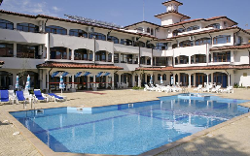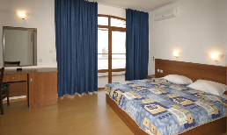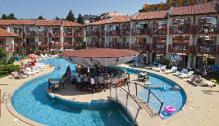
Localizare: la 3 min pe jos100 m de plaja
Dotari camere: baie,A/C; ,TV cablu,telefon ,baie cu dus sau cada;
Facilitati: restaurant; piscina; masaj;terasa; gradina;club copii;fitness;tenis masa; biliard;teren joaca copii;WI FI;parcare
OFERTA LAST MINUTE COD « 098/16.05»

“DISCOUNT 30%” PT REZERVARILE TRIMISE DE LA 16.05.2019 SI ACHITATE INTEGRAL IN 24 H- SEJUR IN PERIOADA 20.05-14.06.2019-EXCLUS AP 1 DORM
ALL INCLUSIVE | 20.05-9.06 | 10.06-14.06
LOC IN CAMERA DUBLA | 25,5 | 36
CAMERA SINGLE | 38 | 55,5
LOC IN CAMERA DUBLA LARGE | 28 | 42
CAMERA SINGLE | 55 | 82
TERMEN DE ANULARE | 12 | 18
PENALIZARI | 2 | 3
IN CAMERA DUBLA MAXIM 2 ADULTI
IN CAMERA DUBLA LARGE MAXIM 2 ADULTI+ 2 COPII/ 3 ADULTI
IN APARTAMENT MAXIM 2 ADULTI+ 2 COPII/ 3 ADULTI+ 1 COPIL
REDUCERI :
- COPIL ( 0-4.99 ANI ) – GRATUIT, FARA SERVICII
- 1 COPIL ( 5-12.99 ANI ) IN PAT SUPLIM.–GRATUIT
- AL 2 LEA COPIL ( 5-12.99 ANI ) IN PAT SUPLIM. IN DBL LARGE– GRATUIT
- AL 2 LEA COPIL ( 5-12.99 ANI ) IN PAT SUPLIM. IN DBL LARGE/AP – 20% REDUCERE
- AL 3 LEA ( 5-12.99 ANI ) IN PAT SUPLIM IN APART CU 2 AD-PLATESTE SUPLIMENT 5 €/ZI
- COPIL ( 5-12.99 ANI ) IN PAT SUPLIM IN APART CU 3 AD -20% REDUCERE
- 1 COPIL ( 5-12.99 ANI ) CU 1 ADULT IN DBL - FARA REDUCERE
- 2 COPII ( 5-12.99 ANI ) CU 1 ADULT IN DBL LARGE - FIECARE PLATESTE 50%
- AL 3-LEA ADULT IN PAT SUPLIMENTAR. –20 % REDUCERE
HOTEL DELFIN 3*/SUNNY BEACH
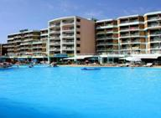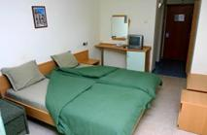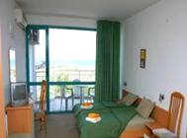

Localizare: la 50 m de plaja

Dotari camera:baie, aer conditionat, balcon, telefon, TV satelit, mini bar

Facilitati hotel:restaurant, bar de zi, lobby bar, loc de joaca pt. copii, piscina exterioara cu bar, piscina pt. copii, fitness
OFERTA LAST MINUTE COD « VT/05.06; 118/05.06 ; TK 10.06»

“DISCOUNT 25%”PT REZERVARILE TRIMISE IN PERIOADA 05.06-01.07.2019 SI ACHITATE INTEGRAL IN 24 H- SEJUR MINIM 2 NOPTI IN PERIOADELE 06.06-15.06/6.09-15.09.2019

“DISCOUNT 15%”PT REZERVARILE TRIMISE IN PERIOADA 05.06-01.07.2019 SI ACHITATE INTEGRAL IN 24 H- SEJUR MINIM 2 NOPTI IN PERIOADA 16.06-29.06.2019/08.07-18.07.2019

“DISCOUNT 10%”PT REZERVARILE TRIMISE IN PERIOADA 05.06-01.07.2019 SI ACHITATE INTEGRAL IN 24 H- SEJUR MINIM 2 NOPTI IN PERIOADA 28.07-5.09.2019

*NU SE COMBINA CU ALTE OFERTE
MIC DEJUN | 1.06-9.06 | 10.06- 20.06  6.09-5.09 | 21.06-7.07  24.08-5.09 | 8.07-23.08
LOC IN CAMERA DUBLA | 14 | 19 | 23,5 | 30
CAMERA SINGLE | 20 | 28 | 34 | 58,5
TRIPLA 3 ADULTI /ZI* | 38,5 | 53 | 66 | 84,5
TRIPLA 4 ADULTI /ZI* | 48 | 66,5 | 82,5 | 105,5
DEMIPENSIUNE | 1.06-9.06 | 10.06- 20.06  6.09-5.09 | 21.06-7.07  24.08-5.09 | 8.07-23.08
LOC IN CAMERA DUBLA | 20 | 25 | 29,5 | 36
CAMERA SINGLE | 24,5 | 34 | 40 | 65
TRIPLA 3 ADULTI /ZI* | 57 | 71,5 | 84,5 | 103
TRIPLA 4 ADULTI /ZI* | 71 | 89,5 | 105,5 | 129
PENSIUNE COMPLETA | 1.06-9.06 | 10.06- 20.06  6.09-5.09 | 21.06-7.07  24.08-5.09 | 8.07-23.08
LOC IN CAMERA DUBLA | 25,5 | 30,5 | 35 | 42
CAMERA SINGLE | 30 | 39,5 | 46 | 70,5
TRIPLA 3 ADULTI /ZI* | 73,5 | 88 | 101 | 119,5
TRIPLA 4 ADULTI /ZI* | 92 | 110,5 | 126,5 | 150
TERMEN DE ANULARE | 12 | 16 | 18 | 20
PENALIZARI | 2 | 3 | 4 | 4
IN CAMERA DUBLA MAXIM 2 ADULTI+ 1 COPIL/3 ADULTI
IN CAMERA TRIPLA MAXIM 3 ADULTI+ 1 COPIL/ 4 ADULTI
REDUCERI :
- COPIL ( 0-1.99 ANI ) – GRATUIT, FARA SERVICII
- 1- 2 COPII ( 2-11.99 ANI ) CU 1 ADULT - FIECARE PLATESTE 50%
- 1 COPIL ( 2-11.99 ANI ) IN PAT SUPLIMENTAR - GRATUIT
- ADULT IN PAT SUPLIMENTAR -25% REDUCERE

HOTEL ARDA 3*SUNNY BEACH
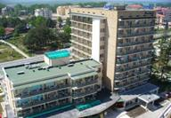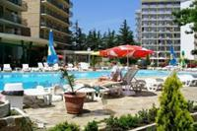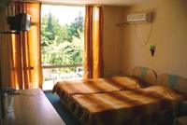
Localizare: in zona centrala a statiunii la circa 200 m de plaja
Dotari camera: Aer Conditionat , TV, frigider, balcon, baie renovata
Facilitati hotel: restaurant, lobby bar , schimb valutar, piscina exterioara cu bar, seif la receptie
OFERTA LAST MINUTE COD « 124/08.06»

“DISCOUNT 20%”PT REZERVARILE TRIMISE IN PERIOADA 11.06-24.08 SI ACHITATE INTEGRAL IN 24 H- SEJUR IN PERIOADA 01.07-24.08.2019
MIC DEJUN | 16.06 - 6.07  B | 7.07 - 24.08  C
LOC IN CAMERA DUBLA | 20 | 26
CAMERA SINGLE | 28,5 | 48,5
APART 1 DORM 3 ADULTI/ ZI* | 56,5 | 77
SUPLIMENT CINA ADULT/COPIL | 9/5 | 9/5
TERMEN DE ANULARE | 16 | 18
PENALIZARI | 3 | 4
*TARIFUL ESTE PENTRU TIP CAMERA, NR PERSOANE INDICATE IN TABEL
IN CAMERA DUBLA MAXIM 2 ADULTI+ 1 COPIL/ 3 ADULTI
IN APARTAMENT MAXIM 2 ADULTI+2 COPII/ 3 ADULTI+ 1 COPIL
REDUCERI :
- COPIL ( 0-1.99 ANI ) – GRATUIT, FARA SERICII
- 1 COPIL ( 2 -11,99 ANI ) IN PAT SUPLIM CU 2 ADULTI– GRATUIT
- AL 2-LEA COPIL ( 2 -11,99 ANI ) IN PAT SUPLIM IN AP– PLATESTE SUPLIMENT 5 €/ZI
-1 COPIL ( 2-11.99 ANI ) CU 1 ADULT–FARA REDUCERE IN PERIOADA VARF; IN REST 50%
- 2 COPII ( 2-11.99 ANI ) CU 1 ADULT–FIECARE PLATESTE 50%
- ADULT IN PAT SUPLIMENTAR - 20% REDUCERE

HOTEL SVEJEST 3*/SUNNY BEACH
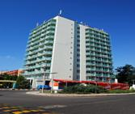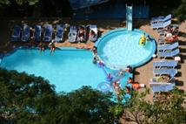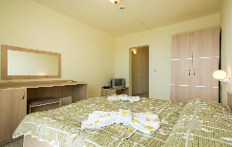
Localizare: in partea centrala a statiunii
Facilitati hotel: restaurant, bar, picina exterioara, sauna, sala fitness, salon masaj, loc de joaca pt copii, schimb valutar
Dotare camere : tv, balcón
OFERTA LAST MINUTE COD « 099/17.05»
“DISCOUNT 10%”PT REZERVARILE TRIMISE DE LA 17.05.2019 SI ACHITATE INTEGRAL IN 24 H-SEJUR IN PERIOADELE 1.06-30.06/1.08-20.09.2019
ALL INCLUSIVE LIGHT | 1.06-19.06  5.09-20.09 | 20.06-30.06  21.08-04.09 | 1.08–20.8
LOC IN CAMERA DUBLA | 24,5 | 28,5 | 35
CAMERA SINGLE | 36 | 42 | 69
TERMEN DE ANULARE | 14 | 18 | 20
PENALIZARI | 2 | 3 | 4
IN CAMERA DUBLA MAXIM 2 ADULTI+1 COPIL /3 ADULTI
REDUCERI :
- COPIL ( 0-1.99 ANI ) – GRATUIT, FARA SERVICII
- 1 COPIL ( 2-13,99 ANI ) IN PAT SUPLIMENTAR–GRATUIT
- AL 2 LEA COPIL ( 2-4,99 ANI ) CU 2 ADULTI IN CAMERA- GRATUIT, FARA PAT
- 1-2 COPII ( 2-13.99 ANI ) CU 1 ADULT IN CAMERA –FIECARE PLATESTE 50 %
- ADULT IN PAT SUPLIMENTAR IN DUBLA– 20 % REDUCERE

HOTEL SOL NESSEBAR PALACE 5*/NESSEBAR
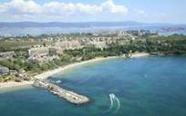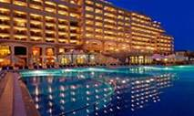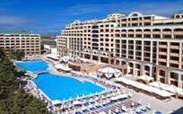

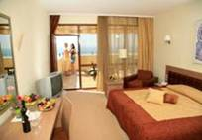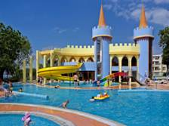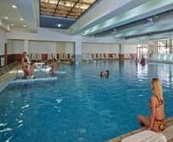
Localizare:se afla intr-o zona plina de verdeata chiar langa plaja la 2-3 km de centrul orasului.
Facilitati:restaurant a la carte, lobby bar, bar, animatie, bar la piscina cu cafea si gustari, discoteca. piscina interioara, spalatorie si curatatorie chimica.
AQUA PARK CU 4 TOPOGANE
Dotari camera:sunt dotate cu grup sanitar propriu, TV cablu, balcoane, telefon in camera si in baie, aer-conditionat, safe in camera, Uscator de par, minibar, cada si cabina de dus.
OFERTA LAST MINUTE COD « 103/22.05; TK/29.05»
“DISCOUNT 20%”PT REZERVARILE TRIMISE IN PERIOADA 23.05-11.07.2019 SI ACHITATE INTEGRAL IN 24 H- SEJUR IN PERIOADA 10.06-14.07.2017
ALL INCLUSIVE | 10.6-20.06  C | 21.06-30.06  D | 01.07-14.07  E
SEJUR MINIM / NOPTI | 7/1 | 7 | 7
LOC IN CAMERA VED PARK | 76,5 | 80 | 101
SUPLIM. CAMERA SINGLE | 45 | 56 | 62
LOC IN CAMERA VED MARE | 83 | 87,5 | 109
SUPLIM. CAMERA SINGLE | 45 | 56 | 62
TERMEN DE ANULARE | 18 | 20 | 20
PENALIZARI | 100% | 100% | 100%
IN CAMERA DUBLA , MAXIM 2 ADULTI+ 1 COPIL/ 3 ADULTI
INFANTII CONTEAZA LA OCUPARE !!
REDUCERI :
- COPIL ( 0-1.99 ANI ) – GRATUIT, FARA SERVICII
- 1 COPIL ( 2-11.99 ANI ) IN PAT SUPLIM CU 2 ADULTI–GRATUIT
- AL 2 LEA COPIL ( 2-11.99 ANI ) IN PAT SUPLIM CU 2 ADULTI- 50%
- 1 COPIL ( 2-11.99 ANI ) CU 1 ADULT IN CAMERA – 30% REDUCERE
- 2 COPII ( 2-11.99 ANI ) CU 1 ADULT IN CAMERA - FIECARE PLATESTE 50%
- ADULT IN PAT SUPLIMENTAR – 25 % REDUCERE
HOTEL SOL BAY & MARE 4*++/NESSEBAR
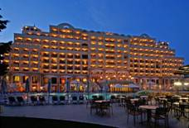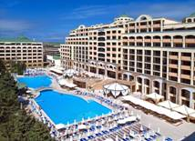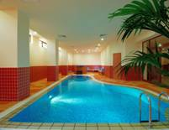

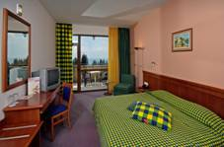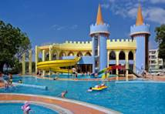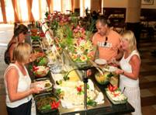
Localizare: pe plaja , intr-o zona retrasa , la cativa km de orasul-statiune Nessebar .
Facilitati: restaurant, bar, lobby, piscina, lift, discoteca, centru SPA, Internet, solar.
AQUA PARK CU 4 TOPOGANE
Dotari camera: aer conditionat, telefon, TV, uscator de par, balcon.
OFERTA LAST MINUTE COD « VT/29.05; TK/1.06; 113/3.06»
“DISCOUNT 15%”PT REZERVARILE TRIMISE IN PERIOADA 1.06-20.06.2019 SI ACHITATE INTEGRAL IN 24 H- SEJUR IN PERIOADA 9.06-23.06.2019
“DISCOUNT 15%”PT REZERVARILE TRIMISE IN PERIOADA 1.06-20.06.2019 SI ACHITATE INTEGRAL IN 24 H- SEJUR IN PERIOADA 29.06-7.07.2019
“DISCOUNT 15%”PT REZERVARILE TRIMISE IN PERIOADA 1.06-20.06.2019 SI ACHITATE INTEGRAL IN 24 H- SEJUR IN PERIOADA 30.08-SF SEZON
ALL INCLUSIVE | 23.09-31.10  A | 09.06  16.9-22.09  B | 10.6-20.06  30.08-15.09  C | 21.06-30.06  D | 01.07-29.08  E
SEJUR MINIM NOPTI | 1 | 1 | 7/1 | 7 | 7
LOC IN CAMERA VED PARK | 35,5 | 47 | 64 | 67,5 | 87,5
SUPLIM. CAMERA SINGLE | 17 | 28 | 45 | 45 | 62
LOC IN CAMERA VED MARE | 39 | 51 | 71 | 75 | 95,5
SUPLIM. CAMERA SINGLE | 17 | 28 | 45 | 45 | 62
LOC IN CAMERA FAMILY VED. MARE | 51 | 68 | 95,5 | 104,5 | 132,5
TERMEN DE ANULARE | 12 | 16 | 18 | 20 | 20
PENALIZARI | 100% | 100% | 100% | 100% | 100%
IN CAMERA DUBLA, MAXIM 2 ADULTI+2 COPII/ 3 ADULTI+ 1 COPIL
IN CAMERA FAMILY MINIM 2 ADULTI+ 2 COPII; MAXIM 3 ADULTI+ 2 COPII; MAXIM 4 ADULTI+2 COPII/6 ADULTI
INFANTII CONTEAZA LA OCUPARE !!
REDUCERI :
- COPIL ( 0-1.99 ANI ) – GRATUIT, FARA SERVICII
- 1 COPIL ( 2-11.99 ANI ) IN PAT SUPLIM CU 2 ADULTI–GRATUIT
- AL 2-LEA COPIL ( 2-11.99 ANI ) IN PAT SUPLIM.- 50%
- AL 3 LEA SI AL 4 LEA COPIL ( 2-11.99 ANI ) IN PAT SUPLIM.IN FAMILY-FIECARE PLATESTE 50%
- 1 COPIL ( 2-11.99 ANI ) CU 1 ADULT IN CAMERA – 30% REDUCERE
- 2COPII ( 2-11.99 ANI ) CU 1 ADULT IN CAMERA - FIECARE PLATESTE 50%
- ADULT IN PAT SUPLIMENTAR – 25 % REDUCERE
HOTEL MPM ARSENA 4*/NESSEBAR
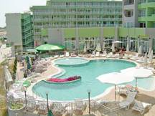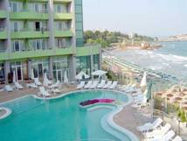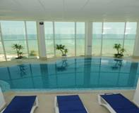

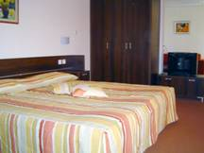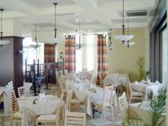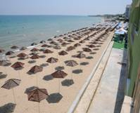
Localizare : in partea noua a Nessebar-ului , nu departe de orasul vechi in partea sudica a orasului nou ; pe plaja
Dotari camere : 75 camere duble , 6 studiouri , 3 apartammente , 2 apartamente VIP –cu ved la mare , aer conditionat , TV, minibar ,telefon, balcon, uscator de par, intrnet ,
Facilitate hotel : piscina exterioara cu sectiune pentru copii , piscine interioara, restaurant , bar , parcare http://www.hotelarsena.com/en/home/
OFERTA LAST MINUTE COD « VT/28.05;TK/29.05;113/3.06»
“DISCOUNT 15%”PT REZERVARILE TRIMISE IN PERIOADA 1.06-20.06.2019 SI ACHITATE INTEGRAL IN 24 H- SEJUR IN PERIOADA 14.08-SF SEZON
ULTRA ALL INCLUSIVE | 22.09-6.10 | 1.09-21.09 | 1.09-14.09 | 14.08-31.08
LOC IN DUBLA PROMO | 36,5 | 43 | 56 | 74
SUPLIMENT CAMERA SINGLE | 0 | 22,5 | 58,5 | 76,5
LOC IN DUBLA STANDARD | 40 | 46 | 59,5 | 77,5
LOC IN APART 1 DORM | 45,5 | 51,5 | 66 | 85,5
TERMEN DE ANULARE | 10 | 16 | 16 | 20
PENALIZARI | 2 | 3 | 4 | 5

OFERTA LAST MINUTE COD « 029/15.02 ; VT/20.02; TK/20.02»
ULTRA ALL INCLUSIVE | 17.09-6.10
LOC IN DUBLA STANDARD | 23,5
TERMEN DE ANULARE | 10
PENALIZARI | 2
TARIFUL INCLUDE 1 UMBRELA SI 2 SEZLONGURI /CAMERA PE PLAJADE LA 1.06- IN LIMITA DISP
IN CAMERA DUBLA PROMO MAXIM 2 ADULTI+ 1 COPIL/ 3 ADULTI
IN CAMERA DUBLA STANDARD MAXIM 2 ADULTI+ 2 COPII/ 3 ADULTI
IN SUITE MAXIM 2 ADULTI+ 2 COPII/4 ADULTI
REDUCERI :
- 1 COPIL ( 0-12.99 ANI )IN PAT SUPLIMENTAR CU 2 ADULTI– GRATUIT
- AL 2 LEA COPIL ( 2-12.99 ANI )IN PAT SUPLIMENTAR - 50%
- 1 COPIL ( 2-12.99 ANI ) CU 1 ADULT IN DBL –25% REDUCERE
- 2 COPII ( 2-12.99 ANI ) CU 1 ADULT IN DBL- FIECARE PLATESTE 50%
- ADULT IN PAT SUPLIMENTAR – 20 % REDUCERE
NOPTI GRATUITE
1)7=5 ;10=8 ;11=9 ;14=10 VALABIL PT SOSIRI IN PERIOADELE 11.05-26.05/17.09-6.10.2019
2)7=6 ;10=9 ;11=10 ;14=12 VALABIL PT SOSIRI IN PERIOADELE 27.05-7.06/10.09-16.09.2019

HOTEL SOL MARINA PALACE 4*/NESSEBAR
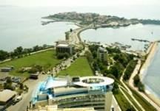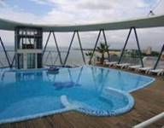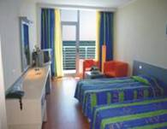
Localizare: 300 m de plaja si la 500 m de centrul orasului.
Facilitati: restaurant, receptie, bar, lobby bar, piscina, lift, sala de conferinte, centru de relaxarw, parcare, Internet.
Dotari camera: TV satelit, telefon, aer conditonat, grup sanitar cu uscator de par, mini bar, balcon.
OFERTA LAST MINUTE COD « 114/3.06 »
“DISCOUNT 15%”PT REZERVARILE TRIMISE IN PERIOADA 3.06-15.06.2019 SI ACHITATE INTEGRAL IN 24 H- SEJUR IN PERIOADA 1.07-31.08.2019
“DISCOUNT 10%”PT REZERVARILE TRIMISE IN PERIOADA 3.06-15.06.2019 SI ACHITATE INTEGRAL IN 24 H- SEJUR IN PERIOADELE 12.06-30.06/1.09-30.09.2019
ALL INCLUSIVE LIGHT | 26.9- 30.09  A | 12.6- 15.06  13.9-25.9  B | 16.6-30.06  26.8-12.09  C | 01.07-  25.08  D
SEJUR MINIM /NOPTI | 1 | 1 | 7/1 | 7
LOC IN CAMERA MICA VED. LATERALA MARE | 33,5 | 42,5 | 55 | 71
SUPLIMENT CAMERA SINGLE | +50% | +60% | +70% | +80%
LOC IN CAMERA MARE VED. LATERALA MARE | 33,5 | 42,5 | 55 | 71
SUPLIMENT CAMERA SINGLE | +50% | +60% | +70% | +80%
TERMEN DE ANULARE | 10 | 18 | 18 | 20
PENALIZARI | 100% | 100% | 100% | 100%
IN CAMERA DUBLA MICA MAXIM 2 ADULTI
IN CAMERA DUBLA MAXIM 2 ADULTI+ 1 COPIL/ 3 ADULTI
REDUCERI :
- COPIL ( 0-1.99 ANI ) – GRATUIT, FARA SERVICII
- 1 COPIL ( 2-11.99 ANI ) IN PAT SUPLIM.CU 2 ADULTI IN CAMERA –50%
- 1 COPIL ( 2-11.99 ANI ) CU 1 ADULT IN CAMERA –FARA REDUCERE
- 2 COPII ( 2-11.99 ANI ) CU 1 ADULT IN CAMERA- PRIMUL 30% REDUCERE;AL 2-LEA 50%
- ADULT IN PAT SUPLIM. –20 % REDUCERE

APARTCOMPLEX ESTEBAN 4*/NESSEBAR
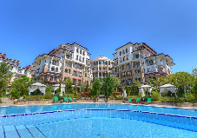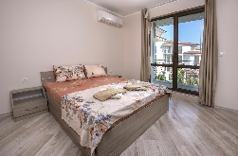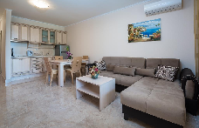
Localizare: la 3,3 km de orasul;vechi
Dotari camere: A/C ; TV ;balcon ;baie cu cada sau dus ;uscator par ;living ;frigider ;chichineta ; cuptor microunde ;
Facilitati: internet ;restautante ;centru spa si welness ; sauna ; masaj ;3 piscine exterioare ;sala jocuri ;bar ;gradina ; WI FI ; parcare
OFERTA LAST MINUTE COD « 108/28.05 »
“DISCOUNT 25%”PT REZERVARILE TRIMISE PANA PE 15.06.2019 SI ACHITATE INTEGRAL IN 24 H- SOSIRI IN PERIOADELE 28.05-18.06/1.09-30.09.2019
FARA MASA | 20.5-26.5  05.9-30.9 | 26.6-18.6  1.09-4.9
SEJUR MINIM NOPTI | 1 | 1
STUDIO CU SOFA 3 ADULTI/ZI* | 42 | 55
SUPLIMENT SINGLE | +80% | +80%
APART. 1 DORM CU SOFA 3 AD+ 1 COPIL/ZI* | 65 | 81
APART. 2 DORM CU SOFA 4 AD+ 1 COPIL/ZI* | 101 | 112
APART. 2 DORM CU SOFA 6 AD+ 2 COPII/ZI* | 120 | 138
SUPLIMENT MD ADULT/COPIL | 6/3 | 6/3
SUPLIMENT CINA ADULT/COPIL | 14/10 | 14/10
TERMEN DE ANULARE | 14 | 16
PENALIZARI | 100% | 100%
REDUCERI :
- COTAT COPIL 2-11,99 ANI

APARTCOMPLEX POSEIDON 4*NESSEBAR RAVDA
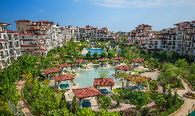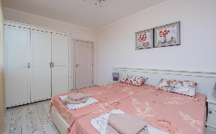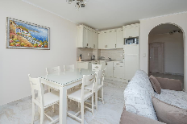
Localizare: la 5 minut pe jos fata de plaja intre Ravda si Nessebar
Dotari camera: A/C;TV, grup sanitar,uscator par; telefon, balcon;frigider;chichineta;
Facilitati: restaurant;piscina;WI FI;seif;parcare;fitness;gradina;masa biliard;darts;masaj;sauna;spa-welness
OFERTA LAST MINUTE COD « 108/28.05 »
“DISCOUNT 25%”PT REZERVARILE TRIMISE PANA PE 15.06.2019 SI ACHITATE INTEGRAL IN 24 H- SOSIRI IN PERIOADELE 28.05-18.06/1.09-30.09.2019
FARA MASA | 5.9-30.9 | 26.6-9.7  1.09-4.9
SEJUR MINIM NOPTI | 1 | 1
STUDIO CU SOFA 3 AD /ZI* | 41,5 | 55
SUPLIMENT SINGLE | +80% | +80%
APART. 1 DORM CU SOFA 3 AD+ 1 COPIL/ZI* | 67 | 81
APART. 2 DORM CU SOFA 4 AD+ 1 COPIL/ZI* | 100 | 112
APART. 2 DORM CU SOFA 6 AD+ 2 COPII/ZI* | 120 | 138
SUPLIMENT MD ADULT/COPIL | 6/3 | 6/3
SUPLIMENT CINA ADULT/COPIL | 14/10 | 14/10
TERMEN DE ANULARE | 14 | 16
PENALIZARI | 100% | 100%
REDUCERI :
- COTAT COPIL 2-11,99 ANI

APARTHOTEL PARADISO 4*/NESSEBAR
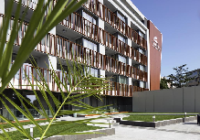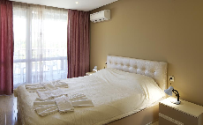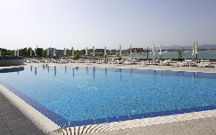
Localizare: la 1 minut pe jos fata de plaja
Dotari camera: A/C;TV, grup sanitar, telefon, balcon;frigider
Facilitati: restaurant;piscina;WI FI;seif;parcare;fitness;
OFERTA LAST MINUTE COD « 129/11.06 »
“DISCOUNT 20%” PT REZERVARILE TRIMISE IN PERIOADA 12.06-23.08.2019 SI ACHITATE INTEGRAL IN 24 H- SOSIRI IN PERIOADA 01.07-25.08.2019
*NU SE COMBINA CU ALTE OFERTE
FARA MASA | 1.5-31.05  5.9-15.10 | 1.06-10.06 | 11.6-14.7  21.8-4.09 | 15.07-20.08
APART. 1 DORM VED. PARK  MAX 3 AD+ 1 COPIL/ZI* | 48 | 66 | 88,5 | 98,5
APART. 1 DORM VED. MARE  MAX 3 ADULTI+ 1 COPIL/ZI* | 59,5 | 77 | 99,5 | 110
SUPLIMENT MD ADULT/COPIL | 4/3 | 4/3 | 4/3 | 4/3
TERMEN DE ANULARE | 10 | 14 | 16 | 25
PENALIZARI | 100% | 100% | 100% | 100%

REDUCERI :
- COTAT COPIL 2-11,99 ANI
HOTEL BIJOU 3*+NESSEBAR RAVDA
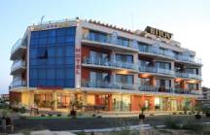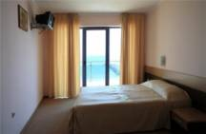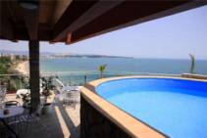
Localizare: pe plaja.
Facilitati: receptie, lift, piscina exterioara ( mica ) bar, lobby bar, restaurant, magazine, Internet, sauna, masaj, Spa, solar, tennis de masa, billiard, cabinet medical,parcare.
Dotari camere: aer conditionat, mini bar, telefon, TV, WC, uscator de par, balcon.
OFERTA LAST MINUTE COD « TK 10.06 »
“DISCOUNT 10%” PT REZERVARILE TRIMISE IN PERIOADA 12.06-30.06.2019 SI ACHITATE INTEGRAL IN 24 H- SOSIRI IN PERIOADA 10.06-31.07.2019
*SE COMBINA CU NOPTI GRATUITE ATUNCI CIND SE APLICA
DEMIPENSIUNE | 20.05-15.06  04.09-30.09 | 16.06-10.07  24.08-03.09 | 11.07-  23.08
LOC IN CAMERA VED.PARK | 21 | 27,5 | 35
CAMERA SINGLE | 31 | 43 | 58,5
LOC IN CAMERA VED.MARE | 23,5 | 29,5 | 37,5
CAMERA SINGLE | 34,5 | 46,5 | 62,5
LOC IN CAMERA DELUXE VED.MARE | 29 | 35 | 43
CAMERA SINGLE | 43 | 55,5 | 72
SUPLIMENT STUDIO VED. MARE/CAMERA | 22 | 22 | 22
SUPLIMENT APART. VED. MARE/CAMERA | 22 | 22 | 22
TERMEN DE ANULARE | 12 | 14 | 18
PENALIZARI | 3 | 3 | 4
BONUS CAMERA DUBLA DELUXE: APA MINERALA( 1,5 L) SI VIN ROSU&ALB(0,75 L)
IN CAMERA DUBLA MAXIM 2 ADULTI+1 COPIL/ 3 ADULTI
IN CAMERA DELUXE MAXIM 2 ADULTI
IN STUDIO MAXIM 2 ADULTI+ 2 COPII/3 ADULTI
IN APARTAMENT MAXIM 2 ADULTI+ 3 COPII/3 ADULTI
ATENTIE: SUPLIMENTELE STUDIO/APARTAMENT SE ADAUGA PESTE VALOARE CAMERA DUBLA VEDERE MARE
REDUCERI :
- COPIL ( 0-1.99 ANI ) – GRATUIT, FARA SERVICII/ PATUT LA RECEPTIE 6 LEVA/ZI
-1 COPIL ( 2-12.99 ANI ) IN PAT SUPLIMENTAR –GRATUIT
- AL 2 LEA SI AL 3 LEA COPIL ( 2-12.99 ANI ) IN PAT SUPLIMENTARIN STUDIO/AP- FIECARE PLATESTE 50% DIN LOC IN DBL SV
- 1 -2 COPII ( 2-12.99 ANI ) CU 1 ADULT IN DBL –FIECARE PLATESTE 50 %
- ADULT IN PAT SUPLIMENTAR – 30 % REDUCERE
NOPTI GRATUITE VALABIL PT SOSIRI PANA PE 15.06.
  - NOAPTE GRATUITA PT SEJUR 7-13 NOPTI
2)2 NOPTI GRATUITE PT SEJUR 14-20 NOPTI
3)3 NOPTI GRATUITE PT SEJUR DE LA 21 NOPTI

PARK HOTEL OASIS 3*/NESSEBAR
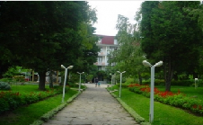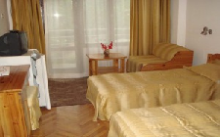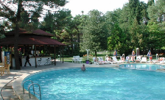
Localizare: intr.-o fumoasa gradina de verdeata ; la 50-100 m de plajă , nisip fin
Facilitati:centru sportiv; fitness; masaj ;sauna; solar; restaurante ;terasa vara; water bar; bistro; seif ;piscine ;billiard ;jocuri ; parcare; http://www.oasishotels.net/
Dotari camera: TV cablu;telefon; frigider; balcon; baie; A/C; internet;
OFERTA LAST MINUTE COD « TK/17.05»
“DISCOUNT 10%”PT REZERVARILE TRIMISE PANA PE 15.06.2019 SI ACHITATE INTEGRAL IN 24 H- SEJUR IN PERIOADA 17.05-15.06.2019
“DISCOUNT 10%”PT REZERVARILE TRIMISE DE LA 17.05.2019 SI ACHITATE INTEGRAL IN 24 H- SEJUR IN PERIOADA 17.05-30.09.2019
*SE POATE COMBINA CU NOPTI GRATUITE
MIC DEJUN | 1.05- 31.05  17.09-30.9 | 1.06-15.6  10.9-16.9 | 16.06-1.07  29.08-9.09 | 2.07-13.07  17.08-28.8 | 14.07-16.08
LOC IN CAMERA DUBLA | 18 | 21 | 28,5 | 37,5 | 42
CAMERA SINGLE | 21 | 28 | 51 | 71 | 77,5
STUDIO STANDARD/2 ADULTI+ 2 COPII/3 ADULTI/ZI* | 36 | 43,5 | 64 | 88,5 | 97,5
APART. STANDARD/ 4 ADULTI/ZI* | 58 | 65 | 98 | 143 | 157
APART. LUX /4 ADULTI/ ZI* | 72 | 82 | 117,5 | 165 | 179
ALL INCLUSIVE | 1.05- 31.05  17.09-30.9 | 1.06-15.6  10.9-16.9 | 16.06-1.07  29.08-9.09 | 2.07-13.07  17.08-28.8 | 14.07-16.08
LOC IN CAMERA DUBLA | 22 | 25,5 | 33 | 44 | 51
CAMERA SINGLE | 25,5 | 32,5 | 57,5 | 77,5 | 86,5
STUDIO STANDARD/2 ADULTI+ 2 COPII/3 ADULTI/ZI* | 49 | 57 | 77 | 104 | 113
APART. STANDARD/ 4 ADULTI/ZI* | 75 | 82 | 123 | 168 | 182
APART. LUX /4 ADULTI/ ZI* | 89 | 98,5 | 143 | 190,5 | 204,5
PENALIZARE ANULARI | 100% | 100% | 100% | 100% | 100%
*TARIFUL ESTE PT TOT APARTAMENTUL/STUDIOUL
IN CAMERA DUBLA MAXIM 2 ADULTI+ 1 COPIL/ 3 ADULTI
IN STUDIO MAXIM 2 ADULTI+ 2 COPII/4 ADULTI
IN APARTAMENT MAXIM 2 ADULTI+ 2 COPII/ 4 ADULTI
IN APARTAMENT LUX MAXIM 2 ADULTI+ 2 COPII/ 4 ADULTI
REDUCERI :
- COPIL ( 0-1.99 ANI ) – GRATUIT, FARA SERVICII
- 1 COPIL ( 2-11.99 ANI ) IN PAT SUPLIM CU 2 ADULTI– GRATUIT
- 1-2 COPII ( 2-11.99 ANI ) CU 1 ADULT- FIECARE PLATESTE 50%
- 1 COPIL ( 2-11.99 ANI ) IN PAT NORMAL IN AP- FARA REDUCERE
- 1 COPIL ( 2-11.99 ANI ) IN PAT SUPLIM IN AP- FIECARE PLATESTE SUPLIMENT 3 €/ZI
- ADULT IN PAT SUPLIMENTAR IN DBL- 25% REDUCERE

HOTEL COMPLEX KAMENETS 3*( LOW BUILDING)/NESSEBAR
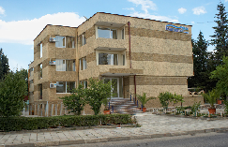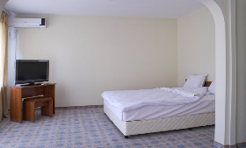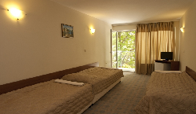
Localizare: in zona orasului nou Nessebar , la 100 m de plaja
Facilitati: lobby ; parcare ; restaurant
Dotari camera: baie; TV; balcon;
OFERTA LAST MINUTE COD « 101/21.05;TK/21.05»
“DISCOUNT 10%”PT REZERVARILE TRIMISE IN PERIOADA 21.05-30.06.2019 SI ACHITATE INTEGRAL IN 24 H
ALL INCLUSIVE | 1.06-20.06  809-30.09 | 21.06-3.07  1.09-7.09 | 4.07-17.07  18.08-31.08 | 18.07-17.08
LOC IN CAMERA DUBLA | 23 | 29,5 | 37 | 38
SUPLIMENT CAMERA SINGLE | +50% | +80% | +80% | +80%
TERMEN DE ANULARE | 10 | 16 | 20 | 20
PENALIZARI | 2 | 2 | 3 | 3
IN CAMERA DUBLA MAXIM 2 ADULTI+ 2 COPII/ 3 ADULTI
REDUCERI :
- COPIL ( 0-1.99 ANI ) – GRATUIT FARA SERVICII
- 1 COPIL (2-11,99 ANI) CU 1 ADULT- FARA REDUCERE
- 2 COPII (2-11,99 ANI) CU 1 ADULT- FIECARE PLATESTE 50%
- 1 COPIL (0-11,99 ANI) IN PAT SUPLIMENTAR- GRATUIT
- AL 2 LEA COPIL (2-11,99 ANI) IN PAT SUPLIMENTAR- 50%
- ADULT IN PAT SUPLIMENTAR – 20% REDUCERE

HOTEL COMPLEX KAMENETS 3*+ ( FOST HAWAII )
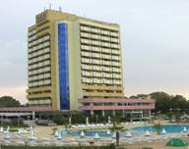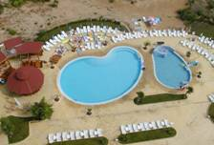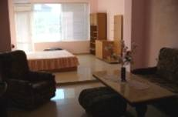
Localizare: este situat in zona istorica a orasului Nessebar, aproape de plaja.
Facilitati:restaurant principal, lobby bar, piscina exterioara cu sectiune pentru copii, bar la piscina, salon de masaj, magazine, coafor, teren de joaca pentru copii, seif la receptie, casa de schimb.
Dotari camera:dus, balcon, tv, telefon si aer conditionat.
OFERTA LAST MINUTE COD « 101/21.05; TK/21.05»
“DISCOUNT 10%”PT REZERVARILE TRIMISE IN PERIOADA 21.05-30.06.2019 SI ACHITATE INTEGRAL IN 24 H
ALL INCLUSIVE | 1.06-20.06  809-30.09 | 21.06-3.7  1.09-7.09 | 4.07-17.07  18.08-31.8 | 18.07-17.08
LOC IN CAMERA ECONOMICA | 25,5 | 30,5 | 38 | 40,5
SUPLIMENT CAMERA SINGLE | +50% | +80% | +80% | +80%
LOC IN STUDIO | 30 | 40,5 | 46 | 48,5
SUPLIMENT CAMERA SINGLE | +50% | +80% | +80% | +80%
TERMEN DE ANULARE | 10 | 16 | 20 | 20
PENALIZARI | 2 | 2 | 3 | 3
IN CAMERA DUBLA ECONOMICA MAXIM 2 ADULTI+ 1 COPIL
IN STUDIO MAXIM 2 ADULTI+ 2 COPII/ 3 ADULTI
REDUCERI :
- COPIL ( 0-1.99 ANI ) – GRATUIT FARA SERVICII
- 1 COPIL (2-11,99 ANI) CU 1 ADULT IN DBL EC- FARA REDUCERE
- 2 COPII (2-11,99 ANI) CU 1 ADULT IN STUDIO - FIECARE PLATESTE 50%
- 1 COPIL (0-6,99 ANI) IN PAT SUPLIMENTARIN DBL EC- GRATUIT
- 2 COPIL ( 2-11,99 ANI) IN PAT SUPLIM IN STUDIO- 1 GRATUIT; AL 2 LEA 50%
- AL 2 LEA COPIL (2-11,99 ANI) IN PAT SUPLIMENTAR- 50%
- ADULT IN PAT SUPLIMENTAR – 20% REDUCERE

HOTEL BIJOU 3*+/RAVDA
Localizare: pe plaja.
Facilitati: receptie, lift, piscina exterioara ( mica ) bar, lobby bar, restaurant, magazine, Internet, sauna, masaj, Spa, solar, tennis de masa, billiard, cabinet medical,parcare.
Dotari camere: aer conditionat, mini bar, telefon, TV, WC, uscator de par, balcon.
OFERTA LAST MINUTE COD « 119/06.06 »
“DISCOUNT 10%”PT REZERVARILE TRIMISE IN PERIOADA 06.06-30.06.2019 SI ACHITATE INTEGRAL IN 24 H-SEJUR IN PERIOADA 06.06-31.07.2019
* SE POATE COMBINA CU NOPTI GRATUITE
DEMIPENSIUNE | 20.05-15.06  04.09-30.09 | 16.06-10.07  24.08-03.09 | 11.07-23.08
LOC IN CAMERA VED.PARK | 21 | 27,5 | 35
CAMERA SINGLE | 31 | 43 | 58,5
LOC IN CAMERA VED.MARE | 23,5 | 29,5 | 37,5
CAMERA SINGLE | 34,5 | 46,5 | 62,5
LOC IN CAMERA DELUXE VED.MARE | 29 | 35 | 43
CAMERA SINGLE | 43 | 55,5 | 72
SUPLIMENT STUDIO VED. MARE/CAMERA | 22 | 22 | 22
SUPLIMENT APART. VED. MARE/CAMERA | 22 | 22 | 22
TERMEN DE ANULARE | 12 | 14 | 18
PENALIZARI | 3 | 3 | 4
BONUS CAMERA DUBLA DELUXE: APA MINERALA( 1,5 L) SI VIN ROSU&ALB(0,75 L)
IN CAMERA DUBLA MAXIM 2 ADULTI+1 COPIL/ 3 ADULTI
IN CAMERA DELUXE MAXIM 2 ADULTI
IN STUDIO MAXIM 2 ADULTI+ 2 COPII/3 ADULTI
IN APARTAMENT MAXIM 2 ADULTI+ 3 COPII/3 ADULTI
ATENTIE: SUPLIMENTELE STUDIO/APARTAMENT SE ADAUGA PESTE VALOARE CAMERA DUBLA VEDERE MARE
REDUCERI :
- COPIL ( 0-1.99 ANI ) – GRATUIT, FARA SERVICII/ PATUT LA RECEPTIE 6 LEVA/ZI
-1 COPIL ( 2-12.99 ANI ) IN PAT SUPLIMENTAR –GRATUIT
- AL 2 LEA SI AL 3 LEA COPIL ( 2-12.99 ANI ) IN PAT SUPLIMENTARIN STUDIO/AP- FIECARE PLATESTE 50% DIN LOC IN DBL SV
- 1 -2 COPII ( 2-12.99 ANI ) CU 1 ADULT IN DBL –FIECARE PLATESTE 50 %
- ADULT IN PAT SUPLIMENTAR – 30 % REDUCERE
NOPTI GRATUITEVALABIL PT SOSIRI PANA PE 15.06. SI DIN 4.09.2019
  - NOAPTE GRATUITA PT SEJUR 7-13 NOPTI
2)2 NOPTI GRATUITE PT SEJUR 14-20 NOPTI
3)3 NOPTI GRATUITE PT SEJUR DE LA 21 NOPTI

APARTHOTEL MARTINEZ 4*/ SOZOPOL
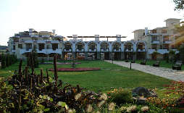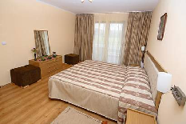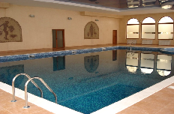
Localizare:in zona noua a statiunii;30 m de plaja
Dotari camere: grup sanitar, Tv-satelit, telefon , aer conditionat, chicineta.
Facilitati: restaurant, loc de joaca pentru copii;seif;parcare;lobby bar;biliard;sky bar;mini golf;fitness;piscina interioara si exterioara;sauna;spa
OFERTA LAST MINUTE COD « TK/21.05 »
“DISCOUNT SUPLIMENTAR 10%”PT REZERVARILE TRIMISE IN PERIOADA 21.05-15.06.2019 SI ACHITATE INTEGRAL IN 24 H- SEJUR IN PERIOADA 1.07-31.07.2019
SE COMBINA CU SPO TK/3.05
ALL INCLUSIVE | 1.07-31.07
SEJUR MINIM NOPTI | 7
APART. 1 DORM.2 ADULTI / ZI* | 157,5
APART. 1 DORM.3 ADULTI / ZI* | 220,5
APART. 1 DORM.4 ADULTI / ZI* | 284
SUPLIM. VED. MARE IN APART./PERS | 8
TERMEN DE ANULARE | 16
PENALIZARI | 4
*TARIFUL ESTE PENTRU TIP SPATIU, NR PERSOANE INDICATE IN TABEL
IN STUDIO MAXIM 2 ADULTI
IN APART. 1 DORM MAXIM 2 ADULTI+ 2 COPII/ 4 ADULTI
IN APART. SUPERIOR 1 DORM MAXIM 2 ADULTI+ 3 COPII/ 3 ADULTI
REDUCERI :
- COPIL (0-1,99 ANI) GRATUIT,FARA SERVICII
- COPIL ( 2-13,99 ANI) CU 1 ADULT- FARA REDUCERE
- 1 COPIL ( 0-6,99 ANI) IN PAT SUPLIMENTAR- GRATUIT
- AL 2 LEA SAU AL 3 LEA COPIL ( 0-6,99 ANI) IN PAT SUPLIMENTAR-PLATESTE FIECARE SUPLIMENT 15 €/ZI
- COPII( 7-13,99 ANI) IN PAT SUPLIMENTAR- 50%
- ADULT IN PAT SUPLIMENTAR- 20% REDUCERE

HOTEL CHUCHULEV 3*SOZOPOL
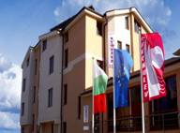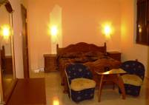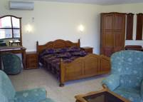
Localizare: la 80 m de la plaja « Harmanite »
Dotari camere: A/C,frigider,TV cablu,balcon cu vedere sper mare (majoritatea)
Facilitati:http://www.hotel-chuchulev.com/index.php?action=page_display&PageID=11
OFERTA LAST MINUTE COD « TK 10.06 ;116/04.06 »
“DISCOUNT 15%”PT REZERVARILE TRIMISE IN PERIOADA 05.06-20.06.2019 SI ACHITATE INTEGRAL IN 24 H (EXCEPTIE CAMERELE ECONOMICE)-SOSIRI IN PERIOADA 05.06-20.06.2019
*NU SE COMBINA CU ALTE OFERTE
FARA MASA | 05.06 -14.06 | 15.06 -20.06
LOC IN CAMERA DUBLA | 14,5 | 19,5
CAMERA SINGLE | 25,5 | 34
CAMERA TRIPLA 3 ADULTI/ZI* | 36 | 49
APART. 2 DORM. / 4 ADULTI/ZI* | 50,5 | 66
SUITE DELUXE 2 ADULTI/ZI* | 35,5 | 46,5
LOC IN DUBLA ECONOMY | 11 | 15
CAMERA SINGLE | 19 | 26
SUITE DELUXE PROMO/2 AD/ZI* | 31 | 41
APART. 2 DORM. ECONOMY / 4 ADULTI/ZI* | 41,5 | 55
MIC DEJUN | 05.06 -14.06 | 15.06 -20.06
LOC IN CAMERA DUBLA | 19 | 24
CAMERA SINGLE | 30 | 38,5
CAMERA TRIPLA 3 ADULTI/ZI* | 49,5 | 62,5
APART. 2 DORM. / 4 ADULTI/ZI* | 68 | 84
SUITE DELUXE 2 ADULTI/ZI* | 44,5 | 55,5
LOC IN DUBLA ECONOMY | 15,5 | 19,5
CAMERA SINGLE | 23,5 | 30,5
SUITE DELUXE PROMO/2 AD/ZI* | 40 | 50
APART. 2 DORM. ECONOMY / 4 ADULTI/ZI* | 59,5 | 73
TERMEN DE ANULARE | 9 | 12
PENALIZARI | 2 | 2
*TARIFUL ESTE PT TIP CAMERA, NR PERSOANE INDICATE IN TABEL
IN CAMERA DUBLA MAXIM 2 ADULTI
IN CAMERA TRIPLA MAXIM 3 ADULTI
IN APARTAMENT 2 DORMITOARE MINIM 3 ADULTI+1 COPIL/ MAXIM 4 ADULTI
IN SUITE DELUXE MAXIM 2 ADULTI
MICUL DEJUN SE SERVESTE IN RESTAURANT VERANDA, LA 100 M.
REDUCERI:
- COPIL (0 -11.99 ANI) CU 1 ADULT IN CAMERA DUBLA – TARIF SGL; PLATESTE SUPLIMENT 4 €/MD
- COPIL (0 -11.99 ANI) IN PAT SUPLIMENTAR- PLATESTE SUPLIMENT 3 €/ZI

HOTEL AMON RA 3* SOZOPOL
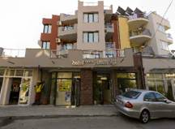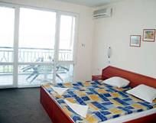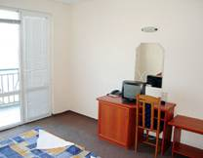
Localizare: la 20 m de plaja ‘’Harmanite’’
Dotari camere: TV,internet wi-fi,telefon,A/C,balcon, seif.
Facilitati: restaurant,room service,centru medical,transfer,centru de inchiriat masini ; http://amonra.domino.bg/hotel_e.htm
OFERTA LAST MINUTE COD « 129/11.06 »
“DISCOUNT 18%”PT REZERVARILE TRIMISE IN PERIOADA 11.06-25.06.2019 SI ACHITATE INTEGRAL IN 24 H PENTRU SEJUR IN PERIOADA 11.06-25.09.2019
MIC DEJUN | 1.06-10.06  11.09-30.9 | 11.06-30.6  26.08-10.9 | 01.7-10.07 | 11.07-  25.08
LOC IN CAMERA VED. PARK | 19 | 21,5 | 24 | 26
CAMERA SINGLE | 32,5 | 37,5 | 46,5 | 51
STUDIO 3 ADULTI /ZI* | 42 | 49 | 57 | 66
APART. 1 DORM. PV 3 AD /ZI* | 45 | 49 | 66 | 77
APART. 1 DORM. SV 3 AD/ZI* | 47,5 | 54,5 | 71,5 | 82,5
APART. 1 DORM. CU CHICINETA 3 AD/ZI* | 47,5 | 54,5 | 71,5 | 82,5
APART. 2 DORM. 4-5 AD/ZI* | 54,5 | 63 | 74 | 91
SUPLIMENT DP ADULT /COPIL | 9/5 | 9/5 | 9/5 | 9/5
TERMEN DE ANULARE | 9 | 12 | 14 | 16
PENALIZARI | 2 | 2 | 3 | 4
*TARIFUL ESTE PENTRU TIP CAMERA, NR PERSOANE INDICATE IN TABEL
IN CAMERA DUBLA PV MAXIM 2 ADULTI+ 1 COPIL/ 3 ADULTI
IN CAMERA DUBLA SV MAXIM 2 ADULTI
IN STUDIO MAXIM 2 ADULTI+ 2 COPII/ 3 ADULTI
IN APARTAMENT 1 DORMITOR MAXIM 2 ADULTI+ 2 COPII/ 3 ADULTI
IN APARTAMENT 2 DORMITOARE MINIM 4 ADULTI; MAXIM 4 ADULTI+ 2 COPII/ 5 ADULTI
REDUCERI:
- 1 COPIL (2-11,99 ANI)CU 1 ADULT IN DBL- FARA REDUCERE
- 1 COPIL (0-4,99 ANI) IN PAT SUPLIM IN DBL- GRATUIT
- 1 COPIL (5-11,99 ANI) IN PAT SUPLIMENTAR IN DBL- 50%
- 1 COPIL ( 2-11,99 ANI) IN PAT SUPLIEMNTAR IN STUDIO/AP- GRATUIT
- AL 2 LEA COPIL ( 2-11,99 ANI) IN PAT SUPLIEMNTAR IN STUDIO/AP-PLATESTE SUPLIMENT 5 E/ZI
- ADULT IN PAT SUPLIMENTAR IN DBL– 20% REDUCERE
“EARLY BOOKING -10%” PT REZERVARILE TRIMISE PANA PE 30.04 .2019 SI ACHITATE INTEGRAL PANA PE 5.05.2019
SANTA MARINA HOLIDAY VILLAGE 4*/SANTA MARINA
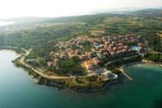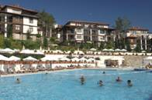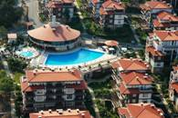

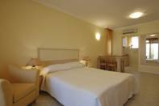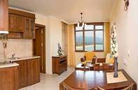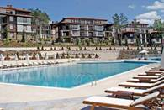
Localizare:se afla deasupra plajei „King’s Beach” la 2 km nord fata de vechiul oras Sozopol
Dotari camere: grup sanitar, Tv-satelit, telefon , aer conditionat, chicineta.
Facilitati: restaurant, receptie, lobby bar, centru medical, bar, lift, parcare, piscina cu bazin separate pentru copii, mini golf, Spa, sauna, masaj, loc de joaca pentru copii.
golf;fitness;piscina interioara si exterioara;sauna;spa
OFERTA LAST MINUTE COD « VT/3.06 »
“DISCOUNT 15%”PT REZERVARILE TRIMISE IN PERIOADA 1.06-30.06.2019 SI ACHITATE IINTEGRAL IN 24 H
FARA MASA | 1.06-03.06  10.9-14.10 | 4.06-24.6  20.8-9.09 | 25.6-1.07 | 02.07-  19.08
STUDIO 2 AD+ 1 COPIL/3 AD/ ZI* | 53 | 69 | 81,5 | 101,5
FAMILY APART 2 AD+ 2 COPII/3 AD/ ZI* | 65 | 100,5 | 124 | 155,5
BIG FAMILY APART 4 AD+ 1 COPIL/5 AD/ ZI* | 80 | 125,5 | 157 | 199,5
SUPLIMENT MD ADULT/COPIL 6-11,99 | 8/5 | 8/5 | 8/5 | 8/5
SUPLIMENT CINA ADULT/COPIL 6-11,99 | 14/8 | 14/8 | 14/8 | 14/8
SUPLIMENT VEDERE MARE /CAM | 11 | 11 | 11 | 11
SUPLIMENT STUDIO DELUXE/CAMERA | 9 | 9 | 9 | 9
SUPLIMENT FAMILY DELUXE CAMERA | 11 | 11 | 11 | 11
SUPLIMENT BIG FAMILY APART DELUXE CAMERA | 13 | 13 | 13 | 13
TERMEN DE ANULARE | 10 | 14 | 16 | 18
PENALIZARI | 2 | 3 | 4 | 4
*TARIFUL ESTE PENTRU TIP SPATIU, NR PERSOANE INDICATE IN TABEL
IN STUDIO MAXIM 2 ADULTI+ 1 COPIL/ 3 ADULTI
IN FAMILY MAXIM 2 ADULTI+ 1 COPIL/ 3 ADULTI
IN BIG FAMILY APART MINIM 4 ADULTI; MAXIM 4 ADULTI+ 1 COPIL/ 5 ADULTI
REDUCERI :
- COPIL (0-5,99 ANI) GRATUIT ( SI LA SUPLIMENTE MASA)
- COTAT COPIL ( 2-11,99 ANI)

APARTHOTEL SERENA RESIDENCE 3*/SOZOPOL
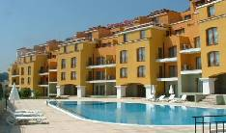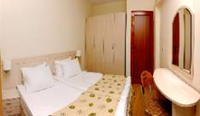

Localizare: aproape de plaja Kavatsite
Dotari camere: A/C; TV; telefon;bucatarie echipata;baie;uscator par;
Facilitati:sala fitness; piscine;gradina;teren joaca copii;internet
OFERTA LAST MINUTE COD « 110/1.06 »
“DISCOUNT 20%”PT REZERVARILE TRIMISE IN PERIOADA 1.06-30.06.2019 SI ACHITATE IN 24 H- SEJUR IN PERIOADA 1.06-30.09.2019

MIC DEJUN | 1.06-14.06  9.09-30.09 | 15.06-27.06
LOC IN APART. 1 DORM. STANDARD | 27 | 33
LOC IN APART. 1 DORM. SUPERIOR | 27 | 33
ALL INCLUSIVE | 1.06-14.06  9.09-30.09 | 15.06-27.06
LOC IN APART. 1 DORM. STANDARD | 32,5 | 38,5
LOC IN APART. 1 DORM. SUPERIOR | 32,5 | 38,5
TERMEN DE ANULARE | 8 | 12
PENALIZARE | 2 | 3
IN APARTAMENT 1 DORMITOR STANDARD MAXIM 2 ADULTI+ 2 COPII/ 3 ADULTI+1 COPIL
IN APARTAMENT 1 DORMITOR SUPERIOR MINIM 4 ADULTI; MAXIM 4 ADULTI+ 2 COPII/5 ADULTI
REDUCERI:
- COPIL (0-1.99 ANI)– GRATUIT, FARA SERVICII
-1 COPIL ( 2-13,99 ANI) CU 1 ADULT IN CAMERA -FARA REDUCERE
- 1 COPIL ( 2-13,99 ANI) IN PAT SUPLIMENTAR – GRATUIT
- AL 2 LEA SI AL 3 LEA COPIL ( 2-13,99 ANI) IN PAT SUPLIM.- FIECARE PLATESTE 50%
- ADULT IN PAT SUPLIMENTAR –20 % REDUCERE

HOTEL FLAGMAN 3*/SOZOPOL
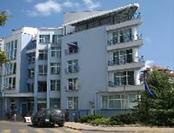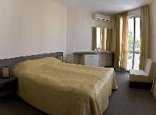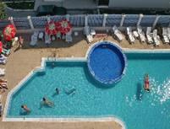
Localizare: la 30 m de plaja ‘’Harmanite’’
Dotari camere: balcon cu vedere la mare; A/C;mini bar;baie cu cada;TV cablu-satelit.
Facilitati: restaurant ;sala conferinte ; lobby bar ;lifturi ; piscina exterioara ; sala fitness ; sauna ; loc joaca copii ; room service ;seif; internet ;gratar.
OFERTA LAST MINUTE COD « 111/3.06 »
“DISCOUNT 10%”PT REZERVARILE TRIMISE IN PERIOADA 2.06-15.06.2019 SI ACHITATE IN 24 H
MIC DEJUN | 1.06-15.06  10.09-30.10 | 16.06-5.07  27.08-9.09 | 6.07-26.08
LOC IN CAMERA DUBLA | 20 | 29,5 | 38,5
CAMERA SINGLE | 30 | 46,5 | 57,5
LOC IN STUDIO | 23,5 | 33 | 42
LOC IN APART. 1 DORM | 28 | 37,5 | 46,5
LOC IN APART. 2 DORM | 22 | 29,5 | 38,5
DEMIPENSIUNE | 1.06-15.06  10.09-30.10 | 16.06-5.07  27.08-9.09 | 6.07-26.08
LOC IN CAMERA DUBLA | 24,5 | 35 | 44
CAMERA SINGLE | 34,5 | 54 | 65,5
LOC IN STUDIO | 28 | 38,5 | 47,5
LOC IN APART. 1 DORM | 32,5 | 43 | 52
LOC IN APART. 2 DORM | 24,5 | 35 | 44
ALL INCLUSIVE | 1.06-15.06  10.09-30.10 | 16.06-5.07  27.08-9.09 | 6.07-26.08
LOC IN CAMERA DUBLA | 29 | 41 | 49,5
CAMERA SINGLE | 43,5 | 63 | 74,5
LOC IN STUDIO | 32,5 | 44 | 53
LOC IN APART. 1 DORM | 37 | 48,5 | 57,5
LOC IN APART. 2 DORM | 29 | 41 | 49,5
TERMEN DE ANULARE | 9 | 12 | 14
PENALIZARI | 2 | 2 | 3
IN CAMERA DUBLA MAXIM 2 ADULTI + 1 COPIL / 3 ADULTI
IN STUDIO MAXIM 2 ADULTI+ 2 COPII/ 3 ADULTI
IN APARTAMENT 1 DORMITOR MAXIM 2 ADULTI+ 2 COPII/ 3 ADULTI
IN APARTAMENT 2 DORMITOARE MAXIM 4 ADULTI+ 2 COPII/ 5 ADULTI
REDUCERI:
- COPIL ( 0-2.99 ANI )– GRATUIT, FARA SERVICII
- 1 COPIL (3-11,99 ANI) CU 1 ADULT–40% REDUCERE
-AL 2 LEA COPIL ( 3-11,99 ANI) CU 1 ADULT–60% REDUCERE
- 1 COPIL (3-6,99 ANI) IN PAT SUPLIM. -PLATESTE SUPLIMENTE: 4 €/ZI CU MD; 5 €/ZI CU DP;9 €/ZI CU ALL INCL
- 1 COPIL (7-11,99 ANI) IN PAT SUPLIM -PLATESTE SUPLIMENTE: 6 €/ZI CU MD; 7 €/ZI CU DP;12 €/ZI CU ALL INCL
COPILUL CEL MAI VARSTNIC E CONSIDERAT MEREU AL 2 LEA !!!
- ADULT IN PAT SUPLIMENTAR- 30% REDUCERE

HOTEL NEVA 3 */KITEN
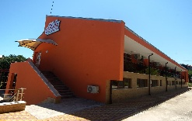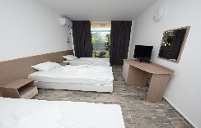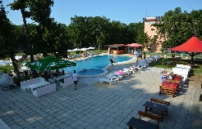
Localizare: este situat la 1 minut pe jos fata de plaja
Facilitati: restaurant ; bar;piscina; tenis masa;teren tenis;piscina;piscina copii;parcare
Dotari camera: TV ; baie; mini bar; A/C; balcon; baie cu dus
http://hotelneva.eu/bg/
OFERTA LAST MINUTE COD « 0017/17.01»
DEMIPENSIUNE | 24.05-22.06
LOC IN CAMERA DUBLA | 19
ALL INCLUSIVE | 24.05-22.06
LOC IN CAMERA DUBLA | 26
TERMEN DE ANULARE | 10
PENALIZARI | 100%
IN CAMERA DUBLA MAXIM 2 ADULTI+ 2 COPII/3 ADULTI/4 ADULTI
REDUCERI :
-COPIL ( 0-1.99 ANI ) – GRATUIT, FARA SERVICII
-1 COPIL ( 2-11.99 ANI ) IN PAT SUPLIM CU 2 SAU 3 ADULTI– GRATUIT
- AL 2 LEA COPIL ( 2-11.99 ANI ) IN PAT SUPLIM- 50%
-1 COPIL ( 2-11.99 ANI ) CU 1 ADULT IN DUBLA– FARA REDUCERE
- 2 COPII ( 2-11.99 ANI ) CU 1 ADULT IN DUBLA- FIECARE PLATESTE 50%
- AL 3 LEA ADULT– FARA REDUCERE
- AL 4 LEA ADULT – FARA REDUCERE

APART HOTEL SUNSET RESORT 5*/POMORIE
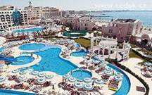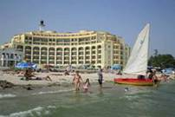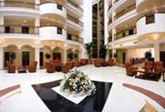

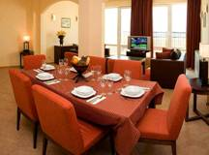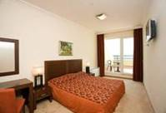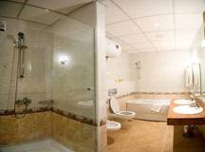
Localizare: 10 minute de aeroportul Burgas , pe plaja
Dotari camera: bucatarie, living, baie, hol si balcon, sunt amenajate modern si dispun de toate facilitatile
OFERTA LAST MINUTE COD « TK/1.06;113/3.06»
“DISCOUNT -15%”PT REZERVARILE TRIMISE DE LA 1.06.2019 SI ACHITATE INTEGRAL IN 24 H-SEJUR IN PERIOADELE 1.06-14.07/12.08-31.10.2019
*SE APLICA SI LA SUPLIMENTE MASA !
MIC DEJUN | 21.09-20.10 | 1.6-19.6  6.9-20.9 | 20.6-5.7  23.8-5.9 | 06.07-  22.08
STUDIO VED.PARK / 2 ADULTI /ZI* | 58 | 69 | 98 | 115
AP.1 DORM. V. PARK/ MAX 3 AD /ZI* | 65 | 81 | 114 | 134
AP.1 DORM. V. MARE / MAX 2 AD /ZI* | 78 | 93,5 | 126 | 148,5
AP.2 DORM. V. PARK /MAX 4 AD/ZI* | 93 | 110 | 162,5 | 191,5
AP.2 DORM. V. MARE /MAX 4 AD/ZI* | 111 | 126,5 | 185 | 218,5
AP.3 DORM. V. PARK/MAX 5 AD/ZI* | 122 | 155,5 | 231 | 276
AP.3 DORM. V. MARE/MAX 6 AD/ZI* | 139,5 | 173 | 260 | 305
SUPLIMENT CINA ADULT/COPIL 7-14,99 | 15/8 | 15/8 | 15/8 | 15/8
SUPLIM. ALL INCLUSIVE ADULT/COPIL7-14,99 | 26/14 | 26/14 | 33/17 | 33/17
TERMEN DE ANULARE | 10 | 12 | 14 | 16
PENALIZARI | 2 | 3 | 3 | 4
*TARIFUL ESTE VALABIL PENTRU TIP CAMERA, NUMAR PERSOANE INDICATE IN TABEL
TARIFUL INCLUDE 1 UMBRELA SI 2 SEZLONGURI/CAMERA/ PE PLAJA (IN LIMITA DISP)-PT SEJURURI CU ALL INCL
STUDIOURILE NU SUNT DISPONIBILE IN PERIOADA 21.09-20.10!!!
IN STUDIO MAXIM 2 ADULTI
IN APART. 1 DORMITOR MAXIM 2 ADULTI+ 1 COPIL/ 3 ADULTI
IN APARTAMENT 2 DORMITOARE MINIM 3 ADULTI;MAXIM 4 AD+ 1 COPIL
IN APARTAMENT 3 DORMITOARE PV MINIM 4 ADULTI; MAXIM 5 ADULTI+ 1 COPIL
IN APARTAMENT 3 DORMITOARE SV MINIM 4 ADULTI; MAXIM 6 ADULTI+ 1 COPIL
REDUCERI :
- COPIL ( 2-6.99 ANI ) – NU PLATESTE SUPLIMENTE MASA !
- COPII ( 2-6,99 ANI) IN PAT NORMAL- FARA REDUCERE
- COPII ( 7-14,99 ANI) CU 1 ADULT- FARA REDUCERE
-COPIL (2-6 ,99 ANI) IN PAT SUPLIMENTAR- GRATUIT
- COPIL ( 7-14,99 ANI)IN PAT SUPLIMENTAR- GRATUIT+ PLATESTE SUPLIMENTE MASA
- ADULT IN PAT SUPLIMENTAR-PLATESTE SUPLIMENTE MASA

HOTEL FESTA VIA PONTICA 4*
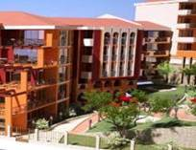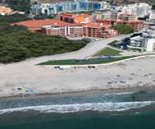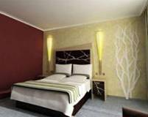

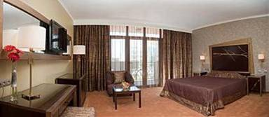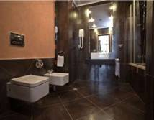
Localizare: pe plaja
Dotari camera: aer conditionat, baie cu dus sau cada, TV cablu, uscator de par, telefon, televizoare LCD
Facilitati hotel: vinarie cu sala pentru degustari, construita in 1932, restaurant, lobby bar, garden bar, pool bar (la piscina exterioara), centru SPA (piscina interioara, tratamente balneare, fizioterapie, masaj, sauna, salon de infrumusetare), sala de conferinte si centru de business, acces la internet, room service, parcare subterana
OFERTA LAST MINUTE COD « 124/08.06»
“DISCOUNT -20%”PT REZERVARILE TRIMISE FACUTE IN PERIOADA 10.06-30.06.2019 SI ACHITATE INTEGRAL IN 24 H-SEJUR IN PERIOADELE 16.06-03.07.2019-DOAR PT CAMERE DUBLE SI SINGLE STANDARD
“DISCOUNT -15%”PT REZERVARILE TRIMISE FACUTE IN PERIOADA 10.06-30.06.2019 SI ACHITATE INTEGRAL IN 24 H-SEJUR IN PERIOADELE 07.07.2019-SFARSITUL SEZONULUI-DOAR PT CAMERE DUBLE SI SINGLE STANDARD
*SE POT COMBINA CU NOPTI GRATUITE INCEPIND CU 09.09
ULTRA ALL INCLUSIVE | 27.04-10.6  16.09-30.9 | 11.06-20.6  1.09-15.09 | 21.06-10.7  23.08-31.8 | 11.07-22.08
LOC IN CAMERA DUBLA | 42,5 | 56 | 66 | 83
SUPLIMENT CAMERA SINGLE | 10 | 17 | 28 | 83
LOC IN CAMERA SUPERIOR | 44,5 | 59,5 | 69,5 | 86,5
LOC IN FAMILY | 47 | 62 | 74 | 92
TERMEN DE ANULARE | 12 | 14 | 16 | 20
PENALIZARI | 3 | 3 | 4 | 5
IN CAMERA DUBLA MAXIM 2 ADULTI+ 1 COPIL/ 3 ADULTI
IN CAMERA SUPERIOR (STUDIO ) MAXIM 2 ADULTI+ 2 COPII/ 3 ADULTI+ 1 COPIL
IN FAMILY MAXIM 2 ADULTI+ 2 COPII/ 3 ADULTI+ 1 COPIL
REDUCERI:
- COPIL ( 0-1.99 ANI ) – GRATUIT, FARA SERVICII
- COPIL ( 2-11.99 ANI ) IN PAT SUPLIM. CU 2 ADULTI– GRATUIT
- AL 2-LEA COPIL ( 2-11.99 ANI ) IN PAT SUPLIM. CU 2 ADULTI IN CAM SUP/ FAM – 50%
- 1 COPIL (2-11.99 ANI) CU 1 ADULT IN CAMERA DBL- 50%
- 2 COPII (2-11.99 ANI) CU 1 ADULT IN CAMERA DBL- FIECARE PLATESTE 50%
- ADULT IN PAT SUPLIMENTAR– 25% REDUCERE
NOPTI GRATUITE:
1)7=6; 14=12 PT SOSIRI IN PERIOADELE 21.05-8.06/9.09-20.09.2019
2)7=5; 14=10 PT SOSIRI IN PERIOADELE 1.05-20.05/21.09-31.10.2019

APARTHOTEL MARINA HOLIDAY CLUB 3*+POMORIE
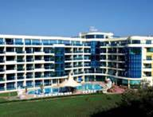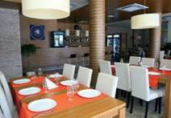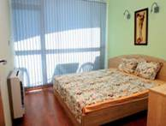
Localizare: la 100m de plaja
Dotari: aer conditionat, tv , internet,
Facilitati hotel: centru fitness, piscina, centru spa, restaurant
OFERTA LAST MINUTE COD « 128/11.06»
“DISCOUNT -25%”PT REZERVARILE TRIMISE IN PERIOADA 11.06-01.07.2019 SI ACHITATE INTEGRAL IN 24 H-SEJUR DE MINIM 4 NOPTI IN PERIOADELE 11.06-25.06/12.09-22.09.2019
“DISCOUNT -15%”PT REZERVARILE TRIMISE IN PERIOADA 11.06-01.07.2019 SI ACHITATE INTEGRAL IN 24 H-SEJUR DE MINIM 4 NOPTI IN PERIOADA 26.06-02.07.2019
“DISCOUNT -10%”PT REZERVARILE TRIMISE IN PERIOADA 11.06-01.07.2019 SI ACHITATE INTEGRAL IN 24 H-SEJUR DE MINIM 4 NOPTI IN PERIOADA 21.07-11.09.2019
-2 COPII GRATUITI IN PERIOADELE 1.06-25.06/12.09-22.09.2019
-2 COPII GRATUITI IN PERIOADA 26.06-11.09.2019
-COTAT COPIL 3-13,99 ANI
ALL INCLUSIVE | 28.05- 14.6  12.9-22.09 | 15.6-25.06  1.09-11.09 | 26.06-8.07  23.08-31.8 | 9.07-22.08
SEJUR MINIM NOPTI | 4 | 4 | 4 | 4
LOC IN APART. 1 DORM. /MAX 2 ADULTI | 34,5 | 41,5 | 48,5 | 59,5
LOC IN APART. 1 DORM. /MAX 4 ADULTI | 32 | 39,5 | 45 | 53
LOC IN APART. 2 DORM. /MAX 5 ADULTI | 30 | 37 | 41,5 | 47
PENALIZARI ANULARI | 100% | 100% | 100% | 100%
IN APART. 1 DORM/MAX 2 ADULTI : MAXIM 2 ADULTI+ 2 COPII
IN APART. 1 DORM /MAX 4 ADULTI: MAXIM 3 ADULTI+ 2 COPII/4 ADULTI
IN APART. 2 DORM/MAX 5 ADULTI: MAXIM 4 ADULTI+ 2 COPII/5 ADULTI
PARCARE SUBTERANA GRATUITA !
REDUCERI
- ADULT IN PAT SUPLIMENTAR IN ORICE TIP AP- 40% REDUCERE

IN APART. 1 DORM/MAX 2 ADULTI : MAXIM 2 ADULTI+ 2 COPII
IN APART. 1 DORM /MAX 4 ADULTI: MAXIM 3 ADULTI+ 2 COPII/4 ADULTI
IN APART. 2 DORM/MAX 5 ADULTI: MAXIM 4 ADULTI+ 2 COPII/5 ADULTI
PARCARE SUBTERANA GRATUITA !
REDUCERI :- COPIL ( 0-2.99 ANI ) – GRATUIT, FARA SERVICII
-1-2 COPII ( 3-13,99 ANI) IN PAT SUPLIM IN AP 1 DORM /MAX 2 ADULTI- GRATUITI
-1-2 COPII ( 3-13,99 ANI) IN PAT SUPLIM IN AP 1 DORM /MAX 2 ADULTI- GRATUITI
- 1-2 COPII ( 3-13,99 ANI) IN PAT SUPLIM IN AP 1 DORM /MAX 4 ADULTI- GRATUITI
LEA 70% REDUCERE
- ADULT IN PAT SUPLIMENTAR IN ORICE TIP AP- 40% REDUCERE
H. POMORIE 3*( EX INTERHOTEL POMORIE)
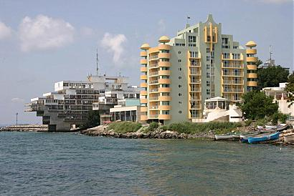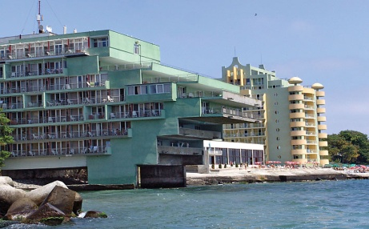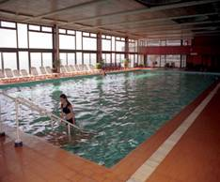

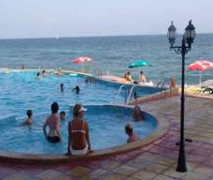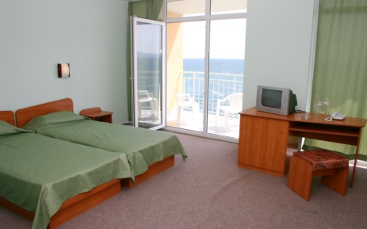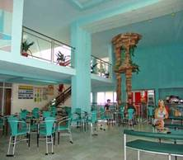
Localizare: la plaja
Dotari camera: baie (cada), tv, aer conditionat, mini-bar, telefon, balcon, aer conditionat
Facilitati hotel: piscina exterioara, piscina interioara, parcare, restaurant, SPA, sauna, solar, salon de masaj, salon de infrumusetare, casa de schimb valutar
MIC DEJUN | 18.05-3.06  14.9-10.10 | 4.06-28.06  4.09-13.09 | 29.06-12.07  20.08-3.09 | 13.07-19.08
LOC IN DUBLA SUPERIOR A/C | 20 | 23 | 25 | 28,5
CAMERA SINGLE | 28 | 35 | 42 | 48,5
LOC IN DUBLA VED PARK FARA A/C | 15,5 | 17 | 18,5 | 20,5
CAMERA SINGLE | 21 | 26 | 30,5 | 35
LOC IN DUBLA VED MARE A/C | 18 | 19,5 | 21,5 | 25
CAMERA SINGLE | 25,5 | 30,5 | 35 | 39,5
SUPLIM. CINA ADULT/COPIL | 9/5 | 9/5 | 9/5 | 9/5
SUPLIM. ALL INCL ADULT/COPIL | 17/9 | 17/9 | 17/9 | 17/9
TERMEN DE ANULARE | 12 | 16 | 18 | 20
PENALIZARI | 2 | 3 | 4 | 5
IN CAMERA DUBLA MAXIM 2 ADULTI+1 COPIL/ 3 ADULTI
IN CAMERA DUBLA SUPERIOR MAXIM 2 ADULTI+ 2 COPII/ 3 ADULTI
REDUCERI :
- COPIL ( 0-3.99 ANI ) – GRATUIT, FARA SERVICII
- 1 COPIL ( 4-11.99 ANI ) IN PAT SUPLIM CU 2 ADULTI– GRATUIT CU MD
- AL 2 LEA COPIL ( 4-11.99 ANI ) IN PAT SUPLIM CU 2 ADULTI- 50% CU MD
- 1-2 COPII ( 4-12.99 ANI ) CU 1 ADULT – FIECARE PLATESTE 50%
- ADULT IN PAT SUPLIMENTAR – 20 % REDUCERE
NOPTI GRATUITE14=12;13=12;12=11;11=10;10=9;9=8;8=7;7=6 VALABIL PT SOSIRI IN PERIOADA 18.05-19.06.2019 SI 14.09-26.09.2019
*OFERTA VALABILA DOAR PT CAMERELE SINGLE SI DUBLE CU AER CONDITIONAT!

HOTEL ZEUS 3*
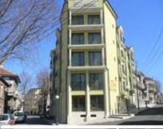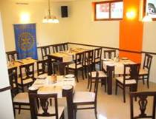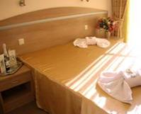
Localizare:la 100 m de centrul statiunii, 300 m de plaja
Dotari camera: aer-conditionat, mini bar, TV, balcon, baie
Facilitati hotel: restaurant, room service, sala de conferinte, lobby bar, incalzire centrala, internet
OFERTA LAST MINUTE COD « 123/08.06»
“DISCOUNT -20%”PT REZERVARILE TRIMISE INCEPIND CU 08.06 SI ACHITATE INTEGRAL IN 24 H- PENTRU SEJUR IN PERIOADELE 08.06-19.06/09.09-30.09.2019
“DISCOUNT -25%”PT REZERVARILE TRIMISE INCEPIND CU 08.06 SI ACHITATE INTEGRAL IN 24 H- PENTRU SEJUR IN PERIOADA 20.06-08.09.2019
*SE COMBINA CU NOPTI GRATUITE INCEPIND CU 09.09
MIC DEJUN | 1.05-19.6  9.09-30.9 | 20.6-30.06  1.09-8.09 | 1.07-31.08 | 1.10-30.04.2020
LOC IN CAMERA DUBLA | 16,5 | 20 | 24 | 16,5
LOC IN APARTAMENT | 20 | 25 | 29 | 20
SUPLIMENT CAMERA SINGLE | 25 | 30,5 | 41,5 | 25
SUPLIMENT CINA ADULT/ COPIL | 7/4 | 7/4 | 7/4 | 7/4
PENALIZARI ANULARI | 100% | 100% | 100% | 100%
IN CAMERA DUBLA MAXIM 2 ADULTI+ 1 COPIL/ 3 ADULTI
IN APARTAMENT MAXIM 2 ADULTI+ 2 COPII/ 3 ADULTI+ 1 COPIL /4 ADULTI
REDUCERI:
- COPIL ( 2-11.99 ANI ) IN PAT SUPLIM CU 2 ADULTI IN DBL– GRATUIT
-1 COPIL ( 2-11.99 ANI ) IN PAT SUPLIM CU 2 ADULTI IN AP– 30% REDUCERE
- AL 2 LEA COPIL ( 2-11.99 ANI ) IN PAT SUPLIM CU 2 ADULTI IN AP- 70% REDUCERE
-1 COPIL ( 2-11.99 ANI ) CU 1 ADULT- 20% REDUCERE
- AL 3 LEA ADULT IN PAT SUPLIMENTAR IN DBL -20% REDUCERE
- AL 3 LEA ADULT IN APARTAMENT- FARA REDUCERE
- AL 4 LEA ADULT IN APARTAMENT- 50%
NOPTI GRATUITE 7=6;14=12;21=18 VALABIL SEJUR IN PERIOADELE 1.05-19.06/9.09-30.09.2019

HOTEL LES MAGNOLIAS 3*/PRIMORSKO
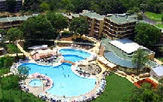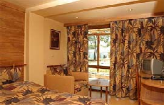
Localizare: la 200m de plaja.
Dotari camere: frigider, baie, TV, telefon.
Facilitati: spa; piscina;2 terenuri tenis; 2 mese tenis; loc joaca copii; club copii
http://www.primorskoclub.com/en/hoteli/forest-beach-hotel
OFERTA LAST MINUTE COD « 088/2.05»
“DISCOUNT -10%”PT REZERVARILE TRIMISE PANA PE 15.06.2019 SI ACHITATE INTEGRAL IN 24 H-SEJUR MINIM 5 NOPTI IN PERIOADA 10.05-25.09.2019
ALL INCLUSIVE | 10.05-7.06  8.09-25.09 | 8.06-21.06 | 22.06-1.07 | 2.07-30.08 | 31.08-7.09
LOC IN CAMERA DUBLA | 33 | 42,5 | 53 | 67,5 | 51
CAMERA SINGLE | 44 | 54,5 | 67,5 | 84,5 | 65,5
TERMEN DE ANULARE | 12 | 14 | 14 | 20 | 16
PENALIZARI | 2 | 3 | 4 | 4 | 4

OFERTA LAST MINUTE COD « 082/24.04»
VALABIL REZERVARI TRIMISE IN PERIOADA 24.04-31.05.2019 SI ACHITATE IN 24 H
ALL INCLUSIVE | 8.06-15.06
LOC IN CAMERA DUBLA | 38
CAMERA SINGLE | 50
TERMEN DE ANULARE | 14
PENALIZARI | 3
IN CAMERA DUBLA , MAXIM 2 ADULTI+ 2 COPII/ 3 ADULTI
REDUCERI :
- 1 COPIL ( 2-11.99 ANI ) IN PAT SUPLIMENTAR- GRATUIT
- AL 2 LEA COPIL ( 2-11.99 ANI ) IN PAT SUPLIMENTAR- 70% REDUCERE
- 1 COPIL ( 2-11.99 ANI ) CU 1 ADULT= TARIF SINGLE
- AL 2 LEA COPIL ( 2-11.99 ANI ) CU 1 ADULT- FIECARE PLATESTE 50%
- ADULT IN PAT SUPLIMENTAR- 20% REDUCERE
HOTEL FOREST BEACH 4*/PRIMORSKO
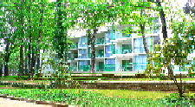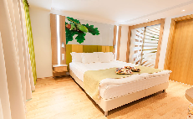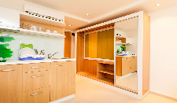
Localizare: 150 m de plaja
Dotari camere: aer conditionat, minibar, telefon, TVcablu, baie, balcon, internet
Facilitati: restaurant; piscina; A/C;
http://www.primorskoclub.com/en/hoteli/forest-beach-hotel
OFERTA LAST MINUTE COD « 088/2.05»
“DISCOUNT -15%”PT REZERVARILE TRIMISE PANA PE 15.06.2019 SI ACHITATE INTEGRAL IN 24 H-SEJUR IN PERIOADA 2.07-30.08.2019
“DISCOUNT -10%”PT REZERVARILE TRIMISE PANA PE 15.06.2019 SI ACHITATE INTEGRAL IN 24 H-SEJUR IN PERIOADELE 17.05-1.07/31.08-25.09.2019
ALL INCLUSIVE | 17.05-7.06 | 8.06-21.06 | 22.06-1.07 | 2.07-30.08 | 31.08-7.09 | 8.09-25.09
LOC IN CAMERA DUBLA | 28,5 | 36 | 47 | 56,5 | 44 | 31
CAMERA SINGLE | 37 | 47 | 59,5 | 73 | 57 | 39,5
LOC IN STUDIO | 33 | 42,5 | 54 | 65 | 50 | 33
TERMEN DE ANULARE | 12 | 14 | 14 | 20 | 16 | 14
PENALIZARI | 2 | 3 | 4 | 4 | 4 | 4
IN STUDIO , MAXIM 2 ADULTI+ 2 COPII/ 3 ADULTI
IN CAMERA DUBLA MAXIM 2 ADULTI
REDUCERI :
- 1 COPIL ( 2-11.99 ANI ) IN PAT SUPLIMENTAR- GRATUIT
- AL 2 LEA COPIL ( 2-11.99 ANI ) IN PAT SUPLIMENTAR- 70% REDUCERE
- 1 COPIL ( 2-11.99 ANI ) CU 1 ADULT - TARIF SINGLE
- 2 COPII ( 2-11.99 ANI ) CU 1 ADULT IN STUDIO – FIECARE PLATESTE 50%
- ADULT IN PAT SUPLIMENTAR- 30% REDUCERE
HOTEL SIENA PALACE 4*/PRIMORSKO
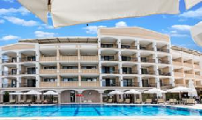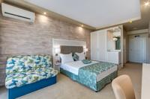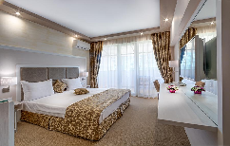
Localizare: 250 m de plaja.
Dotari camere: TV, aer conditionat, baie cu dus;uscator par;mini bar
Facilitati: restaurant; gradina vara; lobby bar; piscine; piscina copii;loc de Joaca;baie turceasca;baie aburi;Jacuzzi;masaj;spa si wellness;sala fitness;sauna;WI FI; parcare
OFERTA LAST MINUTE COD « 128/11.06 »
“EARLY BOOKING -10 %”PT SEJURURI IN PERIOADA 11.06-02.07.2019
MIC DEJUN | 11.06-20.06 | 21.06-02.07
LOC IN CAMERA DUBLA | 25,5 | 35
CAMERA SINGLE | 46 | 63
SUPLIMENT CINA ADULT/COPIL | 11/6 | 11/6
TERMEN DE ANULARE | 16 | 18
PENALIZARI | 3 | 3
IN CAMERA DUBLA MAXIM 2 ADULTI+ 1 COPIL/ 3 ADULTI
REDUCERI:
- COPIL (0-2.99 ANI) – GRATUIT, FARA SERVICII
- COPIL (3- 11,99 ANI) IN PAT SUPLIM. – GRATUIT
- 1-2 COPII (3- 11,99 ANI) IN CAMERA CU 1 ADULT- FIECARE PLATESTE 50%
- ADULT IN PAT SUPLMENTAR – 30% REDUCERE
NOPTI GRATUITEVALABIL PENTRU SOSIRI IN PERIOADA 1.06-20.06 SI DIN 9.09.2019
  - NOAPTE GRATUITA PT SEJUR 7-13 NOPTI
2)2 NOPTI GRATUITE PT SEJUR 14-20 NOPTI
3)3 NOPTI GRATUITE PT SEJUR DE LA 21 NOPTI
HOTEL PRIMORSKO DEL SOL 4*/PRIMORSKO
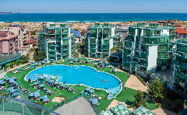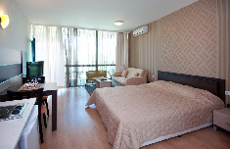
Localizare: la 2 minute fata de plaja( 100 m),in sudul statiunii
Dotari camere: A/C, minibar, telefon, TVcablu, baie cu dus, uscator par;balcon;chichineta la studiouri; apart 2 bai
Facilitati: restaurant; piscina; A/C; parcare subterana;WI FI;fitness;baie aburi;masaj;sala conferinte;seif;discoteca copii;club noapte
OFERTA LAST MINUTE COD « 128/11.06 »
“DISCOUNT -30%”PT REZERVARILE TRIMISE IN PERIOADA 11.06-30.06.2019 SI ACHITATE INTEGRAL IN 24 H-SEJUR IN PERIOADA 11.06-30.06.2019
“DISCOUNT -20%”PT REZERVARILE TRIMISE IN PERIOADA 11.06-30.06.2019 SI ACHITATE INTEGRAL IN 24 H-SEJUR IN PERIOADA 01.07-14.07.2019
“DISCOUNT -15%”PT REZERVARILE TRIMISE IN PERIOADA 11.06-30.06.2019 SI ACHITATE INTEGRAL IN 24 H-SEJUR IN PERIOADA 15.07-SFARSITUL SEZONULUI
*NU SE ACCEPTA MODIFICARI LA REZERVARI
ALL INCLUSIVE | 12.09-  20.09 | 10.6-15.6  5.09-11.9 | 16.6-22.6  28.8-4.09 | 23.6-6.07  20.8-27.8 | 7.07-19.08
LOC IN CAMERA VED. PARK | 39 | 47 | 70 | 75,5 | 85,5
CAMERA SINGLE | 66 | 79 | 118,5 | 127 | 144,5
LOC IN CAMERA VED . MARE | 41,5 | 49 | 72 | 77,5 | 88
CAMERA SINGLE | 69,5 | 83 | 121,5 | 131 | 148
LOC IN STUDIO | 39 | 47 | 70 | 75,5 | 85,5
LOC IN APART. 1 DORM CU KITCHINETA( MAX 3) | 56,5 | 69 | 86 | 103 | 108,5
LOC IN APART. 1 DORM( MAX 3+1) | 38,5 | 50 | 60,5 | 73 | 80,5
LOC IN APART. 2 DORM ( MAX 5) | 38 | 49,5 | 58,5 | 64 | 72,5
PENALIZARI ANULARI | 100% | 100% | 100% | 100% | 100%
IN CAMERA DUBLA MAXIM 2 ADULTI+ 2 COPII/3 ADULTI
IN STUDIO MAXIM MAXIM 2 ADULTI+ 2 COPII/3 ADULTI
IN APART. 1 DORM. ( MAX 3) MAXIM 2 ADULTI+ 2 COPII/3 ADULTI- SE INCASEAZA MINIM 2 LOCURI INTREGI
IN APART. 1 DORM. ( MAX 3+1) MAXIM 3 ADULTI/ 3 ADULTI+ 1 COPIL- SE INCASEAZA MINIM 3 LOCURI INTREGI
IN APART. 2 DORM. MINIM 4 ADULTI; MAXIM 4 ADULTI+ 2 COPII/5 ADULTI-SE INCASEAZA MINIM 4 LOCURI INTREGI
REDUCERI :
- COPIL ( 0-2,99 ANI) –GRATUIT, FARA SERVICII
- 1 COPIL ( 2-13.99 ANI ) CU 1 ADULT IN DBL - 20% REDUCERE
- 2 COPII ( 2-13.99 ANI ) CU 1 ADULT IN DBL - FIECARE PLATESTE 50%
- 1 COPIL ( 2-13.99 ANI ) IN PAT SUPLIMENTAR- GRATUIT
- AL 2 LEA COPIL ( 2-13.99 ANI ) IN PAT SUPLIMENTAR - PLATESTE SUPLIMENT 12,5 €/ZI
- ADULT IN PAT SUPLIMENTAR- 30% REDUCERE
NOPTI GRATUITEVALABIL PENTRU SEJUR IN PERIOADELE 28.05-15.06/5.09-20.09.2019
1) 1 NOAPTE GRATUITA PT SEJUR 7-13 NOPTI
2) 2 NOPTI GRATUITE PT SEJUR DE LA 14 NOPTI

HOTEL OASIS BEACH CLUB 3*/ LOZENETZ
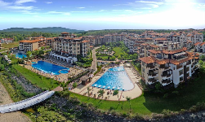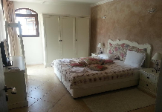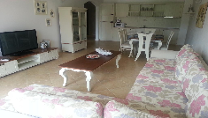
Localizare : langa plaja privata
Facilitati: restaurant; piscina exterioara; piscina copii; parcare;WI FI; spa si centru welness;bar;gradina;fitness;sezlonguri si umbrele pe plaja
Dotari camera:TV; zona relaxare;bucatarie utilata;baie privata;ba;con;A/C
OFERTA LAST MINUTE COD « 088/2.05»
VALABIL REZERVARI DE LA 15.05.2019 SI ACHITATE IN 24 H
MIC DEJUN | 1.05-13.06  9.09-30.09 | 28.06-25.08
APART. 1 DORM 2 AD/ZI* | 80 | 159,5
APART. 1 DORM 3 AD/ZI* | 81 | 161
TERMEN DE ANULARE | 20 | 20
PENALIZARE | 100% | 100%
IN APARTAMENT 1 DORMITOR MAXIM 2 ADULTI+ 2 COPII/3 ADULTI
REDUCERI:
- COPIL ( 0-1,99 ANI)- GRATUIT, FARA SERVICII
- 1 COPIL (2-11,99 ANI) IN PAT SUPLIMENTAR - GRATUIT
- AL 2 LEA COPIL (2-11,99 ANI) IN PAT SUPLIMENTAR - PLATESTE SUPLIMENT 3 €/ZI
- 1 COPIL (2-11,99 ANI) CU 1 ADULT- FARA REDUCERE
- 2 COPII (2-11,99 ANI) CU 1 ADULT- FIECARE PLATESTE 50%
HOTEL LOZENETS RESORT 2* LOZENETS
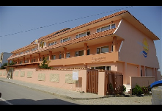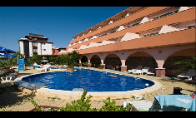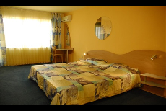

Localizare : la 100 m de plaja
Facilitati: piscina exterioara cu sectiune copii ;restaurant;gradina si terasa;loc joaca;
Dotari camera: A/C;TV satelit;mini bar;baie cu dus ; balcon;WI FI
http://www.sunsetbeach-bg.com/index_en.php
OFERTA LAST MINUTE COD « 128/11.06 »
“DISCOUNT -30%”PT REZERVARILE TRIMISE IN PERIOADA11.06-30.06.2019 SI ACHITATE INTEGRAL IN 24 H-SEJUR IN PERIOADA 11.06-30.06.2019 INCLUSIV
“DISCOUNT -20%”PT REZERVARILE TRIMISE IN PERIOADA 11.06-30.06.2019 SI ACHITATE INTEGRAL IN 24 H-SEJUR IN PERIOADA 01.07.2019-SFARSITUL SEZONULUI
*NU SE ACCEPTA MODIFICARI ALE REZERVARILOR
ALL INCLUSIVE | 28.05-9.06  12.09-20.9 | 10.6-15.6  5.09-11.9 | 16.6-22.6  28.8-4.09 | 23.6-6.07  20.8-27.8 | 7.07-19.08
LOC IN CAMERA DUBLA | 29 | 32,5 | 41 | 46,5 | 52
CAMERA SINGLE | 48,5 | 61,5 | 68 | 77,5 | 87
LOC IN APART. 1 DORM | 47 | 52,5 | 63 | 71 | 79
PENALIZARE | 100% | 100% | 100% | 100% | 100%
IN CAMERA DUBLA MAXIM 2 ADULTI+ 1 COPIL/ 3 ADULTI
IN APARTAMENT MAXIM 2 ADULTI+ 2 COPII/ 3 ADULTI
REDUCERI:
- COPIL ( 0-1,99 ANI)- GRATUIT, FARA SERVICII
- 1 COPIL (2-13,99 ANI) IN PAT SUPLIM. CU 2 ADULTI - GRATUIT
- AL 2 LEA COPIL (2-13,99 ANI) CU 2 ADULTI IN AP - PLATESTE SUPLIMENT 13 €/ZI
- 1 COPIL (2-13,99 ANI) CU 1 ADULT- 20% REDUCERE
- 2 COPII (2-13,99 ANI) CU 1 ADULT- FIECARE PLATESTE 50%
- ADULT IN PAT SUPLIMENTAR- 30% REDUCERE

NOPTI GRATUITEPT SEJUR IN PERIOADELE 28.05-15.06/5.09-20.09.2019
  - NOAPTE GRATUITA PT SEJUR 7-13 NOPTI
2)2 NOPTI GRATUITE PT SEJUR DE LA 14 NOPTI

HOTEL SUNSET BEACH 3* LOZENETS
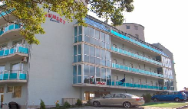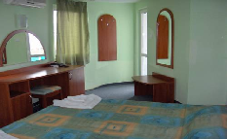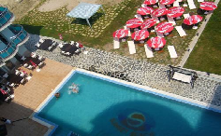
Localizare : la 5 minute de plaja
Facilitati: piscina exterioara ;lobby bar;restaurant; parcare ;sauna;masaj; teren tenis;loc joaca copii;internet
Dotari camera: A/C;TV satelit;mini bar;baie;uscator par;balcon
http://www.sunsetbeach-bg.com/index_en.php
OFERTA LAST MINUTE COD « 116/04.06 »
“DISCOUNT -10%”PT REZERVARILE TRIMISE IN PERIOADA 03.06-20.06.2019 SI ACHITATE INTEGRAL IN 24 H-SEJUR IN PERIOADA 04.06-04.07.2019 SI 02.08-22.09.2019
*NU SE COMBINA CU ALTE OFERTE
ALL INCLUSIVE LIGHT | 04.06-6.06  16.09-22.09 | 7.06-14.06  9.09-15.09 | 15.06-21.06  27.08-8.09 | 22.06-04.07 | 02.08  19.8-26.8 | 3.08-18.08
SEJ. MINIM NOPTI | 5 | 5 | 5 | 5 | 5 | 5
LOC IN CAMERA | 20 | 22 | 24,5 | 26,5 | 34,5 | 35
CAMERA SINGLE | 27 | 30 | 33 | 35,5 | 39,5 | 46,5
LOC IN MAISONETTE | 40,5 | 44,5 | 49 | 53 | 59 | 70
TERMEN DE ANULARE | 20 | 20 | 20 | 20 | 20 | 20
PENALIZARE | 100% | 100% | 100% | 100% | 100% | 100%
IN CAMERA DUBLA MAXIM 2 ADULTI+ 2 COPII/ 3 ADULTI
IN MAISONETTE MAXIM 2 ADULTI+ 2 COPII/ 3 ADULTI+ 1 COPIL
REDUCERI IN DUBLA :
- COPIL ( 0-1,99 ANI)- GRATUIT, FARA SERVICII
- 1 COPIL (2-12,99 ANI) IN PAT SUPLIM. CU 2 ADULTI IN DBL- GRATUIT
- AL 2 LEA COPIL (2-12,99 ANI) IN PAT SUPLIM. CU 2 ADULTI IN DBL- PLATESTE 13 €/ZI
- 1 COPIL (2-12,99 ANI) CU 1 ADULT- 30% REDUCERE
- 2 COPII (2-12,99 ANI) CU 1 ADULT- FIECARE PLATESTE 50%
- ADULT IN PAT SUPLIMENTAR- 20% REDUCERE
REDUCERI IN MAISONETTE :
- 1-2 COPII (2-12,99 ANI) IN PAT SUPLIM. CU 2 ADULTI- FIECARE PLATESTE SUPLIMENT 5 €/ZI
- 1 COPIL (2-12,99 ANI) CU 1 ADULT- FARA REDUCERE
- 2 COPII (2-12,99 ANI) CU 1 ADULT- FIECARE PLATESTE 50%
- ADULT IN PAT SUPLIMENTAR- 50% REDUCERE
HOTEL WAVE RESORT 4* /AHELOY
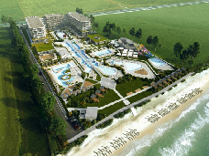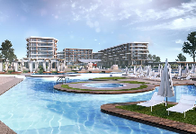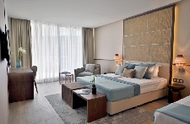
Localizare: pe o suprafata de 2500 mp; la plaja
Facilitati: parc acvatic;numeroase piscine;2 piscine interioare;restaurant buget;3 restaurante a la carte;bistro;sala fitness;hidromasaj;sauna; tratamente namol;centru welness; sezlonguri si umbrele pe plaja;parcare; WI FI;
Camere: TV; A/C;mini bar; baie privata cu dus cu articole toaleta;balcon;
OFERTA LAST MINUTE COD « 077/17.04»
“DISCOUNT -30%”PT REZERVARILE TRIMISE DE LA 16.04.2019 SI ACHITATE INTEGRAL IN 24 H-SEJUR IN PERIOADELE 8.06-5.07/28.09-18.10.09.2019
“DISCOUNT -20%”PT REZERVARILE TRIMISE DE LA 16.04.2019 SI ACHITATE INTEGRAL IN 24 H-SEJUR IN PERIOADA 6.07-27.09.2019
ULTRA ALL INCLUSIVE | 28.09-  18.10 | 31.05-7.06  14.09-27.9 | 8.06-5.07  24.08-13.9 | 6.07-  23.08
LOC IN CAMERA SSV | 51,5 | 67 | 93,5 | 111,5
CAMERA SINGLE | 48 | 83 | 117 | 139,5
LOC IN CAMERA PREMIUM  VED. GRADINA | 57 | 72,5 | 99 | 117
LOC IN CAMERA SV | 57 | 72,5 | 99 | 117
LOC IN CAMERA FAMILY SV | 57 | 72,5 | 99 | 117
LOC IN MAISONETTE 1 DORM. SV | 57 | 72,5 | 99 | 117
LOC IN JUNIOR SUITE SV | 62,5 | 78 | 104,5 | 122,5
LOC IN CAMERA LAGOON  VED. PISCINA | 62,5 | 78 | 104,5 | 122,5
PENALIZARE ANULARE | 100% | 100% | 100% | 100%
IN CAMERA DUBLA SSV SI PREMIUM MAXIM 2 ADULTI+ 2 COPII/3 ADULTI
IN CAMERA DUBLA SV MAXIM 2 ADULTI+ 1 COPIL/3 ADULTI
IN CAMERA FAMILY (3 LOCURI INTREGI)MINIM 2 ADULTI+ 2 COPII/ 3 ADULTI; MAXIM 3 ADULTI+ 1 COPIL/4 ADULTI
IN MAISONETTE MINIM 4 ADULTI(4 LOCURI INTREGI); MAXIM 4 ADULTI+ 2 COPII/5 ADULTI
IN JUNIOR SUITE MAXIM 2 ADULTI+ 2 COPII/3 ADULTI
IN CAMERA DUBLA LAGOON MAXIM 2 ADULTI+ 1 COPIL/3 ADULTI
REDUCERI:
-1 COPIL (0-199 ANI ) –GRATUIT FARA SERVICII
- 1 COPIL ( 2-12.99 ANI ) IN PAT SUPLIMENTAR- GRATUIT
- AL 2 LEA COPIL ( 2-6.99 ANI ) IN PAT SUPLIMENTAR- GRATUIT
- AL 2 LEA COPIL ( 7-12.99 ANI ) IN PAT SUPLIMENTAR-50%
- ADULT IN PAT SUPLIMENTAR- 30% REDUCERE

H. ARKUTINO FAMILY RESORT 4*/ ARKUTINO
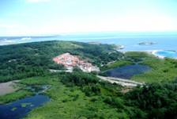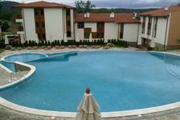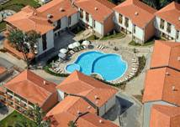

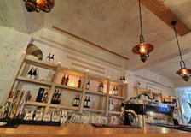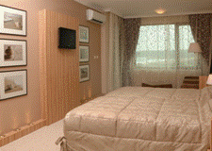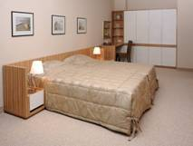
Localizare: Situat intr-o fosta rezervatie naturala, Hotelul Arkutino Resort**** reprezinta locul ideal pentru relaxare in mijlocul naturii salbatice. De-a lungul secolelor, acest tinut a fost locuit de traci, greci, romani, slavi si bulgari, toate aceste populatii lasand o amprenta asupra locului. Pe langa biodiveristatea existenta cu stanci, paduri si pajisti, aici intalnim si ruine ale unor castele, biserici, porturi vechi si pietre de sacrificiu declarate monumente de nepretuit.
Hotelul pune la dispozitia turistilor 55 camere duble standard (aprox. 20 mp), 38 camere duble deluxe (aprox. 30 mp), 48 family room si 7 family room deluxe.
Facilitati camerea : TV-satelit, aer conditionat, minibar, uscator de par, telefon. In camerele deluxe exista si un fotoliu extensibil .
Facilitati hotel : Restaurant principal , Restaurant Barbeque, Organic House ,magazin Bio, club pentru copii, piscina exterioara, internet, parcare. Se accepta animale de companie.
OFERTA LAST MINUTE COD « 112/3.06 »
“DISCOUNT -10%”PT REZERVARILE TRIMISE DE LA 1.06.2019 SI ACHITATE INTEGRAL IN 24 H-SEJUR IN PERIOADA1.07-26.08.2019
PT 2 AD+ 2 COPII IN FAMILY AP PV
ALL INCLUSIVE | 20.05-10.6  11.09-30.9 | 11.6-20.06 | 21.6-30.06 | 1.07-26.08 | 27.08-10.09
FAMILY STAND. 4 ADULTI/ ZI* | 111 | 131,5 | 173,5 | 190,5 | 150,5
TERMEN DE ANULARE | 9 | 15 | 18 | 20 | 18
PENALIZARE | 2 | 3 | 4 | 4 | 4
* TARIFUL ESTE PT TIP CAMERA , NR PERSOANE INDICATE IN TABEL
TARIFUL INCLUDE UMBRELA SI SEZLONGURI PE PLAJA IN LIMITA DISPONIBILITATI
IN CAMERA FAMILY MINIM 4 ADULTI; MAXIM 2 ADULTI+ 2 COPII/3 ADULTI+1 COPIL
REDUCERI:
-1 COPIL (0-3.99 ANI ) –GRATUIT FARA SERVICII
- 1 COPIL ( 4-11.99 ANI ) CU 1 ADULT IN DBL- FARA REDUCERE
- 1 COPIL ( 4-11.99 ANI ) IN PAT SUPLIMENTAR– PLATESTE SUPLIMENT 5€/ZI

HOTEL ARAPYA DEL SOL 3*ARAPYA
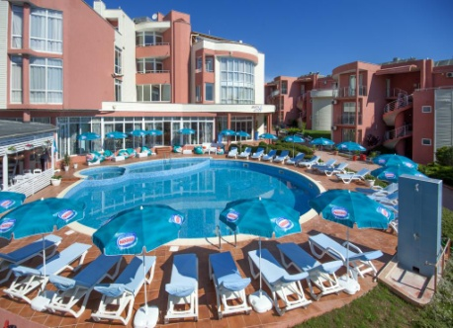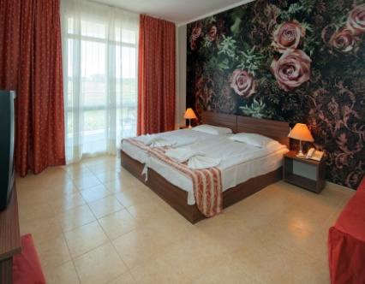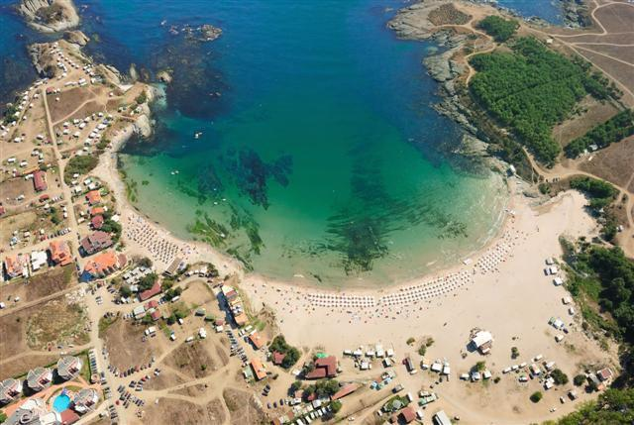
Capul Arapya între Lozenets și Tsarevo. Plaja minunată are 2 golfuri - o plajă mare și una mai mică, înconjurată de păduri de pin și foioase. Complexul reprezintă locul ideal pentru iubitorii de surfing, iahting, pescuit maritim și scufundări. Complexul are piscină în aer liber. În jurul piscinei și pe plajă există umbrele de soare și șezlonguri, alocate în funcție de disponibilitate.
Complexul constă dintr-un hotel și un sat de vacanță cu 7 vile ce oferă diferite facilități și grade de confort. Toate unitățile de cazare sunt dotate cu sistem centralizat de aer condiționat, seif individual, TV prin satelit și minibar. Unele unități beneficiază de balcon și de vedere la mare. În plus, unele includ şi un living cu o canapea. Fiecare unitate are baie privată cu duș sau cadă.
În apropiere se găsesc 3 rezervații naturale naționale, aflate la vărsarea râurilor Ropotamo, Veleka și Rezovska.
OFERTA LAST MINUTE COD « 128/11.06 »
“DISCOUNT -30%”PT REZERVARILE TRIMISE IN PERIOADA 11.06-30.06.2019 SI ACHITATE INTEGRAL IN 24 H-SEJUR IN PERIOADA 11.06-30.06.2019
“DISCOUNT -20%”PT REZERVARILE TRIMISE IN PERIOADA 11.06-30.06.2019 SI ACHITATE INTEGRAL IN 24 H-SEJUR IN PERIOADA 01.07-20.09.2019
*SE POATE COMBINA CU NOPTI GRATUITE ATUNCI CIND ACESTEA SE APLICA
ALL INCLUSIVE | 28.5-09.06  12.9-20.09 | 10.6-15.6  05.9-11.9 | 16.6-22.6  28.8-04.9 | 23.6-06.7  20.8-27.8 | 07.07-19.08
LOC IN CAMERA | 29 | 33 | 42 | 47.5 | 53.5
CAMERA SINGLE | 40.5 | 45.5 | 58 | 66 | 74
LOC IN APART. 1 DORM LUX | 47 | 52.5 | 63 | 70 | 78
TERMEN DE ANULARE | 20 | 20 | 20 | 25 | 25
PENALIZARE | 100% | 100% | 100% | 100% | 100%
IN CAMERA DUBLA MAXIM 2 ADULTI+ 2 COPII/ 3 ADULTI
IN APARTAMENT MINIM 2 PERSOANE; MAXIM 3 ADULTI+ 1 COPIL/4 ADULTI
REDUCERI:
- COPIL ( 0-1,99 ANI)- GRATUIT, FARA SERVICII
- 1 COPIL (2-13,99 ANI) IN PAT SUPLIM. CU 2 ADULTI IN CAMERA- GRATUIT
- AL 2 LEA COPIL (2-13,99 ANI) IN PAT SUPLIM. CU 2 ADULTI IN CAMERA- PLATESTE 50%
- 1 COPIL (2-13,99 ANI) CU 1 ADULT- FARA REDUCERE
- 2 COPII (2-13,99 ANI) CU 1 ADULT- FIECARE COPIL PLATESTE 50%
- ADULT IN PAT SUPLIMENTAR- 30 % REDUCERE

NOPTI GRATUITE PT SEJUR IN PERIOADELE 28.05-15.06/5.09-20.09.2019
- 1 NOAPTE GRATUITA PT SEJUR 7-13 NOPTI
2) 2 NOPTI GRATUITE PT SEJUR DE LA 14 NOPTI

HOTEL JASMIN 3 * KITEN
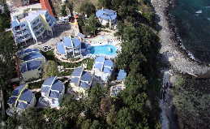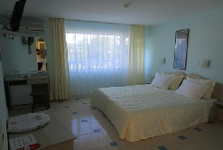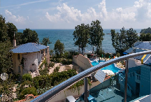
Localizare: este situat în Kiten, la 4 minute pe jos de plaja( 150 m)
Facilitati: restaurant ; piscina; loc joaca copii;parcare;internet;masa tenis;gradina
Dotari camera: TV LCD; A/C; baie cu dus; frigider; balcon;
OFERTA LAST MINUTE COD « 128/11.06 »
“DISCOUNT -30%”PT REZERVARILE TRIMISE IN PERIOADA 11.06-30.06.2019 SI ACHITATE INTEGRAL IN 24 H-SEJUR IN PERIOADA 11.06-30.06.2019
“DISCOUNT -20%”PT REZERVARILE TRIMISE IN PERIOADA 11.06-30.06.2019 SI ACHITATE INTEGRAL IN 24 H-SEJUR IN PERIOADA 01.07-20.09.2019
*SE POATE COMBINA CU NOPTI GRATUITE ATUNCI CIND ACESTEA SE APLICA
ALL INCLUSIVE | 28.05-9.6  12.9-20.9 | 10.6-15.6  5.09-11.9 | 16.6-22.6  28.08-4.9 | 23.6-6.07  20.8-27.8 | 7.07-19.08
SEJUR MINIM NOPTI | 3/2 | 3/3 | 5 | 5 | 7
LOC IN CAMERA | 29 | 32,5 | 41 | 46,5 | 52
CAMERA SINGLE | 48,5 | 54 | 68 | 77,5 | 87
LOC IN APART. 1 DORM | 47 | 52,5 | 63 | 71 | 79
PENALIZARI ANULARI | 100% | 100% | 100% | 100% | 100%
IN CAMERA DUBLA MAXIM 2 ADULTI+ 2 COPII/ 3 ADULTI
IN APARTAMENT MAXIM 2 ADULTI+ 2 COPII/ 3 ADULTI
REDUCERI :
-COPIL ( 0-1.99 ANI ) – GRATUIT, FARA SERVICII/ PATUT 3 E/ZI
-COPIL ( 2-13.99 ANI ) IN PAT SUPLIM CU 2 ADULTI– GRATUIT
- AL 2 LEA COPIL( 2-13.99 ANI ) IN PAT SUPLIM– PLATESTE SUPLIMENT 12,5 €/ZI
- 1-2 COPII ( 2-13.99 ANI ) CU 1 ADULT IN DUBLA- FIECARE PLATESTE 50%
- ADULT IN PAT SUPLIMENTAR – 30 % REDUCERE
NOPTI GRATUITE VALABIL PT SEJUR IN PERIOADELE 28.05-15.06/5.09-20.09.2018
  - NOAPTE GRATUITA PT SEJUR 7-13 NOPTI
2)2 NOPTI GRATUITE PT SEJUR DE LA 14 NOPTI

HOTEL BLACK SEA STAR 3* CHERNOMORETS
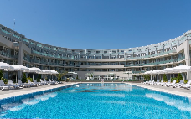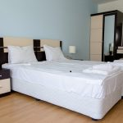
Localizare: la 300 m de plaja Gradina
Dotari camere: TV;A/C; balcon; baie privata;chichineta;frigider
Facilitati: restaurant;2 piscine ;WI FI;terasa;Jacuzzi; sauna;parcare
OFERTA LAST MINUTE COD « 128/11.06 »
“DISCOUNT -30%”PT REZERVARILE TRIMISE IN PERIOADA 11.06-30.06.2019 SI ACHITATE INTEGRAL IN 24 H-SEJUR IN PERIOADA 11.06-30.06.2019
“DISCOUNT -20%”PT REZERVARILE TRIMISE IN PERIOADA 11.06-30.06.2019 SI ACHITATE INTEGRAL IN 24 H-SEJUR IN PERIOADA 01.07-20.09.2019
*SE POATE COMBINA CU NOPTI GRATUITE ATUNCI CIND ACESTEA SE APLICA
ALL INCLUSIVE | 28.5-9.06  12.9-20.9 | 10.6-15.6  5.9-11.09 | 16.6-22.6  28.8-4.09 | 23.6-6.07  20.8-27.8 | 7.07-19.08
LOC IN CAMERA | 29 | 33,5 | 41 | 46,5 | 54
CAMERA SINGLE | 40 | 46 | 56,5 | 64 | 75
LOC IN STUDIO | 30 | 36 | 46,5 | 51 | 57,5
APART. 1 DORM  2 ADULTI/ZI* | 82,5 | 96 | 110,5 | 129,5 | 153
APART. 1 DORM  3 ADULTI/ZI* | 96,5 | 109 | 125 | 144 | 202
APART. 2 DORM  4 ADULTI/ZI* | 112 | 129 | 152 | 178 | 205
APART. 2 DORM  5 ADULTI/ZI* | 126 | 143 | 167 | 193 | 220
PENALIZARI ANULARI | 100% | 100% | 100% | 100% | 100%
IN CAMERA DUBLA MAXIM 2 ADULTI+ 2 COPII/ 3 ADULTI
IN STUDIO MAXIM MAXIM 2 ADULTI+ 2 COPII/ 3 ADULTI
IN APARTAMENT 1 DORM MAXIM 2 ADULTI+ 2 COPII/ 3 ADULTI+ 1 COPIL
IN APARTAMENT 2 DORMITOARE MINIM 4 ADULTI; MAXIM 4 ADULTI+ 2 COPII/5 ADULTI
REDUCERI:
- COPIL ( 0-1,99 ANI ) – GRATUIT, FARA SERVICII
-1 COPIL ( 2- 13,99 ANI) CU 1 ADULT – 20% REDUCERE
- 2 COPII ( 2- 13,99 ANI) CU 1 ADULT- FIECARE PLATESTE 50%
-1 COPIL ( 2-13,99 ANI) IN PAT SUPLIMENTAR- GRATUIT
- AL 2 LEA COPIL ( 2-13,99 ANI) IN PAT SUPLIMENTAR- PLATESTE SUPLIMENT 12,5 €/ZI
- ADULT IN PAT SUPLIMENTAR- 30% REDUCERE
NOPTI GRATUITE VALABIL PT SEJUR IN PERIOADELE 28.05-15.06/5.09-20.09.2019
- 1 NOAPTE GRATUITA PT SEJUR 7-13 NOPTI
- 2 NOPTI GRATUITE PT SEJUR DE LA 14 NOPTI
HOTEL SOUTH BEACH 4*TSAREVO
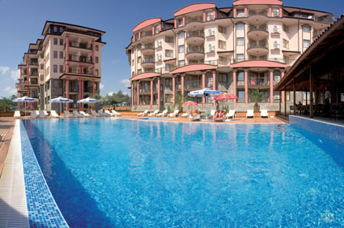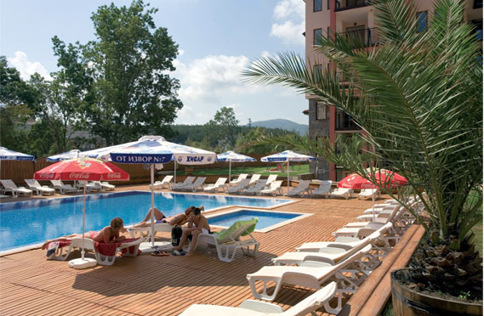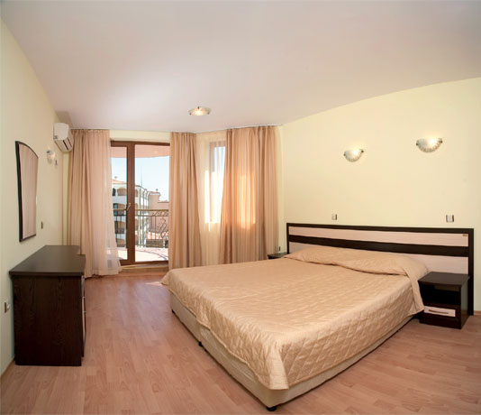
Localizare: 30 m de plaja
Dotari camere: aer conditionat, frigider, seif, balcon, telefon, TV, uscator de par, baie.
Facilitati: loc de joaca, piscina, soare paturi libere şi umbrele, piscină în aer liber, lobby bar, alte restaurante, restaurantul principal, birouri de schimb, magazin, coafor, sala de fitness, sauna, masaj, solar, biliard, centru de sănătate, lifturi.
"ALL INCLUSIVE “: toate mesele buffet suedez ; gustari intre 15.00-17.00 ; cina ; bauturi locale nelimitat intre 11.00-23.00 ; umbrele si sezlonguri gratuite in jurul piscinei ; animatie pt. Copii –de 6 ori/ saptamina ; aminatie pt adulti ; spectacole seara http://www.southbeach-bg.com/
OFERTA LAST MINUTE COD « 122/08.06 »
“DISCOUNT -20%”PT REZERVARILE TRIMISE IN PERIOADA 11.06-22.06.2019 SI ACHITATE INTEGRAL IN 24 H-SEJUR IN PERIOADA 11.06-30.06.2019
“DISCOUNT -15%”PT REZERVARILE TRIMISE IN PERIOADA 11.06-22.06.2019 SI ACHITATE INTEGRAL IN 24 H-SEJUR IN PERIOADA 01.07-15.07.2019
“DISCOUNT -10%”PT REZERVARILE TRIMISE IN PERIOADA 11.06-22.06.2019 SI ACHITATE INTEGRAL IN 24 H-SEJUR IN PERIOADA 28.07-31.08.2019
ALL INCLUSIVE | 1.5-31.05  14.9-30.9 | 1.6-20.6  8.9-13.9 | 21.6-27.6  1.09-7.09 | 28.6-4.7  26.8-31.8 | 5.07-25.08
LOC IN CAMERA ECONOMY | 28 | 32,5 | 39,5 | 48,5 | 52
LOC IN CAMERA STANDARD | 29 | 34,5 | 43 | 51 | 54
CAMERA SINGLE | 39 | 46 | 69 | 73 | 94,5
LOC IN CAMERA LARGE | 30 | 35,5 | 44 | 53 | 56,5
LOC IN STUDIO | 31 | 37 | 45 | 54 | 57,5
LOC IN APART 1 DORM MIC | 32,5 | 38 | 47,5 | 55,5 | 58,5
LOC IN APART 1 DORM LARGE | 33,5 | 41,5 | 48,5 | 56,5 | 60
LOC IN APART 1DORM  VED. MARE | 32,5 | 41,5 | 48,5 | 57,5 | 61
LOC IN APART 2 DORM MIC | 30 | 37 | 45 | 54 | 57,5
LOC IN APART 2 DORM | 33,5 | 42,5 | 49,5 | 57,5 | 61
TERMEN DE ANULARE | 10 | 14 | 16 | 18 | 20
PENALIZARI | 2 | 3 | 3 | 3 | 4
IN CAMERA ECONOMICA MAXIM 2 ADULTI+ 1 COPIL/ 3 ADULTI
IN CAMERA STANDARD MAXIM 2 ADULTI+ 1 COPIL/ 3 ADULTI
IN CAMERA LARGE MAXIM 2 ADULTI+2 COPII/3 ADULTI+ 1 COPIL
IN STUDIO MAXIM 2 ADULTI+2 COPII/3 ADULTI+ 1 COPIL
IN APARTAMENT 1 DORMITOR MINIM 2 ADULTI;MAXIM 2 ADULTI+2 COPII / 3 ADULTI
IN APARTAMENT 2 DORMITOARE MIC MINIM /MAXIM 4 ADULTI
IN APARTAMENT 2 DORM. MAXIM 4 ADULTI+2 COPII /5 ADULTI+ 2 COPII/6 ADULTI
REDUCERI:
- COPIL ( 0-3.99 ANI ) – GRATUIT, FARA SERVICII
- 1 COPIL ( 4-11,99 ANI) IN PAT SUPLIM.CU 2 ADULTI IN DBL /DBL LARGE / STUDIO- GRATUIT
- 1 COPIL ( 4-11,99 ANI) IN PAT SUPLIM.CU 3 ADULTI IN DBL LARGE / STUDIO/AP 1 DORM - GRATUIT
- 1 COPIL ( 4-11,99 ANI) IN PAT NORMAL IN DBL- 50%
- 3 COPII ( 4-11,99 ANI) CU 1 ADULT IN STUDIO/DBL LARGE- FIECARE PLATESTE 50%
- 2 COPII ( 4-11,99 ANI) CU 1 ADULT IN DBL - FIECARE PLATESTE 50%
- 2 COPII (4-11.99 ANI ) IN PAT SUPLIM CU 3 AD IN AP 2 DORM SV- 1 PLATESTE 50%; AL 2 LEA GRATUIT
- 1 COPIL (4-11.99 ANI ) IN PAT SUPLIM CU 4 AD IN AP 2 DORM- GRATUIT
- 1 COPIL (4-11.99 ANI ) IN PAT NORMAL CU 3 AD IN AP 2 DORM- 50%
- ADULT IN PAT SUPLIMENTAR- 20% REDUCERE
NOPTI GRATUITE 21=17;14=11;11=8; PT SOSIRI PANA PE 31.05.2019
8=6;5=4 PT SEJUR PANA PE 22.05 .2019

